Name: Akshaya Neerati
Enrollment No: 2403A510B8
SCHOOL OF COMPUTER SCIENCE AND ARTIFICIAL INTELLIGENCE |  |  |  |  | DEPARTMENT OF COMPUTER SCIENCE ENGINEERING
ProgramName:B. Tech |  |  |  | Assignment Type: Lab |  |  | AcademicYear:2025-2026
CourseCoordinatorName |  |  |  | Venkataramana Veeramsetty
Instructor(s)Name |  |  |  | 1. Dr. Mohammed Ali Shaik  2. Dr. T Sampath Kumar  3. Mr. S Naresh Kumar  4. Dr. V. Rajesh  5. Dr. Brij Kishore  6. Dr Pramoda Patro  7. Dr. Venkataramana  8. Dr. Ravi Chander  9. Dr. Jagjeeth Singh
CourseCode |  |  | 24CS002PC215 | CourseTitle |  | AI Assisted Coding
Year/Sem |  |  | II/I | Regulation |  | R24
Date and Day  of Assignment |  |  | Week2-Tuesday | Time(s)
Duration |  |  | 2 Hours | Applicableto  Batches |  | 24CSBTB01 To 24CSBTB39
AssignmentNumber:3.2(Present assignment number)/24(Total number of assignments)
 | Q.No. | Question |  |  |  |  |  | ExpectedTime  to complete
 | 1 | Lab 3: Prompt Engineering – Improving Prompts and Context Management  Lab Objectives:  - To understand how prompt structure and wording influence AI-generated code.  - To explore how context (like comments and function names) helps AI generate relevant output.  - To evaluate the quality and accuracy of code based on prompt clarity.  - To develop effective prompting strategies for AI-assisted programming.  Lab Outcomes (LOs):  After completing this lab, students will be able to:  - Generate Python code using Google Gemini in Google Colab.  - Analyze the effectiveness of code explanations and suggestions by Gemini.  - Set up and use Cursor AI for AI-powered coding assistance.  - Evaluate and refactor code using Cursor AI features.  - Compare AI tool behavior and code quality across different platforms.  Task Description#1  - Ask AI to write a function to calculate compound interest, starting with only the function name. Then add a docstring, then input-output example  Expected Output#1  - Comparison of AI-generated code styles  Prompt: Create Python code that develops step-by-step a function calculate_compound_interest(): start empty → add docstring → implement → example usage, and briefly compare AI coding styles used in each step.  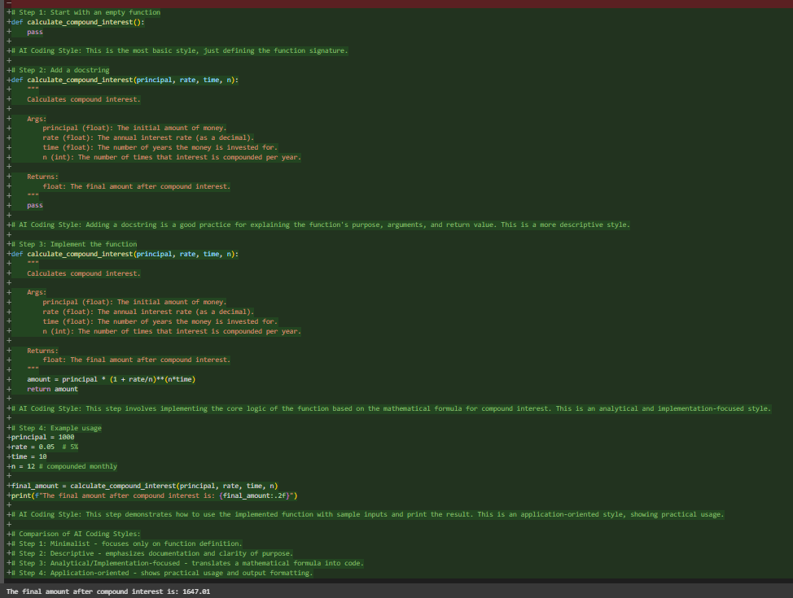  Observation:This code cell shows how to build a Python function calculate_compound_interest step-by-step. It starts empty, adds documentation (docstring), implements the compound interest formula, and finally shows an example of how to use it. The comments point out different coding approaches used in each stage.  Task Description#2  - Do math stuff, then refine it to: # Write a function to calculate average, median, and mode of a list of numbers.  Expected Output#2  - AI-generated function evolves from unclear to accurate multi-statistical operation.  Prompt: Write a Python function that takes a list of numbers and returns the average, median, and mode.  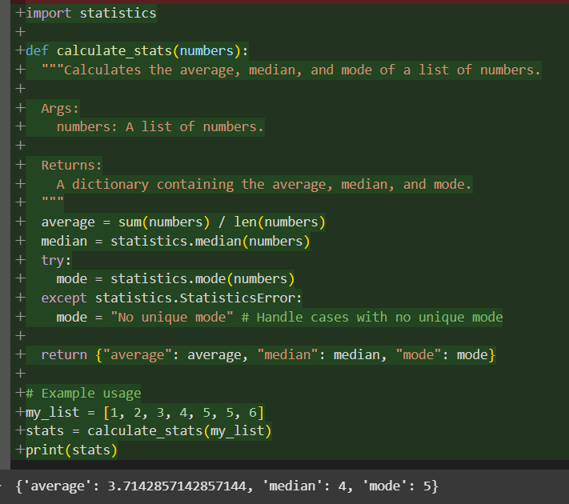  Observation: This code defines a Python function calculate_stats that takes a list of numbers and returns a dictionary with their average, median, and mode using the statistics module. It includes error handling for cases with no unique mode.  Task Description#3  - Provide multiple examples of input-output to the AI for convert_to_binary(num) function. Observe how AI uses few-shot prompting to generalize.  Expected Output#3  - Enhanced AI output with clearer prompts  Prompt: Given examples like 5 → ‘101’, 8 → ‘1000’, and 12 → ‘1100’, write a python function convert_to_binary(num) that converts any integer into its binary representation.  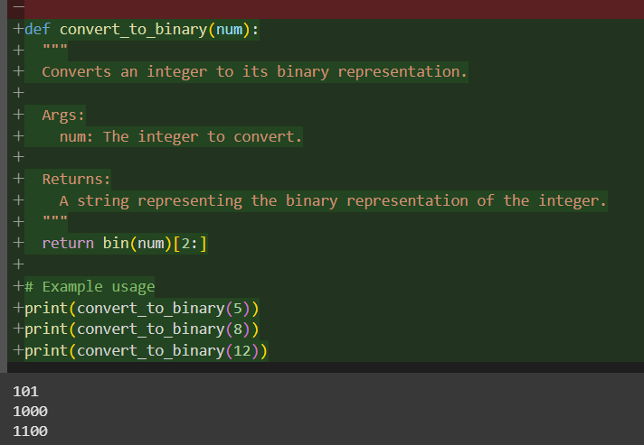  Observation: This code defines a function convert_to_binary(num) that returns the binary form of a number (as a string) without the "0b" prefix.It uses Python’s built-in bin() function and slicing to remove the prefix.The sample prints show how it converts 5 → 101, 8 → 1000, and 12 → 1100.  Task Description#4  - Create an user interface for an hotel to generate bill based on customer requirements  Expected Output#4  - Consistent functions with shared logic  Prompt: Create an python user interface for an hotel to generate bill based on customer requirements.  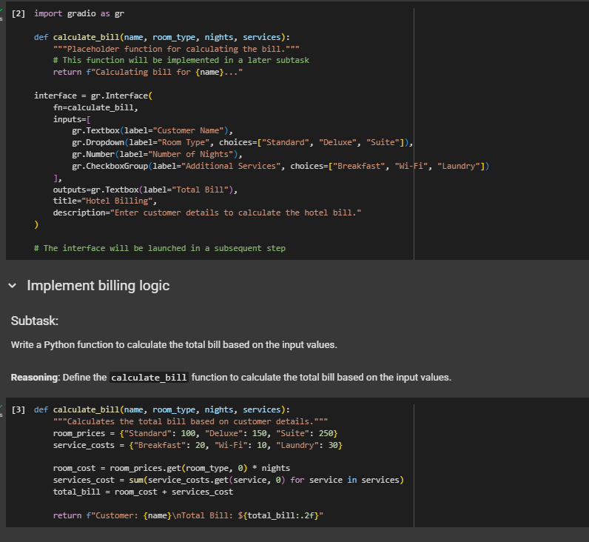    Observation: The provided implementation successfully demonstrates a simple and user-friendly Python GUI (using Gradio) for generating hotel bills based on customer input. The interface accepts key booking details such as customer name, room type, number of nights, and optional additional services (like Breakfast, Wi-Fi, Laundry). Upon submission, the input is passed to a billing function that calculates the total amount by combining room cost and selected service charges. The calculated bill is then displayed clearly to the user. Overall, the design is clean, interactive, and effectively integrates both the billing logic and interface, fulfilling the task requirement of generating hotel bills dynamically based on customer requirements.  Task Description#5  - Analyzing Prompt Specificity: Improving Temperature Conversion Function with Clear Instructions  Expected Output#5  - Code quality difference analysis for various prompts  Prompt: Write a python function that converts a given temperature from Celsius to Fahrenheit and Fahrenheit to Celsius. The function should include input validation, meaningful variable names, and examples of usage.  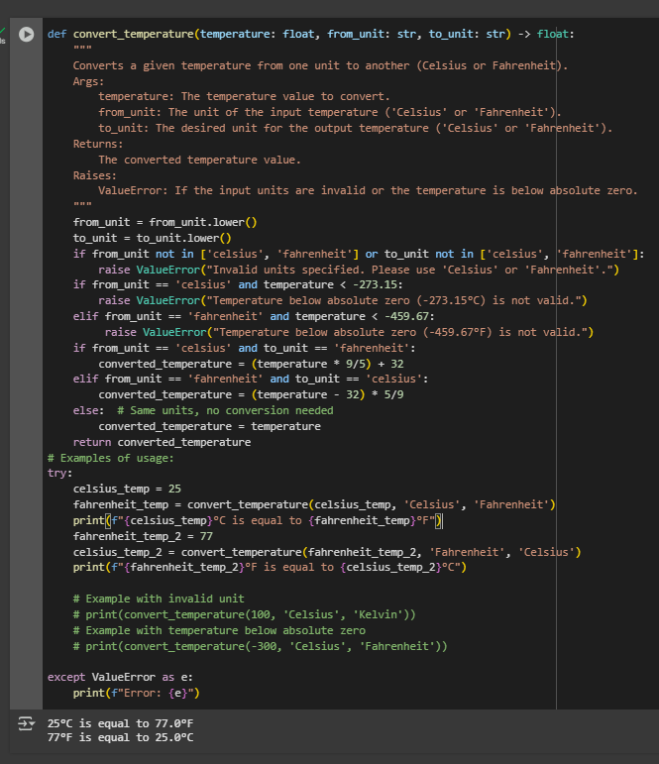  Observation: This code defines a Python function called convert_temperature that takes a temperature value and its original and target units (either 'Celsius' or 'Fahrenheit') as input. It includes input validation to ensure the units are valid and that the temperature is not below absolute zero for the given unit. The function then performs the appropriate conversion based on the input and target units and returns the converted temperature. The code also includes a try...except block with examples of how to use the function and how it handles invalid inputs.  Note: Report should be submitted a word document for all tasks in a single document with prompts, comments & code explanation, and output and if required, screenshots  Evaluation Criteria: |  |  |  |  |  | 03.08.2025 EOD
  Criteria | Max Marks
  Task#1 | 0.5
  Task#2 | 0.5
  Task #3 | 0.5
  Task #4 | 0.5
  Task #5 | 0.5
  Total | 2.5 Marks

