NAME : AKSHAYA

TASKS:

**1.    Setup a local database, create a table, insert some records using any database client**

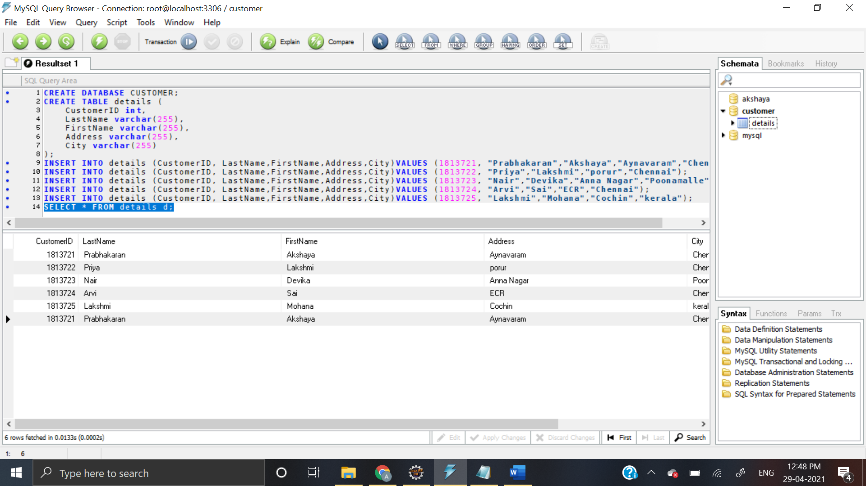**SCREEN SHOTS**

**2.    Write SQL to insert and retrieve records from the above table using the same database client**

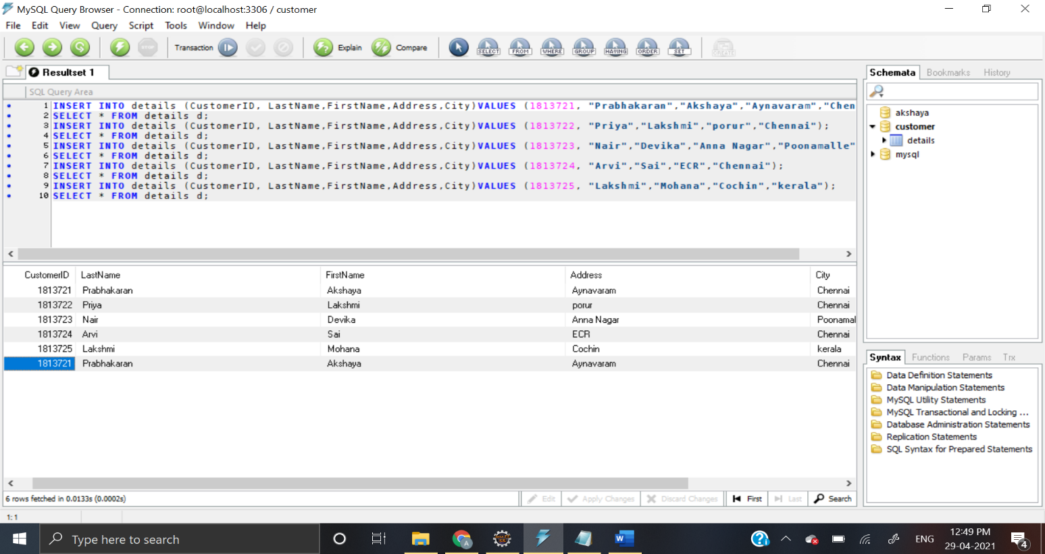

**3.    Write java code to insert and retrieve the records from the database table.**

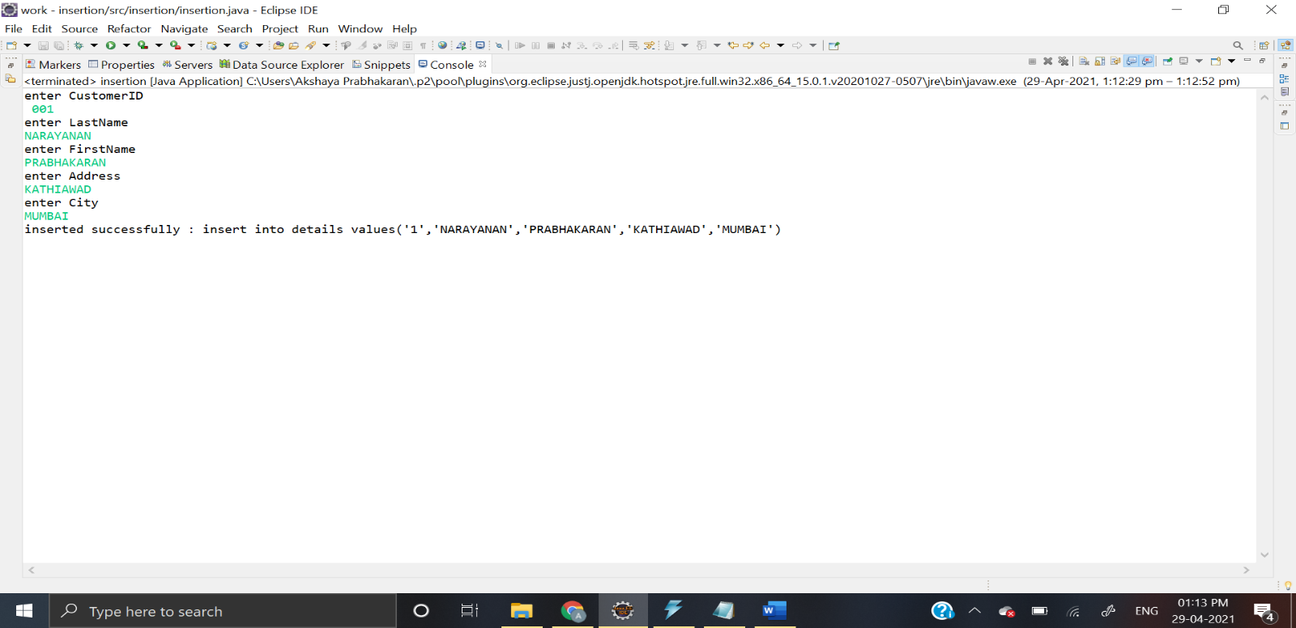**OUTPUT IN JAVA ECLIPSE**

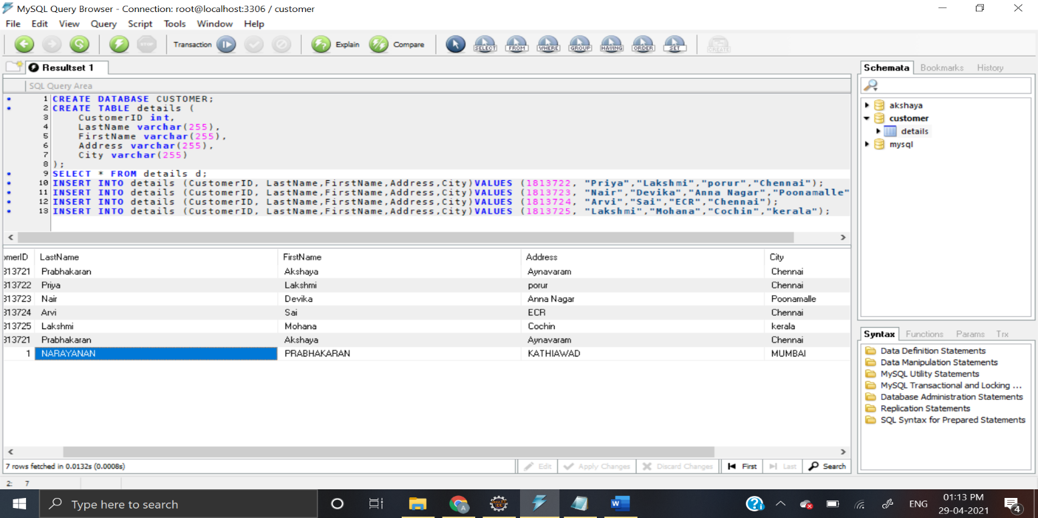**OUTPUT IN SQL**

**RETRIEVING RECORDS FROM DATABASE TABLE:**

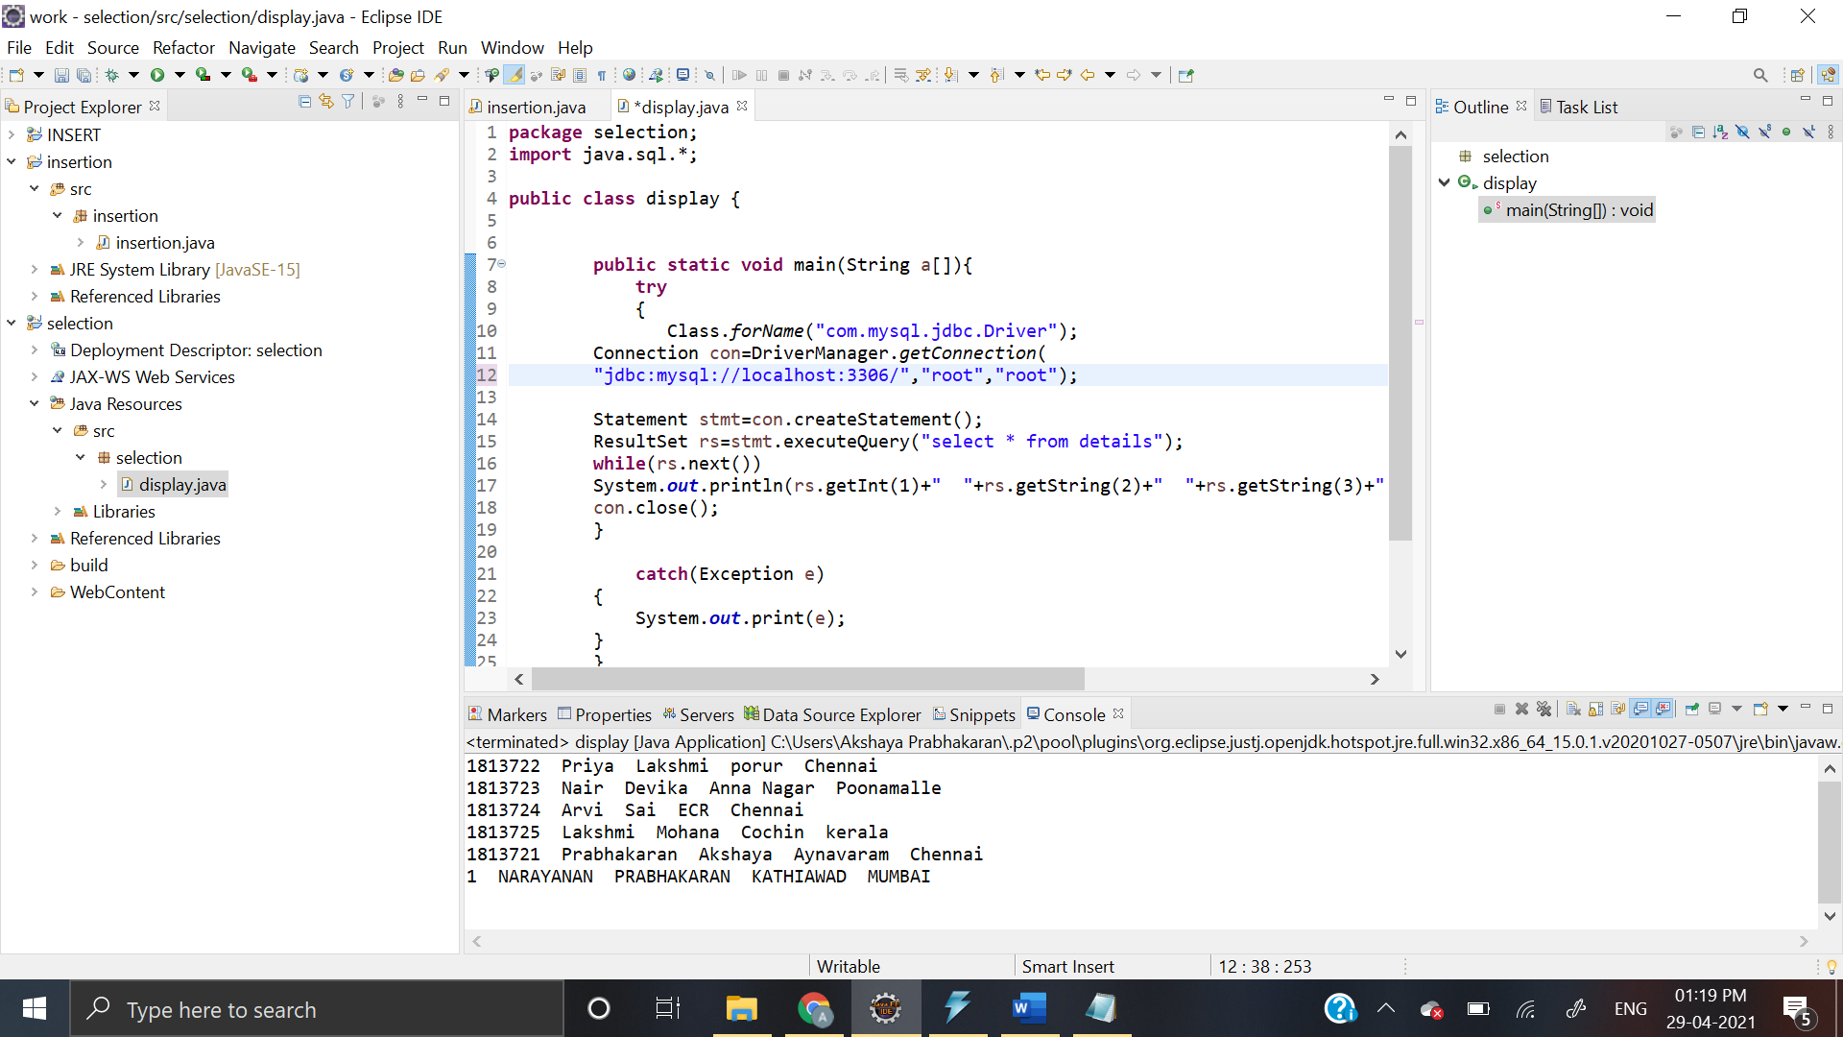**ECLIPSE OUTPUT**

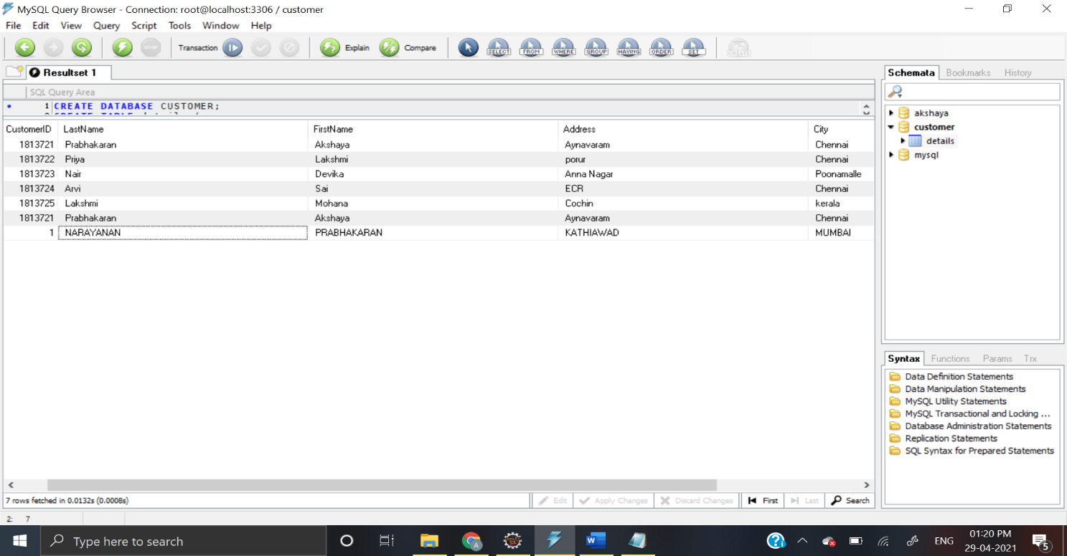**SQL OUTPUT:**