**SKILL TRACKER**

Batch : 17th June 2019 Onboarding - FSD

**Team Members:**

Akshaya R

Arun Kumar K

Geethanjali Peruru

Keerthana K

Priya R

Ram Murti

Sobhesh Barun Tripathy

System Requirement Specification Document V 1.0

Table of Contents:

Introduction 3

Scope: 3

Assumptions 3

Management Summary 3

System Objectives / Overview 4

Figure 1 System Context Diagram 4

Refrences 5

Initial requirement document 5

Common requirements: 5

Email requirements:

Functional Requirement 1 6

Brief Description 6

Interface Details 6

Table of requirement 6

Email template: 7

Database Schema: 8

SQL Script for table creation: 8

Test Cases: 8

Test cases 9

Disclaimer 10

Products to be used: 10

**INTRODUCTION**

**SCOPE**

The main scope of this application is keeping track of skill of individual full stack Engineers. To use the single page application (skill tracker) to keep track of employee skills. The skill Tracker should be the single page application (SPA). Using the internal portal an admin will be able to perform following operations.

* Search by associate name
* Search by associate ID
* Search by associate Email ID
* Search by associate Mobile Number
* Search by associate Strong Skills
* Add new associate

The admin will be able to add new associate and its respective Full Stack Development Skills.

The associate which is searched can be updated , deleted and viewed.

**ASSUMPTIONS**

This app is developed for the main purpose of tracking the skills of individual Full Stack Engineers.

**MANAGEMENT SUMMARY**

John Dempsey works in an IT company. He is a new age HR Academic Manager. Few of his responsibilities includes:

1. Search associate: John will be able to search associate with following criteria

* Search by associate name
* Search by associate ID
* Search by associate Email ID
* Search by associate Mobile Number
* Search by associate Strong Skills

1. Add new Associate

The admin will be able to add new associate and its respective Full Stack Development Skills.

1. Edit, Delete & View Associate

The associate which is searched can be updated, deleted and viewed.

1. Add skills

It will allow the john to add new skills so that it can be used in “add new Associate “ page.

**SYSTEM OBJECTIVES AND OVERVIEW**

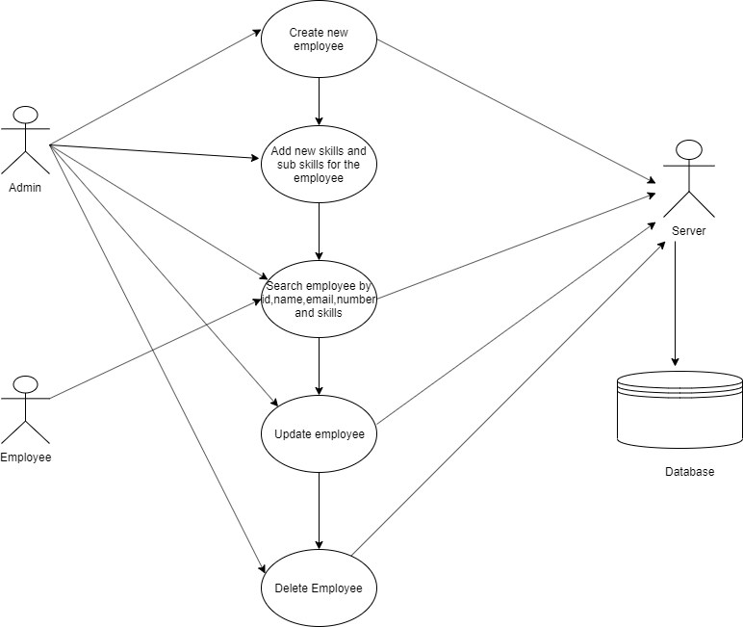

## Figure 1 System Context Diagram

The diagram above explains the main conceptual elements in the solution and its

relationships with the architecture. The Skill Tracker application is responsible for adding and maintaining skills of employees.

Employee’s skills along with its sub skills and its certifications can be added and updated.

This provides an option of searching the employee based on their id, name, email, mobile number and also by their skills.

|  |  |
| --- | --- |
| Employee | Employee can search the employee by their id, name, email, mobile number and skills. |
| Admin | Admin can add a new employee, update an existing employee, delete an employee, search as well. |

**REFRENCES:**

Initial requirement document



# COMMON REQUIREMENTS:

**Email Requirements:**

There are no specific sequencing requirements for sending mail to the associate. Each message will be max of 4KBs.

**FUNCTIONAL REQUIREMENT:**

**Brief description**

An Admin add the new associate, search employees, delete employees, update employees, provides rating to the skills with the help of server and database. An employee can able to view other employees and update their own skills.

**Interface requirement**

See the use case diagram between employee and admin.

**Table Requirement**

|  |  |
| --- | --- |
| Database | It used to store and retrieve the values of employees to and from the database respectively with the help of server. |
| Server | It is a interconnection between the client and database and provide response to the client. |

**Email Template**

Dear <Associate Name>,

Hi (Associate Name), welcome to skill tracker. You have successfully created an account in the Skill Tracker.

At your service,

Skill Tracker.

**DATABASE SCHEMA:**

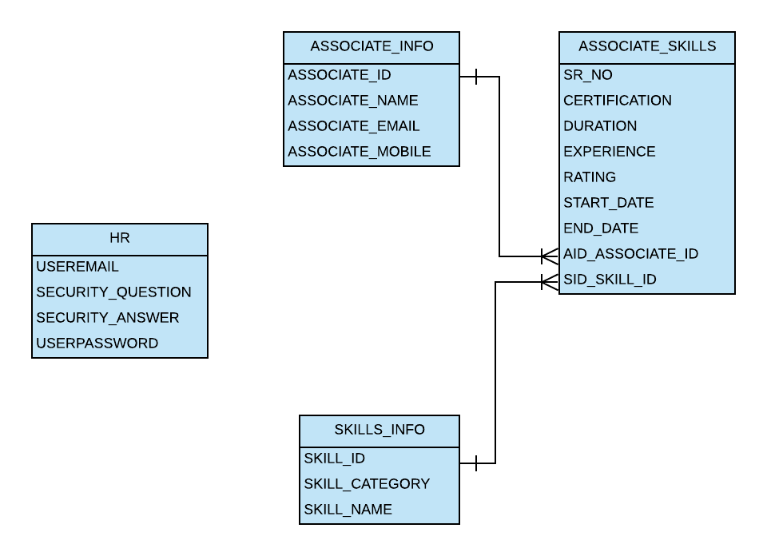

## 

## SQL SCRIPT FOR TABLE CREATION:

This DB scripts were prepared against the derby DB for the above topology.



**TEST CASES:**



**DISCLAIMER:**

Most of the DB requirements are captured in the specification. But while developing the solution if the developer has a valid point to add more fields then it can be accommodated after consultation since the DB schema is not freezed as yet.

# PRODUCTS TO BE USED:

|  |  |  |
| --- | --- | --- |
| Scenario | Product | Description |
| Developing Use case & UML related activites | Rational rose | All the UML related specs needs to be developed using Rational rose only. |
| Development | Spring micro services | The development of the applications is done only by making use spring micro services |
| Database | MySQL version 8.0 | For all the DB requirements, the team should use Mysql only |
| Team repository | Git hub | The project team should share their artifacts between them using Github repository only. |
| Deployment – Java/J2EE solutions | Amazon web services (AWS) | The team should deploy their solutions for testing/production on AWS. They should be able to configure the server resources that are required for their solution. |
| Deployment – Message Oriented Middleware | Java mail sender | For all the messaging requirements in the solution, the team should use java mail sender only. |