|  |  |
| --- | --- |
| **WEEK 5 – Microservices with API Gateway** | **Superset Id : 6429486**  **Name : Akshaya V** |

**Exercise 1: Creating Microservices for Account and Loan**

**Account Microservice:**

**Code:**

**Account.java:**

package com.cognizant.account.model;  
public class Account{  
 private String number;  
 private String type;  
 private double balance;  
 public Account(String number, String type, double balance){  
 this.number=number;  
 this.type=type;  
 this.balance=balance;  
 }  
 public String getNumber(){  
 return number;  
 }  
 public String getType(){  
 return type;  
 }  
 public double getBalance(){  
 return balance;  
 }  
}

**AccountController.java:**

package com.cognizant.account.controller;  
import com.cognizant.account.model.Account;  
import com.cognizant.account.service.AccountService;  
import org.springframework.beans.factory.annotation.Autowired;  
import org.springframework.http.ResponseEntity;  
import org.springframework.web.bind.annotation.*;  
@RestController  
@RequestMapping("/accounts")  
public class AccountController{  
 @Autowired  
 private AccountService accountService;  
 @GetMapping("/{number}")  
 public ResponseEntity<Account> getAccount(@PathVariable String number){  
 Account account=accountService.getAccountByNumber(number);  
 return ResponseEntity.*ok*(account);  
 }  
}

**AccountService.java:**

package com.cognizant.account.service;  
import com.cognizant.account.model.Account;  
public interface AccountService{  
 Account getAccountByNumber(String number);  
}

**AccountServiceImpl.java:**

package com.cognizant.account.service;  
import com.cognizant.account.model.Account;  
import org.springframework.stereotype.Service;  
@Service  
public class AccountServiceImpl implements AccountService{  
 @Override  
 public Account getAccountByNumber(String number){  
 return new Account(number,"Savings",234343.0);  
 }  
}

**application.properties:**

spring.application.name=Account  
server.port=8080

**Loan Microservice**

**Loan.java:**

package com.cognizant.loan.model;  
public class Loan{  
 private String number;  
 private String type;  
 private double loanAmount;  
 private double emi;  
 private int tenure;  
 public Loan(String number,String type,double loanAmount,double emi,int tenure){  
 this.number=number;  
 this.type=type;  
 this.loanAmount=loanAmount;  
 this.emi=emi;  
 this.tenure=tenure;  
 }  
 public String getNumber(){  
 return number;  
 }  
 public String getType(){  
 return type;  
 }  
 public double getLoanAmount(){  
 return loanAmount;  
 }  
 public double getEmi(){  
 return emi;  
 }  
 public int getTenure(){  
 return tenure;  
 }  
}

**LoanController.java:**

package com.cognizant.loan.controller;  
import com.cognizant.loan.model.Loan;  
import com.cognizant.loan.service.LoanService;  
import org.springframework.beans.factory.annotation.Autowired;  
import org.springframework.http.ResponseEntity;  
import org.springframework.web.bind.annotation.*;  
@RestController  
@RequestMapping("/loans")  
public class LoanController{  
 @Autowired  
 private LoanService loanService;  
 @GetMapping("/{number}")  
 public ResponseEntity<Loan> getLoan(@PathVariable String number){  
 Loan loan=loanService.getLoanByNumber(number);  
 return ResponseEntity.*ok*(loan);  
 }  
}

**LoanService.java:**

package com.cognizant.loan.service;  
import com.cognizant.loan.model.Loan;  
public interface LoanService{  
 Loan getLoanByNumber(String number);  
}

**LoanServiceImpl.java:**

package com.cognizant.loan.service;  
import com.cognizant.loan.model.Loan;  
import org.springframework.stereotype.Service;  
@Service  
public class LoanServiceImpl implements LoanService{  
 @Override  
 public Loan getLoanByNumber(String number){  
 return new Loan(number,"Car",400000,3258,18);  
 }  
}

**application.properties:**

spring.application.name=Loan  
server.port=8081

**Output:**

**Account Microservice**

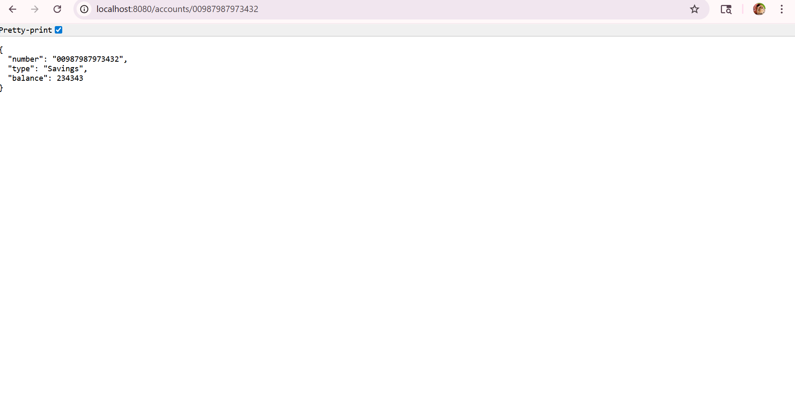

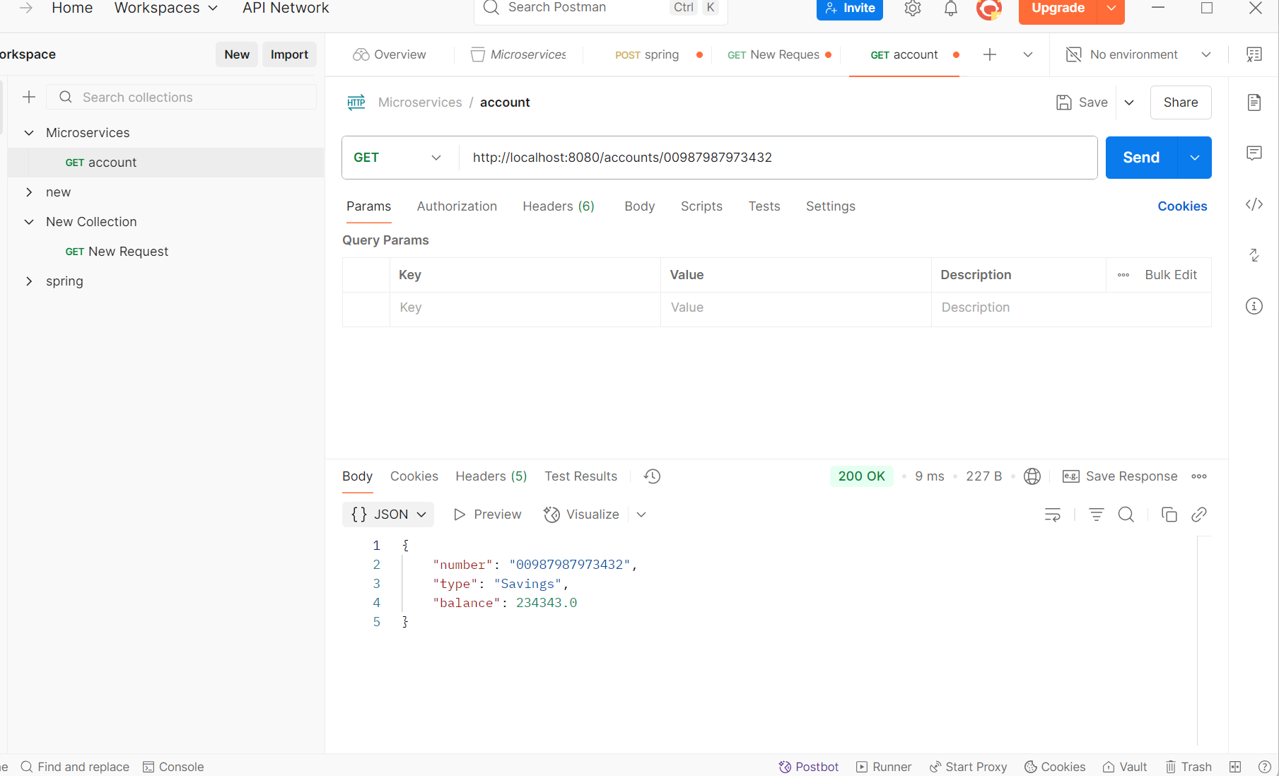

**Loan Microservice**



