|  |  |
| --- | --- |
| **WEEK 6 - React** | **Superset Id : 6429486**  **Name : Akshaya V** |

**Exercise 1: Create a new React Application**

**Code:**

**App.js:**

import './App.css';

function App(){

  return(

    <div className="App">

      <div className="card">

        <h1>Welcome to My First React Application</h1>

        <p className="name">Akshaya V - 6429486</p>

      </div>

    </div>

  );

}

export default App;

**App.css:**

body{

  margin: 0;

  font-family: 'Segoe UI', Tahoma, Geneva, Verdana, sans-serif;

  background: linear-gradient(135deg, #b92b27, #1565C0);

  height: 100vh;

  display: flex;

  justify-content: center;

  align-items: center;

  color: white;

}

.App{

  text-align: center;

}

.card{

  background: rgba(255, 255, 255, 0.15);

  padding: 50px 40px;

  border-radius: 20px;

  box-shadow: 0 8px 30px rgba(0, 0, 0, 0.4);

  backdrop-filter: blur(12px);

  transition: transform 0.3s ease, box-shadow 0.3s ease;

  max-width: 500px;

}

.card:hover{

  transform: scale(1.03);

  box-shadow: 0 12px 40px rgba(0, 0, 0, 0.6);

}

.card h1{

  font-size: 2rem;

  font-weight: 600;

  margin-bottom: 20px;

}

.card .name{

  font-size: 1.3rem;

  font-weight: 500;

  color: #fff;

  text-align: center;

  margin-top: 10px;

}

**Output:**

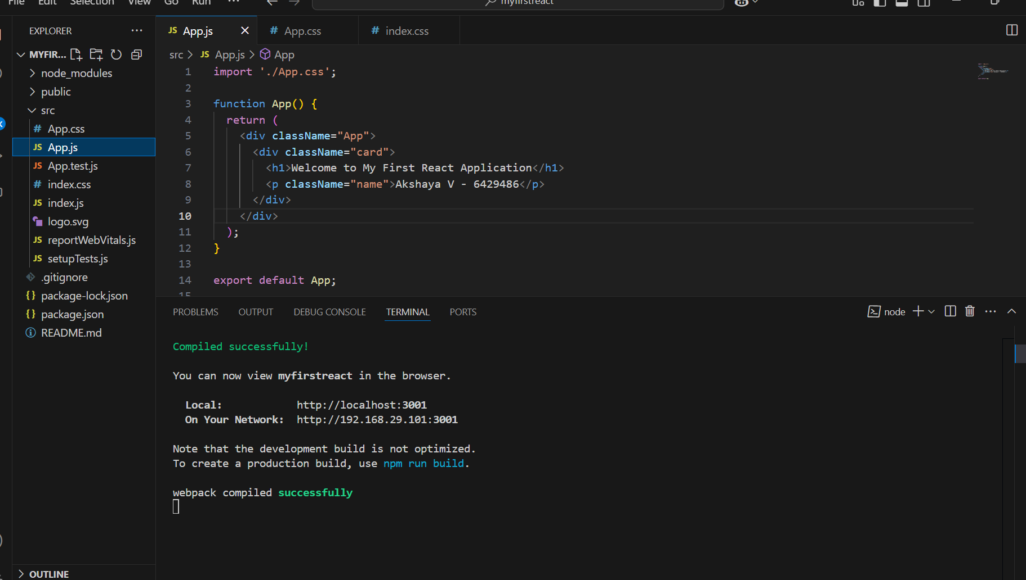

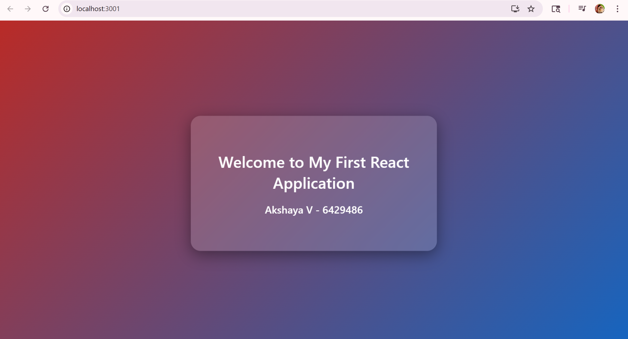

**Exercise 2: Create a react app for Student Management Portal**

**Code:**

**Home.js:**

import React from 'react';

function Home(){

  return(

    <div>

      <h2>Welcome to the Home page of Student Management Portal</h2>

    </div>

  );

}

export default Home;

**About.js:**

import React from 'react';

function About(){

  return(

    <div>

      <h2>Welcome to the About page of the Student Management Portal</h2>

    </div>

  )

}

export default About;

**Contact.js:**

import React from 'react';

function Contact(){

  return(

    <div>

      <h2>Welcome to the Contact page of the Student Management Portal</h2>

    </div>

  );

}

export default Contact;

**App.js:**

import React from 'react';

import './App.css';

import Home from './components/Home';

import About from './components/About';

import Contact from './components/Contact';

function App(){

  return(

    <div className="App">

      <h1>Student Management Portal</h1>

      <Home />

      <About />

      <Contact />

    </div>

  );

}

export default App;

**App.css:**

body{

  margin: 0;

  height: 100vh;

  background: linear-gradient(-45deg, #ee7752, #e73c7e, #23a6d5, #23d5ab);

  background-size: 400% 400%;

  animation: gradientBG 15s ease infinite;

}

@keyframes gradientBG{

  0%{

    background-position: 0% 50%;

  }

  50%{

    background-position: 100% 50%;

  }

  100%{

    background-position: 0% 50%;

  }

}

.App{

  text-align: center;

  padding: 20px;

  font-family: 'Segoe UI', Tahoma, Geneva, Verdana, sans-serif;

}

h1{

  color: #040921;

  margin-bottom: 40px;

}

h2{

  background-color: #f0f0f0;

  color: #333;

  margin: 20px auto;

  padding: 15px;

  border-radius: 10px;

  width: 60%;

  box-shadow: 0 4px 8px rgba(0, 0, 0, 0.2);

}

**Output:**

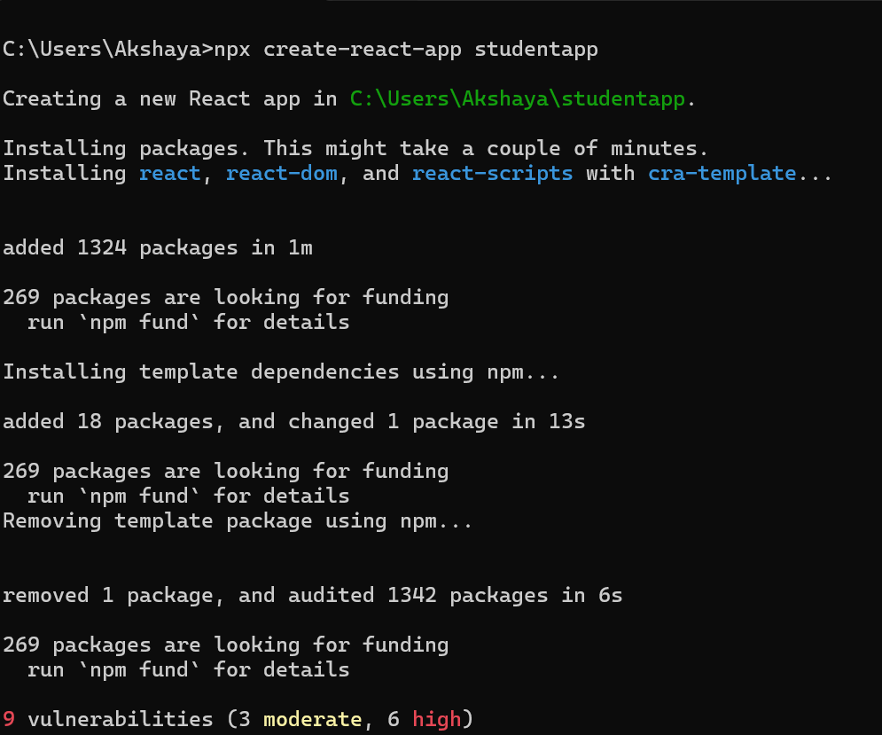

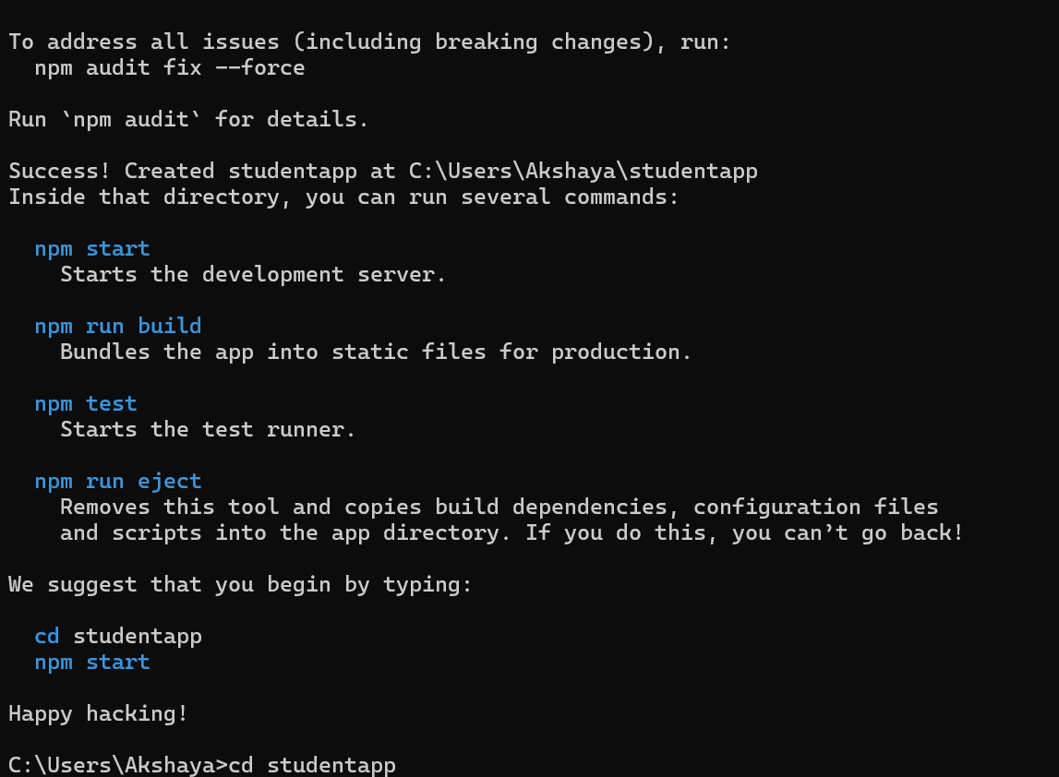

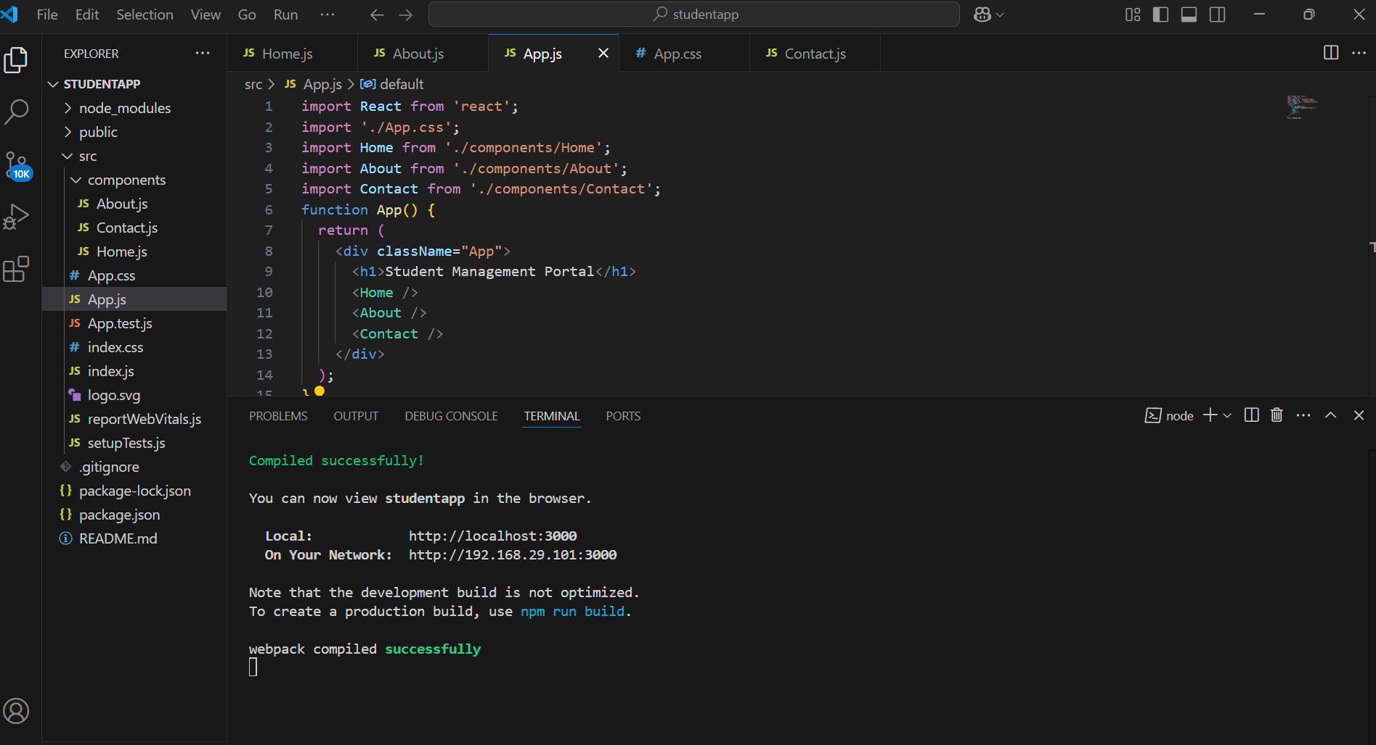

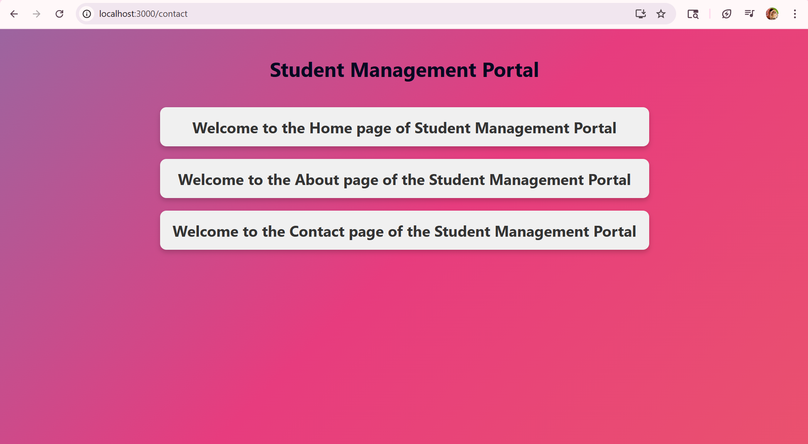

**Exercise 3 : Create a new React Application**

**Code:**

**CalculateScore.js:**

import '../Stylesheets/mystyle.css';

const percentToDecimal = (decimal) => {

  return (decimal * 100).toFixed(2) + '%';

};

const calcScore = (total, goal) => {

  return percentToDecimal(total / goal);

};

export const CalculateScore = ({ Name, School, total, goal }) => {

  return (

    <div className="container">

      <h1 className="title">Student Details</h1>

      <div className="formatstyle">

        <div className="row">

          <div className="label">Name</div>

          <div className="value NameVal">{Name}</div>

        </div>

        <div className="row">

          <div className="label">School</div>

          <div className="value SchoolVal">{School}</div>

        </div>

        <div className="row">

          <div className="label">Total</div>

          <div className="value TotalVal">{total} Marks</div>

        </div>

        <div className="row">

          <div className="label">Score</div>

          <div className="value ScoreVal">{calcScore(total, goal)}</div>

        </div>

      </div>

    </div>

  );

};

**App.js:**

import { CalculateScore } from './Components/CalculateScore';

function App() {

  return (

    <div>

      <CalculateScore

        Name="Akshaya V - 6429486"

        School="ABC Public School"

        total={294}

        goal={300}

      />

    </div>

  );

}

export default App;

**mystyle.css:**

body {

    margin: 0;

    padding: 0;

    background: linear-gradient(135deg, #e3f2fd, #fff1f2);

    font-family: 'Poppins', sans-serif;

    display: flex;

    justify-content: center;

    align-items: center;

    min-height: 100vh;

}

.formatstyle {

    background: #ffffff;

    padding: 50px 60px;

    border-radius: 18px;

    box-shadow: 0 12px 30px rgba(0, 0, 0, 0.1);

    width: 100%;

    max-width: 520px;

    border-left: 6px solid #1565c0;

    box-sizing: border-box;

    display: table;

    table-layout: fixed;

    transition: transform 0.3s ease;

}

.formatstyle:hover {

    transform: scale(1.01);

}

.title {

    font-size: 28px;

    font-weight: 700;

    text-align: center;

    color: #2b2b2b;

    margin-bottom: 35px;

    padding-bottom: 15px;

    border-bottom: 2px solid #e0e0e0;

    background: linear-gradient(to right, #207bc6, #b8194e);

    background-clip: border-box;

    -webkit-background-clip: text;

    -webkit-text-fill-color: transparent;

    letter-spacing: -0.5px;

}

.row {

    display: table-row;

    border-bottom: 1px solid #f0f0f0;

}

.row:last-child {

    border-bottom: none;

}

.label {

    display: table-cell;

    font-weight: 500;

    color: #444;

    font-size: 17px;

    padding: 14px 10px 14px 0;

    vertical-align: middle;

    white-space: nowrap;

}

.label::after {

    content: ":";

    margin-left: 2px;

}

.value {

    display: table-cell;

    font-size: 17px;

    font-weight: 600;

    text-align: left;

    padding: 14px 0 14px 15px;

    color: #1a1a1a;

    white-space: nowrap;

    overflow: hidden;

    text-overflow: ellipsis;

}

.NameVal {

    color: #1e88e5;

}

.SchoolVal {

    color: #e53935;

}

.TotalVal {

    color: #8e24aa;

}

.ScoreVal {

    color: #2e7d32;

    font-size: 18px;

    font-weight: 700;

}

@media (max-width: 500px) {

    .formatstyle {

        padding: 25px;

        display: block;

    }

    .row {

        display: flex;

        justify-content: flex-start;

        align-items: center;

        padding: 12px 0;

        border-bottom: 1px solid #f0f0f0;

    }

    .label {

        font-weight: 500;

        font-size: 17px;

        color: #444;

        margin-right: 10px;

        white-space: nowrap;

    }

    .value {

        font-weight: 600;

        font-size: 17px;

        color: #1a1a1a;

        flex: 1;

        white-space: nowrap;

    }

    .title {

        font-size: 22px;

    }

}

**Output:**

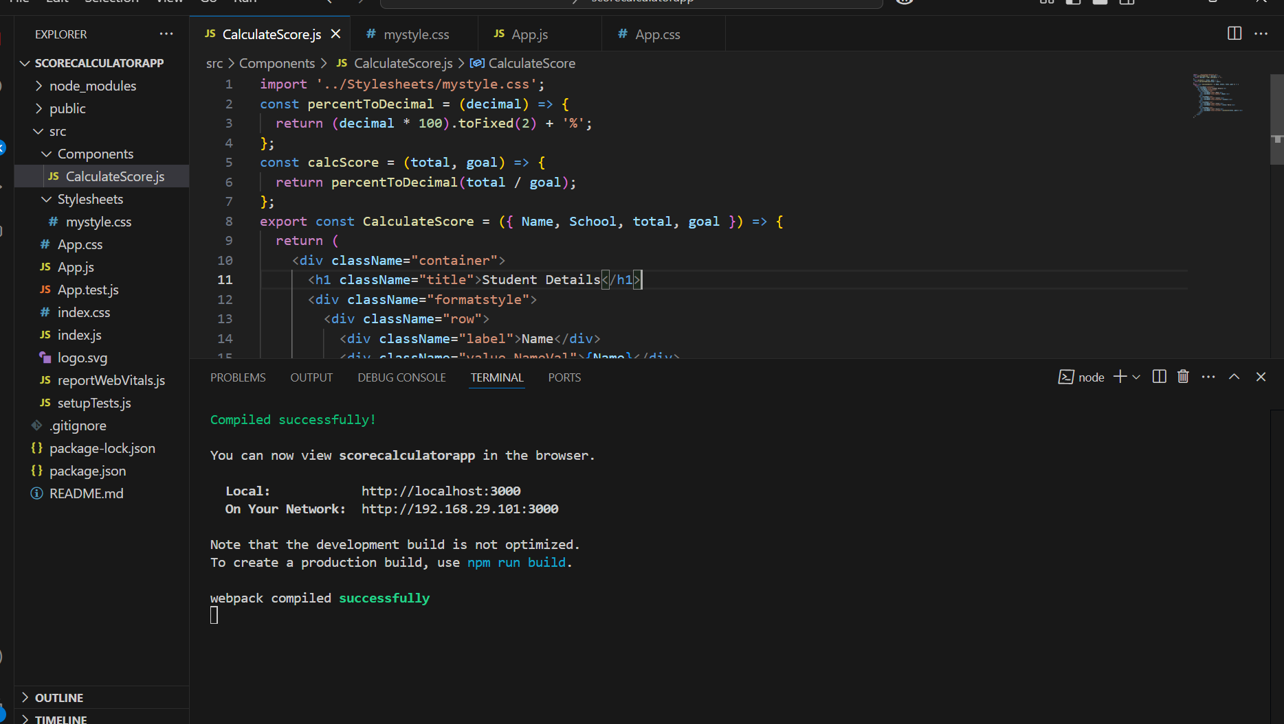

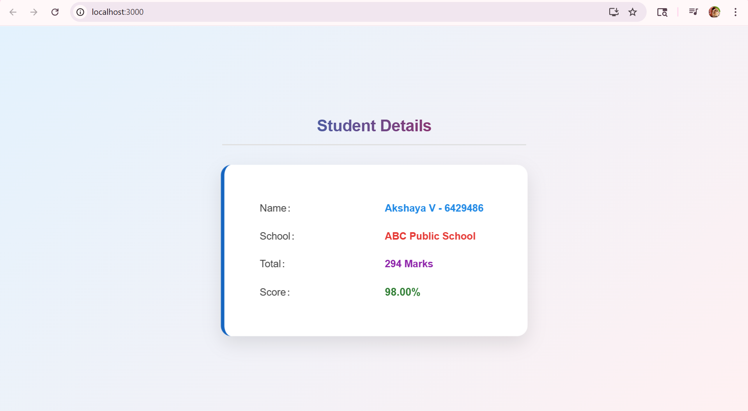

**Exercise 4 : Create a Blog App**

**Code:**

**Post.js:**

import React from 'react';

import './App.css';

class Post extends React.Component {

    render() {

        return (

            <div className="post">

                <h3>{this.props.title}</h3>

                <p className="author">by {this.props.author}</p>

                <p>{this.props.body}</p>

            </div>

        );

    }

}

export default Post;

**Posts.js:**

import React from 'react';

import Post from './Post';

import './App.css';

class Posts extends React.Component {

    constructor(props) {

        super(props);

        this.state = {

            posts: [],

            loading: true,

            error: false,

            search: ''

        };

    }

    componentDidMount() {

        this.loadPosts();

    }

    loadPosts() {

        const authors = ['Alice', 'Bob', 'Carol', 'David', 'Eve'];

        fetch('https://jsonplaceholder.typicode.com/posts')

            .then(res => res.json())

            .then(data => {

                const enhanced = data.slice(0, 20).map((item, idx) => ({

                    ...item,

                    author: authors[idx % authors.length]

                }));

                this.setState({ posts: enhanced, loading: false });

            })

            .catch(() => this.setState({ error: true, loading: false }));

    }

    componentDidCatch(error, info) {

        alert("An error occurred while rendering blog posts.");

        console.error("componentDidCatch error:", error, info);

    }

    handleSearch = (e) => {

        this.setState({ search: e.target.value });

    };

    render() {

        const { posts, loading, error, search } = this.state;

        if (loading) return <p>Loading blog posts...</p>;

        if (error) return <p style={{ color: 'red' }}>Error fetching blog posts.</p>;

        const filtered = posts.filter(post =>

            post.title.toLowerCase().includes(search.toLowerCase())

        );

        return (

            <div>

                <input

                    type="text"

                    className="search"

                    placeholder="Search blog posts by title..."

                    value={search}

                    onChange={this.handleSearch}

                />

                {filtered.map(post => (

                    <Post

                        key={post.id}

                        title={post.title}

                        body={post.body}

                        author={post.author}

                    />

                ))}

            </div>

        );

    }

}

export default Posts;

**App.js:**

import React from 'react';

import './App.css';

import Posts from './Posts';

function App() {

  return (

    <div className="App">

      <h1>My React Blog</h1>

      <Posts />

    </div>

  );

}

export default App;

**App.css:**

body {

margin: 0;

  padding: 0;

  background: linear-gradient(to right, #fdfbfb, #ebedee);

  font-family: 'Segoe UI', sans-serif;

  color: #333;

}

.App {

  max-width: 960px;

  margin: 40px auto;

  padding: 40px;

  background-color: white;

  border-radius: 12px;

  box-shadow: 0 8px 20px rgba(0, 0, 0, 0.1);

}

h1 {

  text-align: center;

  color: #3e3e3e;

  margin-bottom: 40px;

  font-size: 2.5em;

}

input.search {

  width: 100%;

  padding: 14px 16px;

  font-size: 16px;

  border: 1px solid #ccc;

  border-radius: 8px;

  margin-bottom: 30px;

  box-sizing: border-box;

  transition: border 0.3s, box-shadow 0.3s;

}

input.search:focus {

  border-color: #007acc;

  box-shadow: 0 0 8px rgba(0, 122, 204, 0.2);

  outline: none;

}

.post {

  background-color: #fafafa;

  padding: 25px 20px;

  margin-bottom: 20px;

  border-radius: 10px;

  box-shadow: 0 2px 6px rgba(0, 0, 0, 0.05);

  transition: transform 0.2s ease, box-shadow 0.2s ease;

}

.post:hover {

  transform: translateY(-3px);

  box-shadow: 0 6px 12px rgba(0, 0, 0, 0.1);

}

.post h3 {

  margin-top: 0;

  color: #007acc;

  font-size: 20px;

  margin-bottom: 10px;

}

.post .author {

  font-size: 14px;

  color: #888;

  margin-bottom: 12px;

  font-style: italic;

}

.post p {

  font-size: 16px;

  line-height: 1.6;

}

**Output:**

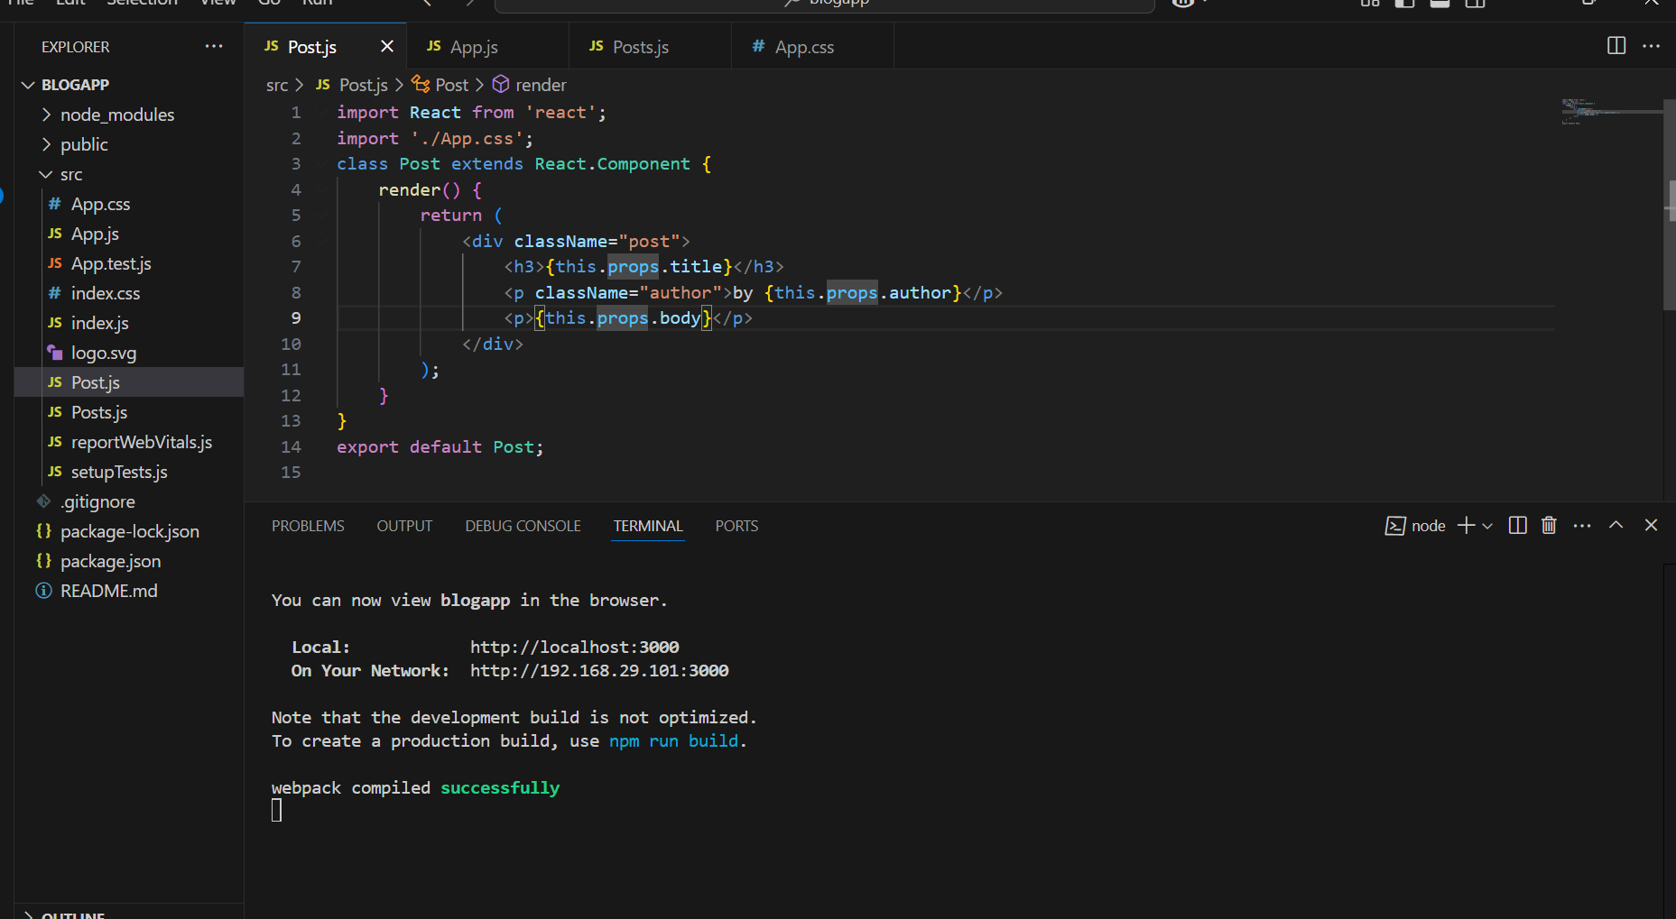

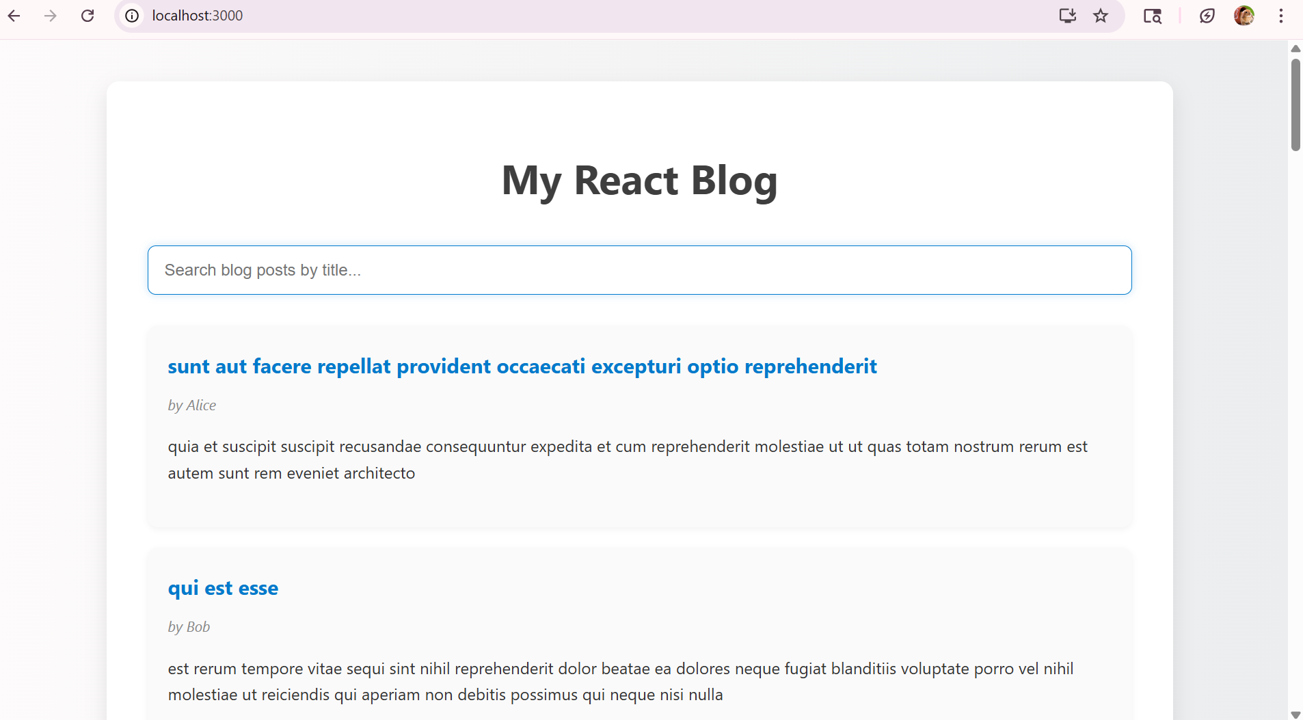

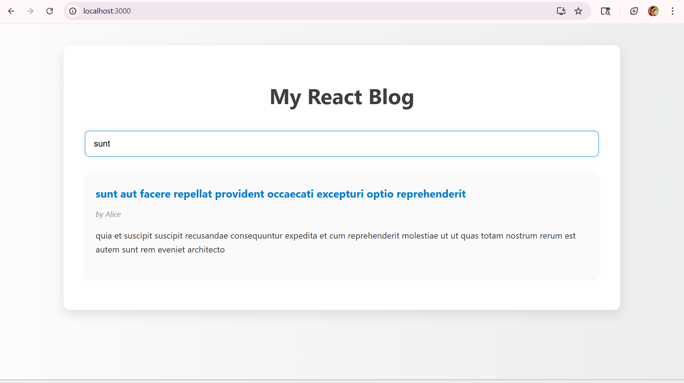

**Exercise 5 :**

**Code:**

**CohortDetails.js:**

import React from 'react';

import styles from './CohortDetails.module.css';

function CohortDetails(props) {

  const { cohort } = props;

  const h3Style = {

    color: cohort.currentStatus === 'ongoing' ? 'green' : 'blue'

  };

  return (

    <div className={styles.box}>

      <h3 style={h3Style}>

        {cohort.cohortCode} - <span>{cohort.technology}</span>

      </h3>

      <dl>

        <dt>Started On</dt>

        <dd>{cohort.startDate}</dd>

        <dt>Current Status</dt>

        <dd>{cohort.currentStatus}</dd>

        <dt>Coach</dt>

        <dd>{cohort.coachName}</dd>

        <dt>Trainer</dt>

        <dd>{cohort.trainerName}</dd>

      </dl>

    </div>

  );

}

export default CohortDetails;

**CohortDetails.module.css:**

.box {

    width: 280px;

    margin: 0;

    padding: 10px 20px;

    border: 1px solid black;

    border-radius: 10px;

    background-color: #f9f9f9;

    box-shadow: 0 2px 8px rgba(0, 0, 0, 0.08);

    text-align: left;

  }

  dt {

    font-weight: 500;

    margin-top: 10px;

  }

**App.js:**

import React from 'react';

import CohortDetails from './CohortDetails';

import './App.css';

function App() {

  const cohorts = [

    {

      cohortCode: "C123",

      technology: ".Net FSD",

      startDate: "2025-04-01",

      currentStatus: "completed",

      coachName: "Arun",

      trainerName: "Divya"

    },

    {

      cohortCode: "C456",

      technology: "Java FSD",

      startDate: "2025-06-01",

      currentStatus: "ongoing",

      coachName: "Meena",

      trainerName: "Suresh"

    },

    {

      cohortCode: "C789",

      technology: "Java FSD",

      startDate: "2025-07-01",

      currentStatus: "ongoing",

      coachName: "Akshaya",

      trainerName: "Sowmya"

    }

  ];

  return (

    <div className="App">

      <h1>Cohort Dashboard</h1>

      <div className="cohort-container">

        {cohorts.map((c, i) => (

          <CohortDetails key={i} cohort={c} />

        ))}

      </div>

    </div>

  );

}

export default App;

**App.css:**

body{

  font-family: 'Segoe UI', sans-serif;

  background-color: #f0f2f5;

  margin: 0;

  padding: 30px;

  text-align: center;

}

.App {

  max-width: 1000px;

  margin: auto;

}

.cohort-container {

  display: flex;

  flex-wrap: nowrap;

  justify-content: center;

  gap: 20px;

  margin-top: 30px;

  overflow-x: auto;

}

**Output:**

