|  |  |
| --- | --- |
| **WEEK 7 - React** | **Superset Id : 6429486**  **Name : Akshaya V** |

**Exercise 1 : Create Cricket App**

**Code:**

**ListofPlayers.js:**

import React from 'react';

const ListofPlayers = () => {

  const players = [

    { name: 'Virat', score: 80 },

    { name: 'Rohit', score: 65 },

    { name: 'Dhoni', score: 90 },

    { name: 'Pant', score: 45 },

    { name: 'Jadeja', score: 75 },

    { name: 'Ashwin', score: 60 },

    { name: 'Bumrah', score: 85 },

    { name: 'Kohli', score: 30 },

    { name: 'Rahul', score: 55 },

    { name: 'Shami', score: 72 },

    { name: 'Surya', score: 88 }

  ];

  const lowScorers = players.filter(player => player.score < 70);

  return (

    <div className="component-box">

      <h2>All Players</h2>

      <ul>

        {players.map((player, index) => (

          <li key={index}>{player.name} - {player.score}</li>

        ))}

      </ul>

      <h3>Players with score below 70</h3>

      <ul>

        {lowScorers.map((player, index) => (

          <li key={index}>{player.name} - {player.score}</li>

        ))}

      </ul>

    </div>

  );

};

export default ListofPlayers;

**IndianPlayers.js:**

import React from 'react';

const IndianPlayers = () => {

  const team = ['Virat', 'Rohit', 'Dhoni', 'Pant', 'Jadeja', 'Ashwin'];

  const positionLabels = ['First', 'Second', 'Third', 'Fourth', 'Fifth', 'Sixth'];

  const evenPlayers = team

    .filter((_, index) => index % 2 === 0)

    .map((player, i) => (

      <li key={i}>{positionLabels[i * 2]} : {player}</li>

    ));

  const oddPlayers = team

    .filter((_, index) => index % 2 !== 0)

    .map((player, i) => (

      <li key={i}>{positionLabels[i * 2 + 1]} : {player}</li>

    ));

  const mergedPlayers = team.map((player, index) => (

    <li key={index}>{positionLabels[index]} : {player}</li>

  ));

  return (

    <div className="component-box">

      <h2>Odd Team Players</h2>

      <ul>{oddPlayers}</ul>

      <h2>Even Team Players</h2>

      <ul>{evenPlayers}</ul>

      <h2>List of Indian Players Merged (In Position Order)</h2>

      <ul>{mergedPlayers}</ul>

    </div>

  );

};

export default IndianPlayers;

**App.js:**

import React, { useState } from 'react';

import './App.css';

import ListofPlayers from './components/ListofPlayers';

import IndianPlayers from './components/IndianPlayers';

function App() {

  const [flag, setFlag] = useState(true);

  return (

    <div className="App">

      <h1> Cricket App Dashboard</h1>

      <div className="toggle-container">

        <button className={`toggle-btn ${flag ? 'active' : ''}`} onClick={() => setFlag(true)}>

          List of Players

        </button>

        <button className={`toggle-btn ${!flag ? 'active' : ''}`} onClick={() => setFlag(false)}>

          Indian Teams

        </button>

      </div>

      <div className="fade-in">

        {flag ? <ListofPlayers /> : <IndianPlayers />}

      </div>

    </div>

  );

}

export default App;

**App.css:**

body {

  margin: 0;

  padding: 0;

  background: linear-gradient(135deg, #e0f7fa, #ffffff);

  font-family: 'Segoe UI', sans-serif;

  overflow: hidden;

}

.App {

  text-align: center;

  padding: 2rem;

  min-height: 100vh;

  display: flex;

  flex-direction: column;

  align-items: center;

  box-sizing: border-box;

}

h1 {

  font-size: 2.5rem;

  color: #007acc;

  margin-bottom: 2rem;

}

.toggle-container {

  margin-bottom: 2rem;

  display: flex;

  gap: 1rem;

}

.toggle-btn {

  padding: 10px 20px;

  border: none;

  background-color: #e0e0e0;

  color: #333;

  font-size: 1rem;

  border-radius: 8px;

  cursor: pointer;

  transition: background 0.3s, transform 0.2s;

}

.toggle-btn:hover {

  background-color: #ccc;

}

.toggle-btn.active {

  background-color: #007acc;

  color: #fff;

  transform: scale(1.05);

}

.component-box {

  background-color: white;

  width: 100%;

  max-width: 700px;

  padding: 2rem;

  border-radius: 16px;

  box-shadow: 0 8px 24px rgba(0, 0, 0, 0.15);

  animation: slideUp 0.5s ease-in-out;

  max-height: 60vh;

  overflow-y: auto;

}

h2, h3 {

  color: #005c99;

  border-bottom: 2px solid #007acc;

  display: inline-block;

  margin-bottom: 1rem;

  padding-bottom: 4px;

}

ul {

  list-style: none;

  padding: 0;

  margin: 0;

}

li {

  background-color: #f1faff;

  margin: 0.5rem 0;

  padding: 10px 15px;

  border-radius: 10px;

  text-align: left;

  transition: background 0.2s ease;

}

li:hover {

  background-color: #cce7ff;

}

.fade-in {

  animation: fadeIn 0.5s ease-in-out;

}

@keyframes fadeIn {

  from { opacity: 0; transform: translateY(20px); }

  to { opacity: 1; transform: translateY(0); }

}

@keyframes slideUp {

  from { transform: translateY(30px); opacity: 0; }

  to { transform: translateY(0); opacity: 1; }

}

@media screen and (max-width: 500px) {

  .toggle-container {

    flex-direction: column;

    width: 100%;

  }

  .toggle-btn {

    width: 100%;

  }

}

**Output:**

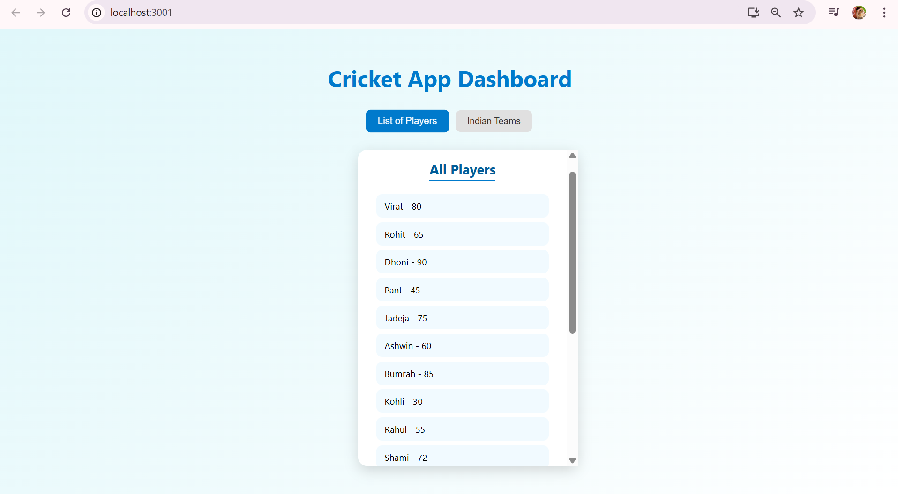

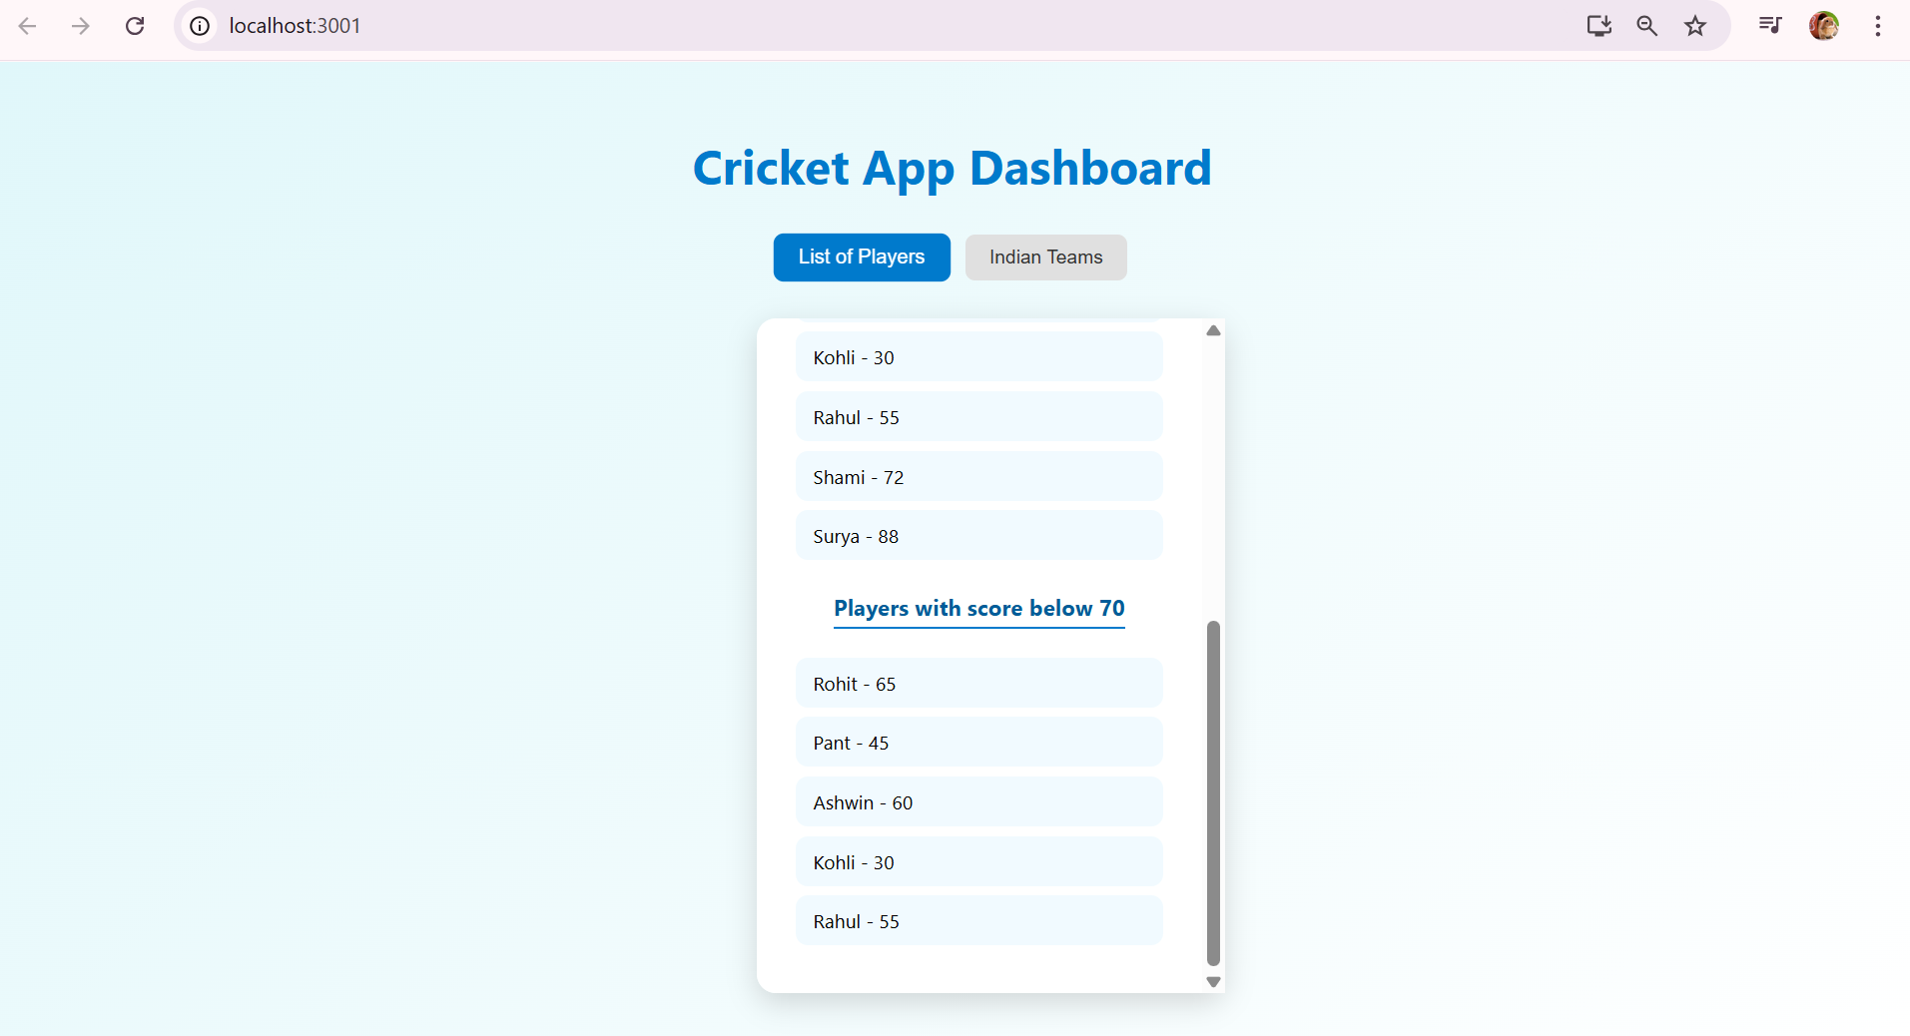

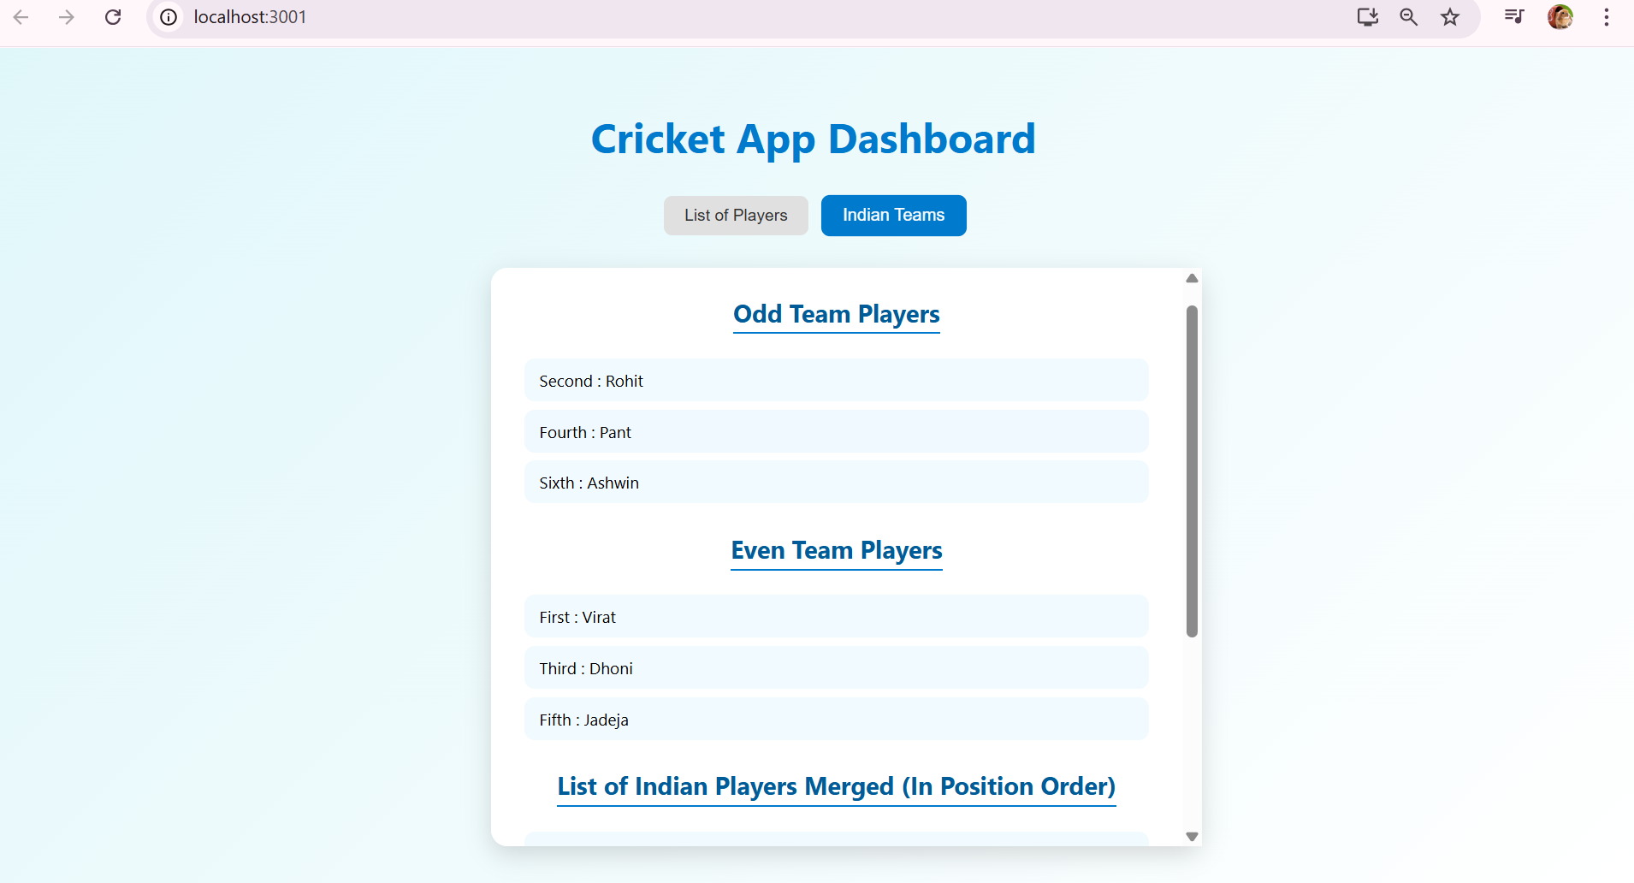

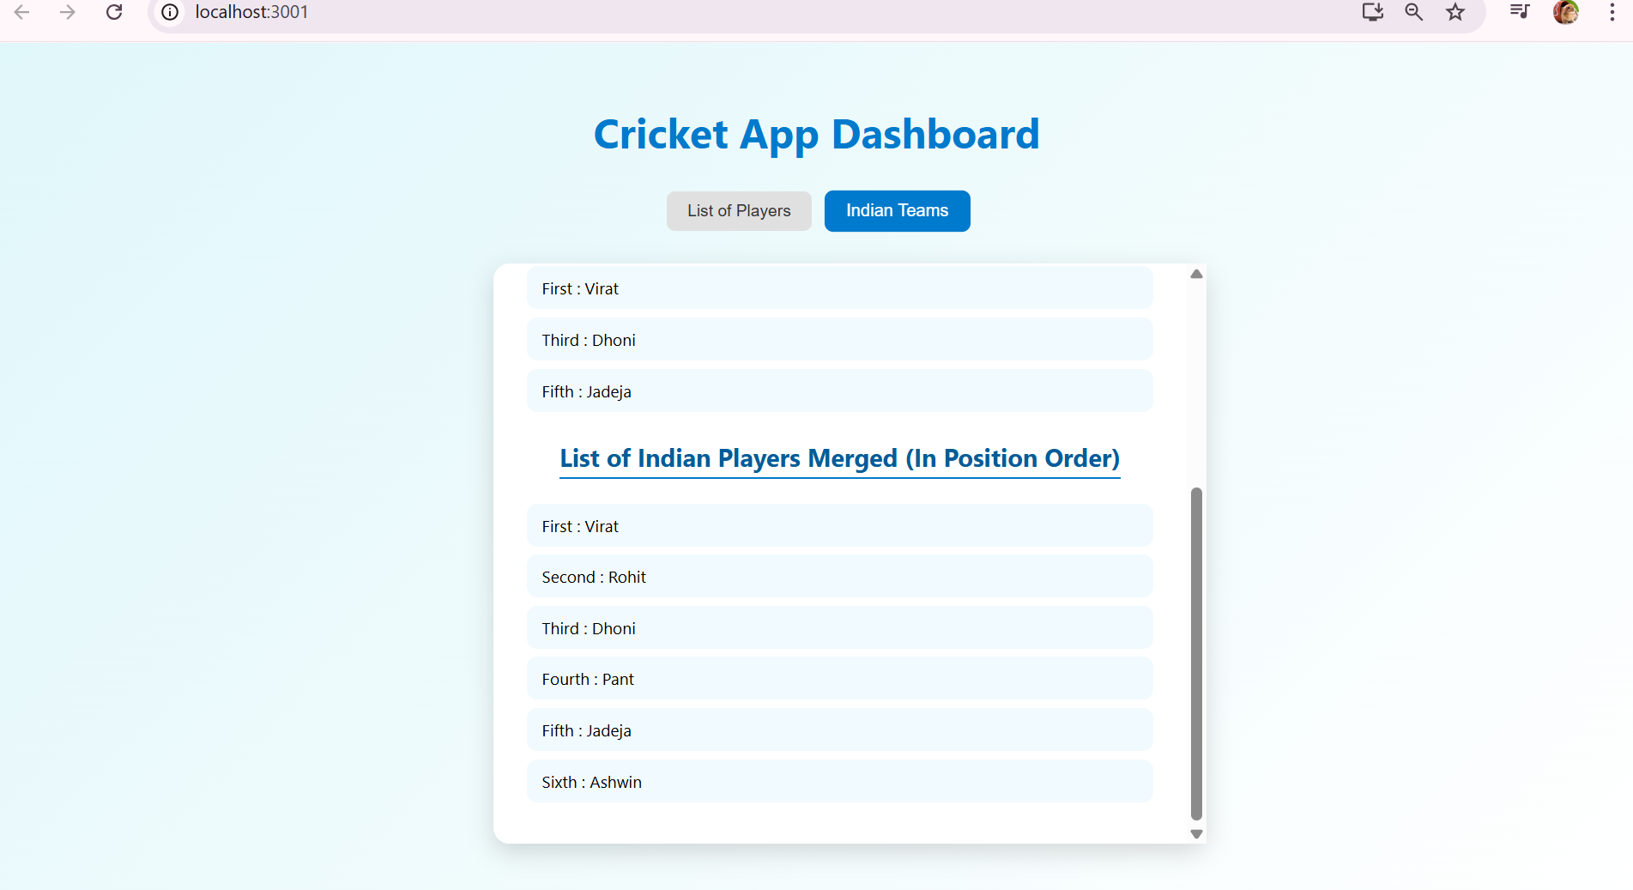

**Exercise 2 : Office Space Rental App**

**Code:**

**OffliceList.js:**

import React from 'react';

const OfficeList = () => {

  const offices = [

    {

      id: 1,

      name: 'Orion WorkHub',

      rent: 55000,

      address: 'Koramangala, Bengaluru',

      image:

        'https://images.unsplash.com/photo-1600585154340- be6161a56a0c?auto=format&fit=crop&w=800&q=80',

    },

    {

      id: 2,

      name: 'Skyline Offices',

      rent: 72000,

      address: 'Bandra East, Mumbai',

      image:

        'https://plus.unsplash.com/premium_photo-1670315264879-59cc6b15db5f?w=600&auto=format&fit=crop&q=60&ixlib=rb-4.1.0&ixid=M3wxMjA3fDB8MHxzZWFyY2h8NXx8b2ZmaWNlfGVufDB8fDB8fHww',

    },

    {

      id: 3,

      name: 'TechNest Towers',

      rent: 60000,

      address: 'T. Nagar, Chennai',

      image:

        'https://plus.unsplash.com/premium_photo-1661879435429-a396d927c686?w=600&auto=format&fit=crop&q=60&ixlib=rb-4.1.0&ixid=M3wxMjA3fDB8MHxzZWFyY2h8MTN8fG9mZmljZSUyMHNwYWNlfGVufDB8fDB8fHww',

    },

  ];

  return (

    <div className="office-list">

      {offices.map((office) => (

        <div className="office-card" key={office.id}>

          <img src={office.image} alt={office.name} className="office-img" />

          <h2>{office.name}</h2>

          <p><strong>Address:</strong> {office.address}</p>

          <p>

            <strong>Rent:</strong>{' '}

            <span

              style={{

                color: office.rent < 60000 ? 'red' : 'green',

                fontWeight: 'bold',

              }}

            >

              ₹{office.rent.toLocaleString()}

            </span>

          </p>

        </div>

      ))}

    </div>

  );

};

export default OfficeList;

**App.js:**

import React from 'react';

import './App.css';

import OfficeList from './OfficeList';

function App() {

  return (

    <div className="App">

      <h1 className="heading">Office Space Rental App</h1>

      <OfficeList />

    </div>

  );

}

export default App;

**App.css:**

body {

  margin: 0;

  padding: 0;

  background: linear-gradient(to right, #efc2e8, #ddb9f6);

  font-family: 'Segoe UI', sans-serif;

}

.App {

  padding: 2rem;

  text-align: center;

}

.heading {

  color: #1565c0;

  font-size: 2.5rem;

  margin-bottom: 2rem;

}

.office-list {

  display: flex;

  justify-content: center;

  gap: 2rem;

  flex-wrap: wrap;

}

.office-card {

  background-color: white;

  border-radius: 12px;

  box-shadow: 0 6px 20px rgba(0, 0, 0, 0.1);

  width: 320px;

  padding: 1.5rem;

  text-align: left;

  transition: transform 0.2s ease-in-out;

}

.office-card:hover {

  transform: translateY(-5px);

}

.office-img {

  width: 100%;

  height: 180px;

  object-fit: cover;

  border-radius: 8px;

  margin-bottom: 1rem;

}

h2 {

  color: #0d47a1;

  margin: 0.5rem 0;

}

p {

  font-size: 1rem;

  margin: 0.5rem 0;

}

**Output:**

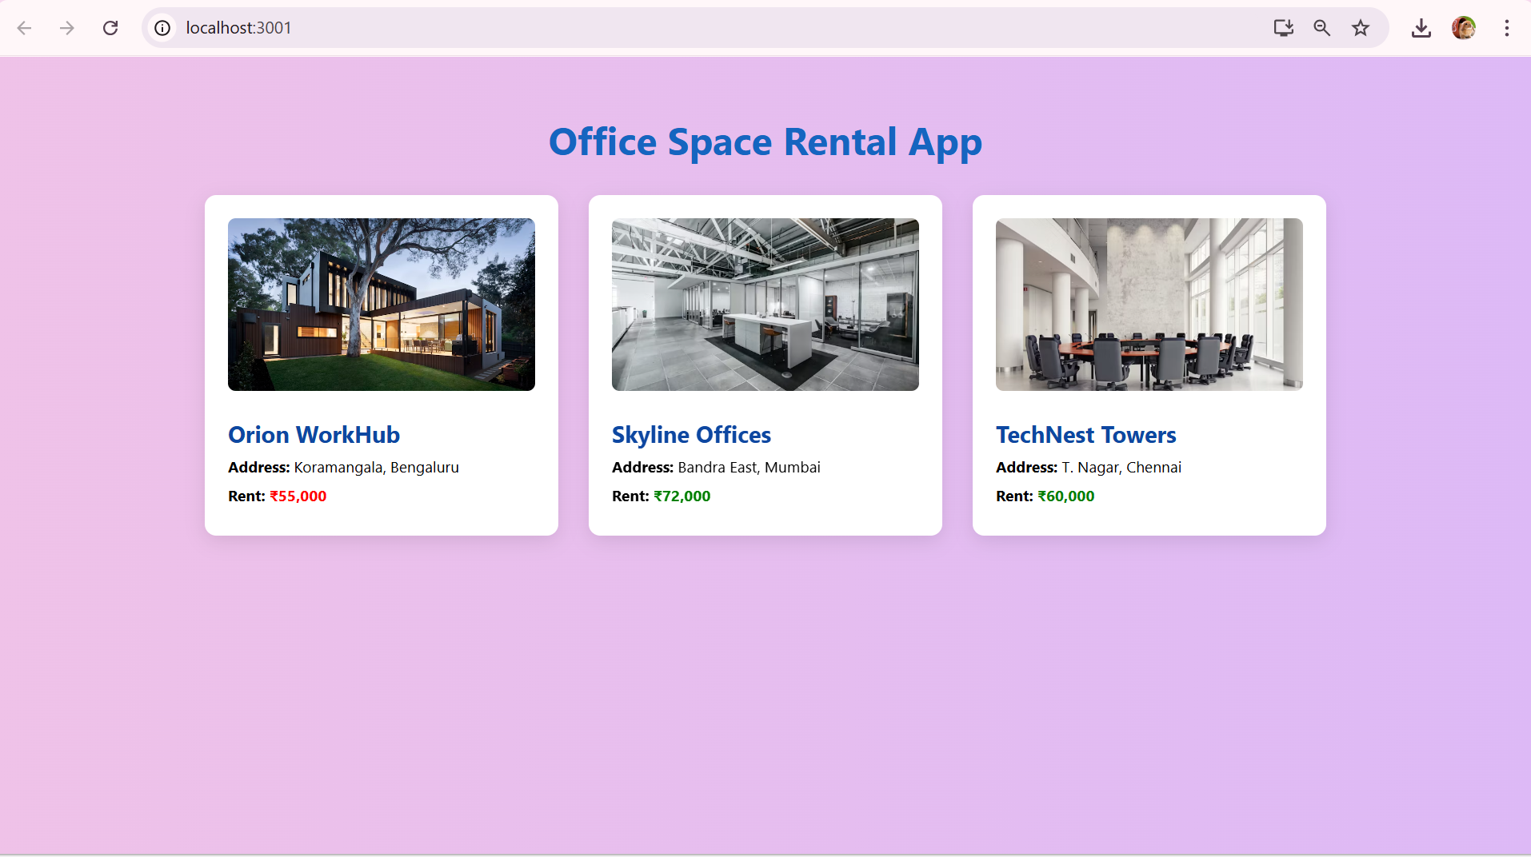

**Exercise 3 : Event examples app**

**Code:**

**Counter.js:**

import React, { useState } from 'react';

const Counter = () => {

  const [count, setCount] = useState(0);

  const increment = () => {

    setCount(count + 1);

    sayHello();

  };

  const decrement = () => {

    setCount(count - 1);

  };

  const sayHello = () => {

    alert('Hello! You clicked increment.');

  };

  return (

    <div className="card">

      <h2>Counter</h2>

      <p>Count: {count}</p>

      <button onClick={increment}>Increment</button>

      <button onClick={decrement}>Decrement</button>

    </div>

  );

};

export default Counter;

**WelcomeButton.js:**

import React from 'react';

const WelcomeButton = () => {

  const sayWelcome = (message) => {

    alert(`Welcome! ${message}`);

  };

  return (

    <div className="card">

      <h2>Welcome</h2>

      <button onClick={() => sayWelcome('Glad to see you!')}>Say Welcome</button>

    </div>

  );

};

export default WelcomeButton;

**SyntheticEvent.js**

import React from 'react';

const SyntheticEvent = () => {

  const handleClick = (e) => {

    e.preventDefault();

    alert('Button clicked using Synthetic Event!');

    console.log('SyntheticEvent object:', e);

  };

  return (

    <div className="card">

      <h2>Synthetic Event</h2>

      <button onClick={handleClick}>Trigger Event</button>

    </div>

  );

};

export default SyntheticEvent;

**CurrencyConvertor.js:**

import React, { useState } from 'react';

const CurrencyConvertor = () => {

  const [rupees, setRupees] = useState('');

  const [euro, setEuro] = useState('');

  const handleConvert = () => {

    const conversionRate = 0.011;

    const result = (parseFloat(rupees) * conversionRate).toFixed(2);

    setEuro(result);

  };

  return (

    <div className="card">

      <h2>Currency Converter</h2>

      <input

        type="number"

        value={rupees}

        placeholder="Enter amount in ₹"

        onChange={(e) => setRupees(e.target.value)}

      />

      <button onClick={handleConvert}>Convert to €</button>

      {euro && <p>Converted: €{euro}</p>}

    </div>

  );

};

export default CurrencyConvertor;

**App.js:**

import React from 'react';

import './App.css';

import Counter from './components/Counter';

import WelcomeButton from './components/WelcomeButton';

import SyntheticEvent from './components/SyntheticEvent';

import CurrencyConvertor from './components/CurrencyConvertor';

function App() {

  return (

    <div className="App">

      <h1>Event Examples App</h1>

      <Counter />

      <WelcomeButton />

      <SyntheticEvent />

      <CurrencyConvertor />

    </div>

  );

}

export default App;

**App.css:**

body {

  margin: 0;

  padding: 0;

  background-color: #f5f8fc;

  font-family: 'Segoe UI', sans-serif;

}

.App {

  text-align: center;

  padding: 2rem;

}

h1 {

  color: #1565c0;

  font-size: 2.4rem;

  margin-bottom: 2rem;

}

.card {

  background: white;

  max-width: 500px;

  margin: 1rem auto;

  padding: 1.5rem;

  border-radius: 12px;

  box-shadow: 0 6px 18px rgba(0, 0, 0, 0.1);

  text-align: center;

}

button {

  background-color: #1976d2;

  color: white;

  border: none;

  padding: 10px 16px;

  margin: 0.5rem;

  font-size: 1rem;

  border-radius: 8px;

  cursor: pointer;

  transition: background 0.3s;

}

button:hover {

  background-color: #0d47a1;

}

input {

  padding: 10px;

  font-size: 1rem;

  border-radius: 6px;

  border: 1px solid #ccc;

  margin-right: 10px;

  width: 60%;

}

**Output:** 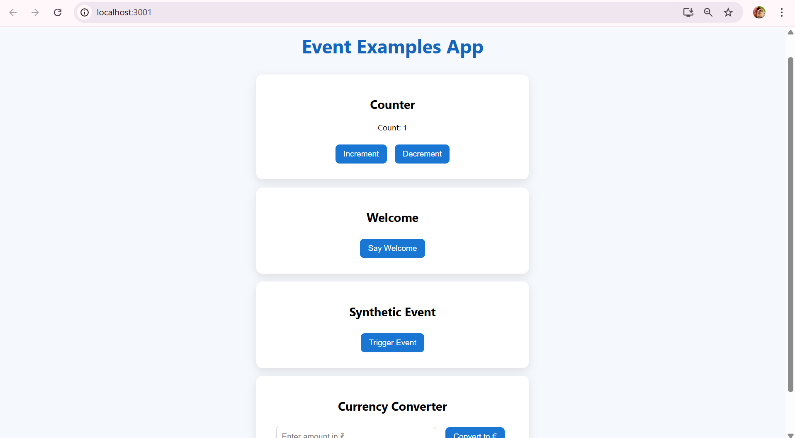

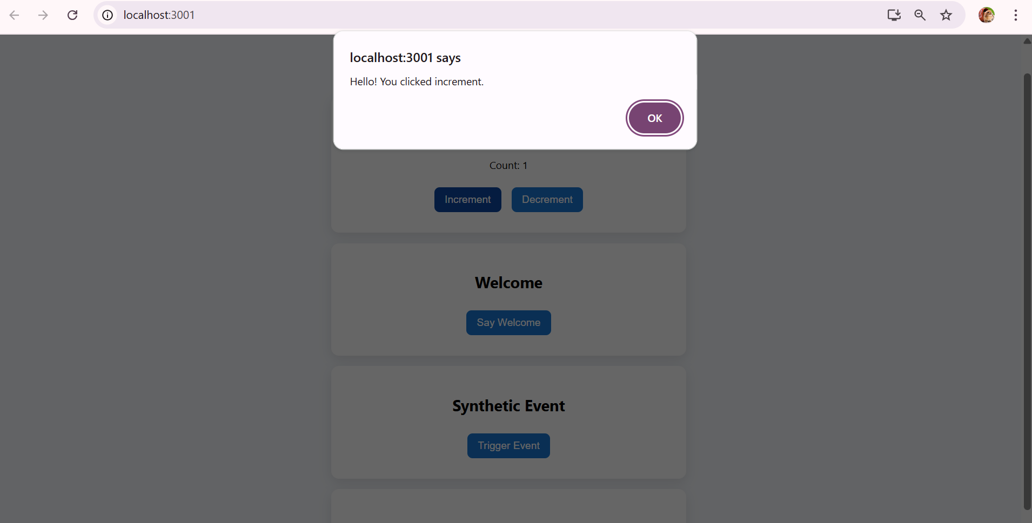

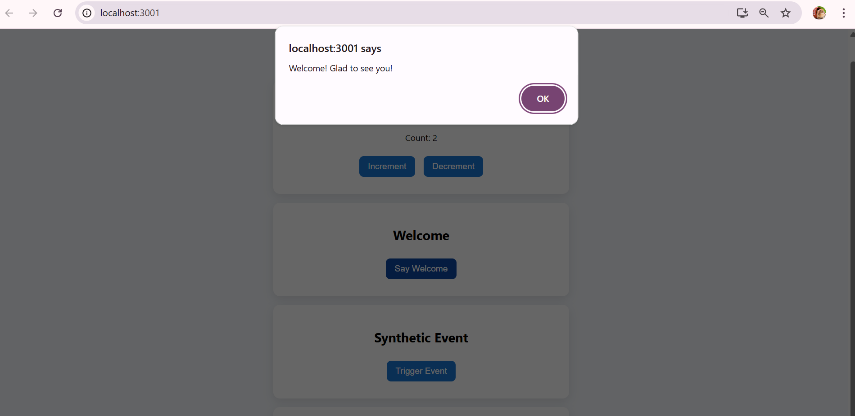

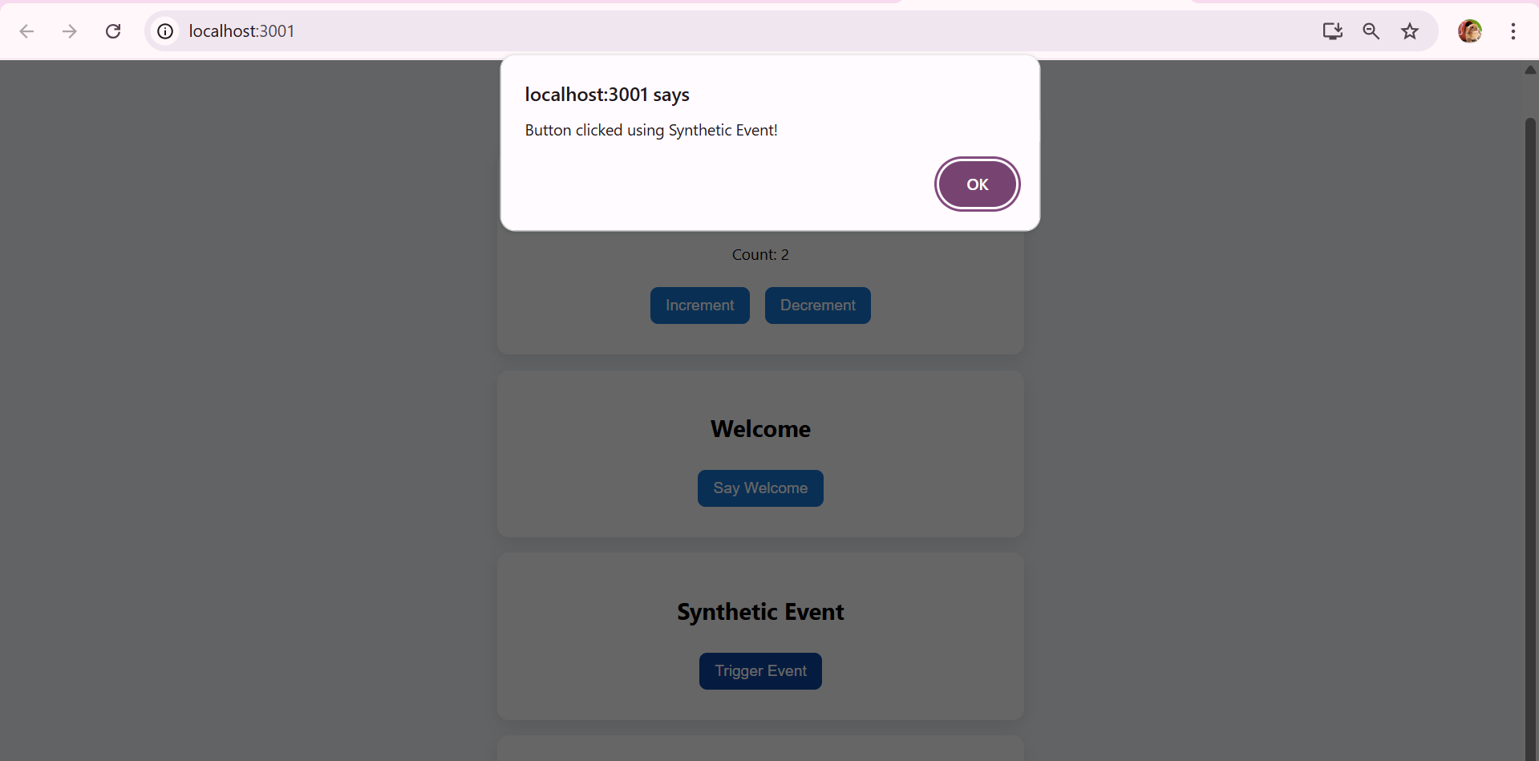

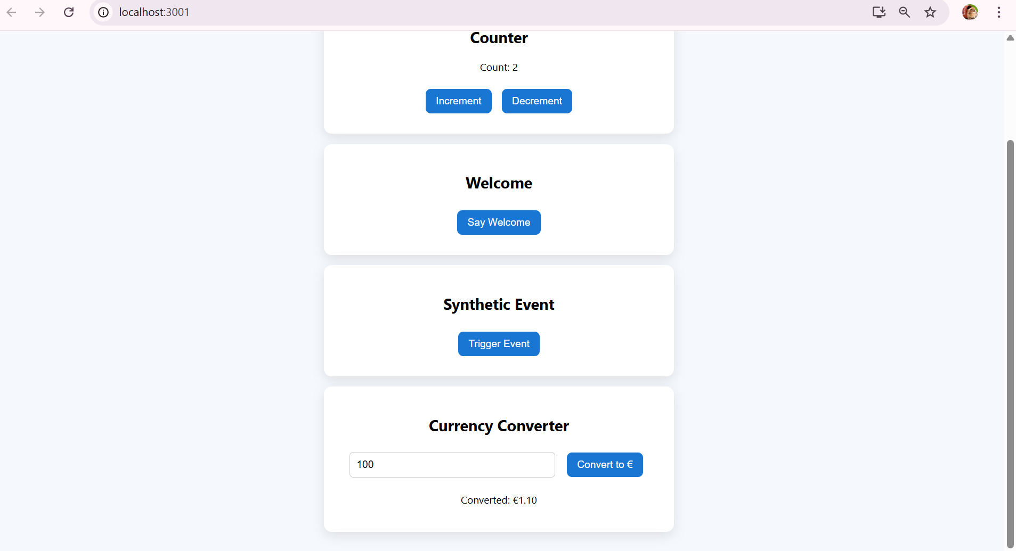

**Exercise 4 : Create ticket booking app**

**Code:**

**GuestPage.js:**

import React from 'react';

const GuestPage = () => {

  return (

    <div className="card">

      <h2>Welcome, Guest!</h2>

      <p>Here are the available flights:</p>

      <ul>

        <li>Chennai → Delhi | 9:00 AM</li>

        <li>Mumbai → Bangalore | 12:30 PM</li>

        <li>Kolkata → Hyderabad | 6:45 PM</li>

      </ul>

      <p>Please login to book your ticket.</p>

    </div>

  );

};

export default GuestPage;

**UserPage.js:**

import React from 'react';

const UserPage = () => {

  const handleBooking = () => {

    alert("Your ticket has been booked!");

  };

  return (

    <div className="card">

      <h2>Welcome Back, User!</h2>

      <p>Ready to book your flight?</p>

      <button onClick={handleBooking}>Book Ticket</button>

    </div>

  );

};

export default UserPage;

**App.js:**

import React, { useState } from 'react';

import './App.css';

import GuestPage from './components/GuestPage';

import UserPage from './components/UserPage';

function App() {

  const [isLoggedIn, setIsLoggedIn] = useState(false);

  const handleLogin = () => setIsLoggedIn(true);

  const handleLogout = () => setIsLoggedIn(false);

  let content;

  if (isLoggedIn) {

    content = <UserPage />;

  } else {

    content = <GuestPage />;

  }

  return (

    <div className="App">

      <h1>Ticket Booking App</h1>

      <div className="button-group">

        {!isLoggedIn ? (

          <button onClick={handleLogin}>Login</button>

        ) : (

          <button onClick={handleLogout}>Logout</button>

        )}

      </div>

      {content}

    </div>

  );

}

export default App;

**App.css:**

body {

  margin: 0;

  padding: 0;

  font-family: 'Segoe UI', sans-serif;

  background: linear-gradient(to right, #e0f7fa, #e1f5fe);

  min-height: 100vh;

}

.App {

  text-align: center;

  padding: 2rem;

}

h1 {

  color: #01579b;

  font-size: 2.5rem;

  margin-bottom: 1.5rem;

}

.button-group {

  margin-bottom: 2rem;

}

.button-group button {

  padding: 12px 24px;

  font-size: 1rem;

  margin: 0 10px;

  border: none;

  border-radius: 8px;

  background-color: #039be5;

  color: white;

  cursor: pointer;

  transition: background 0.3s ease, transform 0.2s ease;

}

.button-group button:hover {

  background-color: #0277bd;

  transform: translateY(-2px);

}

.card {

  background-color: white;

  max-width: 600px;

  margin: 0 auto;

  padding: 2rem;

  border-radius: 16px;

  box-shadow: 0 8px 24px rgba(0, 0, 0, 0.1);

  text-align: left;

  animation: fadeIn 0.5s ease;

}

.card h2 {

  color: #00796b;

  margin-bottom: 1rem;

}

.card p, .card ul {

  font-size: 1.1rem;

  margin: 0.75rem 0;

}

.card ul {

  list-style: none;

  padding-left: 0;

}

.card ul li {

  background-color: #e0f2f1;

  margin-bottom: 0.5rem;

  padding: 10px 15px;

  border-radius: 8px;

}

.card button {

  background-color: #43a047;

  color: white;

  padding: 10px 20px;

  font-size: 1rem;

  border: none;

  border-radius: 8px;

  cursor: pointer;

  margin-top: 1rem;

  transition: background 0.3s ease;

}

.card button:hover {

  background-color: #2e7d32;

}

@keyframes fadeIn {

  from {

    opacity: 0;

    transform: translateY(20px);

  }

  to {

    opacity: 1;

    transform: translateY(0);

  }

}

**Output:**

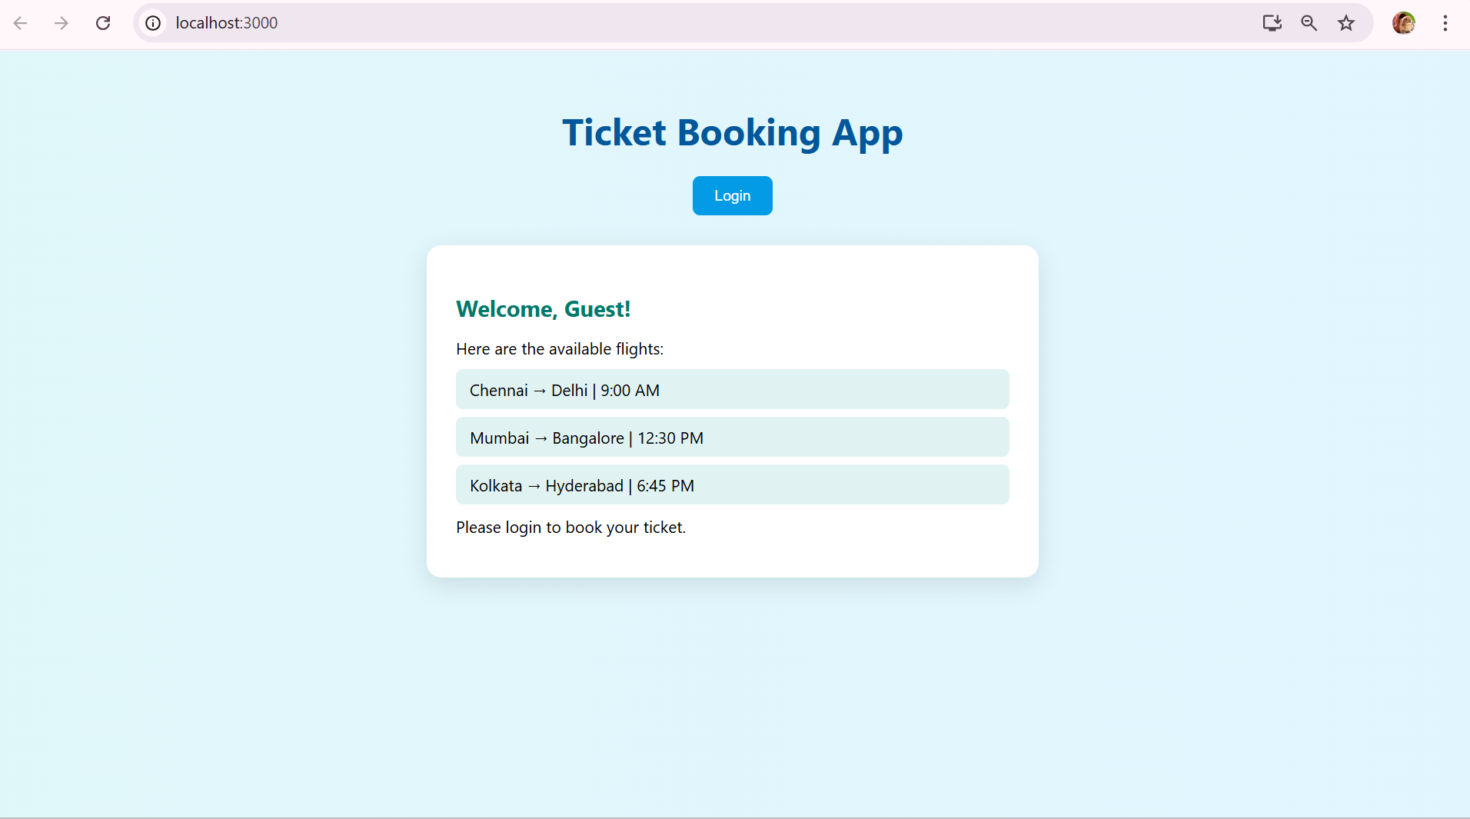

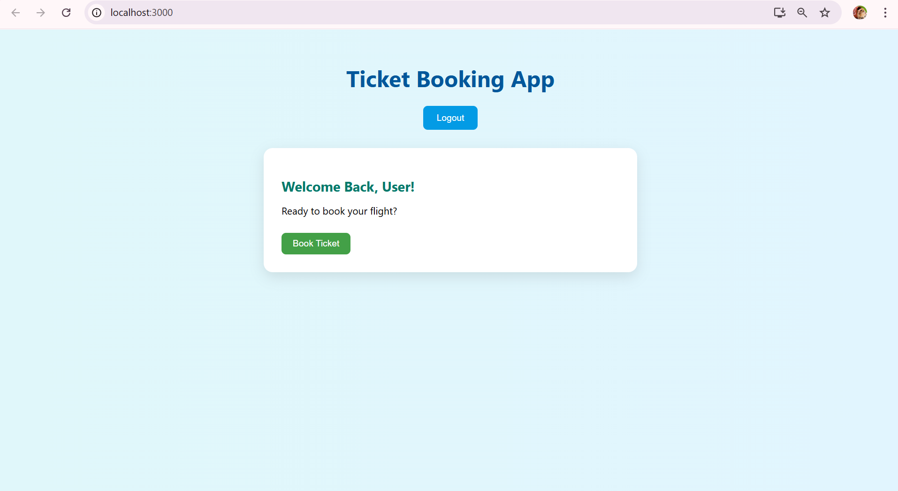

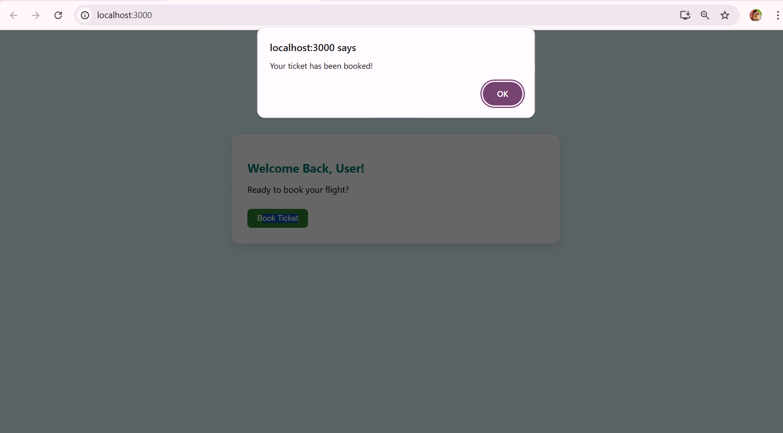

**Exercise 5 : Create Blogger app**

**Code:**

**BookDetails.js:**

import React from 'react';

const BookDetails = () => {

  const books = [

    { id: 1, title: 'The React Journey', author: 'Sarah Drasner' },

    { id: 2, title: 'Deep Dive into JavaScript', author: 'Nicholas C. Zakas' },

    { id: 3, title: 'UI/UX Design Thinking', author: 'Don Norman' },

    { id: 4, title: 'Clean Code with React', author: 'Kent C. Dodds' },

    { id: 5, title: 'TypeScript in Action', author: 'Anders Hejlsberg' }

  ];

  return (

    <div className="card">

      <h2>Book List</h2>

      <ul>

        {books.map((book) => (

          <li key={book.id}>

            <strong>{book.title}</strong> by {book.author}

          </li>

        ))}

      </ul>

    </div>

  );

};

export default BookDetails;

**BlogDetails.js:**

import React from 'react';

const BlogDetails = () => {

  return (

    <div className="card">

      <h2>Featured Blog Posts</h2>

      <ul>

        <li>10 Performance Tips for React Developers</li>

        <li>Why You Should Use useCallback and useMemo Wisely</li>

        <li>Exploring Vite as a React Build Tool</li>

        <li>Securing React Apps with JWT Authentication</li>

        <li>CSS Modules vs Styled Components – What to Choose?</li>

      </ul>

    </div>

  );

};

export default BlogDetails;

**CourseDetails.js:**

import React from 'react';

const CourseDetails = () => {

  const courses = [

    { id: 'c1', name: 'React Pro: Build Real Projects' },

    { id: 'c2', name: 'JavaScript Mastery with ES6+' },

    { id: 'c3', name: 'TypeScript for Beginners' },

    { id: 'c4', name: 'Advanced Frontend Architecture' },

    { id: 'c5', name: 'UI/UX Design for Developers' }

  ];

  return (

    <div className="card">

      <h2>Available Courses</h2>

      <ul>

        {courses.map(course => (

          <li key={course.id}>{course.name}</li>

        ))}

      </ul>

    </div>

  );

};

export default CourseDetails;

**App.js:**

import React, { useState } from 'react';

import './App.css';

import BookDetails from './components/BookDetails';

import BlogDetails from './components/BlogDetails';

import CourseDetails from './components/CourseDetails';

function App() {

  const [page, setPage] = useState('book');

  let displayContent;

  if (page === 'book') {

    displayContent = <BookDetails />;

  } else if (page === 'blog') {

    displayContent = <BlogDetails />;

  } else {

    displayContent = <CourseDetails />;

  }

  return (

    <div className="App">

      <h1>Blogger App</h1>

      <div className="nav">

        <button onClick={() => setPage('book')}>Books</button>

        <button onClick={() => setPage('blog')}>Blogs</button>

        <button onClick={() => setPage('course')}>Courses</button>

      </div>

      {/* 2. Using variable */}

      {displayContent}

      {/* 3. Using ternary operator */}

      <div className="card">

        {page === 'blog' ? (

          <p>You are viewing <strong>Blogs</strong>.</p>

        ) : page === 'book' ? (

          <p>You are viewing <strong>Books</strong>.</p>

        ) : (

          <p>You are viewing <strong>Courses</strong>.</p>

        )}

      </div>

      {/* 4. Short-circuit rendering */}

      {page === 'course' && <p style={{ color: 'green' }}>Explore and Enroll!</p>}

    </div>

  );

}

export default App;

**App.css:**

body {

  margin: 0;

  padding: 0;

  font-family: 'Segoe UI', Tahoma, Geneva, Verdana, sans-serif;

  background-color: #f0f4f8;

}

.App {

  text-align: center;

  padding: 2rem;

  max-width: 900px;

  margin: auto;

}

h1 {

  color: #1e88e5;

  font-size: 2.5rem;

  margin-bottom: 1rem;

}

.nav {

  margin-bottom: 2rem;

}

.nav button {

  background-color: #1e88e5;

  color: white;

  border: none;

  padding: 10px 18px;

  margin: 0 0.5rem;

  font-size: 1rem;

  border-radius: 8px;

  cursor: pointer;

  transition: all 0.3s ease-in-out;

}

.nav button:hover {

  background-color: #1565c0;

  transform: translateY(-2px);

}

.card {

  background-color: white;

  padding: 1.8rem;

  margin: 1.5rem auto;

  border-radius: 12px;

  box-shadow: 0 8px 20px rgba(0, 0, 0, 0.08);

  text-align: left;

  max-width: 700px;

  transition: transform 0.2s ease-in-out;

}

.card:hover {

  transform: translateY(-4px);

}

.card h2 {

  color: #333;

  border-bottom: 2px solid #1e88e5;

  display: inline-block;

  padding-bottom: 4px;

  margin-bottom: 1rem;

}

.card ul {

  list-style: none;

  padding-left: 0;

}

.card li {

  background-color: #e3f2fd;

  margin-bottom: 8px;

  padding: 10px 14px;

  border-radius: 6px;

  transition: background-color 0.2s;

}

.card li:hover {

  background-color: #bbdefb;

}

.card p {

  font-size: 1.1rem;

  color: #555;

}

.card strong {

  color: #1e88e5;

}

**Output:**

