Smart Canteen System
A
REAL TIME RESEARCH PROJECT REPORT (IT409PC)

Submitted in partial fulfilment of the requirements for the award of the degree
of

Bachelor of Technology (B.Tech : II YEAR-II SEM)

in

DEPARTMENT OF INFORMATION TECHNOLOGY
By
GUNDA AKSHAYA 24AG1A1221
GUMMA SAKETH KUMAR 24AG1A1220
KESHAYAGARE VARUN 24AG1A1227

Under the Esteemed Guidance of
Mrs. V. Swetha
Assistant Professor


Department of Information Technology

ACE ENGINEERING COLLEGE
An Autonomous Institution
All the courses are Accredited by NBA and NAAC with A Grade
(Affiliated to Jawaharlal Nehru Technological University, Hyderabad, Telangana)
Ankushapur,Ghatkesar,Medchal,Hyderabad-501301

APRIL-2026


ACE
Engineering College
An Autonomous Institution
(All the courses are Accredited by NBA and NAAC with A Grade)
(Affiliated to Jawaharlal Nehru Technological University, Hyderabad, Telangana)
Ghatkesar, Hyderabad–501 301
Website: www.aceec.ac.in E-mail: info@aceec.ac.in

CERTIFICATE
This is to certify that the Real Time Research Project work entitled “SMART CANTEEN SYSTEM” is being submitted by Gunda Akshaya (24AG1A1221),Gumma Saketh Kumar (24AG1A1220),Kshayagare Varun (24AG1A1227) in partial fulfillment for the award of the degree of BACHELOR OF TECHNOLOGY in DEPARTMENT OF INFORMATION TECHNOLOGY to the Jawaharlal Nehru Technological University, Hyderabad during the academic year 2025-26 is a record of Bonafide work carried out by them under our guidance and supervision.

The results embodied in this report have not been submitted by the students to any other
University or Institution for the award of any degree or diploma.

Internal Guide Project Coordinator
Mrs. V. Swetha Mr. M. Siva Kumar
Assistant Professor Assistant Professor
Dept. of IT Dept. of IT

Head of the Department
Dr. S. Mani Kuchibhatla
Professor and Head
Dept. of IT

ACKNOWLEDGEMENT
We would like to express our gratitude to all the people behind the screen who have helped me transform an idea into a real time application.
We would like to express our heart-felt gratitude to our parents without whom we would not have been privileged to achieve and fulfill our dreams.
A special thanks to our General Secretary, Prof. Y. V. GOPALA KRISHNA MURTHY, for having founded such an esteemed institution.
We are also grateful to our beloved principal, Dr. N. SUDHAKAR REDDY, for permitting us to carry out this project.
We profoundly thank Dr. S. MANI KUCHIBHATLA, Head of the Department of Information Technology, who has been a great source of inspiration to our work.
We sincerely thank our Project Coordinator Mr. M. SIVA KUMAR, Assistant Professor, for the continuous support and guidance throughout the project.
We are very thankful to our Project internal Guide Mrs. V. SWETHA, Assistant Professor, who has been an excellent guide and also given continuous support for the Completion of our Project work.
The satisfaction and euphoria that accompany the successful completion of the task would be great, but incomplete without the mention of the people who made it possible, whose constant guidance and encouragement crown all the efforts with success. In this context, i would like to thank all the other staff members, both teaching and non-teaching, who have extended their timely help and eased our task.

Gunda Akshaya 24AG1A1221
Gumma Saketh Kumar 24AG1A1220
Keshayagare Varun 24AG1A1227

DECLARATION

We here by declare that Real Time Research Project entitled “SMART CANTEEN SYSTEM” which is being submitted in the partial fulfilment of the requirements for the award of degree of Bachelor of Technology in Information Technology. This dissertation is our original work and the project has not formed the basis for the award of any degree, associate ship, fellowship or any other similar titles and no part of it has been published or sent for the publication at the time of submission.

Gunda Akshaya 24AG1A1221
Gumma Saketh Kumar 24AG1A1220
Kshayagare Varun 24AG1A1227

Table of Contents
CONTENTS PAGE NO.

1. Introduction 1-2

1.1 Background 1

1.2 Motivation 1

1.3 Problem statement 2

2. Literature Survey 3

3. Existing and Proposed System 4

3.1 Existing System 5

3.2 Proposed System 5

4. System requirements 5-7

4.1 Operating environments 5

4.2 Functional Requirements 5

4.3 Non-Functional Requirements 6

4.4 System Analysis 7

5. System Design 8-9

5.1 System Architecture 8

5.2 Data flow diagram 9

6. Software and Hardware requirements 10

7. Modules 11-12

8. Sample Source Code 13-15

9. Testing 16

10. Output Screens 17-19

11. Conclusion 20

12. Further Enhancements 21

13. References 22

ABSTRACT

Smart Canteen System

The Smart Canteen System is a frontend-based application designed to digitalize the food ordering process in a college canteen. It allows students to log in, view the menu, place orders, select payment methods, and choose a pickup time conveniently. Each order is stored in local storage and assigned a unique token for easy identification and faster service. This system helps in reducing long queues and saves valuable time for students. It also includes a manager dashboard to monitor orders in real time, update order status, and manage cancellations. Automated scheduling ensures that orders are prepared before the selected pickup time. By reducing manual work and confusion during peak hours, the system enhances efficiency. Overall, it provides a smooth and user-friendly canteen management experience.

LIST OF FIGURES

S.NO Fig.No List of Figures Page No.

1 5.1 Smart Canteen System Architecture 8

2 5.2 Smart Canteen System Data Flow 9

3 10.1 Login & Registration interface 17

5 10.2 Menu interface 17

6 10.3 Cart interface 18

7 10.4 Order Placed interface 18

8 10.5 Order Status Interface 19

9 10.6 Admin Interface 19

10 10.7 Updating items interface 19

List of Tables

S.No Table No Name of Table Page No

1 9.1 details of Unit Testing 16

2 9.2 details of Integration Testing 16

LIST OF ABBREVIATIONS

S.No. Abbreviation Full Form

1 API Application Programming Interface

2 QR Quick Response

3 PDF Portable Document Format

4 ZIP ZIP Archive Format (not Zone Information Protocol)

5 UI User Interface

6 DB Database

7 CRUD Create, Read, Update, Delete

8 HTTP Hypertext Transfer Protocol

9 HTTPS Hypertext Transfer Protocol Secure

10 SQL Structured Query Language

11 HTML Hypertext Markup Language

12 CSV Comma-Separated Values

13 CSS Cascading Style Sheet

CHAPTER 1
INTRODUCTION
1.1 Background
Canteen management plays an important role in educational institutions where a large number of students depend on timely and efficient food services. Traditionally, canteen activities such as taking orders, managing menus, handling payments, and delivering food are performed manually through counters, paper tokens, and verbal communication. Although this method has been followed for many years, it is often slow, less organized, and difficult to manage during busy hours.

With the increasing number of students and limited serving time, manual canteen systems create several problems such as long queues, order confusion, delays in food preparation, and difficulty in tracking orders. Students often spend a significant amount of time waiting in line, which affects their academic schedule. Similarly, canteen staff face challenges in managing multiple orders efficiently and maintaining proper coordination.

To overcome these issues, the Smart Canteen System is introduced as a digital solution that simplifies and automates the food ordering process. The system is a frontend-based application that allows students to log in, view the menu, place orders, select payment methods, and choose a pickup time conveniently. Each order is stored using local storage and assigned a unique token for easy identification. The system also provides a manager dashboard to monitor orders, update their status, and manage cancellations. This digital approach improves efficiency, reduces waiting time, and enhances the overall canteen experience.

1.2 Motivation
• Manual Canteen Management Process
Many canteens still use manual methods for taking orders and managing food services. This process is time-consuming and often leads to errors in order handling and billing.

• Long Queues and Waiting Time
Students usually have to stand in long queues during peak hours, which wastes time and creates inconvenience.

• Lack of Proper Order Tracking
In traditional systems, it is difficult to track placed orders, leading to confusion, missed orders, or delays in food delivery.

• Data Management Challenges
Without a digital system, maintaining records of orders, payments, and menu updates becomes difficult and may result in data loss or duplication.

• Need for Quick and Easy Ordering
Students require a simple and fast way to place orders without waiting in line, especially during short break times.

• Requirement for Automated System
Canteen management needs a system that can handle orders efficiently, reduce manual work, and improve accuracy and speed of service.

1.3 Problem Statement
The problem is that existing canteen management systems rely heavily on manual processes and do not provide a simple, efficient, and organized way of handling food orders and services. This makes canteen operations time-consuming, less accurate, and difficult to manage during peak hours.

• Lack of Proper Order Tracking
Traditional canteen systems do not provide an effective way to track orders, which leads to confusion and delays in serving food.

• No Instant Digital Ordering
Students must depend on standing in queues and placing orders manually, which is not fast or convenient.

• Inefficient and Error-Prone Processes
Manual order handling often causes mistakes such as wrong orders, missed orders, and incorrect billing.

• Limited Accessibility and Management
Without a centralized system, both students and canteen staff face difficulty in managing, updating, and accessing order-related information efficiently.

CHAPTER 2
LITERATURE SURVEY

1)Title: Online Food Ordering System for Smart Canteen
Published By: International Journal of Computer Science and Engineering (IJCSE)
Year: 2025
Authors: R. Kumar et al.
Observations:
This paper emphasizes digital ordering and reducing waiting time, but it does not include features like scheduling and unique token systems used in the Smart Canteen System.

2)Title: Smart Canteen Management System Using Web Technology
Published By: International Journal of Innovative Science and Research Technology (IJISRT)
Year: 2024
Authors: S. Sharma et al.
Observations:
This paper provides real-time tracking and menu management, but its backend dependency makes it more complex compared to a frontend-based Smart Canteen System.

3)Title: Automated Food Ordering System in College Canteens
Published By: International Journal of Applied Engineering Research (IJAER)
Year: 2023
Authors: M. Patel, K. Singh
Observations:
This paper focuses on automation and token systems, but it does not include scheduling and user-friendly features available in the Smart Canteen System.

4)Title: Web-Based Food Pre-Ordering System
Published By: IEEE Xplore
Year: 2022
Authors: A. Verma et al.
Observations:
This paper supports advance ordering concepts, but it does not provide complete order management capabilities like the Smart Canteen System.

CHAPTER 3
EXISTING AND PROPOSED SYSTEM

  - Existing System

Existing canteen systems in colleges mainly rely on manual methods for food ordering and service management. Students usually stand in long queues to place orders, make payments, and collect food. This process is time-consuming, especially during peak hours such as lunch breaks, leading to overcrowding and inconvenience. Manual handling of orders often results in errors such as incorrect orders, missed items, and delays in food preparation.

Some canteens have basic digital systems, but they are often limited to billing or simple order display and do not provide a complete solution for order management. These systems lack features like advance ordering, pickup scheduling, and proper order tracking. As a result, both students and canteen staff face difficulties in managing orders efficiently.

Additionally, existing systems do not provide centralized monitoring or real-time updates. There is no proper mechanism to track order status, which creates confusion among students regarding their orders. Therefore, there is a need for a smart and efficient canteen management system that reduces waiting time and improves overall service quality.

  - Proposed System

The proposed Smart Canteen System addresses the limitations of traditional canteen operations by providing a digital platform for efficient food ordering and management. It is a frontend-based application that allows students to log in, browse the menu, add items to the cart, select payment methods, and choose a convenient pickup time. Each order is assigned a unique token, which helps in easy identification and smooth order processing.

The system uses local storage to maintain user data, menu details, and order information, eliminating the need for a backend server. A manager dashboard is provided to monitor all orders, update order status (Pending, Preparing, Ready, Completed), and manage menu items by adding or deleting them. This ensures better control and coordination during busy hours.

The Smart Canteen System is designed to be simple, user-friendly, and efficient. It reduces manual work, minimizes errors, and saves time for both students and staff. Although it is a frontend-based solution, it can be further enhanced with backend integration for real-time multi-user support and improved data security, making it suitable for real-world applications.

CHAPTER 4
SYSTEM REQUIREMENT

4.1 Operating Environments
The operating environment explains where the Smart Canteen System runs during development and usage. As a frontend-based web application, it operates within a browser environment using local storage instead of a backend server. The system is designed to work on user devices without requiring complex infrastructure.

4.1.1 Client-Side Environment (User Device)

• Description
This is the main environment where students and the manager interact with the system. It includes desktops, laptops, tablets, or smartphones used to access the application through a web browser. This layer handles actions such as user login, menu browsing, placing orders, selecting payment methods, and managing orders.
• Components
Web browser (Chrome, Edge, Firefox), HTML, CSS, JavaScript, and responsive UI design.
• Requirement
The system should run smoothly on modern web browsers across Windows, Android, and other platforms. It must support responsive design, fast loading, and easy navigation for both students and the manager.

4.1.2 Data Storage Environment (Local Storage Layer)

• Description
This layer stores all system-related data using browser local storage. It maintains user details, menu items, cart data, and order information. It acts as a lightweight storage system without requiring a backend database.
• Components
Browser Local Storage, user data, menu data, and order records.
• Requirement
The storage system should provide fast data access, proper data organization, and reliable storage within the browser. It should ensure data consistency during system usage.

4.1.3 Application Logic Environment (Processing Layer)

• Description
This layer contains the frontend logic responsible for handling login, order processing, cart management, token generation, and updating order status. It processes user actions and updates the interface accordingly.
• Components
JavaScript functions, event handling, cart logic, order processing functions, and UI updates.
• Requirement
The system should process user actions quickly, handle multiple operations efficiently, and provide accurate outputs without errors.

4.2 Functional Requirements
Functional requirements define what the Smart Canteen System must do to meet user needs.

4.2.1 Student Login

• Requirement
The system must allow students to log in using their email or roll number and password.
• Detail
The login module verifies user credentials and provides access to the student dashboard for ordering food.

4.2.2 Manager Login

• Requirement
The system must allow the manager to log in securely.
• Detail
The manager login provides access to the dashboard where orders can be monitored and managed.

4.2.3 Menu Viewing and Search

• Requirement
The system must allow users to view and search food items.
• Detail
Students can browse menu items by category and search for specific items easily.

4.2.4 Order Placement

• Requirement
The system must allow students to add items to cart and place orders.
• Detail
Students can select items, choose quantity, payment method, and pickup time before placing the order.

4.2.5 Order Management

• Requirement
The system must allow the manager to monitor and update order status.
• Detail
The manager can update order status as Pending, Preparing, Ready, or Completed.

4.2.6 Menu Management

• Requirement
The system must allow the manager to add or delete menu items.
• Detail
The manager can update menu items dynamically through the dashboard.

4.3 Non-Functional Requirements

4.3.1 Performance (Speed)

• Requirement
The system must respond quickly to user actions.
• Detail
Fast frontend processing ensures smooth ordering, menu loading, and status updates.

4.3.2 Reliability
• Requirement
The system must work without errors during normal usage.
• Detail
Proper input handling and validation ensure stable operation.

4.3.3 Security
• Requirement
The system must protect user data.
• Detail
Basic authentication is implemented, but it can be improved with encryption and backend security.

4.3.4 Usability
• Requirement
The system must be user-friendly.
• Detail
Simple design, easy navigation, and clear interface improve user experience.

4.4 System Analysis

4.4.1 Feasibility
The Smart Canteen System is highly feasible as it uses simple technologies such as HTML, CSS, and JavaScript. It does not require backend infrastructure, making it cost-effective and easy to implement.

4.4.2 Modules Relationship
Modules such as authentication, menu display, cart management, order processing, and manager dashboard work together to provide a complete system.

4.4.3 Data Flow Verification
Data flows as:
User input → frontend processing → local storage → dashboard display → order status update

CHAPTER 5
SYSTEM DESIGN

5.1 System Architecture

The Smart Canteen System follows a frontend-based architecture where all operations are handled within the browser. The process begins with the user interface, where students and the manager interact with the system through login pages and dashboards. Students can browse the menu, place orders, and select pickup time, while the manager can monitor and manage orders.
All user actions are processed using JavaScript logic, which handles data operations such as cart management, order placement, and token generation. The data is stored in browser local storage instead of a backend database.

This architecture is simple, efficient, and suitable for small-scale applications. It reduces complexity while maintaining essential functionality.

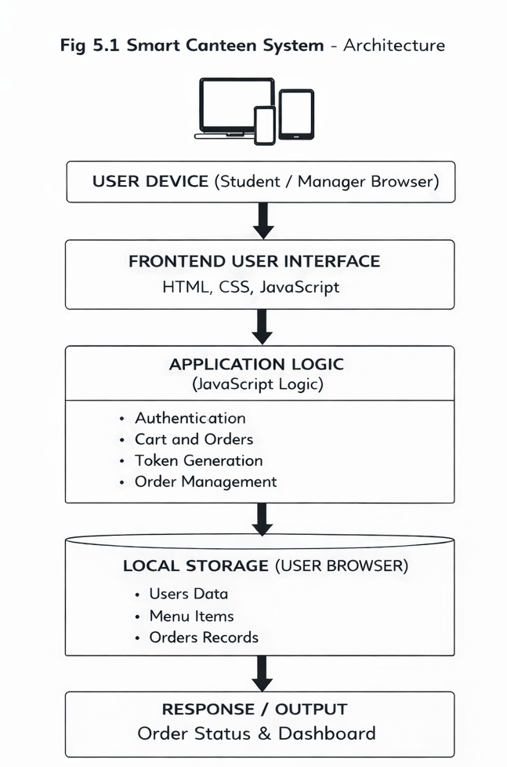

5.2 Data Flow Diagram

The data flow of the Smart Canteen System begins when the user logs in using valid credentials. After login, the student can browse menu items, add items to the cart, and place an order by selecting payment method and pickup time.
The system processes the order using frontend logic and stores it in local storage with a unique token. The manager can then view all orders through the dashboard and update their status accordingly.

Finally, the updated order status is displayed to the user in the “My Orders” section, completing the data flow of the system.

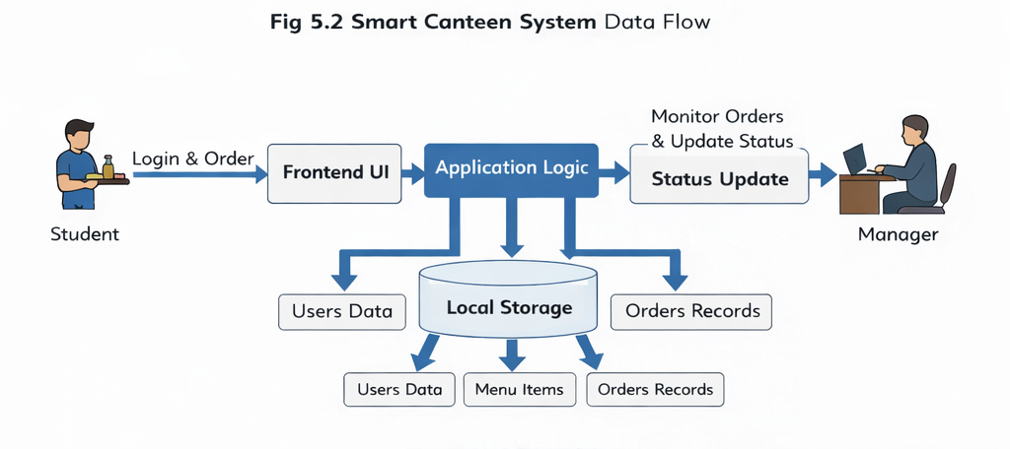

CHAPTER 6
Software and Hardware Requirements

6.1 SOFTWARE REQUIREMENTS:
The Smart Canteen System requires a combination of frontend technologies and local data handling mechanisms to function efficiently as a web-based application.

1.Operating System:
The system can be developed and run on Windows, Linux, or macOS platforms.

2. Frontend Technologies:
The user interface is developed using HTML, CSS, and Bootstrap to provide a responsive and user-friendly web application.

3. Backend Technologies:
Since the system is frontend-based, no dedicated backend server is required. JavaScript is used for handling application logic and interactions.

4. Programming Languages:
HTML, CSS, and JavaScript are used to design and implement the system.

5. Data Storage:
Local Storage (browser-based storage) is used to store menu items, orders, and user-related data temporarily.

6. Libraries and Frameworks:
Bootstrap is used for responsive design, and JavaScript libraries are used for dynamic content handling and UI interactions.

7. Development Tools:
Tools such as Visual Studio Code and web browsers like Chrome are used for development, testing, and debugging.

6.2 HARDWARE REQUIREMENTS:

The hardware requirements for the Smart Canteen System are minimal and suitable for basic computing devices.

1. Processor:
A minimum Intel Core i3 or equivalent processor is sufficient.
2. Memory (RAM):
At least 4 GB RAM is required for smooth browser operation.
3. Storage:
A minimum of 500 MB to 1 GB free space is required for project files and browser storage.
4. Network:
Internet is optional. The system can work offline if implemented using local storage.
5. Input Devices:
Keyboard, mouse, or touchscreen devices are required for user interaction.
6. Display Device:
A monitor, laptop, or mobile screen is required to access the system interface.

CHAPTER 7
MODULES

The Smart Canteen System is divided into several modules to organize its functionality efficiently. Each module performs a specific task and together they provide a smooth and user-friendly food ordering experience.

7.1 User Authentication Module:

The Authentication Module manages user access to the system. It allows users (students/customers) to log in using basic credentials and ensures secure access.
Key Points:
- User login functionality
- Basic authentication validation
- Session handling using browser storage
- Prevents unauthorized access
- Ensures system usability

7.2 Menu Management Module:

The Menu Management Module is responsible for displaying available food items in the canteen. It allows the admin to manage menu items and pricing.
Key Points:
- Display food items with price
- Add or update menu items
- Remove unavailable items
- Organized menu categories
- Improves user selection experience

7.3 Order Management Module:

The Order Management Module allows users to select food items and place orders. It processes and stores order details using local storage.
Key Points:
- Select and add items to cart
- Place orders
- Store order details
- Display order summary
- Simplifies ordering process

7.4 Order Tracking Module:

The Order Tracking Module enables users to view the status of their placed orders.
Key Points:
- View current order status
- Displays order progress (e.g., pending, preparing, completed)
- Updates dynamically
- Improves transparency

7.5 Admin Management Module:

The Admin Module allows the canteen manager to monitor and manage all system activities.
Key Points:
- View all orders
- Update order status
- Manage menu items
- Monitor system usage
- Ensures smooth canteen operations

CHAPTER 8
SAMPLE CODE
<!DOCTYPE html>
<html lang="en">
<head>
<meta charset="UTF-8" />
<meta name="viewport" content="width=device-width, initial-scale=1.0"/>
<title>Smart Canteen System</title>
<link href="https://fonts.googleapis.com/css2?family=Syne:wght@400;600;700;800&family=DM+Sans:ital,wght@0,300;0,400;0,500;1,300&display=swap" rel="stylesheet"/>
<link rel="stylesheet" href="https://cdnjs.cloudflare.com/ajax/libs/font-awesome/6.5.0/css/all.min.css"/>
<style>
:root {
--orange: #FF5722;
--orange-light: #FF7043;
--orange-bg: #FFF3EE;
--green: #2E7D32;
--yellow: #FFB300;
--red: #E53935;
--dark: #1A1A1A;
--dark2: #2D2D2D;
--gray: #6B7280;
--gray-light: #F3F4F6;
--border: #E5E7EB;
--white: #FFFFFF;
--card-shadow: 0 4px 20px rgba(0,0,0,0.08);
--card-shadow-hover: 0 8px 32px rgba(255,87,34,0.18);
--radius: 16px;
--radius-sm: 10px;
--font-head: 'Syne', sans-serif;
--font-body: 'DM Sans', sans-serif;
}
* { margin: 0; padding: 0; box-sizing: border-box; }
body { font-family: var(--font-body); background: #FAFAFA; color: var(--dark); min-height: 100vh; }

/* SCREENS */
.screen { display: none; }
.screen.active { display: block; }

/* AUTH */
#authScreen {
min-height: 100vh; display: none; align-items: center;
justify-content: center; position: relative;
background: linear-gradient(135deg, #1A1A1A 0%, #2D2D2D 50%, #3D1F00 100%);
overflow: hidden;
}
#authScreen.active { display: flex; }
.auth-bg { position: absolute; inset: 0; pointer-events: none; }
.auth-blob { position: absolute; border-radius: 50%; filter: blur(80px); opacity: 0.2; animation: blobFloat 6s ease-in-out infinite alternate; }
.b1 { width: 400px; height: 400px; background: var(--orange); top: -100px; right: -80px; }
.b2 { width: 300px; height: 300px; background: var(--yellow); bottom: -50px; left: -60px; animation-delay: 2s; }
.b3 { width: 200px; height: 200px; background: #FF8A65; top: 50%; left: 30%; animation-delay: 4s; }
@keyframes blobFloat { from { transform: translate(0,0) scale(1); } to { transform: translate(20px,-30px) scale(1.08); } }

.auth-card {
background: rgba(255,255,255,0.97); backdrop-filter: blur(20px);
border-radius: 24px; padding: 40px 36px; width: 420px; max-width: 95vw;
box-shadow: 0 24px 64px rgba(0,0,0,0.4); position: relative; z-index: 10;
animation: slideUp 0.5s cubic-bezier(0.34,1.56,0.64,1);
}
@keyframes slideUp { from { opacity:0; transform:translateY(40px) scale(0.95); } to { opacity:1; transform:translateY(0) scale(1); } }

.brand { display: flex; align-items: center; gap: 10px; margin-bottom: 28px; }
.brand-icon { font-size: 2rem; }
.brand-name { font-family: var(--font-head); font-size: 1.6rem; font-weight: 800; color: var(--dark); letter-spacing: -0.5px; }

.auth-tabs { display: flex; background: var(--gray-light); border-radius: 10px; padding: 4px; margin-bottom: 24px; }
.tab-btn { flex:1; padding:10px; border:none; background:transparent; border-radius:8px; font-family:var(--font-body); font-size:0.9rem; font-weight:500; color:var(--gray); cursor:pointer; transition:all 0.25s; }
.tab-btn.active { background:var(--white); color:var(--orange); font-weight:600; box-shadow:0 2px 8px rgba(0,0,0,0.1); }

.auth-form { display: none; flex-direction: column; gap: 16px; }
.auth-form.active { display: flex; }

.form-group { display: flex; flex-direction: column; gap: 6px; }
.form-group label { font-size:0.82rem; font-weight:600; color:var(--gray); text-transform:uppercase; letter-spacing:0.5px; }
.form-group input, .form-group select { padding:13px 16px; border:1.5px solid var(--border); border-radius:var(--radius-sm); font-family:var(--font-body); font-size:0.95rem; color:var(--dark); transition:border-color 0.2s; outline:none; background:var(--white); }
.form-group input:focus, .form-group select:focus { border-color: var(--orange); }

.role-options { display: flex; gap: 10px; }
.role-card { flex:1; display:flex; align-items:center; justify-content:center; gap:8px; padding:12px; border:2px solid var(--border); border-radius:var(--radius-sm); cursor:pointer; font-size:0.9rem; font-weight:500; transition:all 0.2s; }
.role-card:has(input:checked) { border-color:var(--orange); background:var(--orange-bg); color:var(--orange); }
.role-card input { display: none; }

.btn-primary { padding:14px 24px; background:linear-gradient(135deg,var(--orange),var(--orange-light)); color:white; border:none; border-radius:var(--radius-sm); font-family:var(--font-body); font-size:1rem; font-weight:600; cursor:pointer; display:flex; align-items:center; justify-content:center; gap:8px; transition:all 0.2s; box-shadow:0 4px 16px rgba(255,87,34,0.35); }
.btn-primary:hover { transform:translateY(-1px); box-shadow:0 6px 20px rgba(255,87,34,0.45); }
.btn-primary.full { width: 100%; }

.auth-msg { font-size:0.85rem; text-align:center; min-height:20px; font-weight:500; }
.auth-msg.error { color: var(--red); }
.auth-msg.success { color: var(--green); }

/* NAVBAR */
.navbar { display:flex; align-items:center; justify-content:space-between; padding:0 32px; height:68px; background:var(--white); border-bottom:1.5px solid var(--border); position:sticky; top:0; z-index:100; box-shadow:0 2px 12px rgba(0,0,0,0.06); }
.nav-brand { font-family:var(--font-head); font-size:1.3rem; font-weight:800; color:var(--dark); display:flex; align-items:center; gap:8px; }
.mgr-badge { font-size:0.65rem; background:var(--orange); color:white; padding:3px 8px; border-radius:20px; font-family:var(--font-body); font-weight:600; letter-spacing:0.5px; text-transform:uppercase; }
.nav-center { flex:1; max-width:480px; margin:0 24px; }
.search-bar { display:flex; align-items:center; gap:10px; background:var(--gray-light); border-radius:12px; padding:10px 16px; }
.search-bar i { color:var(--gray); font-size:0.85rem; }
.search-bar input { border:none; background:transparent; font-family:var(--font-body); font-size:0.9rem; color:var(--dark); outline:none; width:100%; }
.nav-right { display:flex; align-items:center; gap:14px; }
.user-badge { font-size:0.82rem; font-weight:600; color:var(--gray); background:var(--gray-light); padding:6px 14px; border-radius:20px; }
.cart-btn { position:relative; background:var(--orange); color:white; border:none; width:44px; height:44px; border-radius:12px; cursor:pointer; font-size:1rem; display:flex; align-items:center; justify-content:center; transition:all 0.2s; }
.cart-btn:hover { background:var(--orange-light); transform:scale(1.05); }
.cart-count { position:absolute; top:-6px; right:-6px; background:var(--yellow); color:var(--dark); font-size:0.65rem; font-weight:800; width:18px; height:18px; border-radius:50%; display:flex; align-items:center; justify-content:center; }
.btn-outline-sm { padding:8px 18px; border:1.5px solid var(--border); background:transparent; border-radius:10px; font-family:var(--font-body); font-size:0.85rem; font-weight:500; color:var(--gray); cursor:pointer; transition:all 0.2s; }
.btn-outline-sm:hover { border-color:var(--orange); color:var(--orange); }

/* HERO */
.hero-banner { background:linear-gradient(135deg,#1A1A1A 0%,#2D2D2D 60%,#3D1F00 100%); margin:24px 32px; border-radius:24px; padding:40px 48px; display:flex; align-items:center; justify-content:space-between; overflow:hidden; position:relative; }
.hero-banner::before { content:''; position:absolute; top:-50px; right:120px; width:200px; height:200px; background:var(--orange); border-radius:50%; opacity:0.08; }
.hero-tag { display:inline-block; background:rgba(255,87,34,0.2); color:#FF7043; font-size:0.78rem; font-weight:600; padding:6px 14px; border-radius:20px; margin-bottom:12px; border:1px solid rgba(255,87,34,0.3); }
.hero-text h1 { font-family:var(--font-head); font-size:2.6rem; font-weight:800; color:var(--white); line-height:1.1; letter-spacing:-1px; }

CHAPTER 9
TESTING

Types of Testing Used
1)Unit Testing
2)Integration Testing

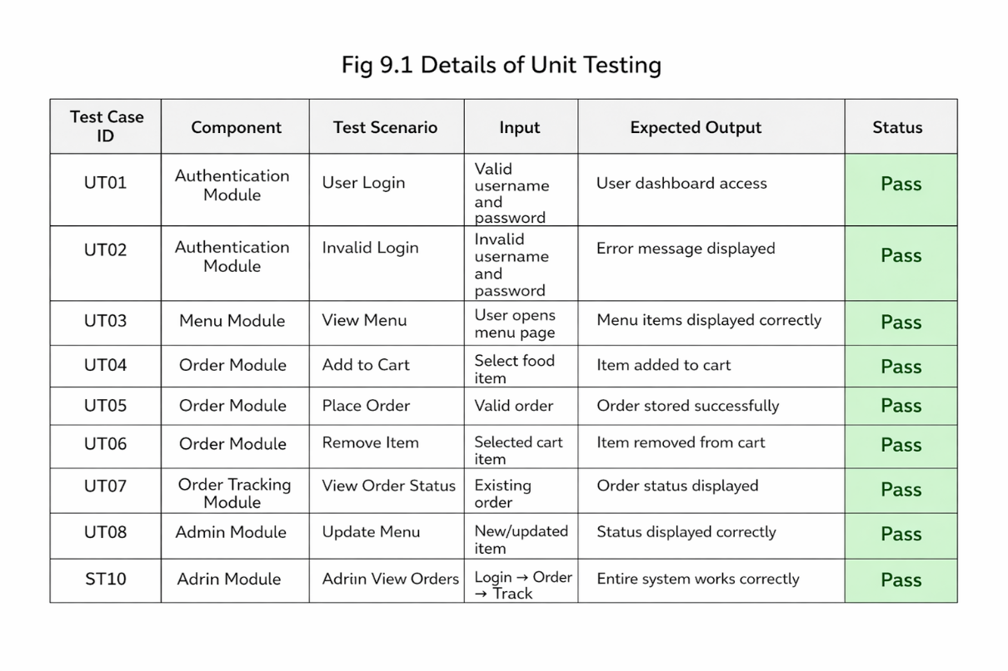
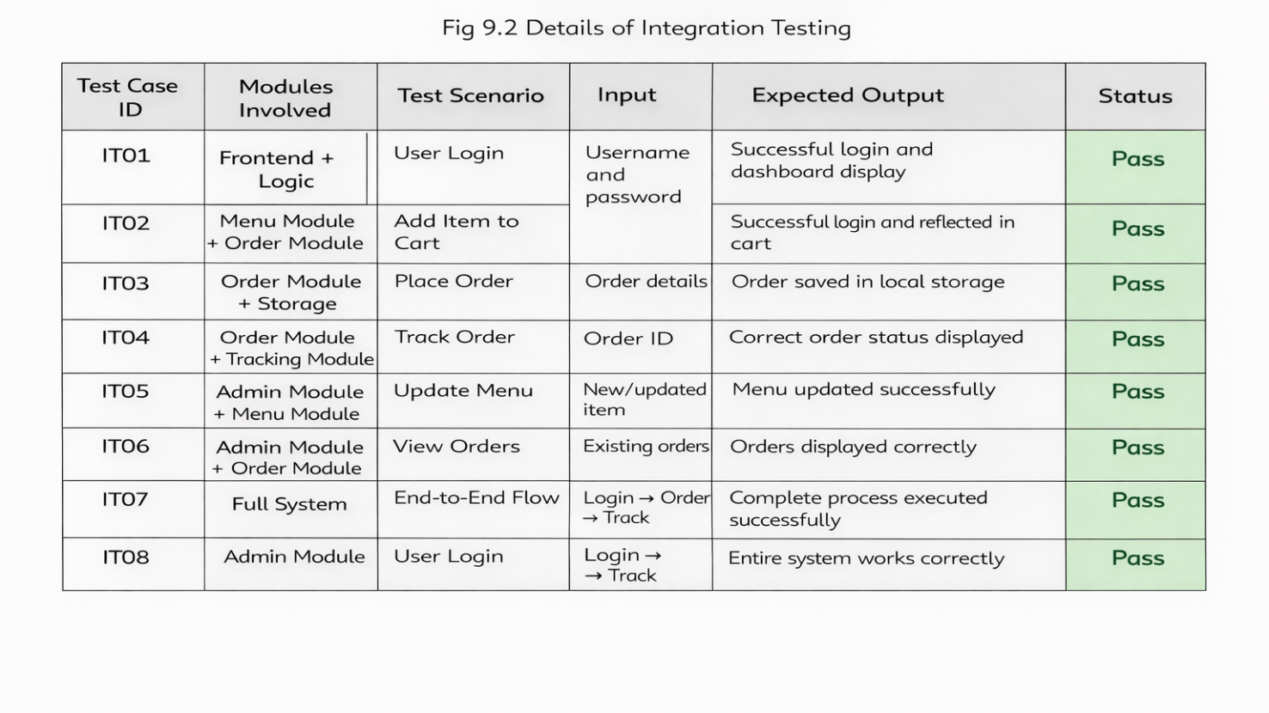

CHAPTER 10
OUTPUT SCREENS

Interface of the Smart Canteen System Website:
10.1 Login & registration Interface:

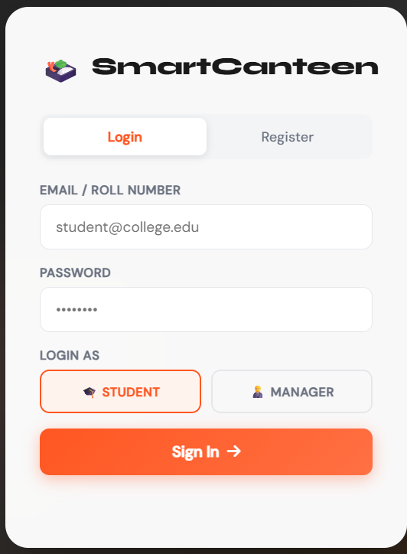

10.2 Menu Interface:

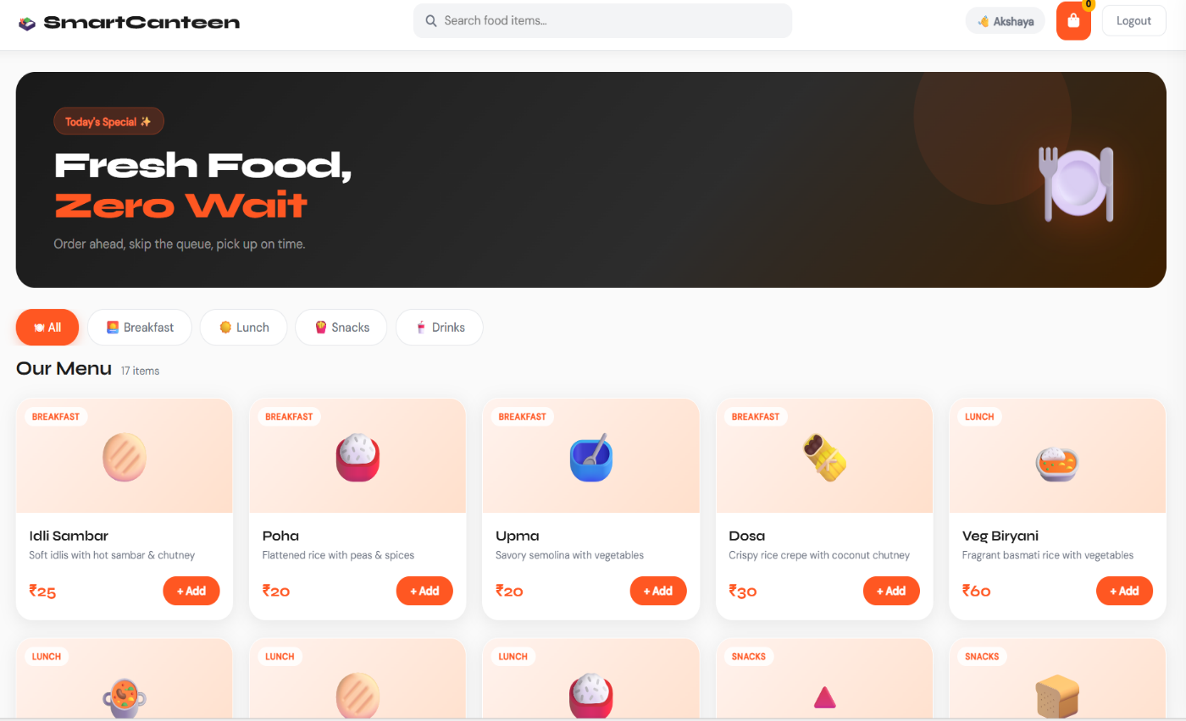

10.3 Cart Interface:

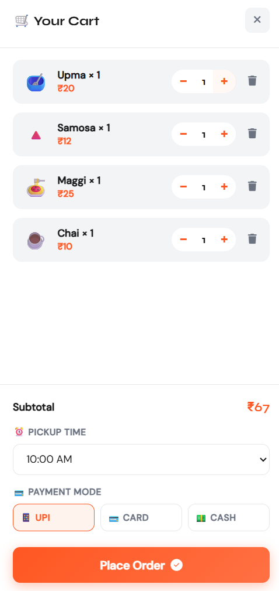

10.4 Order placed Interface:

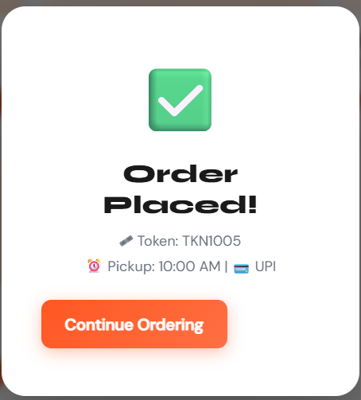

10.5 Order Status Interface:

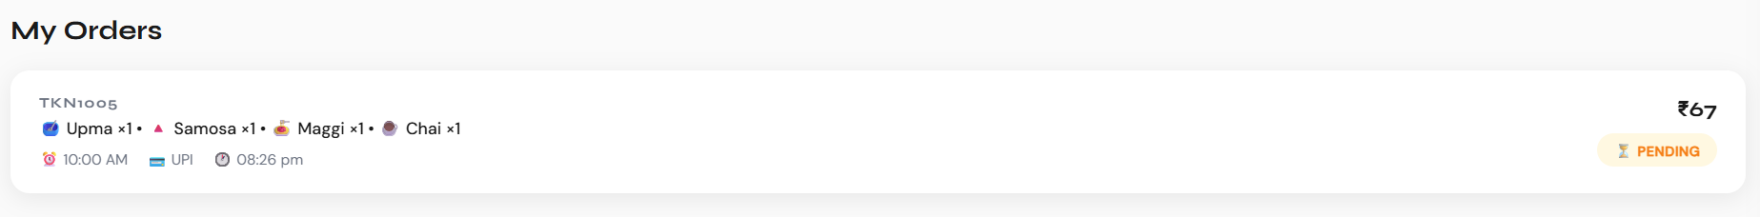

10.6 Admin Interface:

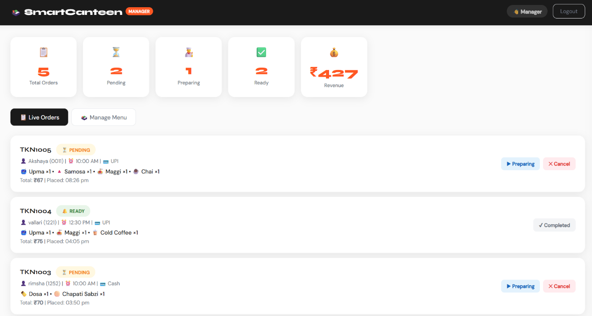

10.7 updating items interface:

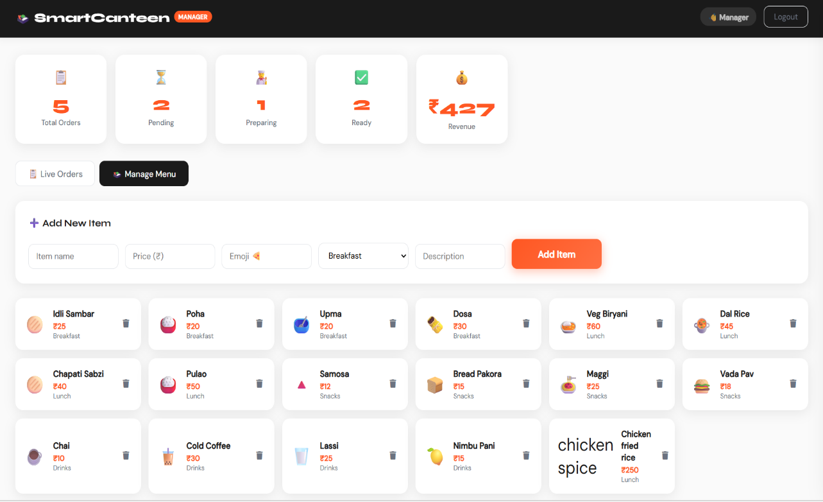
CHAPTER 11
CONCLUSION

In conclusion, our project, the Smart Canteen System, successfully addresses the need for a modern and efficient food ordering platform in educational institutions. By integrating features like online menu viewing, order placement, and real-time status updates into a single user-friendly system, it enhances the experience for both students and canteen management while reducing waiting time and manual effort. The system focuses on simplicity, speed, and accessibility, ensuring smooth navigation, improved order accuracy, and reduced crowd congestion. It is also scalable and can be extended with features such as online payments, mobile applications, and AI-based recommendations.

The development of this project has strengthened our technical knowledge in web technologies, database management, and system design, while also improving our understanding of real-world problem-solving and teamwork. By combining technology with everyday needs, the system provides a practical solution to improve canteen services. This project marks an important step in our learning journey and serves as a foundation for building more advanced and innovative systems in the future, guiding us toward developing efficient and user-centric applications.

CHAPTER 12
FURTHER ENHANCEMENTS

1.Integration with AI-Based Recommendations
The system can be improved by using artificial intelligence to suggest food items based on user preferences, previous orders, and popular dishes, helping users make faster and better choices.

2. Mobile Application Development
A dedicated mobile app can be developed to allow users to order food easily, receive real-time notifications about order status, and access the system anytime, anywhere.

3. Online Payment Integration
The system can be enhanced by adding secure online payment options such as UPI, debit/credit cards, and wallets, making the ordering process faster and cashless.

4. Real-Time Order Tracking
Future improvements can include live order tracking, where users can see the status of their order (preparing, ready, delivered) in real time.

5. Inventory Management System
An inventory module can be added to track available ingredients and stock levels, helping the canteen manage resources efficiently and avoid shortages.

CHAPTER 13

REFERENCES

[1] Sujata Joshi, Bivek Kasaju, Pratik Karki, et al., "Smart Canteen Management System", International Journal for Research in Applied Science & Engineering Technology (IJRASET), 2022. Available: https://ieeexplore.ieee.org/abstract/document/9971803
[2] Prathamesh Auti, Mohit Bawankar, Pranav Bochare, Vaibhav Harane, Nitisha K. Rajgure, "Smart Canteen System", International Journal for Research in Applied Science & Engineering Technology (IJRASET), 2021. DOI: https://doi.org/10.22214/IJRASET.2021.34840
[3] Harshada Menewar, Siya Bhandari, Prajakta Mahajan, Prof. Kiran Dange, "Smart Canteen and Cafeteria Management System using RFID & IoT", International Journal for Research in Applied Science & Engineering Technology (IJRASET), 2022. DOI: https://doi.org/10.22214/ijraset.2023.51975

