ECA5403-ELECTROMAGNETIC FILEDS AND WAVES
J.Priya
192512394
C01-1
EXPERIMENT 1
AIM:
To write a MATLAB program for transformation between Cartesian, Cylindrical and Spherical coordinate systems.
PROGRAM:
clc;
x=input('Enter the value of X=');
y=input('Enter the value of y=');
z=input('Enter the value of z=');
% Cartesian to Cylindrical
rho=sqrt(x^2+y^2);
phi=atan2d(y,x);
disp('Cartesian to cylindrical coordinate system of p(rho,phi,z)=');
disp([rho phi z]);
% Cartesian to Spherical
r=sqrt(x^2+y^2+z^2);
theta=acosd(z/r);
phi=atan2d(y,x);
disp('Cartesian to spherical coordinate system of s(r,theta,phi)=');
disp([r theta phi]);
clc;
rho=input('Enter the value of rho=');
phi=input('Enter the value of phi=');
z=input('Enter the value of z=');
% Cylindrical to Cartesian
x=rho*cosd(phi);
y=rho*sind(phi);
disp('Cylindrical to Cartesian coordinate system of p(x,y,z)=');
disp([x y z]);
% Cylindrical to Spherical
r=sqrt(rho^2+z^2);
theta=acosd(z/r);
disp('Cylindrical to spherical coordinate system of s(r,theta,phi)=');
disp([r theta phi]);
clc;
r=input('Enter the value of r=');
theta=input('Enter the value of theta (deg)=');
phi=input('Enter the value of phi (deg)=');
% Spherical to Cartesian
x=r*sind(theta)*cosd(phi);
y=r*sind(theta)*sind(phi);
z=r*cosd(theta);
disp('Spherical to Cartesian coordinate system of p(x,y,z)=');
disp([x y z]);
% Spherical to Cylindrical
rho=r*sind(theta);
disp('Spherical to cylindrical coordinate system of s(rho,phi,z)=');
disp([rho phi z]);
OUTPUT:

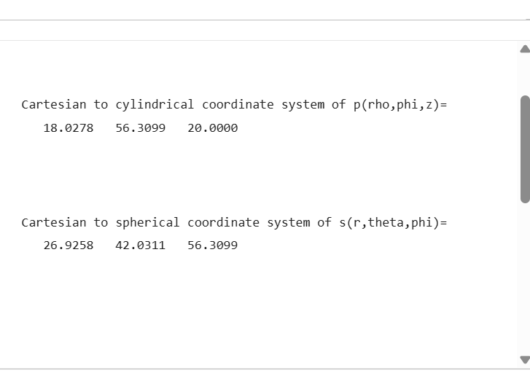
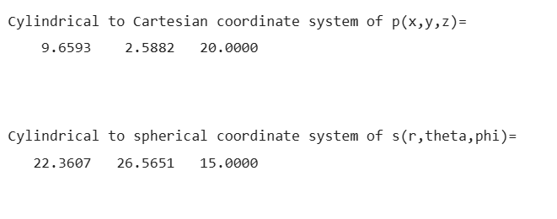
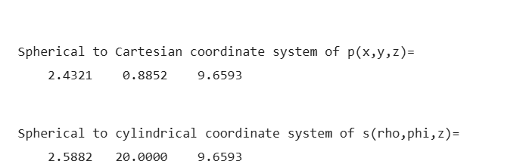
RESULTS:
Thus the transformation between Cartesian, Cylindrical and Spherical coordinate systems have been done using MATLAB software.
S. No. | Objective | Assessment Criterion | Excellent – 4 | Good – 3 | Satisfactory – 2 | Needs Improvement – 1 | Weighting (%) | Marks given | Marks obtained
1 | Apply coordinate-system definitions and angle conventions | Apply coordinate-system definitions, symbols, units, and angle conventions | Applies coordinate-system definitions and angle conventions throughout. | Uses correct definitions with one minor notation or convention error. | Shows partial understanding; multiple corrections are needed. | Uses incorrect coordinate definitions or angle conventions. | 25 | 2.5
2 | Implement transformations in MATLAB | Implement six transformations in MATLAB | Implements all six transformations correctly using suitable degree-based functions. | Implements most transformations correctly with minor coding errors. | Implements some transformations but needs assistance to correct errors. | Unable to implement the required transformations. | 25 | 2.5
3 | Verify numerical values and reverse transformations | Verify numerical values and reverse transformations | All outputs agree with analytical values; reverse transformations recover the original point within rounding precision. | Most values agree; small unexplained differences occur. | Several values differ or reverse verification is incomplete. | Outputs are incorrect or not verified. | 30 | 3
4 | Interpret and document results | Interpret and document results | Presents complete tables, units, deviations, and a clear conclusion. | Documentation is clear with minor omissions. | Tables or interpretation are incomplete. | Results and conclusion are missing or unclear. | 20 | 2
Total |  |  |  |  |  |  | 100 | 10

