ECA5403-ELECTROMAGNETIC FILEDS AND WAVES
- Priya
192512394
C01-2
EXPERIMENT 2
AIM:
To write and validate MATLAB programs for electric field intensity (E) and electric flux density (D) for specified spherical charge distributions.
Test case (i) Determination and plotting of electric field and electric flux density in sphere full of charges with varying radius
clc;
clear;
q=input('Enter the value of q=');
r=input('Enter the value of r=');
epsilon=8.854e-12;
k=1/(4*pi*epsilon);
E=k*q/(r^2);
disp("The electric field is");
disp(E);
D=epsilon*E;
disp("The flux density is");
disp(D);
% Plot
x=linspace(0.1,10,50);
E_plot=k*q./(x.^2);
D_plot=epsilon*E_plot;
figure;
subplot(1,2,1);
plot(x,E_plot);
xlabel('Radius');
ylabel('Electric field');
subplot(1,2,2);
plot(x,D_plot);
xlabel('Radius');
ylabel('Flux density')
OUTPUT:
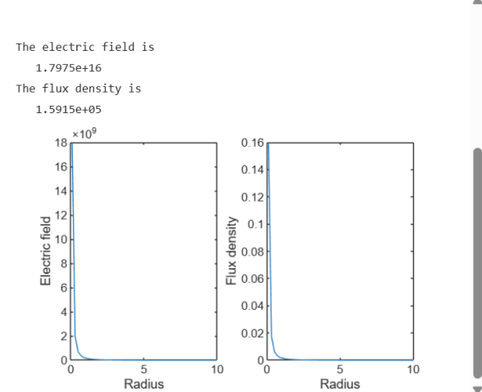

Test case (ii) Derive and plot the electric field (E) and electric flux density (D) inside a uniformly charged sphere with charge density ρ₀

Program:
clc;
rho0 = 1e-6;
epsilon = 8.854e-12;
R = 1;
r = linspace(0, R, 100);
D = (rho0 .* r) / 3;
E = D / epsilon;
subplot(1,2,1);
plot(r,D,'LineWidth',2);
xlabel("Radius (m)");
ylabel("Electric Flux Density (D)");
title("Uniform Density: D vs Radius");
subplot(1,2,2);
plot(r,E,'LineWidth',2);
xlabel("Radius (m)");
ylabel("Electric Field (E)");
title("Uniform Density: E vs Radius");
OUTPUT:
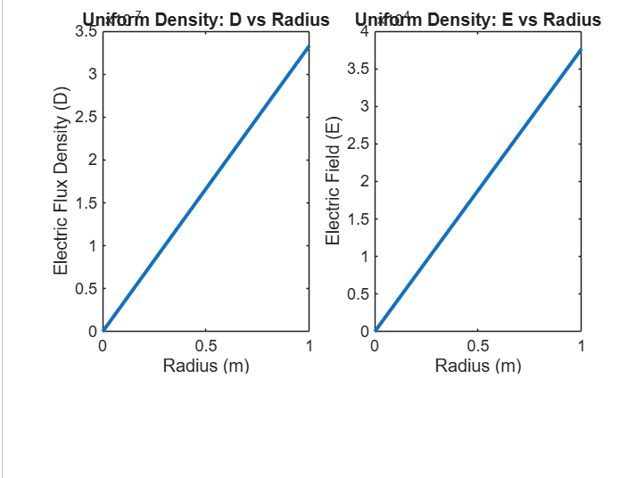
Test case (iii) For a sphere with a linearly increasing charge density ρᵥ = ρ₀r, derive and plot the electric field (E) and electric flux density (D)
Program:
clc;
rho0 = 1e-6;
epsilon = 8.854e-12;
R = 1;
r = linspace(0, R, 100);
D = (rho0 .* r.^2) / 4;
E = D / epsilon;
subplot(1,2,1);
plot(r,D,'LineWidth',2);
xlabel("Radius (m)");
ylabel("Electric Flux Density (D)");
title("Linear Density: D vs Radius");
subplot(1,2,2);
plot(r,E,'LineWidth',2);
xlabel("Radius (m)");
ylabel("Electric Field (E)");
title("Linear Density: E vs Radius");
OUTPUT:
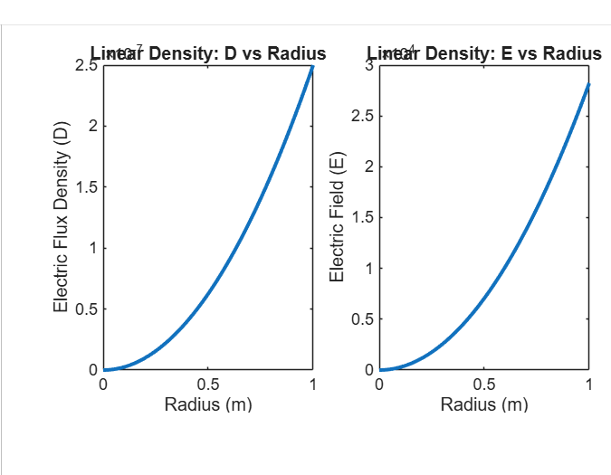
Test case (iv): For a uniformly charged solid sphere of radius R = 2 m and volume charge density ρᵥ = 3×10⁻⁶ C/m³, calculate and plot E and D inside and outside the sphere.
Program:
clc; clear; close all;
rho0 = 3e-6; % Uniform volume charge density (C/m^3)
epsilon0 = 8.854187817e-12; % Permittivity of free space (F/m)
R = 2; % Sphere radius (m)
r = linspace(0,4,401); % Radial distance (m)
E = zeros(size(r));
inside = (r <= R);
outside = (r > R);
E(inside) = rho0 .* r(inside) ./ (3*epsilon0);
E(outside) = rho0*R^3 ./ (3*epsilon0 .* r(outside).^2);
D = epsilon0 .* E; % D = epsilon0 E in free space
figure;
subplot(1,2,1); plot(r,E,'LineWidth',1.5); grid on;
xline(R,'--','R'); xlabel('Radius r (m)'); ylabel('E (V/m)'); title('Electric Field');
subplot(1,2,2); plot(r,D,'LineWidth',1.5); grid on;
xline(R,'--','R'); xlabel('Radius r (m)'); ylabel('D (C/m^2)'); title('Electric Flux Density');
% E and D increase linearly for r <= R and decay as 1/r^2 for r > R.
ylabel("Electric Field (E)");
title("Electric Field Inside and Outside Sphere");

OUTPUT:

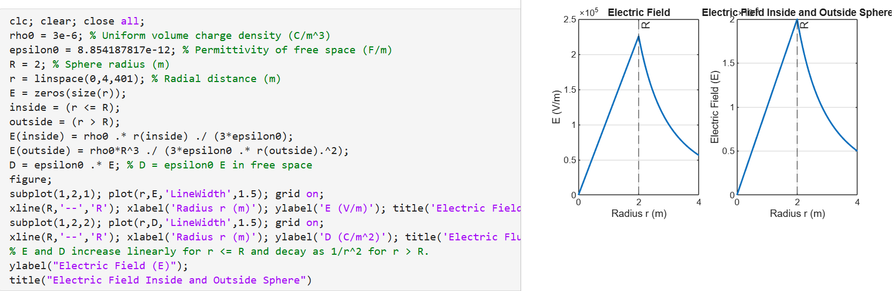
S. No. | Objective | Assessment Criterion | Excellent – 4 | Good – 3 | Satisfactory – 2 | Needs Improvement – 1 | Weighting (%) | Marks given | Marks obtained
1 | Select the appropriate charge-distribution model | Select the appropriate charge-distribution model | Correctly distinguishes point, uniform-volume and specified non-uniform charge models and their assumptions. | Selects the correct model with minor clarification needed. | Shows partial understanding; multiple corrections are needed. | Uses an unsuitable model or assumptions. | 25 | 2.5
2 | Implement transformations in MATLAB | Implement six transformations in MATLAB | Implements all six transformations correctly using suitable degree-based functions. | Implements most transformations correctly with minor coding errors. | Implements some transformations but needs assistance to correct errors. | Unable to implement the required transformations. | 25 | 2.5
3 | Verify numerical values and reverse transformations | Implement E and D calculations in MATLAB | Correctly calculates electric field E and flux density D with consistent SI units. | Calculations are mostly correct with minor coding or unit errors. | Some calculations work but require assistance. | Unable to obtain valid E and D values. | 30 | 3
4 | Analyze radial variation and validate results | Analyze radial variation and validate results | Plots the correct inside/outside or stated distribution behaviour and verifies against theory. | Plots and validation are mostly correct with minor discrepancies. | Plots or theoretical validation are incomplete. | Plots are incorrect or results are not validated. | 20 | 2
Total |  |  |  |  |  |  | 100 | 10

