SOLUTION ARCHITECTURE
Enterprise Smart City Data Platform (ESCDP)
UC10 – Enterprise Data Engineering Capstone Project

1. Architecture Overview
The Enterprise Smart City Data Platform (ESCDP) follows a layered data-platform architecture. Smart-city data sources provide heterogeneous operational data to a Pentaho ETL layer. The data then moves through Bronze, Silver, and Gold processing layers before being stored in the PostgreSQL data warehouse. Curated information is exposed through Power BI dashboards for city administration and decision-making.

2. High-Level Architecture
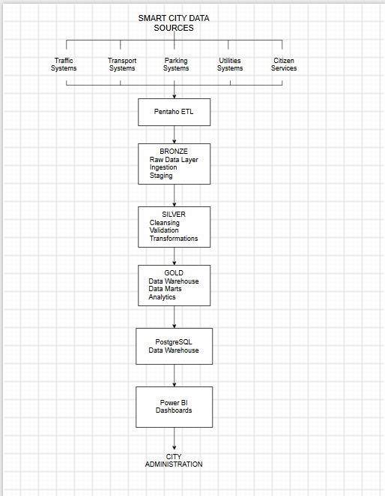
Figure 1: High-level ESCDP solution architecture

3. Architecture Layers
Layer | Component | Purpose | Output
Source Layer | Smart City Data Sources | Provides operational data from traffic, transport, parking, utilities, and citizen services. | Raw source datasets
ETL Layer | Pentaho ETL | Extracts data from heterogeneous sources and performs ingestion and transformation workflows. | Ingested data
Bronze Layer | Raw Data / Ingestion / Staging | Preserves incoming operational data in a raw or minimally processed form for downstream processing. | Raw/staged data
Silver Layer | Cleaning / Validation / Transformation | Cleans, validates, standardizes, and transforms the ingested data. | Trusted/standardized data
Gold Layer | Data Warehouse / Data Marts / Analytics | Provides curated, analytics-ready datasets and business-oriented data structures. | Curated analytical data
Storage Layer | PostgreSQL Data Warehouse | Stores the enterprise analytical data for querying and reporting. | Enterprise warehouse
Reporting Layer | Power BI Dashboards | Presents curated information through dashboards and reports. | Business insights
Consumer Layer | City Administration | Uses reports and analytics to support governance, monitoring, and decision-making. | Operational and executive decisions

4. Source Systems
The source layer represents the municipal and smart-city systems that generate operational data. The architecture diagram groups these sources into five categories.
- Traffic Systems – traffic activity, road and congestion-related information.
- Transport Systems – public transportation operations and service information.
- Parking Systems – parking capacity, occupancy and availability information.
- Utilities Systems – utility-related operational information such as water and electricity.
- Citizen Services – citizen requests, grievances and other service-related information.

5. Data Flow
- Smart-city source systems generate or provide operational datasets.
- Pentaho ETL extracts and ingests data from the heterogeneous sources.
- The Bronze layer receives the raw ingested data and acts as the initial staging area.
- The Silver layer performs cleaning, validation, standardization, and transformation.
- The Gold layer produces curated data, data-mart structures, and analytics-ready information.
- Curated data is stored in the PostgreSQL data warehouse.
- Power BI consumes the curated warehouse data to produce dashboards.
- City Administration uses the dashboards and analytical information for monitoring and decision-making.

6. Technology Mapping
Technology | Architecture Role | Reason for Use
Pentaho Data Integration (Spoon) | ETL / ingestion | Integrates heterogeneous source data and manages ETL transformations.
Python / Pandas | Data profiling and quality | Identifies missing, duplicate, inconsistent, and other data-quality issues.
PostgreSQL | Data warehouse / storage | Provides centralized relational storage for staging and curated enterprise data.
Power BI | Analytics and reporting | Provides dashboards and reporting for business users.
Git / GitHub | Version control | Maintains collaborative project code, ETL assets and documentation.

7. Data Quality and Governance Flow
Data quality is addressed between ingestion and analytics. Raw data is retained in the Bronze stage, while the Silver stage is responsible for cleaning, validation, standardization, and transformation. The Gold stage contains curated information suitable for analytical use. Metadata, audit information, source-to-target mappings, and data lineage are maintained as governance requirements of the platform.

8. Architecture Responsibilities by Sprint
Sprint | Architecture Focus | Key Outputs
Sprint 0 | Business understanding and architecture | BRD, solution architecture, source identification, repository, backlog and project charter.
Sprint 1 | Source integration and raw landing | Source inventory, data dictionary, Pentaho ingestion pipelines and PostgreSQL staging.
Sprint 2 | Quality and warehouse development | Python profiling, data quality report, Star Schema, fact/dimension tables and warehouse.
Sprint 3 | Governance and analytics | Lineage, metadata, orchestration, validation, Power BI dashboards and final documentation.

9. Architecture Boundaries
- ESCDP integrates and processes data; it does not replace the municipal source systems.
- The platform does not directly control traffic, electricity, water, waste, emergency infrastructure, or IoT devices.
- The architecture is focused on data ingestion, processing, storage, governance, and analytics.
- Where real municipal datasets are unavailable, simulated or representative datasets may be used for project demonstration and must be clearly identified as such.

10. Summary
The proposed ESCDP architecture creates a unified flow from heterogeneous smart-city data sources to enterprise analytics. Pentaho provides the ETL capability, the Bronze/Silver/Gold layers organize the data-processing lifecycle, PostgreSQL provides centralized warehouse storage, and Power BI provides the reporting layer for City Administration. This architecture provides the foundation for the subsequent Sprint 1 ingestion work and Sprint 2–3 warehouse, governance, and analytics activities.

