**Exercise 1: Control Structures**

**Scenario 1**

CREATE PROCEDURE ApplyDiscountForSeniorCustomers()

BEGIN

UPDATE customers

SET loan_interest_rate = loan_interest_rate - 1

WHERE age > 60;

END $$

**Scenario 2**

CREATE PROCEDURE PromoteVIPCustomers()

BEGIN

UPDATE customers

SET isVIP = TRUE

WHERE balance > 10000;

END $$

**Scenario 3**

CREATE PROCEDURE RemindDueLoans()

BEGIN

DECLARE done INT DEFAULT FALSE;

DECLARE c_id INT;

DECLARE l_id INT;

DECLARE due DATE;

DECLARE cust_name VARCHAR(100);

DECLARE cur CURSOR FOR

SELECT loans.loan_id, loans.customer_id, loans.due_date, customers.name

FROM loans

JOIN customers ON loans.customer_id = customers.customer_id

WHERE loans.due_date <= CURDATE() + INTERVAL 30 DAY;

DECLARE CONTINUE HANDLER FOR NOT FOUND SET done = TRUE;

OPEN cur;

read_loop: LOOP

FETCH cur INTO l_id, c_id, due, cust_name;

IF done THEN

LEAVE read_loop;

END IF;

SELECT CONCAT('Reminder: Customer ', cust_name, ' (ID: ', c_id, ') has a loan due on ', due) AS ReminderMessage;

END LOOP;

CLOSE cur;

END $$

**Output:**

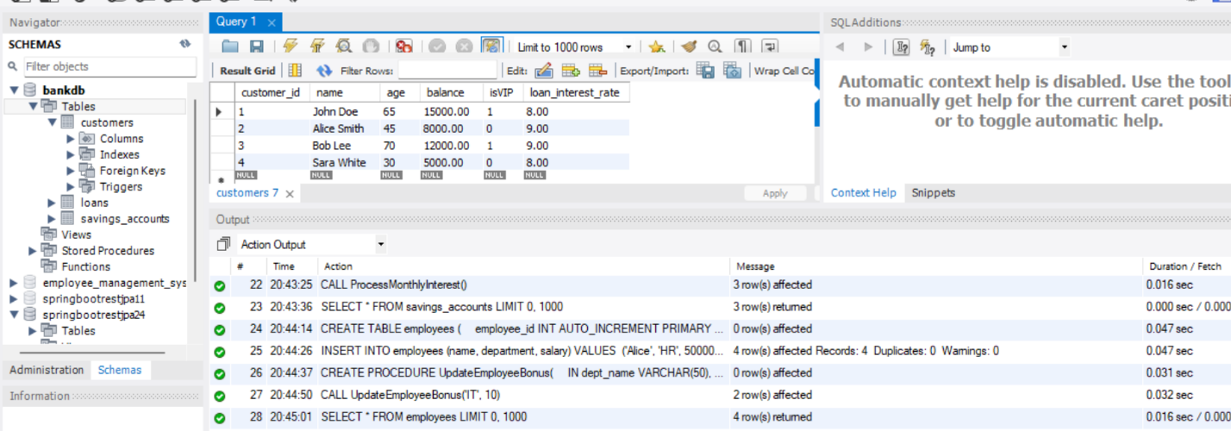

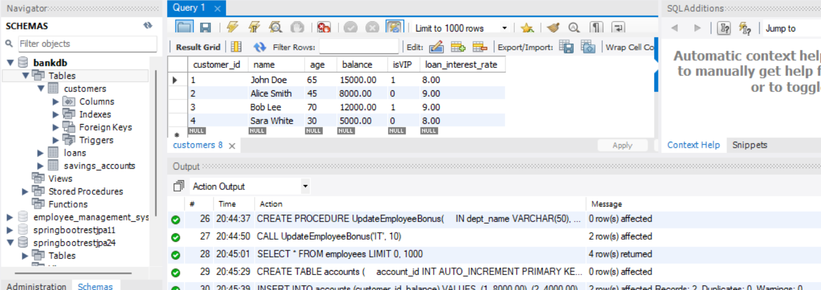

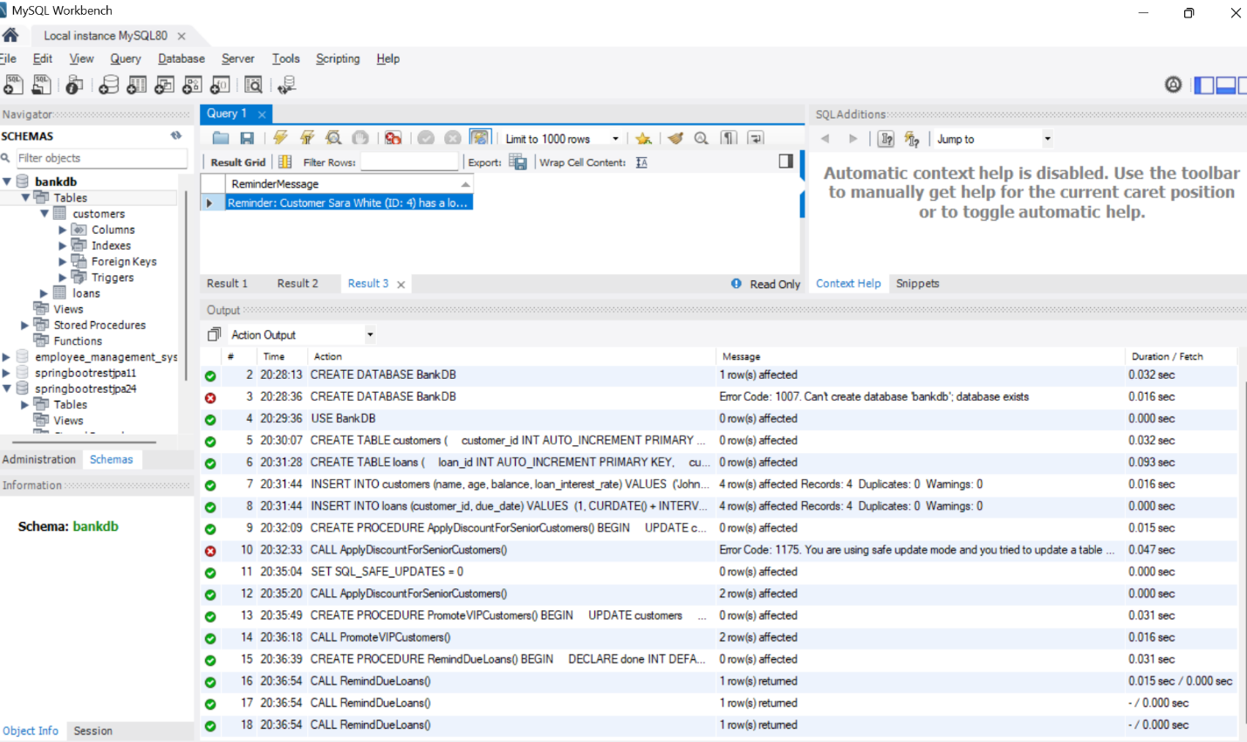

**Exercise 3: Stored Procedures**

**Scenario 1:**

CREATE PROCEDURE ProcessMonthlyInterest()

BEGIN

UPDATE savings_accounts

SET balance = balance * 1.01;

END $$

**Scenario 2:**

CREATE PROCEDURE UpdateEmployeeBonus(

IN dept_name VARCHAR(50),

IN bonus_percent DECIMAL(5,2)

)

BEGIN

UPDATE employees

SET salary = salary + (salary * bonus_percent / 100)

WHERE department = dept_name;

END $$

**Scenario 3:**

CREATE PROCEDURE TransferFunds(

IN from_account INT,

IN to_account INT,

IN amount DECIMAL(12,2)

)

BEGIN

DECLARE from_balance DECIMAL(12,2);

-- Get balance of source account

SELECT balance INTO from_balance

FROM accounts

WHERE account_id = from_account;

-- Check if sufficient

IF from_balance >= amount THEN

-- Deduct from source

UPDATE accounts

SET balance = balance - amount

WHERE account_id = from_account;

-- Add to target

UPDATE accounts

SET balance = balance + amount

WHERE account_id = to_account;

ELSE

SIGNAL SQLSTATE '45000'

SET MESSAGE_TEXT = 'Insufficient balance in source account';

END IF;

END $$

**Output:**

