**1.Spring Data JPA - Quick Example**

**Country.java**

import javax.persistence.Column;

import javax.persistence.Entity;

import javax.persistence.Id;

import javax.persistence.Table;

@Entity

@Table(name="country")

public class Country {

  @Id

    @Column(name="code")

    private String code;

    @Column(name="name")

    private String name;

// getters and setters

  // toString()

}

**CountryRepository.java**

import org.springframework.data.jpa.repository.JpaRepository;

import org.springframework.stereotype.Repository;

import com.cognizant.ormlearn.model.Country;

@Repository

public interface CountryRepository extends JpaRepository<Country, String> {

}

**OrmLearnApplication.java**

package com.cognizant.orm_learn;

import com.cognizant.orm_learn.model.Country;

import com.cognizant.orm_learn.service.CountryService;

import org.slf4j.Logger;

import org.slf4j.LoggerFactory;

import org.springframework.boot.SpringApplication;

import org.springframework.boot.autoconfigure.SpringBootApplication;

import org.springframework.context.ApplicationContext;

import java.util.List;

@SpringBootApplication

public class OrmLearnApplication {

private static final Logger LOGGER = LoggerFactory.getLogger(OrmLearnApplication.class);

private static CountryService countryService;

public static void main(String[] args) {

ApplicationContext context = SpringApplication.run(OrmLearnApplication.class, args);

countryService = context.getBean(CountryService.class);

LOGGER.info("Inside main");

testGetAllCountries();

}

private static void testGetAllCountries() {

LOGGER.info("Start");

List<Country> countries = countryService.getAllCountries();

LOGGER.debug("countries={}", countries);

LOGGER.info("End");

}

}

**Output:**

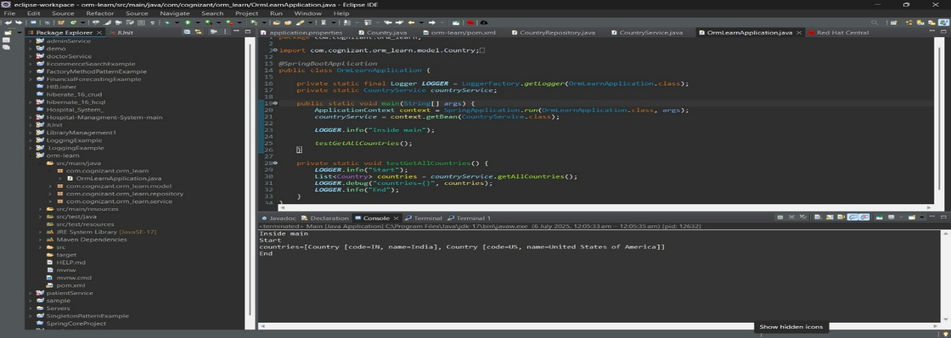

**4.Difference between JPA, Hibernate and Spring Data JPA**   
**Employee.java**

package com.example.employeejpademo.model;

import jakarta.persistence.Entity;

import jakarta.persistence.GeneratedValue;

import jakarta.persistence.GenerationType;

import jakarta.persistence.Id;

*@Entity*

public class Employee {

*@Id*

*@GeneratedValue*(strategy = *GenerationType*.***IDENTITY***)

private Long id;

private String name;

private String department;

// Constructors

public Employee() {}

public Employee(String name, String department) {

this.name = name;

this.department = department;

}

// Getters and Setters

public Long getId() {

return id;

}

public void setId(Long id) {

this.id = id;

}

public String getName() {

return name;

}

public void setName(String name) {

this.name = name;

}

public String getDepartment() {

return department;

}

public void setDepartment(String department) {

this.department = department;

}

}

**EmployeeRepository.java**

package com.example.employeejpademo.repository;

import com.example.employeejpademo.model.Employee;

import org.springframework.data.jpa.repository.JpaRepository;

import org.springframework.stereotype.Repository;

*@Repository*

public interface EmployeeRepository extends JpaRepository<Employee, Integer> {

}

**EmployeeService.java**

package com.example.employeejpademo.service;

import com.example.employeejpademo.model.Employee;

import com.example.employeejpademo.repository.EmployeeRepository;

import org.springframework.beans.factory.annotation.Autowired;

import org.springframework.stereotype.Service;

import java.util.List;

import java.util.Optional;

*@Service*

public class EmployeeService {

*@Autowired*

private EmployeeRepository employeeRepository;

public List<Employee> getAllEmployees() {

return employeeRepository.findAll();

}

public Optional<Employee> getEmployeeById(Long id) {

return employeeRepository.findById(id);

}

public Employee saveEmployee1(Employee employee) {

return employeeRepository.save(employee);

}

public Employee saveEmployee(Employee employee) {

return employeeRepository.save(employee);

}

public void deleteEmployee(Long id) {

employeeRepository.deleteById(id);

}

}

**HomeController.java**

package com.example.employeejpademo.controller;

import org.springframework.web.bind.annotation.GetMapping;

import org.springframework.web.bind.annotation.RestController;

*@RestController*

public class HomeController {

*@GetMapping*("/")

public String home() {

return "<h1>Welcome to the Employee JPA Demo Application!</h1><p>Your application is running successfully and connected to the database.</p>";

}

**}**

**Output:**

