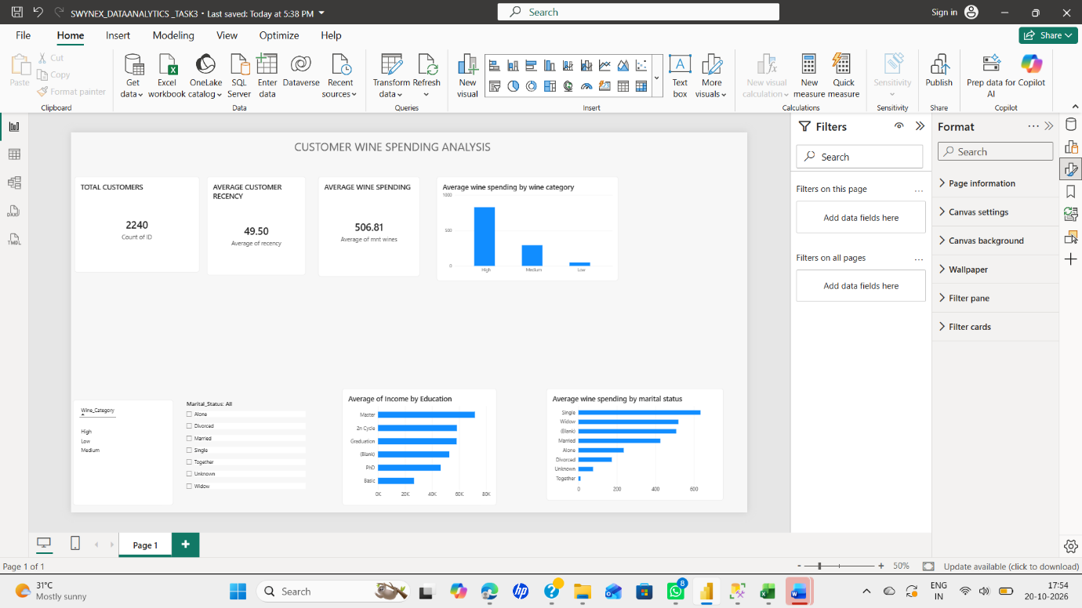
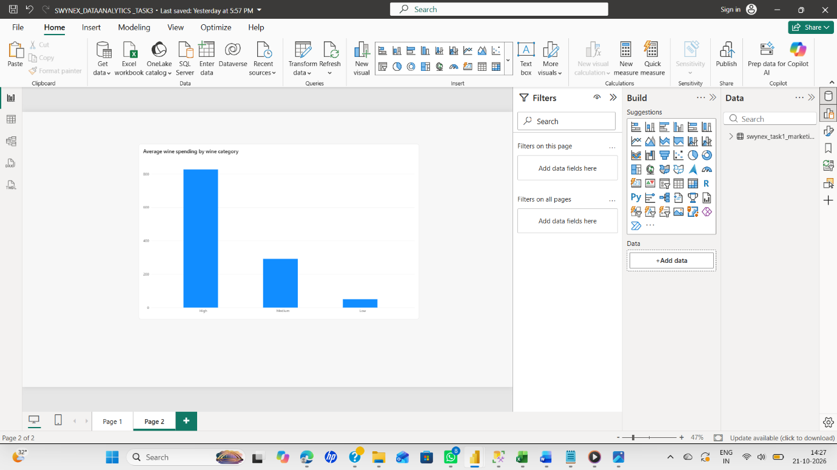
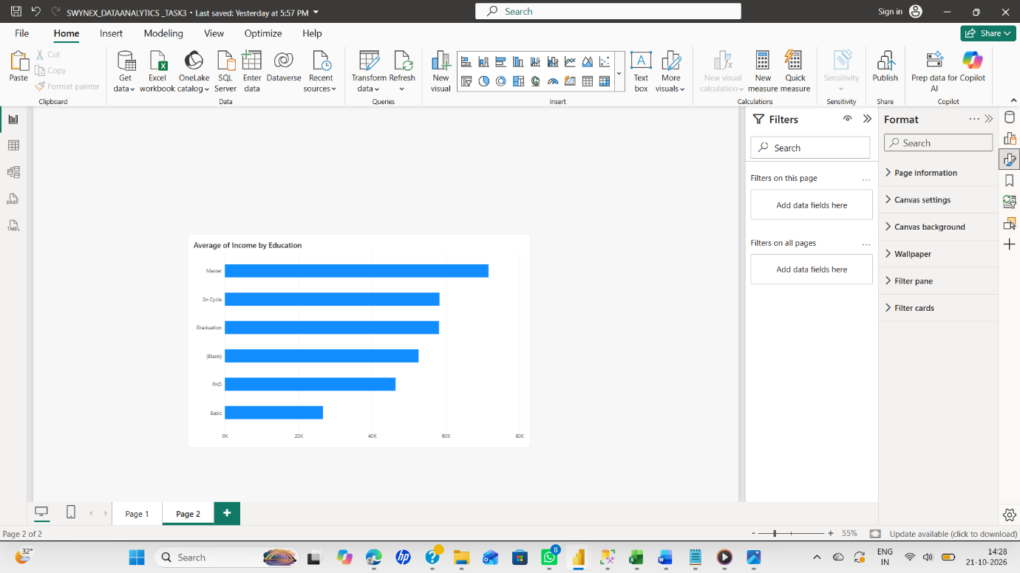
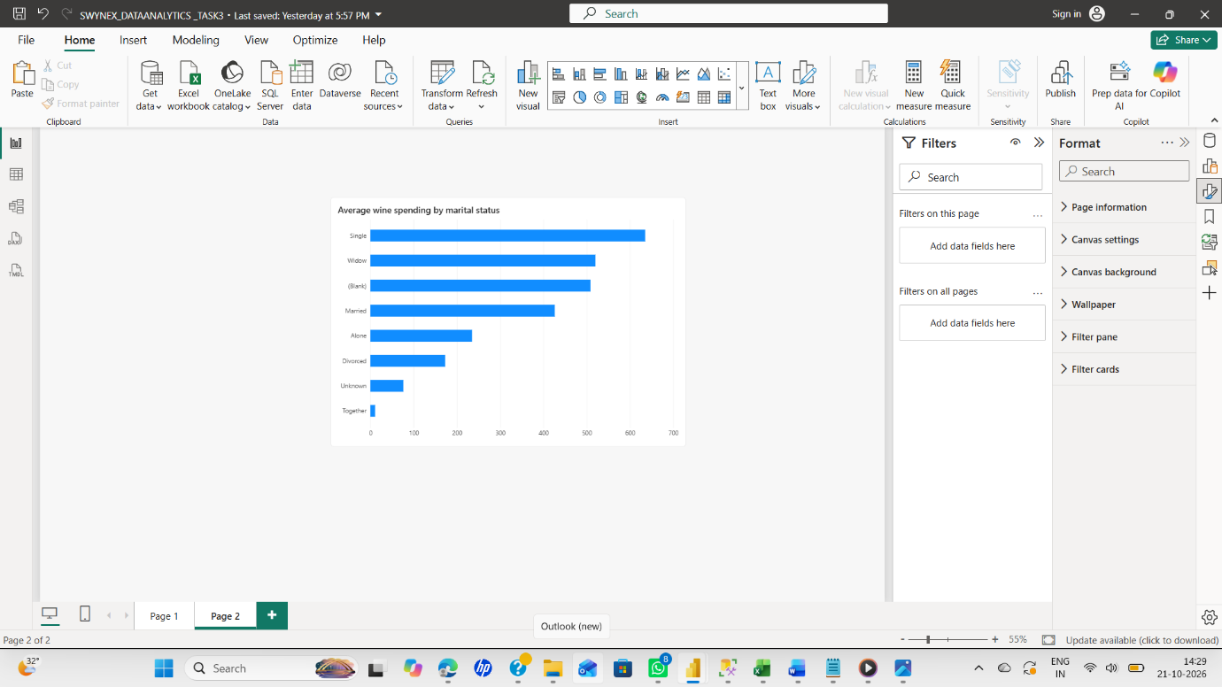
Key Business Insights
- Wine category comparison: Compare the average spending of customers in the High, Medium, and Low wine categories to understand differences in spending.
- Customer segmentation: Use the wine category slicer to explore customer groups and identify segments that may benefit from targeted marketing.
- Customer recency: Use the average recency KPI to understand how recently customers purchased and consider appropriate re-engagement campaigns.
- Income and education: Compare average income across education groups to understand differences in customer profiles.
- Marital status and spending: Compare average wine spending across marital-status groups to identify differences in purchasing behavior.
Recommendations
Use the analysis to guide customer segmentation, design targeted marketing campaigns, and investigate unusual spending patterns. Validate findings with additional data before making business decisions.
Conclusion
This project provided practical experience in data cleaning, exploratory data analysis, Power BI visualization, and business insight development.

