**NAME : AKSHAYA P**

ASSISTED PRACTICE PROJECT- 2

ACCESS MODIFIER PROGRAM:

**DEFAULT:**

class Accessmodifier{

void display() {

System.out.println("Default access specifier is used to display addition to two numbers ");

int a=10,b=20;

int sum=a+b;

System.out.println("sum:" +sum);

}

}

public class defAccess {

public static void main(String[] args) {

Accessmodifier am=new Accessmodifier();

am.display();

}

}

**OUTPUT**

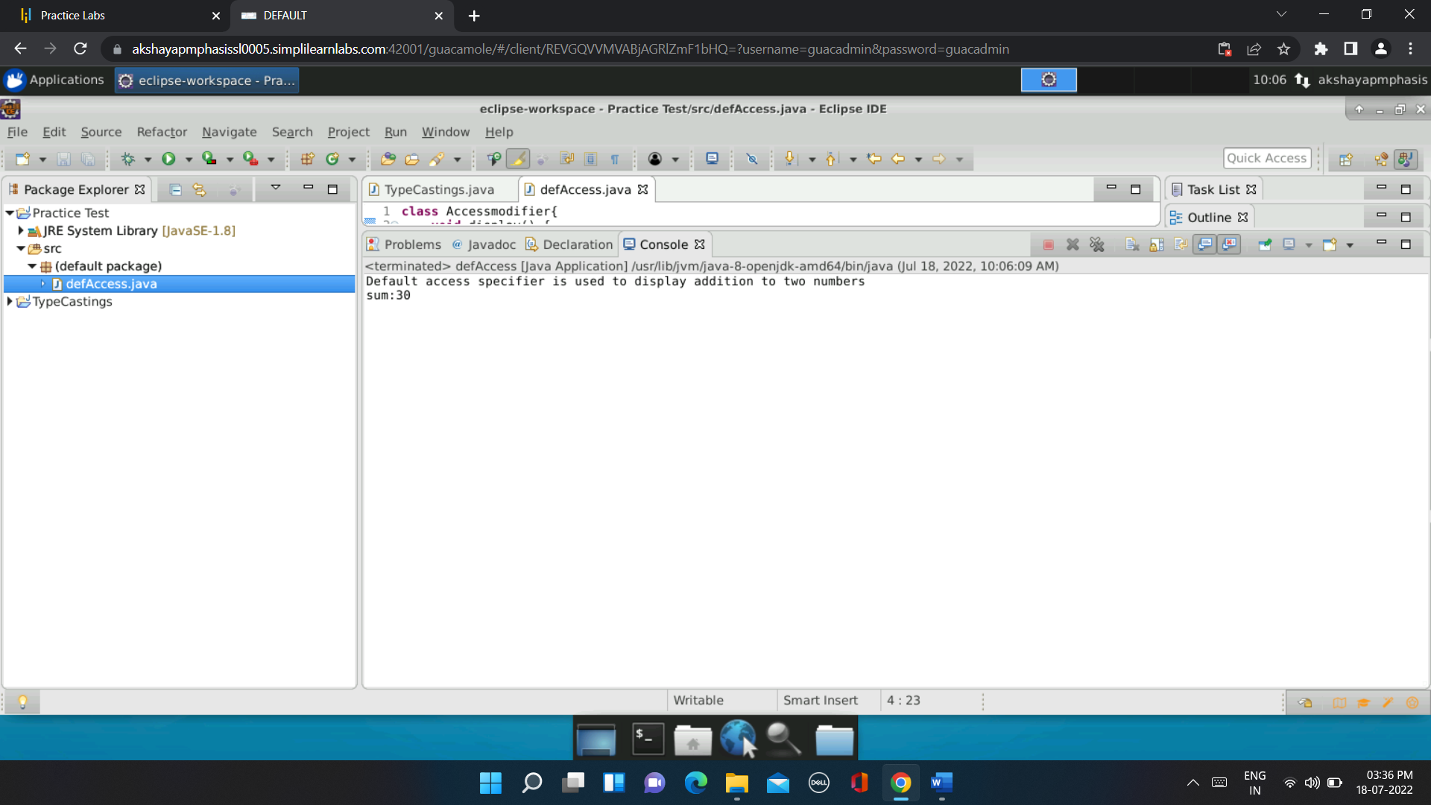

**PRIVATE:**

public class PriAccess {

private int show(int a, int b) {

System.out.println("Private access specifier is used");

return (a-b);

}

public static void main(String[] args) {

PriAccess as=new PriAccess();

System.out.println("Subtraction of 2 numbers:" +as.show(20,10));

}

}

**OUTPUT:**

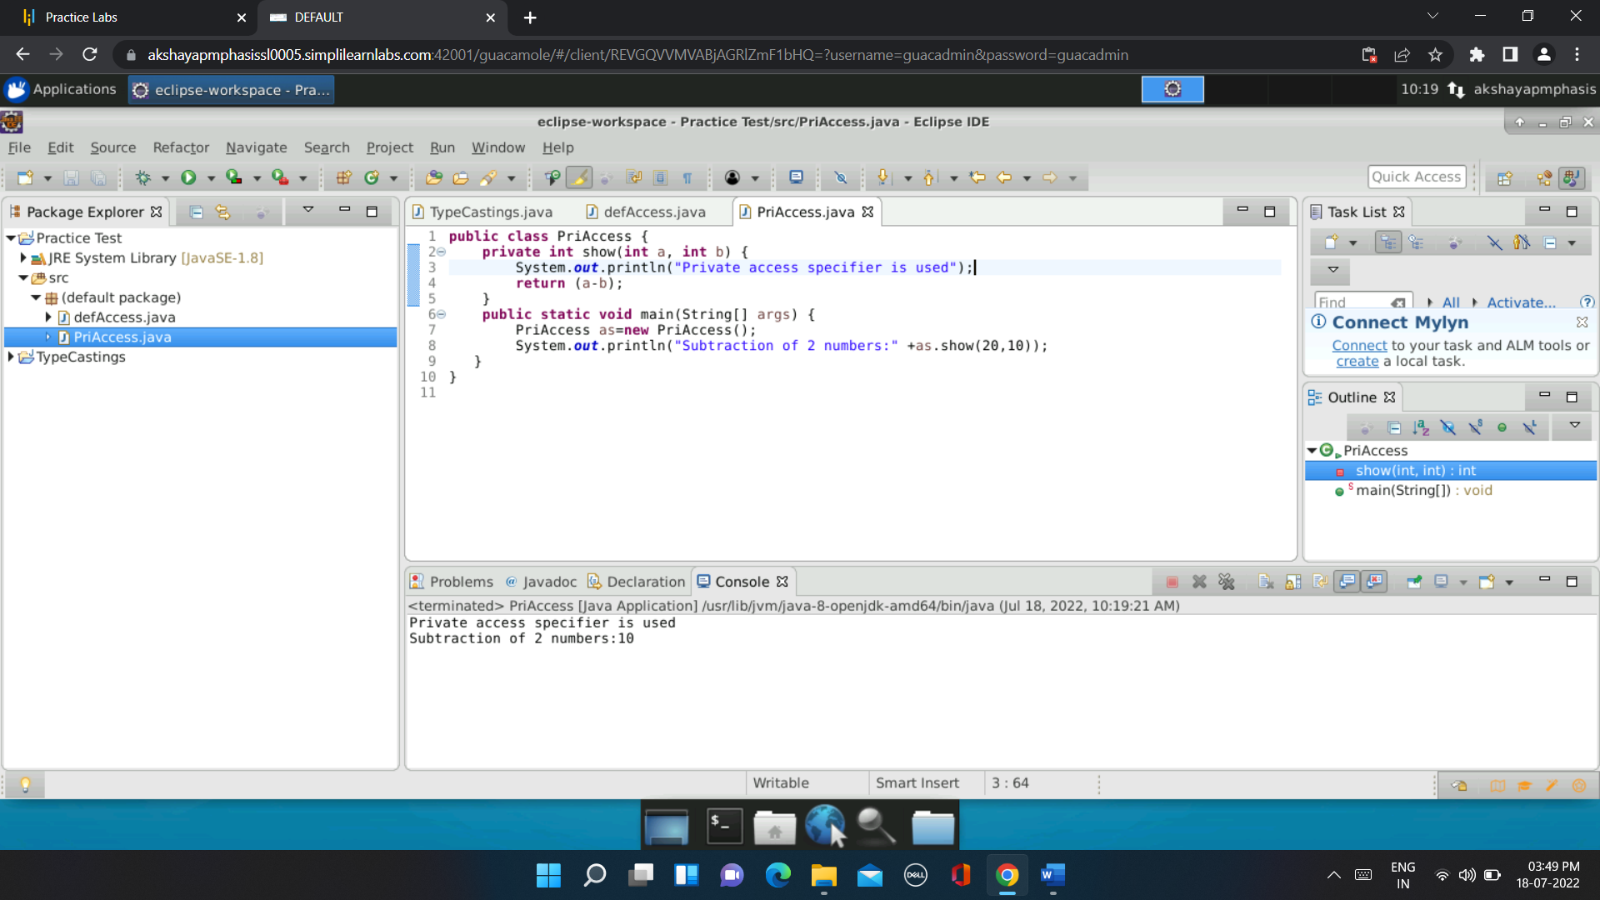

**PROTECTED:**

package pack2;

public class AccSpec {

protected void show() {

int a=10,b=5;

System.out.println("Protected Access modifier is used");

int c=a*b;

System.out.println("Multiplication of two numbers using protected access specifier:"+c);

}

}

package pack1;

import pack2.*;

public class ProAccess extends AccSpec{

public static void main(String args[]) {

ProAccess pa=new ProAccess();

pa.show();

}

}

**OUTPUT:**

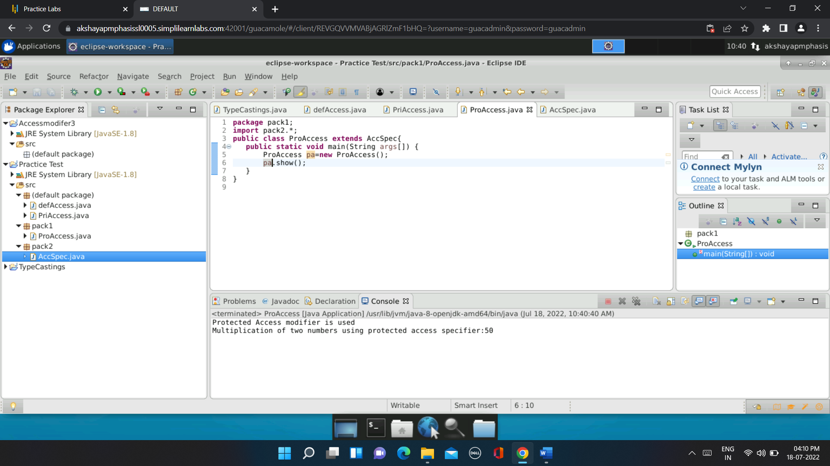

**PUBLIC:**

package Pack4;

public class PublicAcc {

public void display() {

System.out.println("Public Access specifier is used ");

String str1="Welcome";

int len=str1.length();

System.out.println("The length of the string using public acess modifier is:"+len);

}

}

package pack3;

import Pack4.*;

public class modPubl {

public static void main(String[] args) {

PublicAcc pa=new PublicAcc();

pa.display();

}

}

**OUTPUT:**

