Write a word count program using partitioner and implement the following logic in the partitioner words with length 5 should go into reducer 1 and words with length 6 should go into reduer 2 and the rest of the words should go into reducer 3.

Sample Input

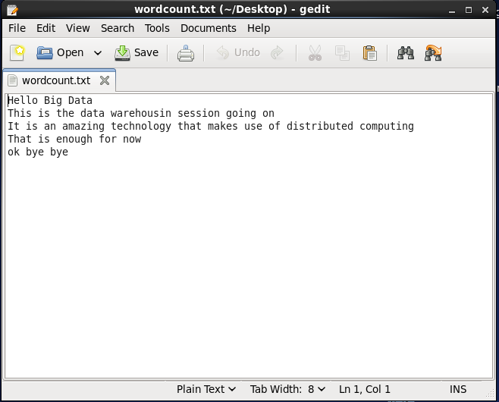

Driver class

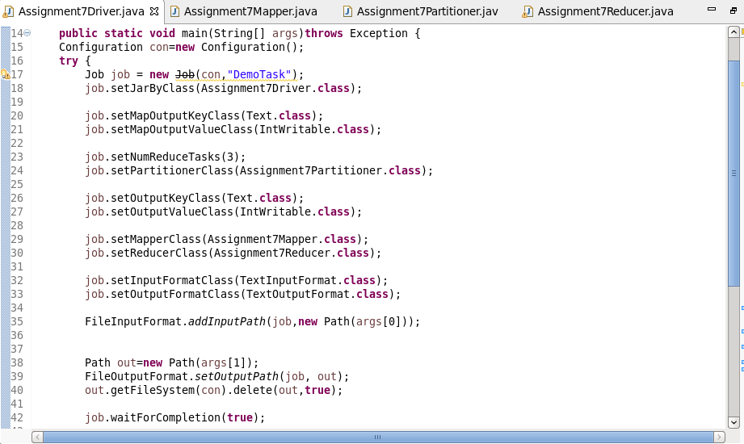

Mapper class

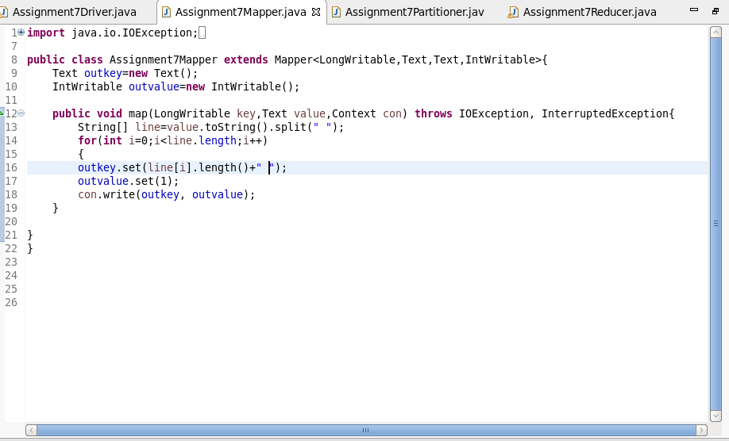

Partitioner class

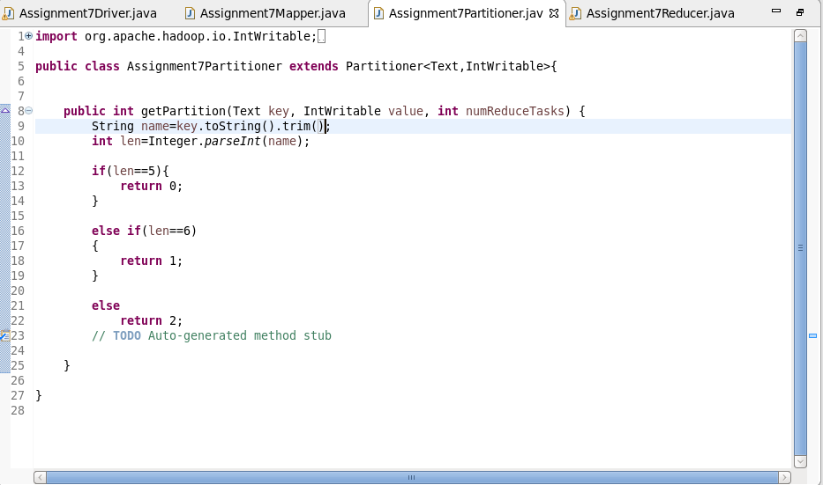

Reducer class

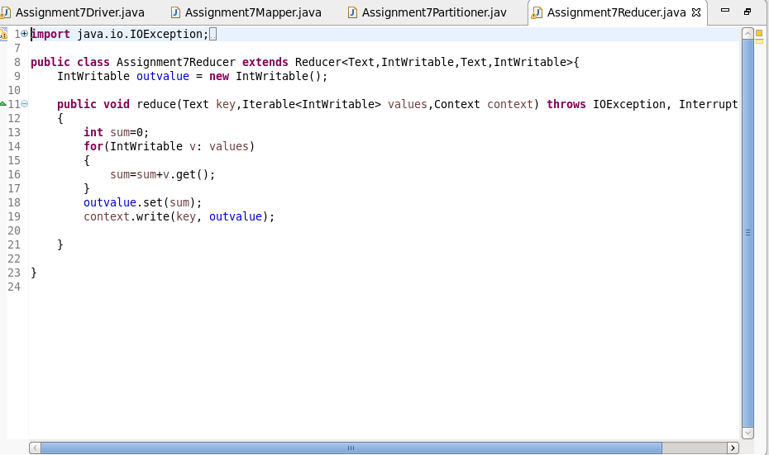

Output

