WEB APPLICATIONS ASSIGNMENT
CRUD Operations
- Database and Collection
Database Name: akshaya_175641
Collection Name: students
- Creation of Database and Collection
Part A – CRUD Operations on a Single Record
1. Create – Insert One Record
A single student record was inserted into the students collection.
- Single Record Insertion

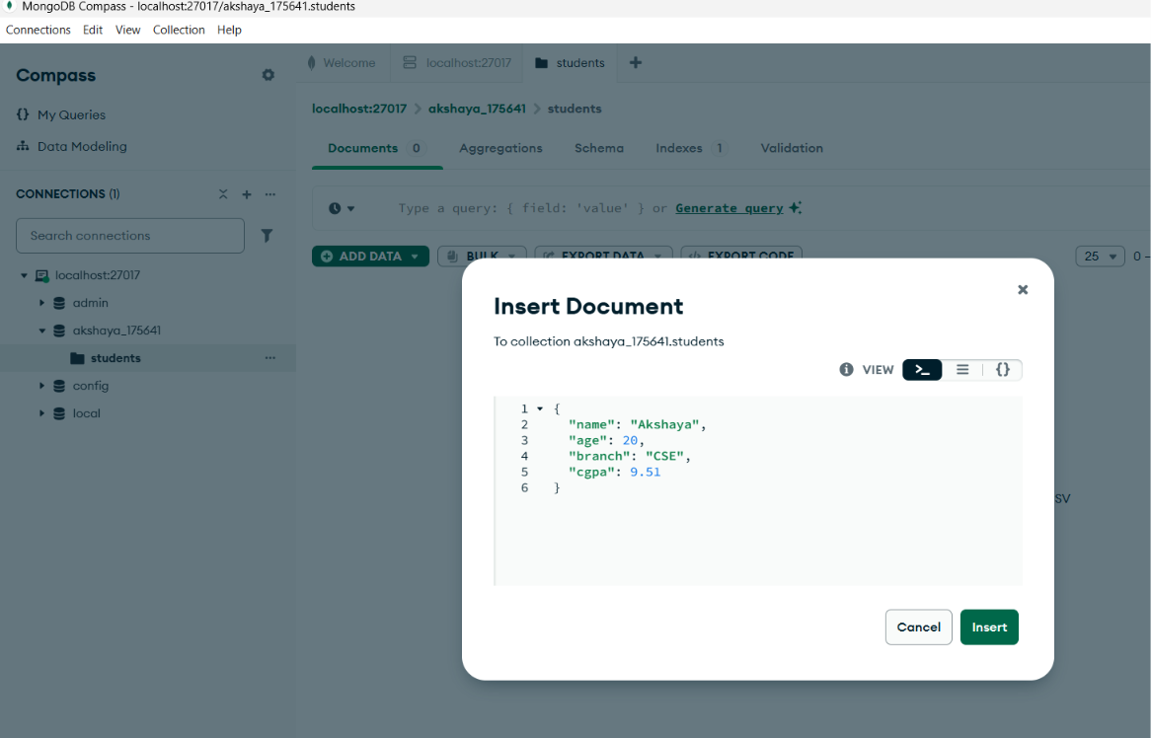
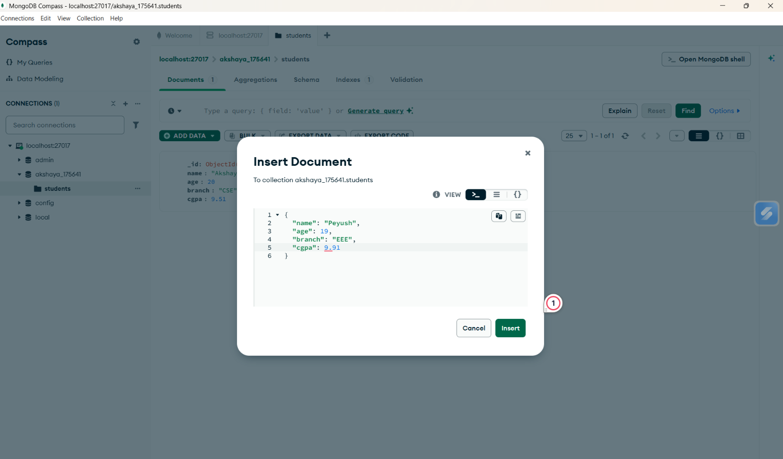

2. Read – Retrieve One Record
The inserted student record was retrieved using the filter/query option.
- Read Operation
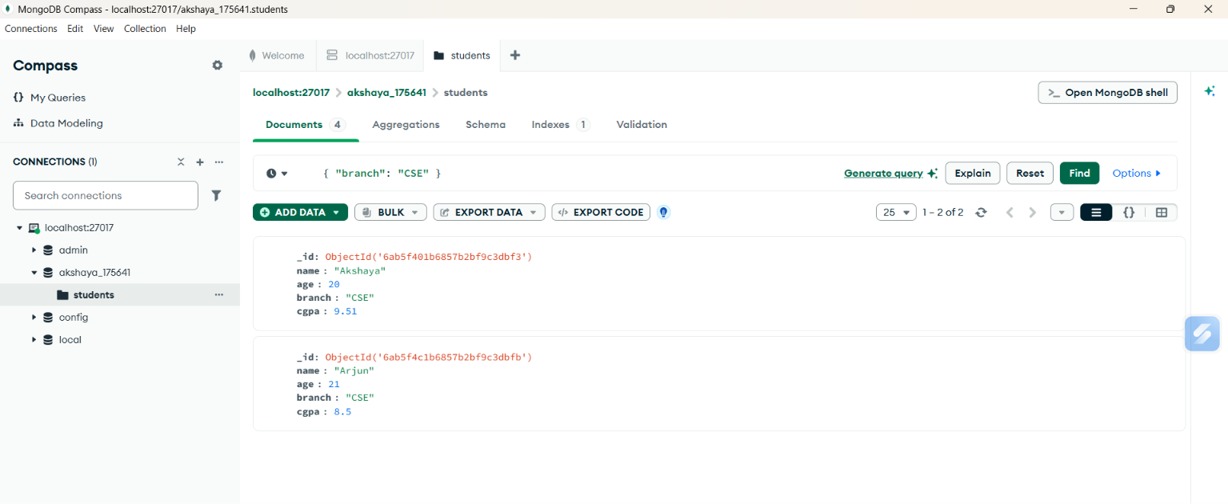
3. Update – Modify One Record
The student's cgpa updated
- Update Operation

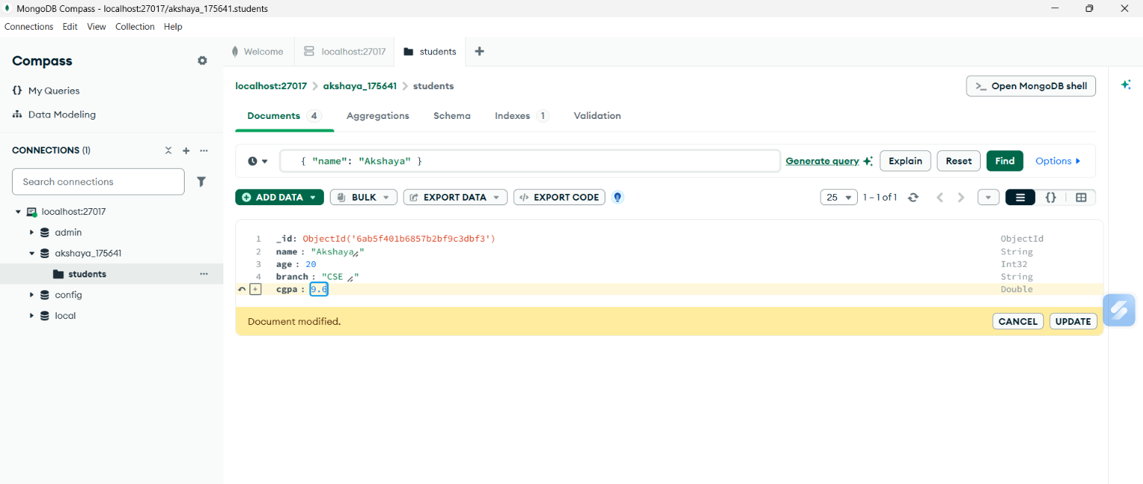
4. Delete – Delete One Record
The student record was deleted from the collection.
- Delete Operation

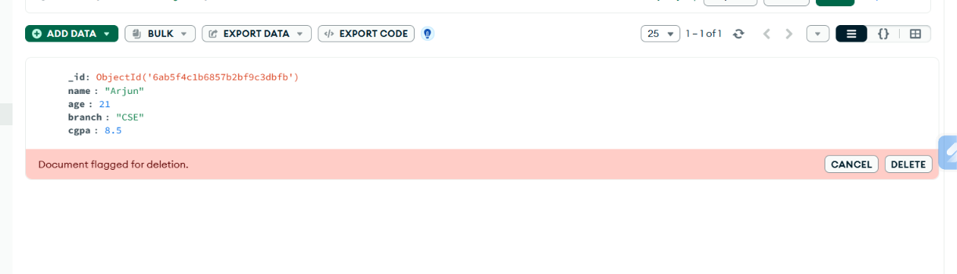
Part B – CRUD Operations on Multiple Records
1. Create – Insert Multiple Records
Multiple student records were inserted using the insertMany() operation.
- Insert Many Operation
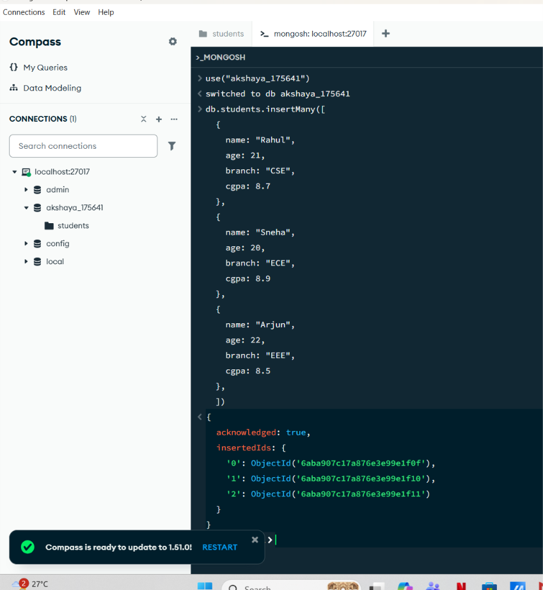
2. Read – Retrieve Multiple Records
Multiple student records were retrieved using the find() operation.
- Read Multiple Records
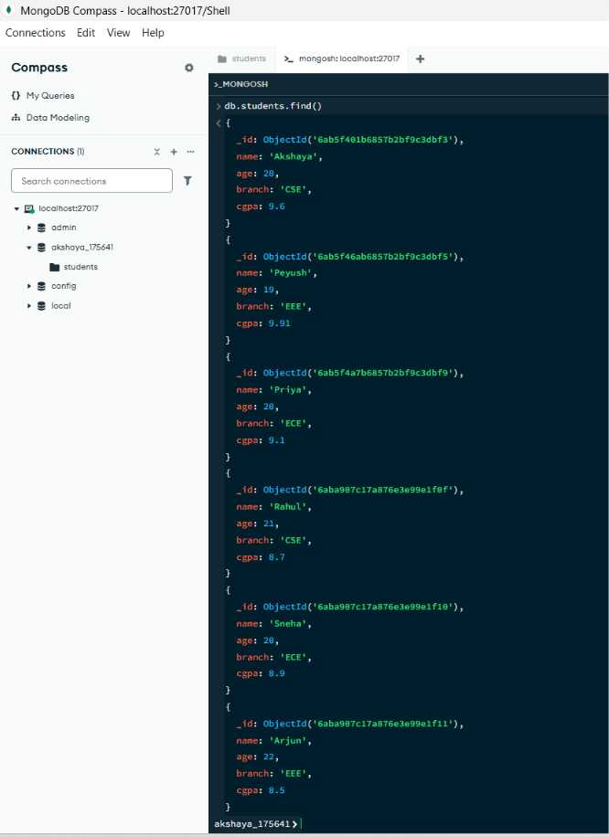 3. Update – Modify Multiple Records
Multiple records were updated using the updateMany() operation.
- Update Many Operation
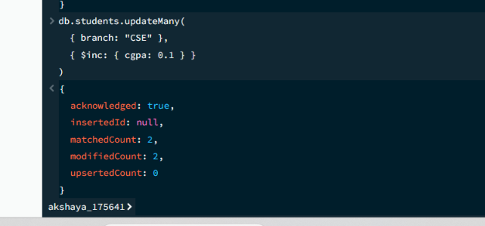
4. Delete – Delete Multiple Records
Multiple records were deleted using the deleteMany() operation.
- Delete Many Operation
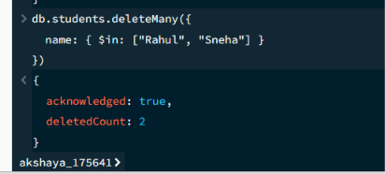

Part -C : Import JSON File
1. Create JSON File
A JSON file named students.json was created using Notepad containing multiple student records.
- students.json File
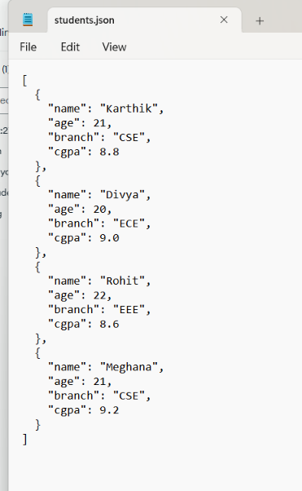
2. Import JSON File into MongoDB
The students.json file was imported into the students collection using the Import JSON or CSV file option in MongoDB Compass.
- JSON Import
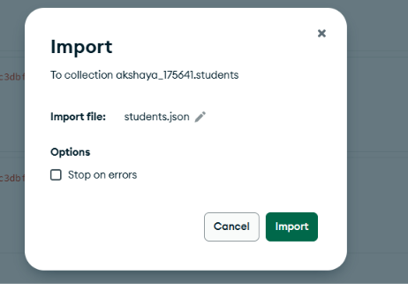
3. Verify Imported Records
The imported records were displayed and verified in the students collection.
Imported Records
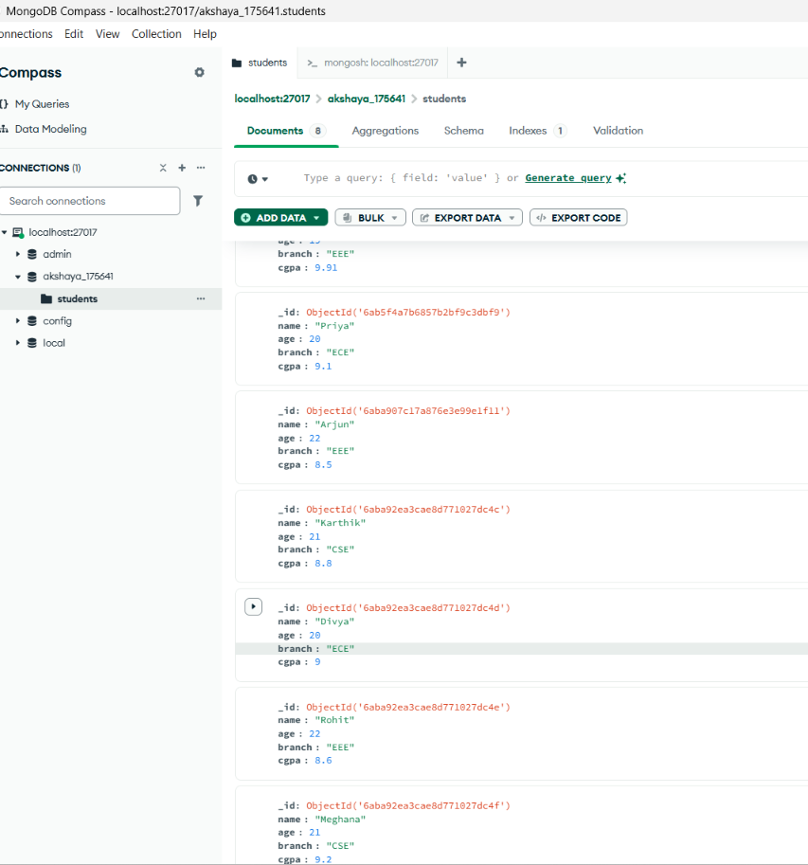
Part – D: 1. Primary and Unique Constraints
- Primary Key : MongoDB automatically creates the _id field for every document. The _id field uniquely identifies each document.
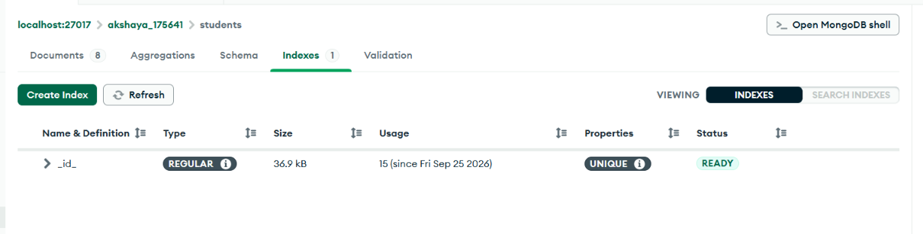
- Unique Constraint : Created a unique index on the name field so that duplicate student names cannot be inserted.
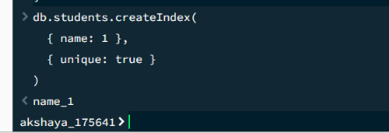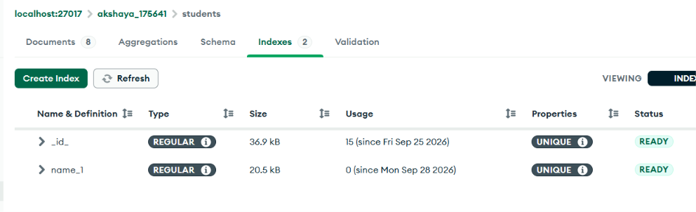
2. ANY Operation : The $in operator was used to find students whose course matches any of the specified values.
Command: db.students.find({
branch: { $in: ["CSE", "ECE"] }
})
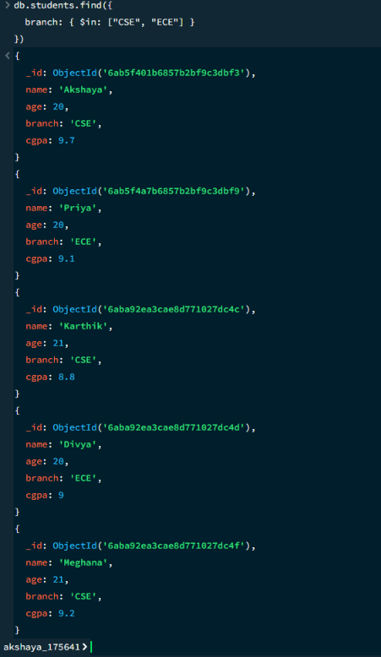
3. ALL Operation : The $all operator was used to find students whose subjects array contains all the specified values.
Command: db.students.find({
subjects: { $all: ["DBMS", "OS"] }
})
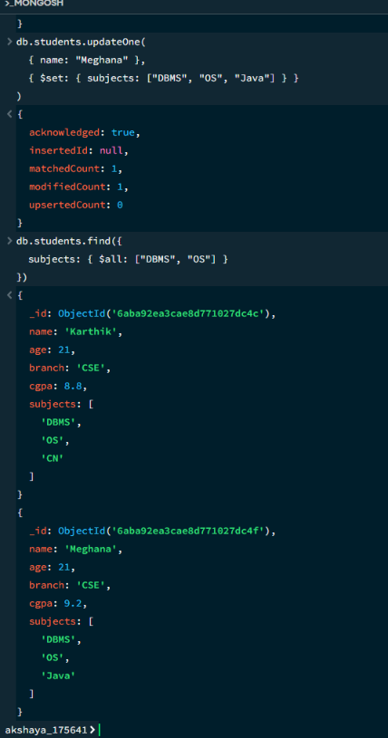
4. EXISTS Operation : The $exists operator was used to find documents where the specified field exists.
Command: db.students.find({
subjects: { $exists: true }
})
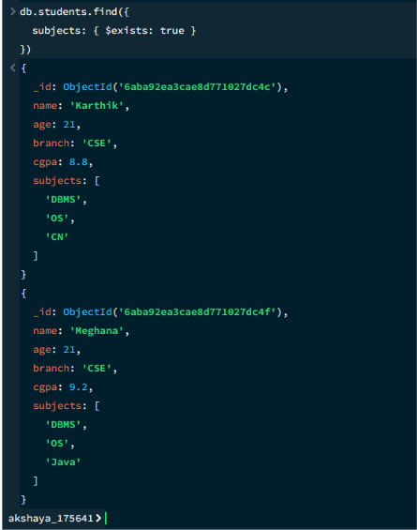
5. GROUP BY Operation : MongoDB aggregation with $group was used to group students according to their course and count the number of students in each course.
Command: db.students.aggregate([
{
$group: {
_id: "$branch",
totalStudents: { $sum: 1 }
}
}
])
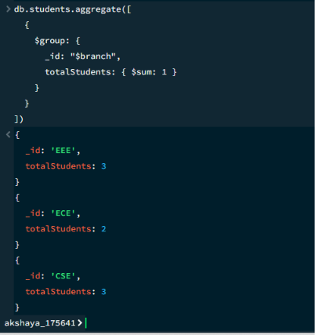
6. HAVING Operation : The $match stage was used after $group to filter grouped results where the number of students is greater than 1.
Command: db.students.aggregate([
{
$group: {
_id: "$branch",
totalStudents: { $sum: 1 }
}
},
{
$match: {
totalStudents: { $gt: 1 }
}
}
])
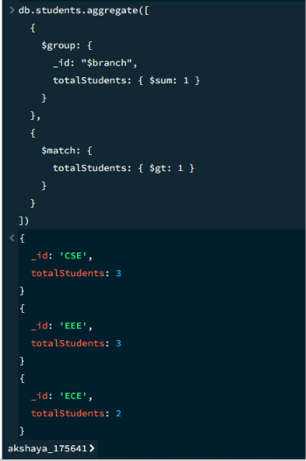
7. COUNT Operation : Used countDocuments() to count the total number of documents in the students collection.
Command: db.students.countDocuments()
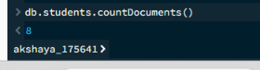

Part – E: Node.js and MongoDB Integration
The MongoDB database was integrated with Node.js using the MongoDB Node.js driver. Express.js was used to perform CRUD operations on the students collection in the akshaya_175641 database.
Node.js Code
const express = require("express");
const { MongoClient } = require("mongodb");
const app = express();
const PORT = 3000;
app.use(express.json());
const uri = "mongodb://127.0.0.1:27017";
const client = new MongoClient(uri);

const dbName = "akshaya_175641";
// GET - Retrieve all students
app.get("/students", async (req, res) => {
try {
await client.connect();
const db = client.db(dbName);
const collection = db.collection("students");
const students = await collection.find({}).toArray();
res.json(students);
} catch (error) {
console.error(error);
res.status(500).send("Error connecting to MongoDB");
}
});
// POST - Add a student
app.post("/students", async (req, res) => {
try {
await client.connect();
const db = client.db(dbName);
const collection = db.collection("students");
const result = await collection.insertOne(req.body);
res.json({
message: "Student added successfully",
insertedId: result.insertedId
});
} catch (error) {
console.error(error);
res.status(500).send("Error adding student");
}
});
// PUT - Update a student
app.put("/students/:name", async (req, res) => {
try {
await client.connect();
const db = client.db(dbName);
const collection = db.collection("students");
const result = await collection.updateOne(
{ name: req.params.name },
{ $set: req.body }
);
if (result.matchedCount === 0) {
return res.status(404).send("Student not found");
}
res.json({
message: "Student updated successfully"
});
} catch (error) {
console.error(error);
res.status(500).send("Error updating student");
}
});
// DELETE - Delete a student
app.delete("/students/:name", async (req, res) => {
try {
await client.connect();
const db = client.db(dbName);
const collection = db.collection("students");
const result = await collection.deleteOne({
name: req.params.name
});
if (result.deletedCount === 0) {
return res.status(404).send("Student not found");
}
res.json({
message: "Student deleted successfully"
});
} catch (error) {
console.error(error);
res.status(500).send("Error deleting student");
}
});
app.listen(PORT, () => {
console.log(`Server running on port ${PORT}`);
});
- GET Operation : The GET operation retrieves all student records from the MongoDB students collection.
Endpoint: GET /students
Output: 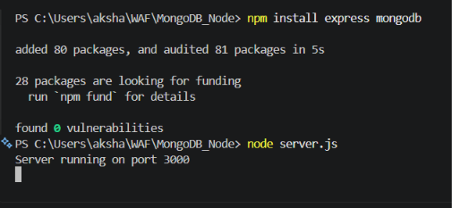
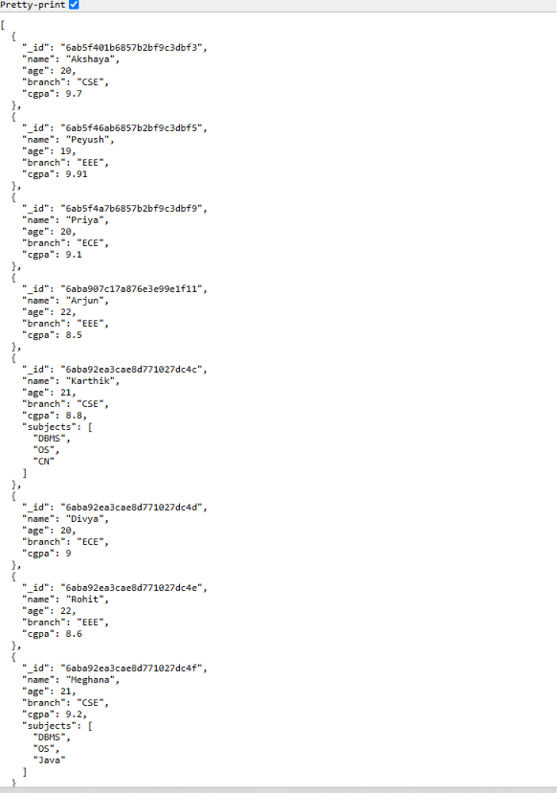
- POST Operation : The POST operation inserts a new student record into the MongoDB students collection.
Endpoint: POST /students
Output: 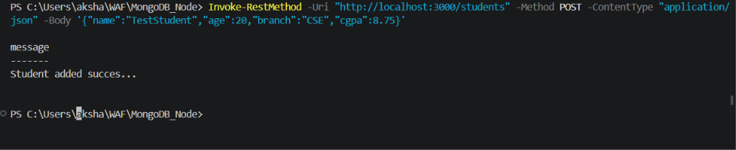 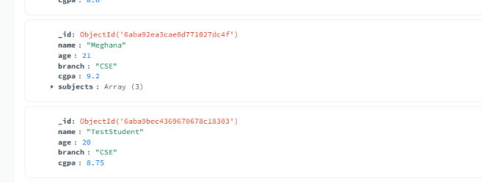
- PUT Operation : The PUT operation updates an existing student record using the student's name.
Endpoint: PUT /students/:name
Output:
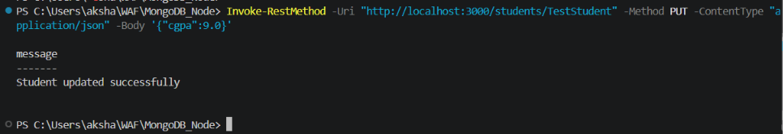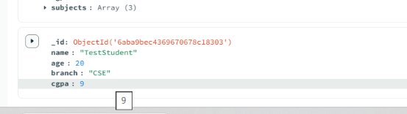
- DELETE Operation : The DELETE operation removes an existing student record using the student's name.
Endpoint: DELETE /students/:name
Output: 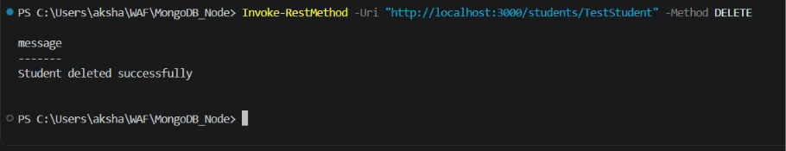 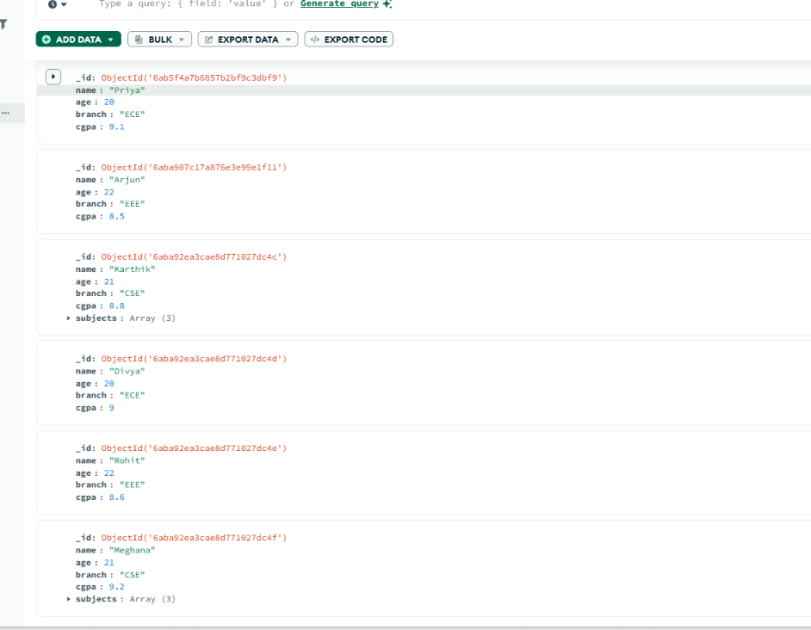

Part – F: React.js Frontend Integration
The React.js frontend was integrated with the Node.js and Express backend to perform CRUD operations on student records stored in MongoDB. The frontend communicates with the backend using HTTP requests.

- GET Operation : The GET operation retrieves all student records from the MongoDB database through the Node.js and Express backend and displays them on the server.js frontend.
Code: const getStudents = async () => {
const response = await fetch("http://localhost:3000/students");
const data = await response.json();
setStudents(data);
};
useEffect(() => {
getStudents();
}, []);
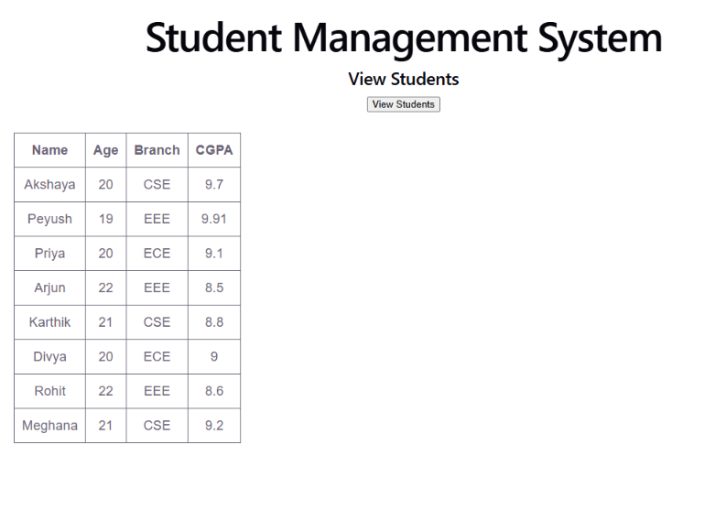
The student records are successfully displayed on the React.js frontend.

2. POST Operation : The POST operation is used to add a new student to the MongoDB database through the React.js frontend.
Code: const addStudent = async () => {
await fetch("http://localhost:3000/students", {
method: "POST",
headers: {
"Content-Type": "application/json"
},
body: JSON.stringify({
name: name,
age: Number(age),
branch: course,
cgpa: Number(cbpa)
})
});
setName("");
setAge("");
setBranch("");
setCgpa("");

};
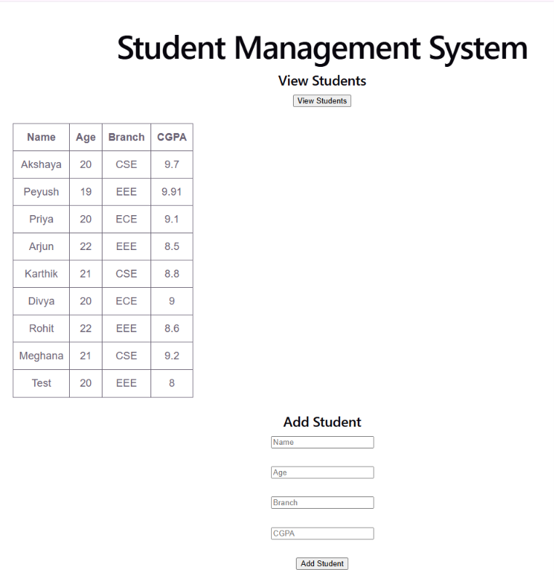
A new student record was successfully added using the React.js frontend.

3. PUT Operation : The PUT operation is used to update the marks of an existing student through the React.js frontend.
Code: const updateStudent = async () => {
if (!updateName || !updateCgpa) {
alert("Please enter student name and new CGPA");
return;
}
try {
const response = await fetch(
`http://localhost:3000/students/${updateName}`,
{
method: "PUT",
headers: {
"Content-Type": "application/json"
},
body: JSON.stringify({
cgpa: Number(updateCgpa)
})
}
);
if (!response.ok) {
alert("Student not found");
return;
}
alert("Student CGPA updated successfully");
setUpdateName("");
setUpdateCgpa("");
getStudents();
} catch (error) {
console.error(error);
alert("Unable to update student");
}
};
Frontend fields: Student Name
New CGPA
Output:
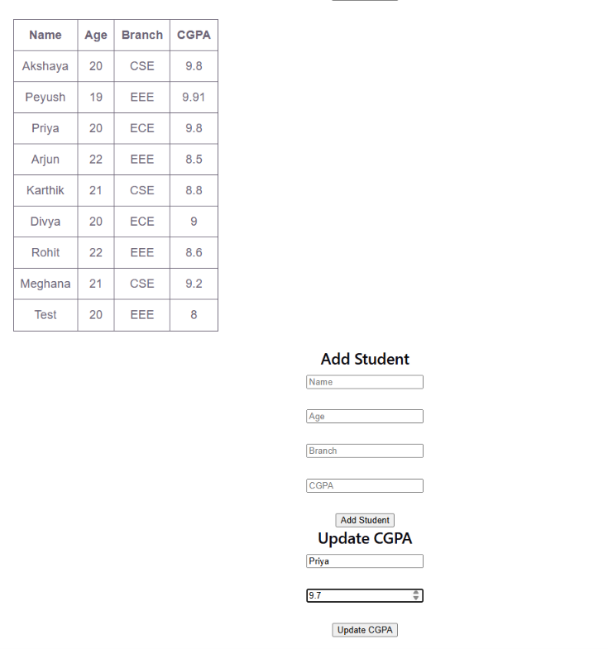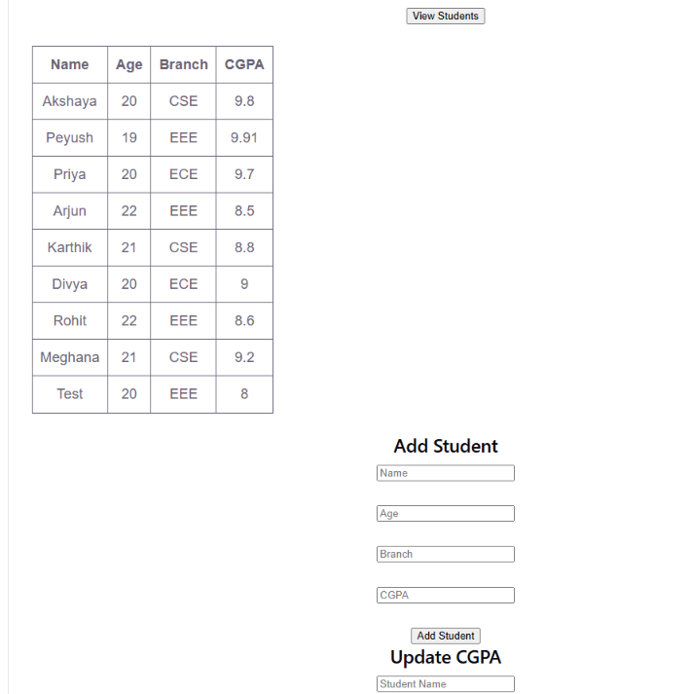
The student's marks were successfully updated using the React.js frontend.

4. DELETE Operation : The DELETE operation is used to remove a student record from MongoDB through the React.js frontend.
Code: const deleteStudent = async (studentName) => {
await fetch(`http://localhost:3000/students/${studentName}`, {
method: "DELETE"
});
getStudents();
};
Delete button code:
<button onClick={() => deleteStudent(student.name)}>
Delete
</button>
Output:

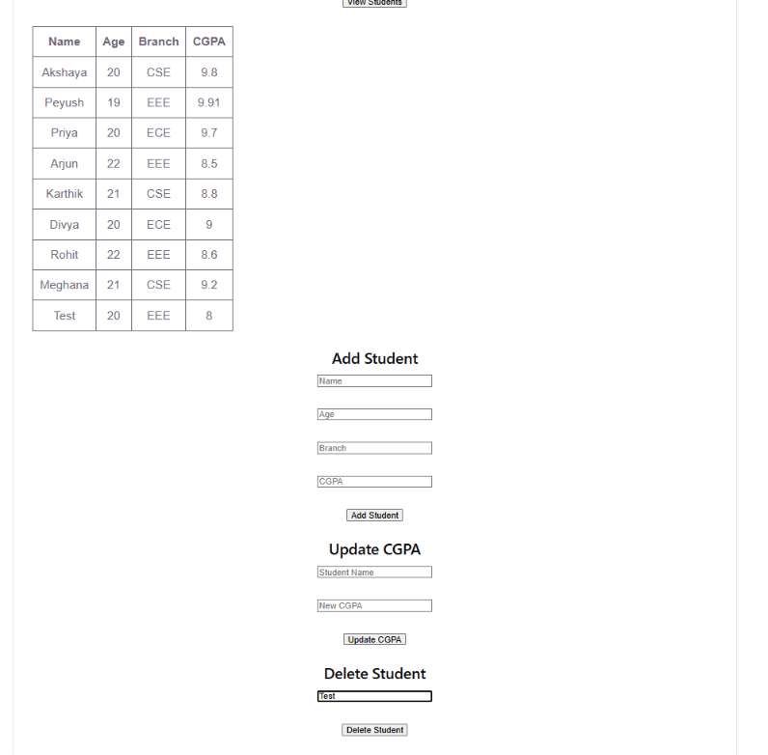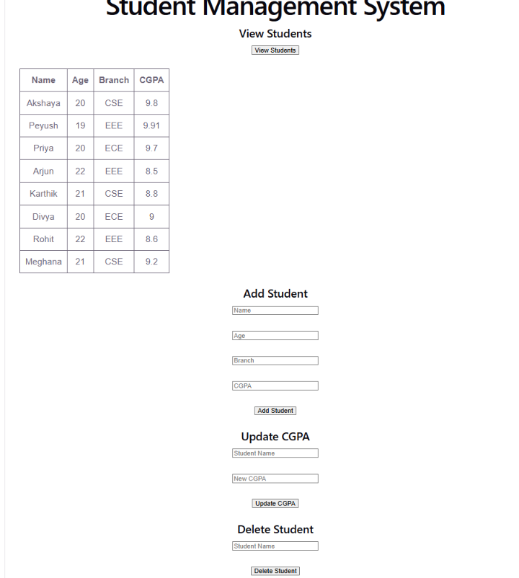
The student record was successfully deleted using the React.js frontend.

