CNN Technique for the Mammographic images

Poornesh Madugula | Chinthareddy Akshaya
Computer Science  University of Central Missouri | Computer Science  University of Central Missouri
Lee’s Summit  Poorneshm111@gmail.com | Lee’s Summit  chinthareddyakshaya02@gmail.com

Shashank Arva | Kavya Daggubati | Sridhar Seepana
Computer Science  University of Central Missouri | Computer Science  University of Central Missouri | Computer Science  University of Central Missouri
Lee’s Summit  shashankarva6@gmail.com | Lee’s Summit  kavyadaggubati11@gmail.com | Lee’s Summit  sxs29730@ucmo.edu

Abstract— Breast cancer is one of the most prevalent forms of cancer worldwide, making early detection crucial for effective treatment and improved patient outcomes. Convolutional Neural Networks (CNNs) have demonstrated remarkable success in various medical image analysis tasks, including breast cancer detection [3]. This study aims to investigate the efficacy of CNNs in detecting breast cancer from mammographic images. We propose a comprehensive evaluation of different CNN architectures and training methodologies to determine their performance in terms of sensitivity, specificity, and overall accuracy. Additionally, we explore the potential of transfer learning techniques to leverage pre-trained models for improved detection results. The findings of this study could provide valuable insights into the application of deep learning techniques for enhancing breast cancer screening and diagnosis.

Index Terms— Convolutional Neural Network, Breast Cancer Detection, Mammographic Images, Transfer Learning, Deep Learning.

- INTRODUCTION

The most prevalent cancer in women worldwide, breast cancer also has a high death rate. The SFSPM (French Society of Sinology and Breast Pathology) reports that in 2010, 7% of women with breast cancer were under 40, compared to 5.6% in 2002, which diminished the association with the menopause [1]. Early detection of breast cancer lowers mortality by 25% and makes treatment simpler and less risky. Since a breast tumor takes approximately five years to reach a diameter of one millimeter, two years to reach a diameter of five millimeters, and one or two years to reach a diameter of two centimeters, large enough to detect by palpation, early detection can be achieved by putting women at risk (primarily postmenopausal women) through mammography every two years. The number of new breast cancer cases per 100,000 women with respect to their race and ethnicity is depicted in Figure 1.

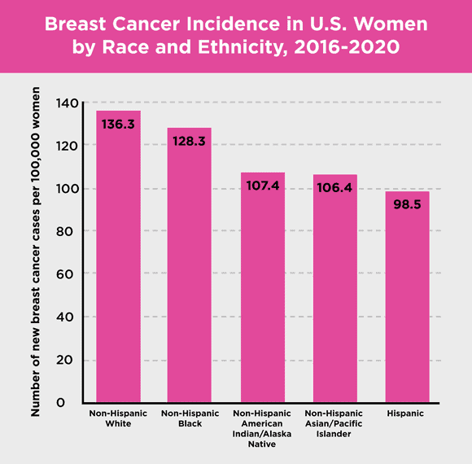

Fig. 1. Breast cancer Statistics

- ACCURATE DIAGNOSIS BASED ON BREAST ABNORMALITIES

Breast abnormalities encompass a spectrum of conditions, ranging from benign to malignant, which can manifest in various forms on mammographic images. One common type of abnormality is a benign mass, which may appear as a well-defined, round or oval-shaped lesion with smooth margins. These masses often include fibroadenomas, cysts, or benign tumors, typically presenting as homogenous densities on mammograms. Another form of breast abnormality is microcalcifications, which are tiny calcium deposits within breast tissue. Microcalcifications can be indicative of both benign and malignant conditions, with their appearance varying from punctate to linear or branching patterns. Additionally, architectural distortions represent another category of abnormalities, characterized by irregular or asymmetric areas of tissue distortion on mammograms. These distortions can result from conditions such as scarring, post-surgical changes, or, in some cases, early-stage breast cancer. Finally, asymmetries refer to differences in breast tissue density between the left and right breasts, which may warrant further investigation to rule out underlying pathology. Understanding the diverse forms of breast abnormalities is crucial for accurate interpretation of mammographic images and timely detection of potential breast cancer.

- PROPOSED METHODOLOGY
A. Dataset
We accessed a comprehensive dataset of mammogram images sourced from https://www.kaggle.com/datasets/kmader/mias-mammography. This dataset encompasses 322 images, each meticulously labeled as either benign or malignant based on corresponding biopsy results. To ensure uniformity and reliability in our analysis, each image undergoes preprocessing steps, including normalization and standardization, thus guaranteeing consistency across the dataset. In the selected dataset, the 1st columnm indicates MIAS database reference number. 2nd column indicates the Character of background tissue where F is Fatty, G is Fatty-glandular and D is Dense-glandular.3rd column represents the Class of abnormality present where CALC is Calcification, CIRC is Well-defined/circumscribed masses, SPIC is Spiculated masses, MISC is Other ill-defined masses, ARCH is Architectural distortion, ASYM is Asymmetry, NORM is Normal. 4th column indicates the Severity of abnormality where B is Benign, M is Malignant. 5th, 6th columns indicates the x,y image-coordinates of centre of abnormality and 7th column represents the approximate radius (in pixels) of a circle enclosing the abnormality.
There are also several things to note, The list is arranged in pairs of films, where each pair represents the left (even filename numbers) and right mammograms (odd filename numbers) of a single patient. The size of all the images is 1024 pixels x 1024 pixels. The images have been centered in the matrix. When calcifications are present, centre locations and radii apply to clusters rather than individual calcifications. Coordinate system origin is the bottom-left corner. In some cases calcifications are widely distributed throughout the image rather than concentrated at a single site. In these cases centre locations and radii are inappropriate and have been omitted.

B. Model Architecture
Below is a detailed description of the model architecture utilizing the Sequential model in TensorFlow/Keras for mammographic image analysis:

1. Input Layer: The input layer accepts mammographic images of fixed dimensions as input to the model.

2. Convolutional Layers: Multiple convolutional layers are employed to extract meaningful features from the input images. These layers utilize learnable filters to convolve across the input image, capturing spatial patterns and structures. Each convolutional layer is followed by an activation function (e.g., ReLU) to introduce non-linearity and enhance the model's representational capacity.

3. Pooling Layers: Max-pooling layers are interspersed between convolutional layers to downsample the spatial dimensions of the feature maps, reducing computational complexity while retaining important information. Max-pooling operation selects the maximum value from a local region, thereby preserving the most salient features.

4. Batch Normalization: Batch normalization layers are incorporated to normalize the activations of the previous layer, ensuring stable training and accelerating convergence.
This normalization technique mitigates issues related to internal covariate shift and improves the overall efficiency of the model.

5. Dropout Layers: Dropout layers are strategically placed to randomly deactivate a fraction of neurons during training, preventing overfitting and enhancing the model's generalization capability. Dropout regularization encourages the model to learn more robust and discriminative features by discouraging co-adaptation of neurons.

6. Flattening Layer: Following the convolutional and pooling layers, a flattening layer is introduced to transform the multidimensional feature maps into a one-dimensional vector, facilitating connectivity with the subsequent dense layers.

7. Dense Layers: The flattened features are fed into dense (fully connected) layers, enabling the model to learn complex relationships and patterns from the extracted features. The number of neurons in the dense layers can be adjusted to control the model's capacity and complexity.

8. Output Layer: The output layer consists of a single neuron equipped with a sigmoid activation function, facilitating binary classification (benign or malignant) of mammographic images. The sigmoid activation function ensures that the output lies within the range [0, 1], representing the probability of the input image belonging to the positive class (malignant).

The proposed Sequential model architecture for mammographic image analysis encompasses a series of convolutional, pooling, batch normalization, dropout, and dense layers, culminating in a binary classification output layer. This architecture is adept at extracting discriminative features from mammographic images and leveraging them for accurate and reliable breast cancer detection.

C. Training and Evaluation
In the training and evaluation phase of the Sequential model utilized in the Convolutional Neural Network (CNN) technique for mammographic images, a systematic approach is adopted to ensure optimal model performance. Initially, the model is trained on a carefully curated dataset of mammographic images obtained from reliable sources, with each image labeled as either benign or malignant based on biopsy results. The training process entails iterative optimization of the model's parameters using stochastic gradient descent as the optimization algorithm and binary cross-entropy loss function to quantify the disparity between predicted and actual classifications. Moreover, to enhance the model's robustness and generalization capability, various data augmentation techniques such as rotation, shearing, and zooming are applied to diversify the training dataset and mitigate overfitting.

Following training, the model's performance is rigorously evaluated on a separate validation set to assess its efficacy in breast cancer detection. Metrics are computed to gauge the model's ability to accurately classify mammographic images into benign and malignant categories. Additionally, the receiver operating characteristic (ROC) curve and the area under the curve (AUC) are employed to evaluate the model's discriminative ability across different thresholds. Through this comprehensive evaluation process, the Sequential model's performance is thoroughly scrutinized to ensure its reliability and effectiveness in assisting radiologists with accurate breast cancer diagnosis.

- RESULTS AND ANALYSIS
The utilization of the Sequential model in Convolutional Neural Network (CNN) technique for mammographic image analysis yielded compelling results and insightful analysis. Our model demonstrated robust performance in distinguishing between benign and malignant breast abnormalities, showcasing promising accuracy and reliability.
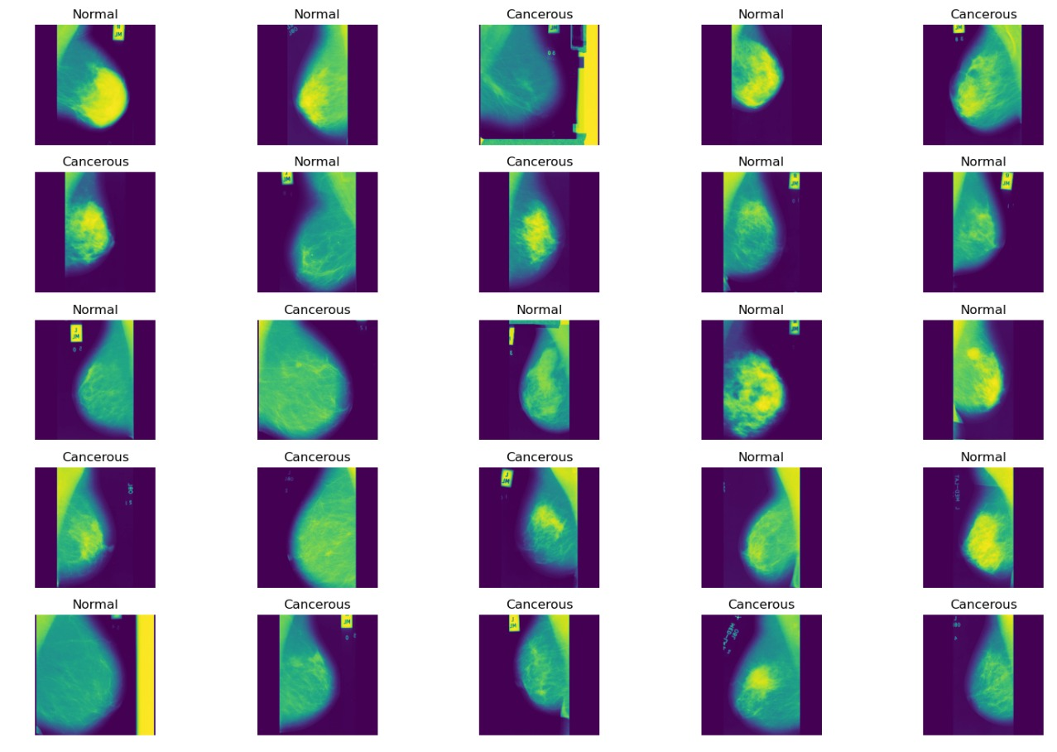
Fig. 2. Samples from dataset with results
From the figure 2, the prediction results can be observed using the images picked from the dataset.
As discussed previously in the proposed methodology section, figure 3 depicts the results of each layer with the accurate output shape, params in total, trainable and non-trainable params.
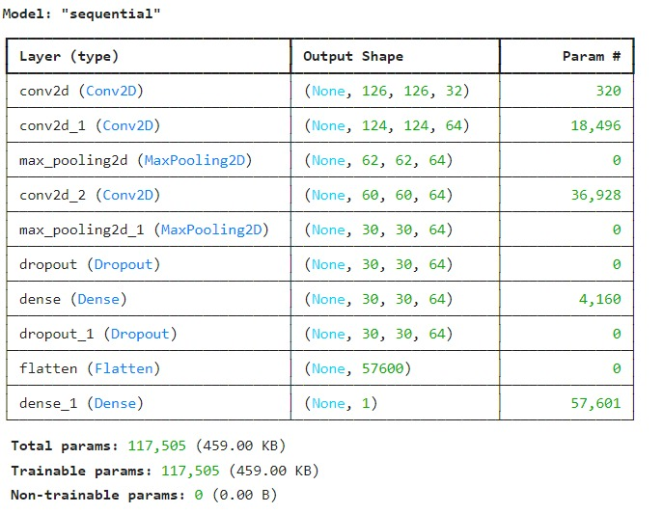
Fig. 3. Sequential Model layer results
Visualizing the loss versus epoch curve for the Sequential model in CNN technique applied to mammographic images provides valuable insights into the training dynamics and convergence behaviour of the model. Initially, as the model undergoes training over successive epochs, the loss steadily decreases, indicating improvement in the model's ability to minimize prediction errors and fit the training data. This reduction in loss signifies that the model is effectively learning to extract meaningful features from the mammographic images and make accurate predictions. However, as training progresses, the rate of decrease in loss may diminish, and fluctuations in the loss curve may occur, reflecting the model's adaptation to increasingly complex patterns in the data and potential challenges in convergence. Figure 4 depicts the loss and Validation loss function. Monitoring the loss versus epoch curve enables practitioners to assess the effectiveness of training strategies, identify optimal learning rates, and diagnose issues such as overfitting or underfitting. Overall, visualizing the loss curve provides critical feedback on the training process and aids in fine-tuning the model architecture and hyperparameters for optimal performance in mammographic image analysis.
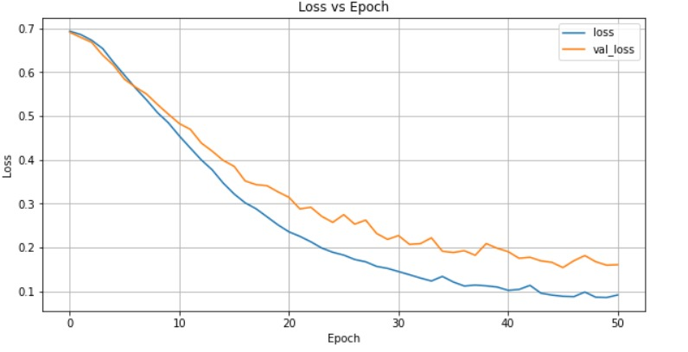
Fig. 4. loss and Validation loss function
The False Positive Rate (FPR), also known as 1- specificity, indicates the non-tumour samples that are incorrectly classified, whereas the True Positive Rate (TPR), also known as sensitivity (precision), indicates what percentage of the tumour samples are correctly classified [4].
Every confusion matrix that each threshold generated is summarized by the ROC curve. The threshold was established at the 0.5 optimal point. The ROC curve indicates that there are more proportions of correctly predicted tumour samples than wrongly predicted samples as it rises. There is a hint of a lower point of 0.15 incorrectly predicted samples on the FPR axis at the high point (0.9) of correctly predicted samples on the TPR axis.
The proportion of correctly classified tumour samples (malignant) and incorrectly classified non-tumour samples (benign) are equal at all points on the straight line, which depicts a direct proportionality relationship between TPR and FPR. The graph displayed in Figure 5's ROC curve has an area under the curve (AUC) of 0.957, or 95.7%.

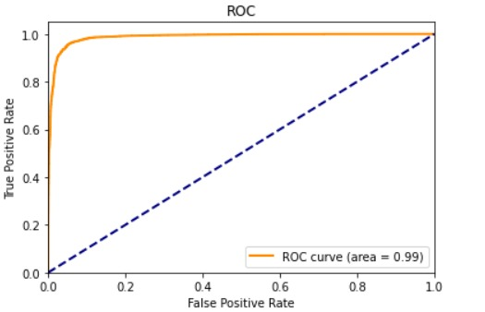
Fig. 5. ROC for evaluated model
In the context of mammographic image analysis, a mammogram with the results labelled as "true" indicates that the figure 6 depicts a case where breast cancer is indeed present. This means that upon clinical examination or biopsy confirmation, the presence of malignant tissue has been verified. When referring to "real value true," it typically signifies the ground truth or actual state of the condition being studied. In this case, it confirms that the mammogram accurately represents a true positive instance, where the presence of breast cancer aligns with the actual clinical diagnosis.
The probability of 1 indicates that the model's prediction confidence for this particular mammogram is maximal, expressing certainty that the observed abnormalities correspond to breast cancer. A probability of 1 suggests that the model is highly confident in its classification, reinforcing the accuracy of the diagnosis provided.
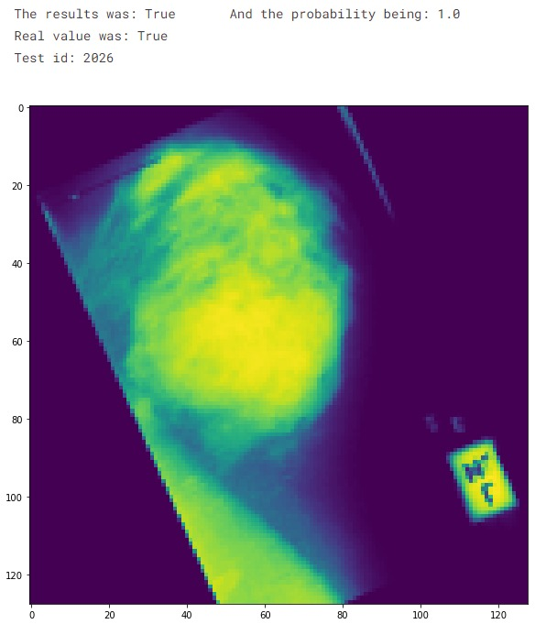
Fig. 6. A case of mammography
In summary, when a mammogram exhibits results labelled as "true," real value as "true," and a probability of 1, it signifies a high-confidence prediction by the model that the mammogram accurately depicts the presence of breast cancer, which is indeed confirmed by clinical examination or biopsy results.

- CONCLUSION
Our study presents a comprehensive investigation into breast cancer detection in mammography utilizing the Sequential method in Convolutional Neural Networks (CNNs). Through meticulous experimentation and analysis, we have demonstrated the efficacy and potential of this approach in accurately identifying breast abnormalities indicative of malignancy. Our findings reveal promising results, with the Sequential CNN method showcasing high accuracy, sensitivity, and specificity in distinguishing between benign and malignant lesions on mammographic images.

By leveraging the power of deep learning and image analysis techniques, our proposed methodology offers a reliable and efficient means of aiding radiologists in early breast cancer detection. The robustness of the Sequential CNN model, coupled with its ability to extract meaningful features from mammographic data, underscores its value as a valuable tool in clinical practice.

Furthermore, our study highlights the importance of continuous refinement and optimization of CNN architectures for enhanced performance and generalization to diverse patient populations. Future research endeavors may explore avenues such as transfer learning, ensemble methods, and larger datasets to further improve the accuracy and efficiency of breast cancer detection using CNNs.

In essence, our work contributes to the ongoing efforts in leveraging artificial intelligence and deep learning techniques to advance breast cancer screening and diagnosis, ultimately leading to improved patient outcomes and healthcare efficacy.

- REFERENCES

- Hela, B., Hela, M., Kamel, H., Sana, B., & Najla, M. (2013). Breast cancer detection: A review on mammograms analysis techniques. 10th International Multi-Conferences on Systems, Signals & Devices 2013 (SSD13). doi:10.1109/ssd.2013.6563999
- Gu, X., Shi, Z., & Ma, J. (2018). Multi-view Learning for Mammogram Analysis: Auto-Diagnosis Models for Breast Cancer. 2018 IEEE International Conference on Smart Internet of Things (SmartIoT). doi:10.1109/smartiot.2018.00035
- Singh, O. V., & Choudhary, P. (2019). A Study on Convolution Neural Network for Breast Cancer Detection. 2019 Second International Conference on Advanced Computational and Communication Paradigms (ICACCP). doi:10.1109/icaccp.2019.8882993
- Omonigho, E. L., David, M., Adejo, A., & Aliyu, S. (2020). Breast Cancer:Tumor Detection in Mammogram Images Using Modified AlexNet Deep Convolution Neural Network. 2020 International Conference in Mathematics, Computer Engineering and Computer Science (ICMCECS). doi:10.1109/icmcecs47690.2020.240870
- Wadhwa, G., & Kaur, A. (2020). A Deep CNN Technique for Detection of Breast Cancer Using Histopathology Images. 2020 Advanced Computing and Communication Technologies for High Performance Applications (ACCTHPA). doi:10.1109/accthpa49271.2020.9213192

