Assignment 1:



Assignment 2:

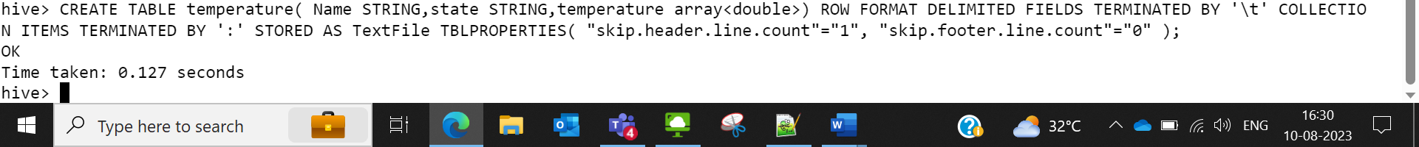

Assignment3:

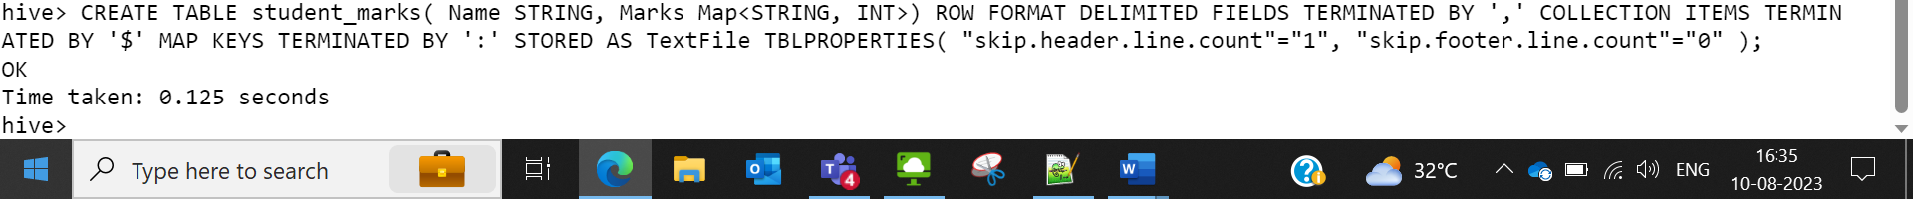



Assignment 4:





