**Week11:exceptions**

1. Write a Python script that asks the user to enter a number within a specified range (e.g., 1 to 100). Handle exceptions for invalid inputs and out-of-range numbers.

**PROGRAM:**

try:

a=input()

if(int(a)>0 and int(a)<101):

print("Valid input.")

else:

print("Error: Number out of allowed range")

except:

print("Error: invalid literal for int()")

**OUTPUT:**

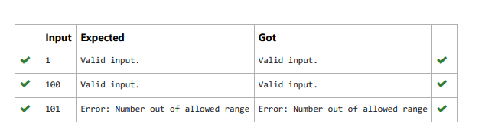

2. Write a Python program that performs division and modulo operations on two numbers provided by the user. Handle division by zero and non-numeric inputs.

**PROGRAM:**

a = input()

b = input()

try:

a = int(a)

b = int(b)

divide = a / b

modulo = a % b

print("Division result:", divide)

print("Modulo result:", modulo)

except ZeroDivisionError:

print("Error: Cannot divide or modulo by zero.")

except ValueError:

print("Error: Non-numeric input provided.")print(a,type(a),sep=",")

print(c,type(b),sep=",")

**OUTPUT:**

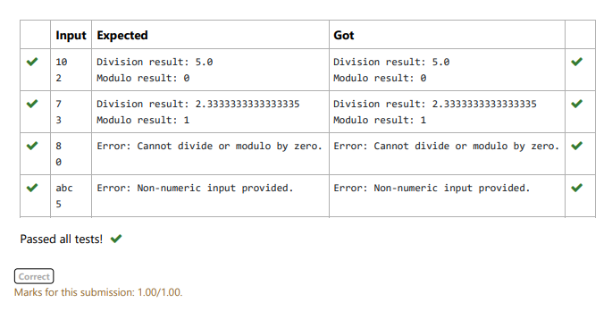

3. Write a Python program that asks the user for their age and prints a message based on the age. Ensure that the program handles cases

where the input is not a valid integer.

**PROGRAM:**

try:

a = input()

if int(a)>=0:

print("You are", a, "years old.")

else:

print("Error: Please enter a valid age.")

except:

print("Error: Please enter a valid age.")

**OUTPUT**

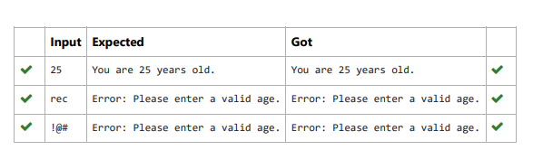

4. Write a Python program that asks the user for their age and prints a message based on the age. Ensure that the program handles cases where the input is not a valid integer.

**PROGRAM:**

try:

a = input()

if int(a)>=0:

print("You are", a, "years old.")

else:

print("Error: Please enter a valid age.")

except:

print("Error: Please enter a valid age.")

**OUTPUT**

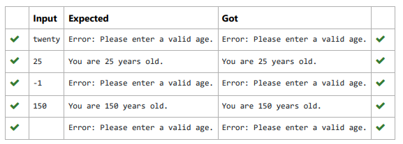

5. Develop a Python program that safely performs division between two numbers provided by the user. Handle exceptions like division by zero and non-numeric inputs.

**PROGRAM:**

def safe_division():

try:

numerator = float(input())

denominator = float(input())

result = numerator / denominator

print(result)

except ZeroDivisionError:

print("Error: Cannot divide or modulo by zero.")

except ValueError:

print("Error: Non-numeric input provided.")

safe_division()

**OUTPUT**

