ASSIGNMENT -1

LINUX-->a free and open-source operating system based on Unix.

-->In simple terms, the brain of a computer helps to run programs.

manage files, and control devices like keyboard and mouse

--> It gives us control through commands or a graphical interface.

adv:

1. free & open source - anyone can use, view, and modify the code.

2. multi-user - multiple users can work at the same time.

3. multitasking - can run multiple tasks/programs at once.

4. secure - very secure and used in banks, servers, etc.

5. portable - works on desktops - Ubuntu, Fedora

phones- based on Linux

servers- Google, Facebook

supercomputers- IoT devices, drones.

==================================================================================

HISTORY:

1969 – The UNIX operating system was created. It was powerful but expensive.

1983 – GNU Project began to make a free version of UNIX, but it didn’t have

a working kernel (the heart of an OS).

1991 – A student named Linus Torvalds from Finland created his kernel called

Linux and shared it for free.

Linux + GNU tools = Fully free OS

==================================================================================

ARCHITECTURE:

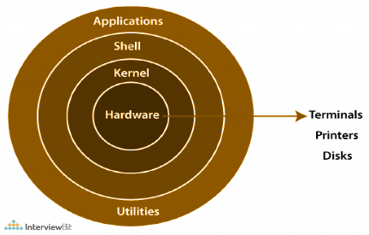

Applications (UI)

|

Shell (Bash, etc.)

|

Utilities & Commands

|

Kernel (core of OS)

|

Hardware (CPU, RAM)

-->Hardware – Actual physical device.

-->Kernel – Brain of Linux, Manages CPU, memory, devices.

-->System Calls / Shell – Interface between user and kernel (like Bash).

-->Utilities/Commands – Tools like ls, mkdir, etc.

-->Applications – Software like browsers, editors, etc.

==================================================================================

LINUX FILE SYSTEM:

/ Root Starting point of everything

/home Users’ personal files Like "My Documents"

/etc Settings System configuration files

/bin Basic programs Commands like ls, cp, mkdir

/usr User programs Installed software

/var Variable data Logs, mails, updates

/tmp Temporary files Auto-deleted later

/dev Devices Keyboard, USB, Hard disk

/proc Process info Info about running programs

/root Root user’s folder Admin’s personal space

/lib Libraries Helpers for programs to run

/boot Boot files Help Linux start

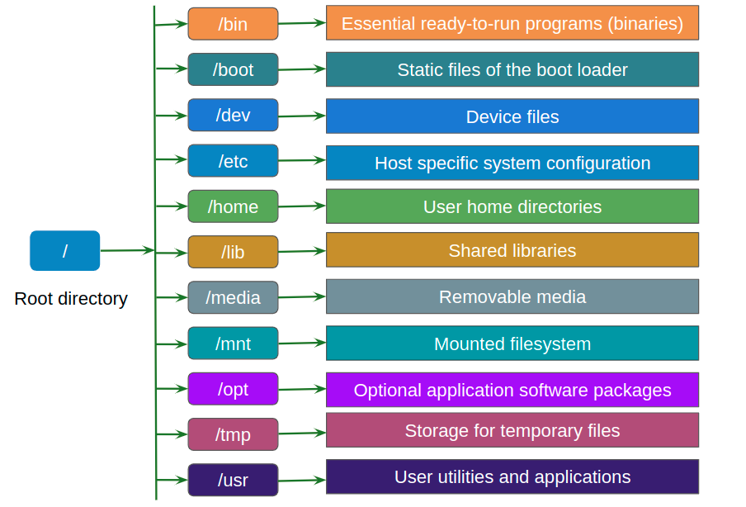

==================================================================================

CMDS:

pwd Show current directory pwd → /home/user

ls List files and folders ls

cd Change directory cd /home/user/Documents

mkdir Make new folder mkdir myfolder

rmdir Remove empty folder rmdir oldfolder

touch Create empty file touch file.txt

rm Delete file/folder rm file.txt

cp Copy file or folder cp file1.txt file2.txt

mv Move or rename file mv file.txt folder/ or mv old.txt new.txt

cat Show file content cat notes.txt

echo Print text echo "Hello World"

clear Clear terminal screen clear

history Show command history history

man Help/manual for command’s man ls

nano Text editor (easy) nano file.txt

vi Advanced text editor vi file.txt

chmod Change permissions chmod 755 script.sh

chown Change file owner chown user: group file.txt

df Show disk space df -h

du Show folder size du -sh folder/

free Show memory info free -h

top View running processes top

kill Stop a process kill 1234 (PID)

ping Check internet/network ping google.com

sudo Run as admin sudo apt update