**Vue_JS_Lab 1:**

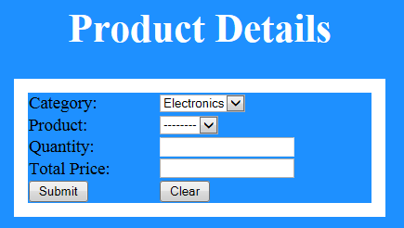

Figure 20: Lab 8.2 Product Details

Data should be prepopulated in category list box (Electronics, Grocery). Based on selection of category, product list need to be populated automatically with values as given in the below table. Also Total price need to be calculated for the entered quantity as per the data in the below table. Total price field should be non-editable field.

|  |  |  |
| --- | --- | --- |
| Category | Product | Price per quantity in Rupees |
| Electronics | Television | 20000 |
| Laptop | 30000 |
| Phone | 10000 |
| Grocery | Soap | 40 |
| Powder | 90 |

While clicking on submit button, if all the text fields contains valid values then display the filled details in a popup window.