Technical Design Document (TDD)

Project: CI/CD Pipeline Health Dashboard

Prepared for: Engineering / DevOps Team

Version: 1.1 (with diagrams)

Date: [Insert Date]

# 1. Introduction

This document defines the technical design of the CI/CD Pipeline Health Dashboard. It includes architecture diagrams, data flow, and database schema (ERD).

# 2. High-Level Architecture

The architecture consists of frontend, backend, database, and external integrations.

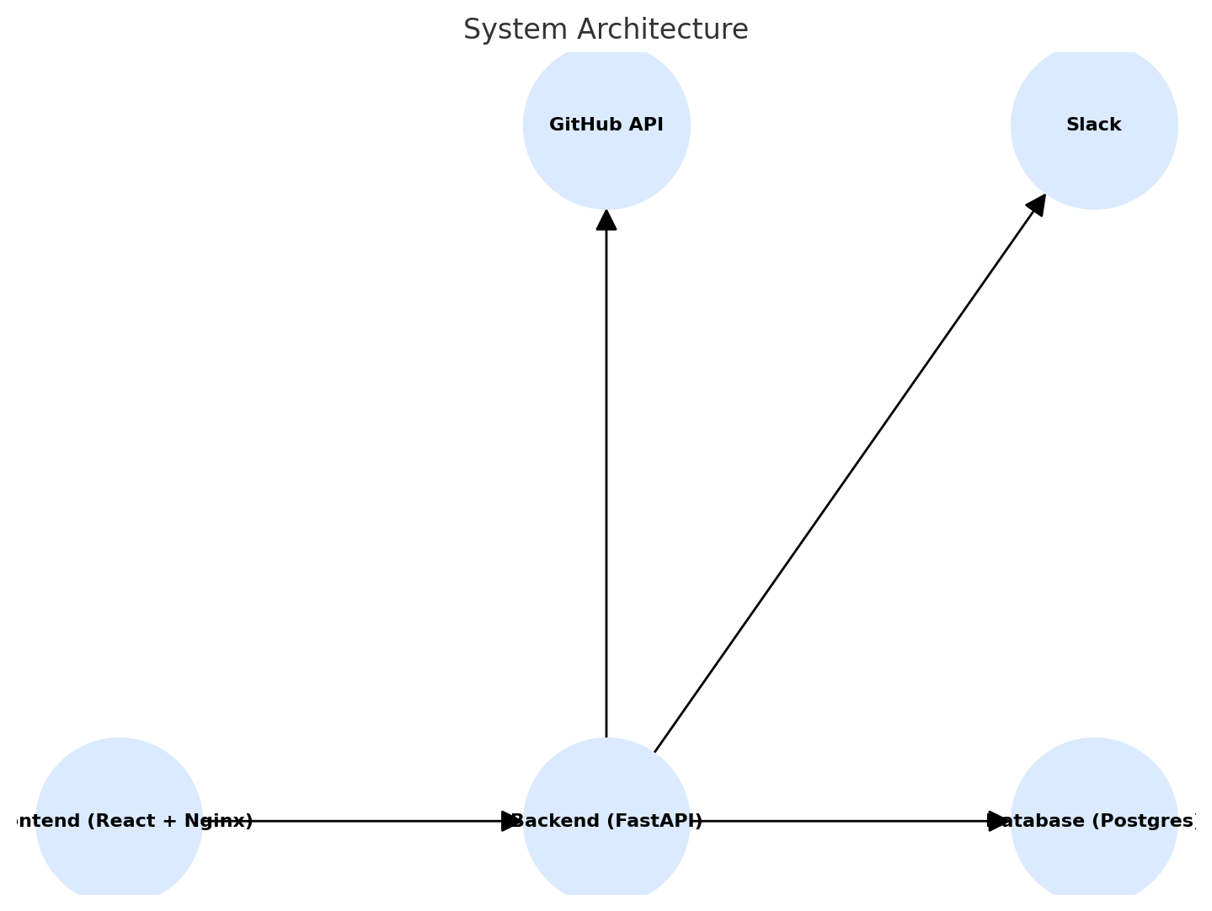

# 3. Data Flow

This diagram shows how data flows through the system.

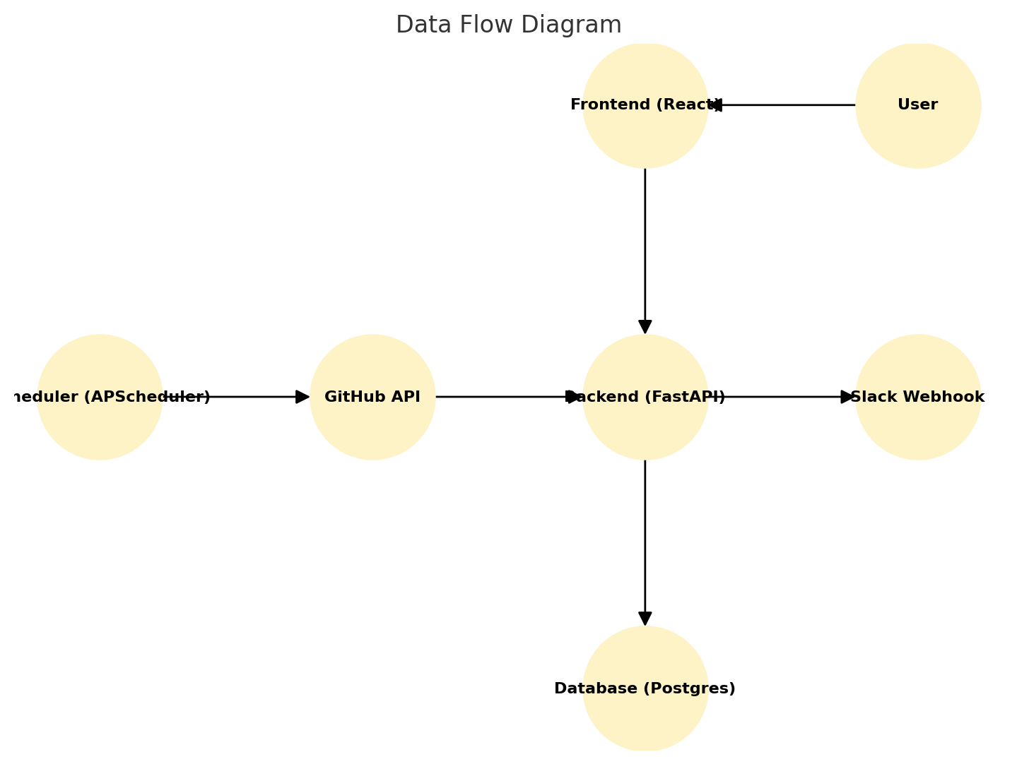

# 4. Database Schema (ERD)

The ERD illustrates relationships between repos, runs, jobs, steps, logs, and alerts.

