Assignment-1

Name : Akshaya Subramanian

Date : 02/05/2021

USN : 1JT18IS007

Github : https://github.com/Akshayajitwta/Webtech/tree/main/Akshaya_Program1

Program – 1: Write a JavaScript to design a simple calculator to perform the following operations : sum, product, difference and quotient.

<!DOCTYPE html>

<html lang="en" dir="ltr">

<head>

<meta charset="utf-8">

<title>Experiment-1</title>

<style type="text/css">

table,td,th {

border: 2px solid;

text-align: center;

background-color: grey;

margin: auto;

}

input{

text-align: center;

}

</style>

<script type="text/javascript">

function calc() {

var v1 = parseFloat(document.getElementsById("value1").value);

var v2 = parseFloat(document.getElementsById("value2").value);

if (isNaN(v1)||isNaN(v2))

alert("Please enter a valid number:");

else if (clicked_id=="add")

document.getElementById("amswer").value = v1+v2;

else if (clicked_id=="sub")

document.getElementById("answer").value = v1-v2;

else if (clicked_id=="mul")

document.getElementById("answer").value = v1*v2;

else if (clicked_id=="div"){

if (v2==0) {

alert("Please enter a non zero denominator");

location.reload();

}

else

document.getElementById("answer").value = v1/v2;

}

}

function cls() {

value1.value="0";

value2.value="0";

answer.value="";

}

</script>

</head>

<body>

<table>

<tr>

<th colspan="4">Simple Calculator</th>

</tr>

<tr>

<td>Enter Operand-1</td>

<td><input type="text" id="value1" value="0"/></td>

<td>Enter Operand-2</td>

<td><input type="text" id="value2" value="0"/></td>

</tr>

<tr>

<td><input type="button" value="Addition" id="add" onclick="calc(this.id)"/></td>

<td><input type="button" value="Subtraction" id="sub" onclick="calc(this.id)"/></td>

<td><input type="button" value="Multiplication" id="mul" onclick="calc(this.id)"/></td>

<td><input type="button" value="Division" id="div" onclick="calc(this.id)"/></td>

</tr>

<tr>

<td>Result: </td>

<td><input type="text" id="answer" value="" disabled/></td>

<td><input type="button" value="Clear All" id="cls" onclick="cls(this.id)"/></td>

</tr>

</table>

</body>

</html>

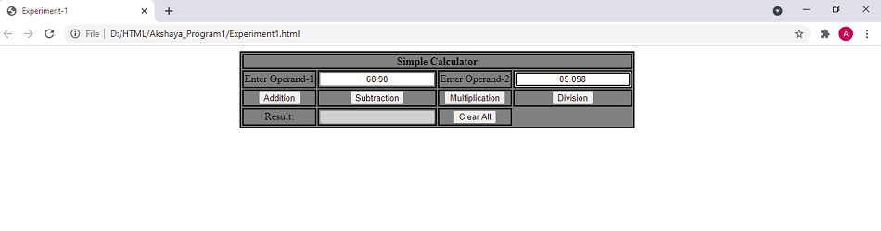

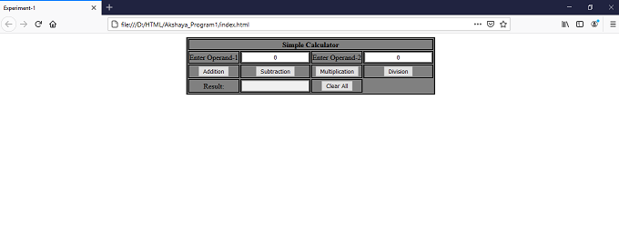

|  |  |  |  |  |
| --- | --- | --- | --- | --- |
| *TEST*  *NO.* | *INPUT*  *PARAMETERS* | *EXPECTED*  *OUTPUT* | *OBTAINED*  *OUTPUT* | *REMARKS* |
| 1. | VALUE 1: 46.065  VALUE 2: 5.55 | ADDITION:  51.614999999999995  SUBTRACTION:  40.515  MULTIPLICATION:  255.66074999999998  DIVISION:  8.3 | ADDITION:  51.614999999999995  SUBTRACTION:  40.515  MULTIPLICATION:  255.66074999999998  DIVISION:  8.3 | PASS |
| 2. | VALUE 1: 0  VALUE 2: 5 | ADDITION:  5  SUBTRACTION:  -5  MULTIPLICATION:  0  DIVISION:  0 | ADDITION:  5  SUBTRACTION:  -5  MULTIPLICATION:  0  DIVISION:  0 | PASS |
| 3. | VALUE 1: 100  VALUE 2:-615 | ADDITION:  -515  SUBTRACTION:  715  MULTIPLICATION:  -61500  DIVISION:  -0.16260162601626016 | ADDITION:  -515  SUBTRACTION:  715  MULTIPLICATION:  -61500  DIVISION:  -0.16260162601626016 | PASS |
| 4. | VALUE 1: 5  VALUE 2: 0 | ADDITION:  5  SUBTRACTION:  5  MULTIPLICATION:  0  DIVISION:  ENTER VALID NUMBER | ADDITION:  5  SUBTRACTION:  5  MULTIPLICATION:  0  DIVISION:  ENTER VALID NUMBER | PASS |
| 5. | VALUE 1: 46  VALUE 2: abc | ENTER VALID NUMBER | ENTER VALID NUMBER | PASS |

Challenge

The challenge consists of 3

files index.html, style.css,

script.js

**HTML code:**

<h2 style="padding-top:100px;"> A Simple Calculator Program</h2>

<table>

<tr>

<td colspan="4" style="height:30px; width:60px"><input type="text" id="result"/></td>

<!-- clr() function will call clr to clear all value -->

</tr>

<tr>

<!-- create button and assign value to each button -->

<!-- dis("1") will call function dis to display value -->

<td><input type="button" value="1" onclick="dis('1')"/> </td>

<td><input type="button" value="2" onclick="dis('2')"/> </td>

<td><input type="button" value="3" onclick="dis('3')"/> </td>

<td><input type="button" value="/" onclick="dis('/')"/> </td>

</tr>

<tr>

<td><input type="button" value="4" onclick="dis('4')"/> </td>

<td><input type="button" value="5" onclick="dis('5')"/> </td>

<td><input type="button" value="6" onclick="dis('6')"/> </td>

<td><input type="button" value="-" onclick="dis('-')"/> </td>

</tr>

<tr>

<td><input type="button" value="7" onclick="dis('7')"/> </td>

<td><input type="button" value="8" onclick="dis('8')"/> </td>

<td><input type="button" value="9" onclick="dis('9')"/> </td>

<td><input type="button" value="+" onclick="dis('+')"/> </td>

</tr>

<tr>

<td><input type="button" value="C" onclick="clr()"/> </td>

<td><input type="button" value="0" onclick="dis('0')"/> </td>

<!-- solve function call function solve to evaluate value -->

<td><input type="button" value="=" onclick="solve()"/> </td>

<td><input type="button" value="*" onclick="dis('*')"/> </td>

</tr>

</table>

**CSS code:**

*{

margin : 0;

padding : 0;

text-align: center;

}

input[type="button"]

{

padding : 5;

background-color: grey;

color: black;

border: solid black 2px;

width: 50;

height: 50;

align: center;

}

input[type="text"]

{

background-color: white;

border: solid black 2px;

width:100%;

text-align: center;

}

table{

padding-top:100px;

padding-left:570px

}

**JavaScript :**

//function that display value

function dis(val)

{

document.getElementById("result").value+=val

}

//function that evaluates the digit and return result

function solve()

{

let x = document.getElementById("result").value

let y = eval(x)

document.getElementById("result").value = y

}

//function that clear the display

function clr()

{

document.getElementById("result").value = ""

}

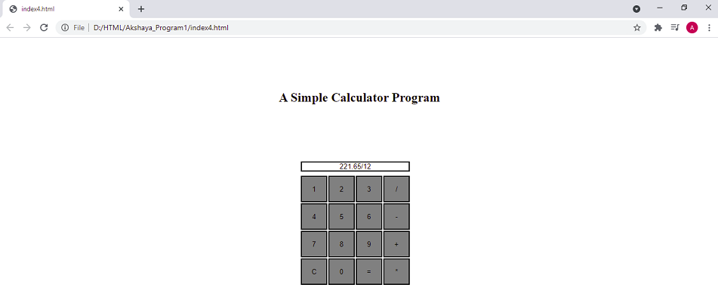

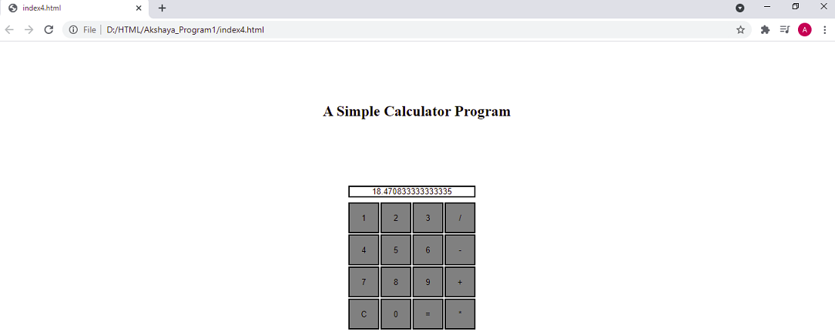

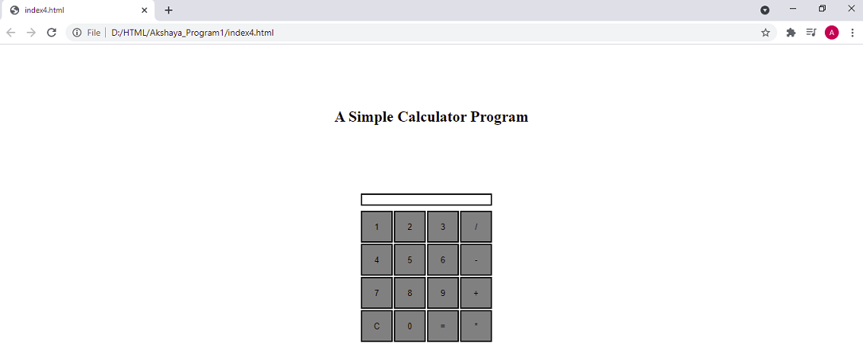

|  |  |  |  |  |
| --- | --- | --- | --- | --- |
| *TEST*  *NO.* | *INPUT*  *PARAMETERS* | *EXPECTED*  *OUTPUT* | *OBTAINED*  *OUTPUT* | *REMARKS* |
| 1. | VALUE 1: 46.065  VALUE 2: 5.55 | ADDITION:  51.614999999999995  SUBTRACTION:  40.515  MULTIPLICATION:  255.66074999999998  DIVISION:  8.3 | ADDITION:  51.614999999999995  SUBTRACTION:  40.515  MULTIPLICATION:  255.66074999999998  DIVISION:  8.3 | PASS |
| 2. | VALUE 1: 0  VALUE 2: 5 | ADDITION:  5  SUBTRACTION:  -5  MULTIPLICATION:  0  DIVISION:  0 | ADDITION:  5  SUBTRACTION:  -5  MULTIPLICATION:  0  DIVISION:  0 | PASS |
| 3. | VALUE 1: 100  VALUE 2:-615 | ADDITION:  -515  SUBTRACTION:  715  MULTIPLICATION:  -61500  DIVISION:  -0.16260162601626016 | ADDITION:  -515  SUBTRACTION:  715  MULTIPLICATION:  -61500  DIVISION:  -0.16260162601626016 | PASS |
| 4. | VALUE 1: 5  VALUE 2: 0 | ADDITION:  5  SUBTRACTION:  5  MULTIPLICATION:  0  DIVISION:  ENTER VALID NUMBER | ADDITION:  5  SUBTRACTION:  5  MULTIPLICATION:  0  DIVISION:  ENTER VALID NUMBER | PASS |
| 5. | VALUE 1: 46  VALUE 2: abc | ENTER VALID NUMBER | ENTER VALID NUMBER | PASS |