Assignment-2

Name : Akshaya Subramanian

USN : 1JT18IS007

Date : 05 May 2021

Github : https://github.com/Akshayajitwta/Webtech

**Program – 2 : Write a JavaScript that calculates the squares and cubes from 0 to 10 and outputs HTML text that displays the resulting values in an HTML table format.**

<!DOCTYPE html>

<html>

<head>

<title>Squares and Cubes</title>

</head>

<body>

<table border="1" align="center">

<tr>

<td>Number</td>

<td>SQUARE</td>

<td>CUBES</td>

</tr>

<script type="text/javascript">

for(var i=0;i<=10;i++)

{

document.write("<tr align='center'><td>" + i + "</td><td>" + i*i +"</td><td>" + i*i*i + "</td></tr>")

}

</script>

</table>

</body>

</html>

**Output :**

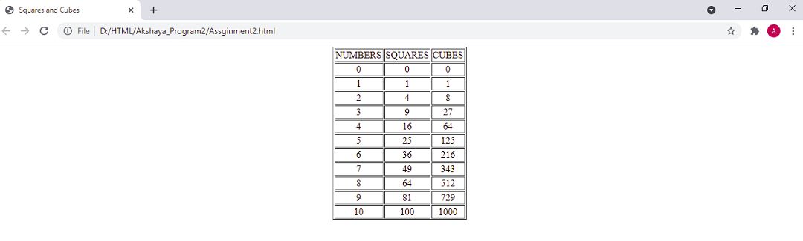

Challenge

1. Change the look of the output to challenge.html
2. Blinking of text in the output.
3. Test Cases.

**Code (**For numbers between 0 and 10**) :**

<!DOCTYPE html>

<html lang="en" dir="ltr">

<head>

<style media="screen">

table,th,td{

width: 500px;

padding: 10px;

text-align: center;

border: 1px sloid black;

border-collapse: collapse;

}

table{

background-color: lightseagreen;

}

#blink{

font-size: 20px;

font-style: oblique;

font-weight: bold;

color: deeppink;

transition: 0.7s;

text-align: center;

}

</style>

<meta charset="utf-8">

<title>Squares and Cubes</title>

</head>

<body>

<table border="1" align="center">

<tr>

<th colspan="3"><b>Numbers from 0 to 10 with their Squares and </br>Cubes</b></th>

</tr>

<tr>

<td><b>NUMBERS</b></td>

<td><b>SQUARES</b></td>

<td><b>CUBES</b></td>

</tr>

<script type="text/javascript">

for(var i=0;i<=10;i++){

document.write("<tr align='center'><td>"+i+"</td><td>"+i*i+"</td><td>"+i*i*i+"</td></tr>")

}

</script>

</table>

<p id="blink">Assignment-2 Challenge Completed</p>

<script>

var blink = document.getElementById('blink');

setInterval(function() {

blink.style.opacity = (blink.style.opacity == 0 ? 1 : 0);

}, 1500);

</script>

</body>

</html>

**Code (**For numbers between 10 and 100**) :**

<script type="text/javascript">

for(var i=10;i<=100;i=i+10){

document.write("<tr align='center'><td>"+i+"</td><td>"+i*i+"</td><td>"+i*i*i+"</td></tr>")

}

</script>

**Code (**For numbers between 100 and 1000**) :**

<script type="text/javascript">

for(var i=100;i<=1000;i=i+100){

document.write("<tr align='center'><td>"+i+"</td><td>"+i*i+"</td><td>"+i*i*i+"</td></tr>")

}

</script>

**Blinking Of Text :**

**<!—The below code should be written after the end of table tag-- >**

<p id="blink">Assignment-2 Challenge Completed</p>

<script>

var blink = document.getElementById('blink');

setInterval(function() {

blink.style.opacity = (blink.style.opacity == 0 ? 1 : 0);

}, 1500);

</script>

**Test Cases for Challenge :**

|  |  |  |
| --- | --- | --- |
| **Test**  **NO.** | **Input Parameters** | **Output Image** |
| **1.** | **i = 0 to 10,**  **increment of i+1** |  |
| **2.** | **i = 10 to 100,**  **increment of i+10** |  |
| **3.** | **i = 100 to 1000,**  **increment of i+100** |  |