Assignment-3

Name : Akshaya Subramanian

USN : 1JT18IS007

Date : 21 May 2021

Github : <https://github.com/Akshayajitwta/Webtech>

**Program-3: Write a JavaScript code that displays text “TEXT- GROWING” with increasing font size in the interval of 100ms in RED COLOR, when the font size reaches 50pt it displays “TEXTSHRINKING” in BLUE color. Then the font size decreases to 5pt.**

<!DOCTYPE HTML>

<html>

<head>

<title>Text Shrink</title>

<style>

p {

position: absolute;

top: 50%;

left: 50%;

transform: translate(-50%, -50%);

}

</style>

</head>

<body>

<p id="demo"></p>

<script>

var var1 = setInterval(inTimer, 500);

var fs = 5; //font size

var ids = document.getElementById("demo");

function inTimer()

{

ids.innerHTML = 'TEXT GROWING';

ids.setAttribute('style', "font-size: " + fs + "px; color: red");

fs += 5;

if (fs >= 50)

{

clearInterval(var1); //paused

var2 = setInterval(deTimer, 500);

}

}

function deTimer() //fs = 50px

{

fs -= 5;

ids.innerHTML = 'TEXT SHRINKING';

ids.setAttribute('style', "font-size: " + fs + "px; color: blue");

if (fs == 5)

{

clearInterval(var2); //paused

var1 = setInterval(inTimer, 500);

}

}

</script>

</body>

</html>

**Output :**

**“TEXT-GROWING” in red color :**

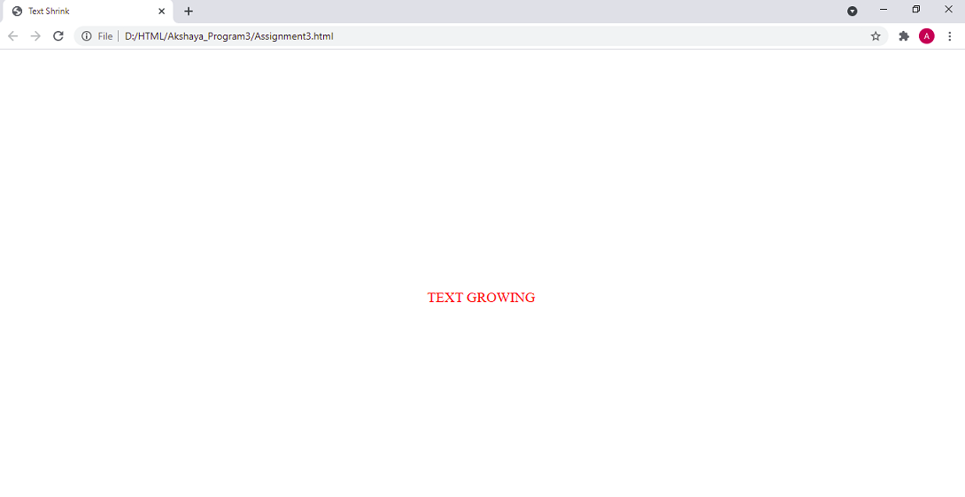

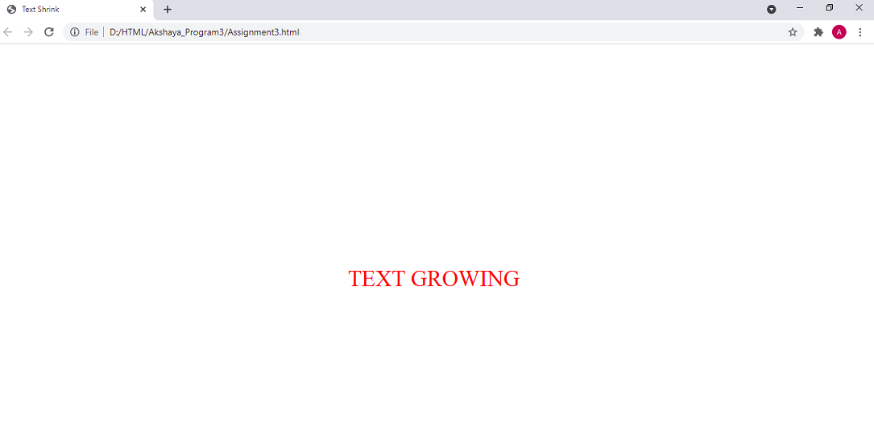

**“TEXT-SHRINKING” in blue color :**

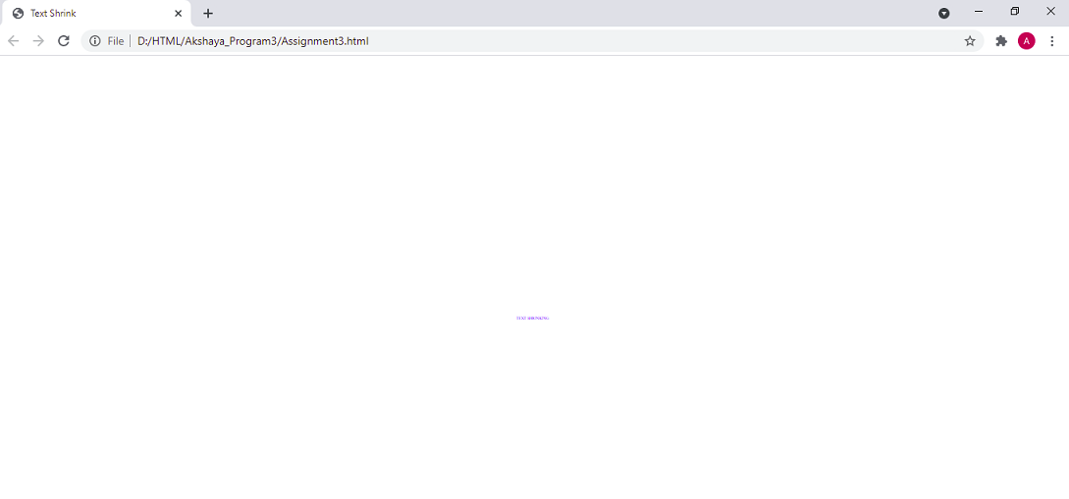

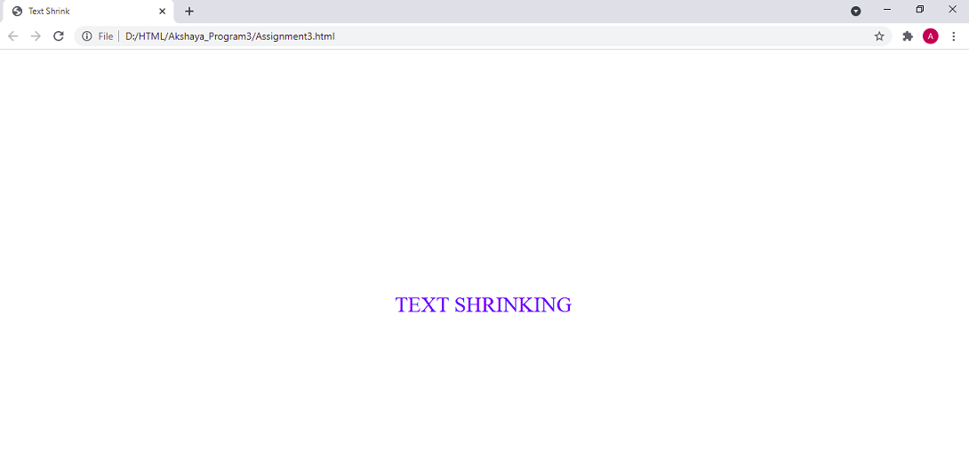

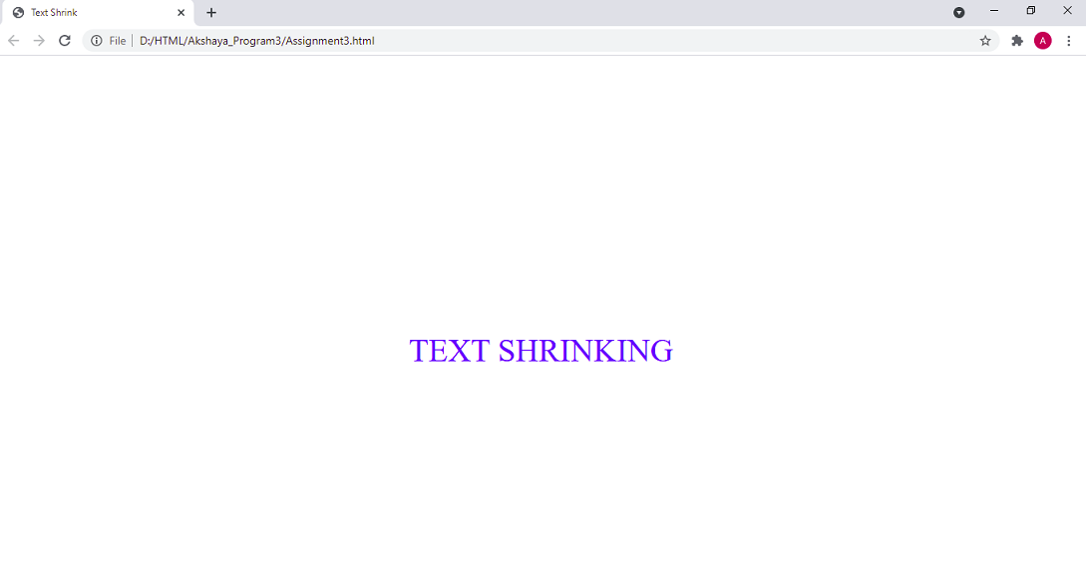

**Challenge**

**a. Add above code of text growing and shrinking.**

**b. Use following tags**

**i. Header**

**ii. Footer**

**iii. Heading tags**

**iv. Paragraphs**

**v. Sections – date and time of photo clicked.**

**vi. Figure – for images**

**vii. Article – for description of images**

**viii. Breaks**

**ix. Basic tags, etc**

<!DOCTYPE html>

<html>

<head>

<title>Photo Rating</title>

</head>

<style media="screen">

.img{

height : 15px;

width : 15px;

}

#demo1{

position: absolute;

right: 550px;

bottom: 350px;

}

a{

color: blue;

}

</style>

<body>

<p id="demo1"></p>

<script>

var var1 = setInterval(inTimer, 500);

var fs = 5; //font size

var ids = document.getElementById("demo1");

function inTimer()

{

ids.innerHTML = 'Photography!!!!';

ids.setAttribute('style', "font-size: " + fs + "px; color: red; text-align: right");

fs += 5;

if (fs >= 50)

{

clearInterval(var1); //paused

var2 = setInterval(deTimer, 500);

}

}

function deTimer() //fs = 50px

{

fs -= 5;

ids.innerHTML = 'Photography!!!!';

ids.setAttribute('style', "font-size: " + fs + "px; color: black; text-align: right");

if (fs == 5)

{

clearInterval(var2); //paused

var1 = setInterval(inTimer, 500);

}

}

</script>

<header>

<a href="#home">Home</a> ||

<a href="#">Places</a> ||

<a href="#last">Gallery</a> ||

<a href="#">About Us</a> ||

<a href="#">Search</a> ||

<h2>Radhanagar Beach, Andaman</h2>

<figure>

<img src="https://cdn.andamanholidays.com/wp-content/uploads/2016/08/Radhanagar-3.jpg" alt="Radhanagar Beach, Andaman"><br>

</figure>

<article class="demo">

<p>by <a href="#">Akshaya Subramanian</a></p>

<p>Over the years, this superb slice of paradise- Radhanagar Beach in Andaman has won many accolades.

The latest being the Tripadvisor’s Traveller’s Choice in 2016 to be named among the Top 25 beaches in Asia.

</p>

</article>

<section>

<p>Year : 2018<br>Date : 4th September</p>

</section>

<h3>Reviews</h3>

<div>

<p><strong>Beautiful!!!</strong> <br> Jasmine

<img src="https://iconsplace.com/wp-content/uploads/_icons/ffa500/256/png/rating-star-icon-11-256.png" class="img">

<img src="https://iconsplace.com/wp-content/uploads/_icons/ffa500/256/png/rating-star-icon-11-256.png" class="img">

<img src="https://iconsplace.com/wp-content/uploads/_icons/ffa500/256/png/rating-star-icon-11-256.png" class="img">

<img src="https://iconsplace.com/wp-content/uploads/_icons/ffa500/256/png/rating-star-icon-11-256.png" class="img">

<img src="https://www.kindpng.com/picc/m/11-115035_yellow-and-grey-star-grey-star-rating-png.png" class="img">

</p>

<p>An Amazing Picture.</p>

<hr>

<p><strong>Cool :)</strong> <br> Nikil

<img src="https://iconsplace.com/wp-content/uploads/_icons/ffa500/256/png/rating-star-icon-11-256.png" class="img">

<img src="https://iconsplace.com/wp-content/uploads/_icons/ffa500/256/png/rating-star-icon-11-256.png" class="img">

<img src="https://iconsplace.com/wp-content/uploads/_icons/ffa500/256/png/rating-star-icon-11-256.png" class="img">

<img src="https://cdn2.iconfinder.com/data/icons/flat-design-basic-set-9/24/star-half-grayed-512.png" class="img">

<img src="https://www.kindpng.com/picc/m/11-115035_yellow-and-grey-star-grey-star-rating-png.png" class="img">

</p>

<p>Wonderful click!!</p>

<hr>

<p><strong>Good</strong> <br> Riya

<img src="https://iconsplace.com/wp-content/uploads/_icons/ffa500/256/png/rating-star-icon-11-256.png" class="img">

<img src="https://iconsplace.com/wp-content/uploads/_icons/ffa500/256/png/rating-star-icon-11-256.png" class="img">

<img src="https://www.kindpng.com/picc/m/11-115035_yellow-and-grey-star-grey-star-rating-png.png" class="img">

<img src="https://www.kindpng.com/picc/m/11-115035_yellow-and-grey-star-grey-star-rating-png.png" class="img">

<img src="https://www.kindpng.com/picc/m/11-115035_yellow-and-grey-star-grey-star-rating-png.png" class="img">

</p>

<p>Nice one.</p>

<hr>

</div>

<a href="#home">Home</a> ||

<a href="#">Places</a> ||

<a href="#last">Gallery</a> ||

<a href="#">About Us</a> ||

<a href="#">Search</a> ||

<p><i><b>Copyright @ 2020 by Akshaya Subramanian</b></i></p>

</header>

</body>

</html>

**Output :**

**Part – 1:**

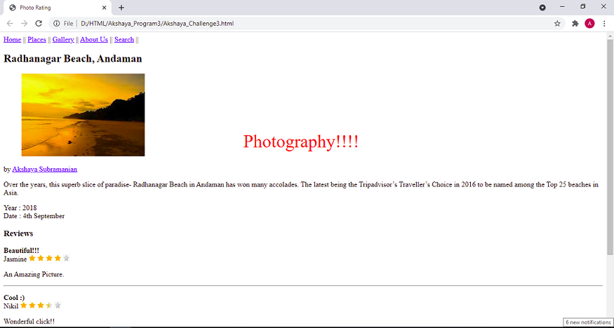

**Part – 2 :**

