Assignment-4

Name : Akshaya Subramanian

USN : 1JT18IS007

Date : 19 May 2021

Github : <https://github.com/Akshayajitwta/Webtech>

**Program-4: Develop and demonstrate a HTML5 file that includes**

**JavaScript script that uses functions for the following problems:**

**a. Parameter: A string**

**b. Output: The position in the string of the left-most vowel**

**c. Parameter: A number**

**d. Output: The number with its digits in the reverse order**

<!DOCTYPE HTML>

<html>

<head><title>Program-4</title></head>

<body>

<script type="text/javascript">

var str = prompt("Enter the Input", "");

if (!(isNaN(str))) //isNaN means is Not a Number

{

var num, rev = 0,remainder;

num = parseInt(str);

while (num != 0)

{

remainder = num % 10;

num = parseInt(num / 10);

rev = rev * 10 + remainder;

}

alert("Reverse of " + str + " is " + rev);

}

else

{

str = str.toUpperCase();

for (var i = 0; i < str.length; i++) //0,1,2,3

{

var chr = str.charAt(i);

if (chr == 'A' || chr == 'E' || chr == 'I' || chr == 'O' || chr == 'U')

break;

}

if (i < str.length)

alert("The position of the left most vowel is " + (i + 1));

else

alert("No vowel found in the entered string");

}

</script>

</body>

</html>

**Output 1 : Integer value test**

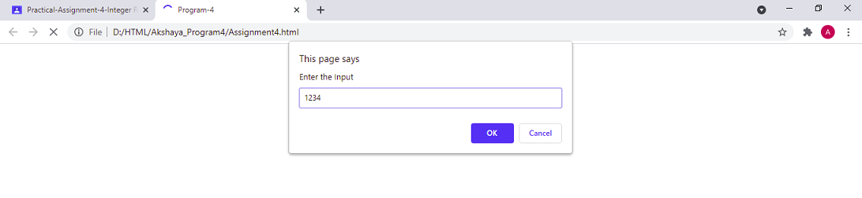

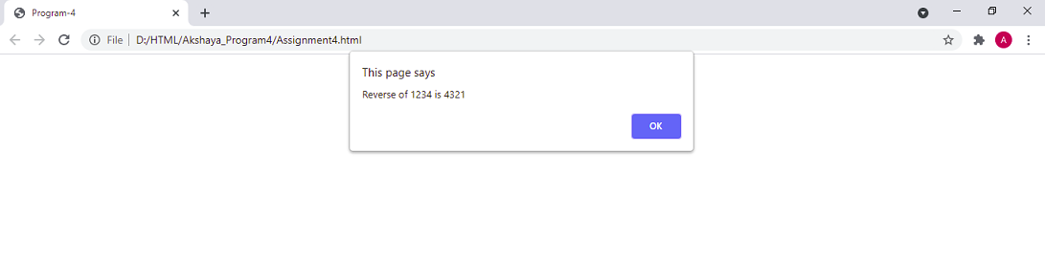

**Output 2 : String value test**

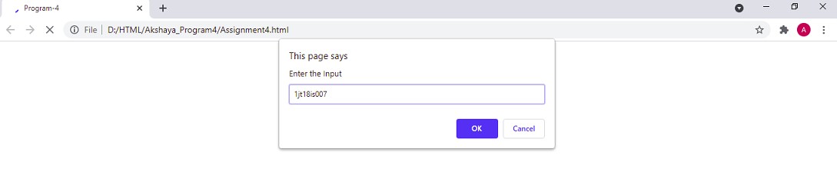

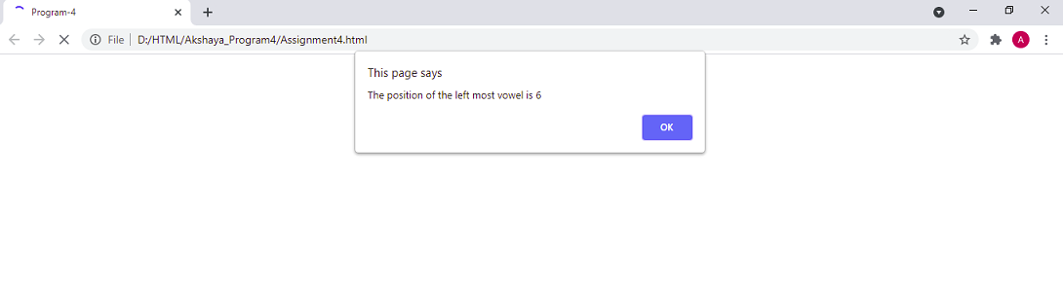

**Output 3 : String without vowels**

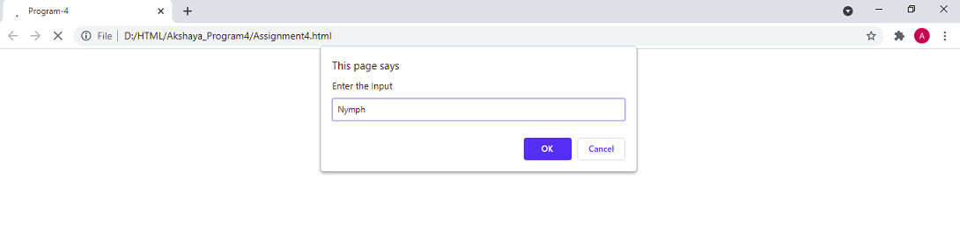

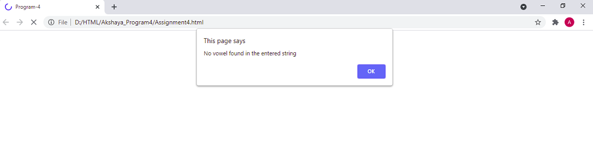

**Output 4 : Negative Integer value**

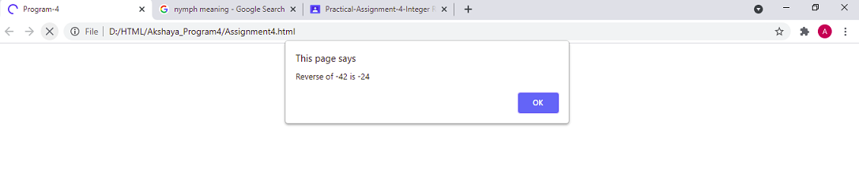

**Test Cases :**

|  |  |  |  |
| --- | --- | --- | --- |
| Test No. | Test Case | Expected Output | Output Obtained |
| 1 | Integer Value: 1234  Text Value: qwerty | Reverse of 1234 is 4321  The position of left most  vowel is 3 | Reverse of 1234 is 4321  The position of left most  vowel is 3 |
| 2 | Negative Integer value: -24  Text Value: good | Reverse of -24 is -42  The position of left most  vowel is 2 | Reverse of -24 is -42  The position of left most  vowel is 2 |
| 3 | Integer Value: 123  Alpha numerical value: 1jt18is007 | Reverse of 123 is 321  The position of left most  vowel is 6 | Reverse of 123 is 321  The position of left most  vowel is 6 |
| 4 | Integer Value: 789  Non vowel string: nymph | Reverse of 789 is 987  No vowel found in the entered string | Reverse of 789 is 987  No vowel found in the entered string |

**Challenge**

**Same as above program by in place of displaying only reverse of string under Integer Value, display the product of actual Integer Entered and Reversed Integer.**

**Code :**

<!DOCTYPE HTML>

<html>

<head><title>Program-4</title></head>

<body>

<script type="text/javascript">

var str = prompt("Enter the Input", "");

if (!(isNaN(str))) //isNaN means is Not a Number

{

var num, rev = 0,remainder;

num = parseInt(str);

while (num != 0)

{

remainder = num % 10;

num = parseInt(num / 10);

rev = rev * 10 + remainder;

}

var a = str * rev;

alert("Reverse of " + str + " is " + rev + " and their Product is " + a );

}

else

{

str = str.toUpperCase();

function vowelCount(str)

{

const count = str.match(/[aeiou]/gi).length;

return count;

}

const result = vowelCount(str);

alert("The given string '" + str + "' has " + result + " number of vowels ");

}

</script>

</body>

</html>

**Output 1 : Integer value test**

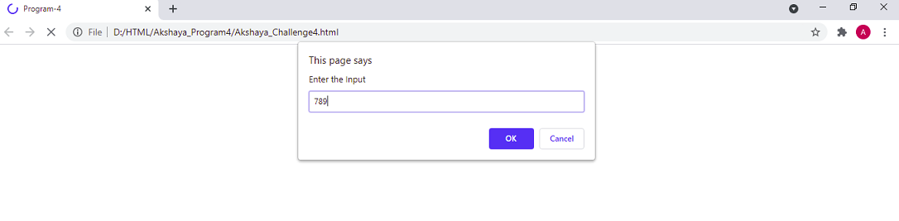

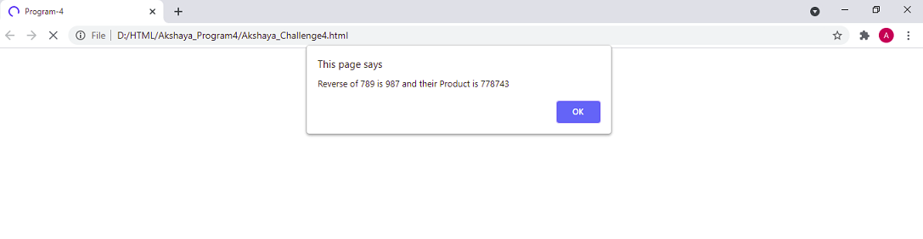

**Output 2 : String value test**

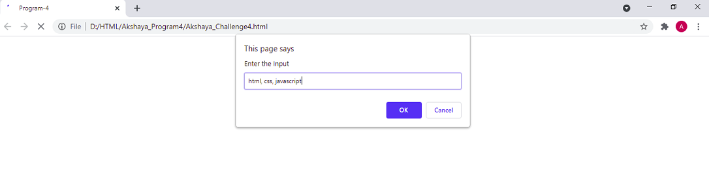

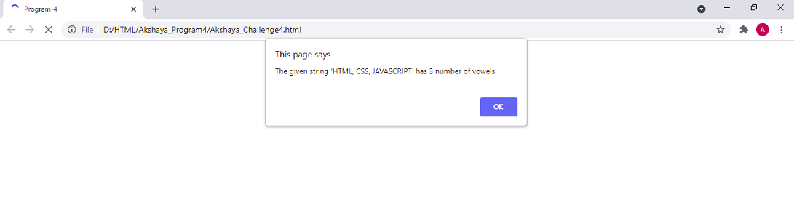

**Output 3 : Negative Integer value test**

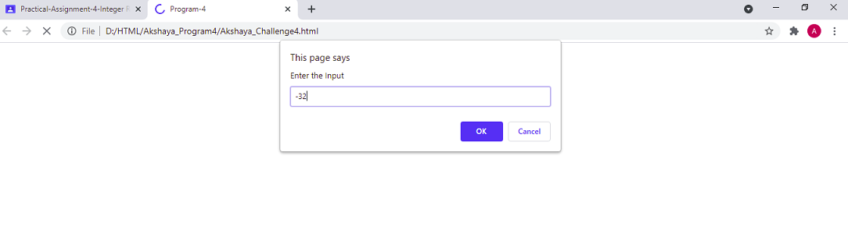

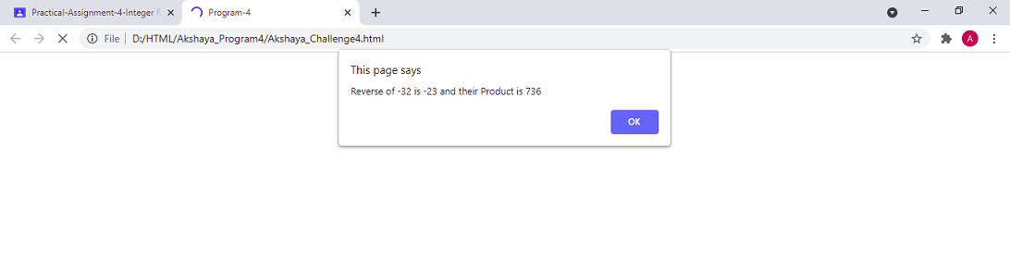

**Test Cases :**

|  |  |  |  |
| --- | --- | --- | --- |
| Test No. | Test Case | Expected Output | Output Obtained |
| 1 | Integer Value: 1234  Text Value: qwerty | Reverse of 1234 is 4321 and their product is 5332114  The given string ‘QWERTY’ has 1 number of vowels | Reverse of 1234 is 4321 and their product is 5332114  The given string ‘QWERTY’ has 1 number of vowels |
| 2 | Negative Integer value: -24  Text Value: good | Reverse of -24 is -42 and their product is 1008  The given string ‘GOOD’ has 2 number of vowels | Reverse of -24 is -42 and their product is 1008  The given string ‘GOOD’ has 2 number of vowels |
| 3 | Integer Value: 123  Alpha numerical value: 1jt18is007 | Reverse of 123 is 321 and their product is 39483  The given string ‘1JT18IS007’ has 1 number of vowels | Reverse of 123 is 321 and their product is 39483  The given string ‘1JT18IS007’ has 1 number of vowels |
| 4 | Integer Value: 789 | Reverse of 789 is 987 and their product is 778743 | Reverse of 789 is 987 and their product is 778743 |