MODULE - 6
1. Capture and analyze ARP packets using Wireshark. Inspect the ARP request and reply frames when your device attempts to find the router's MAC address. Discuss the importance of ARP in packet forwarding.

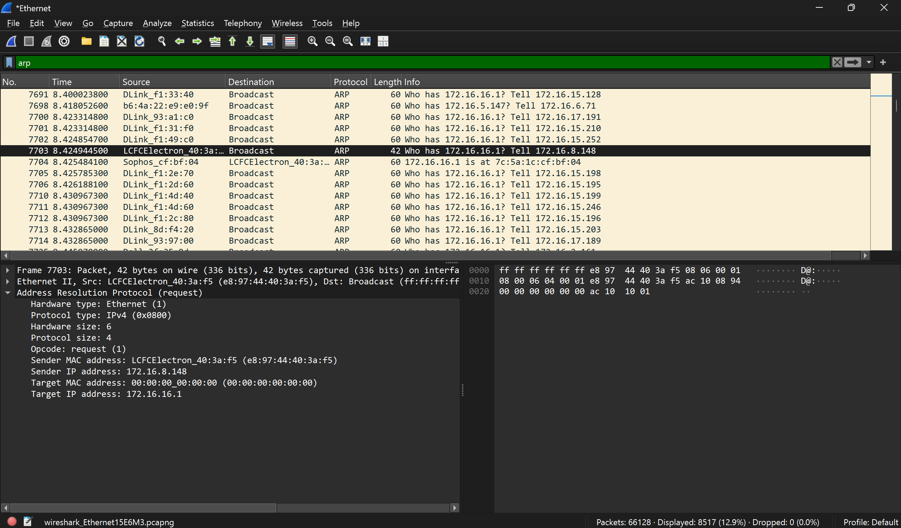

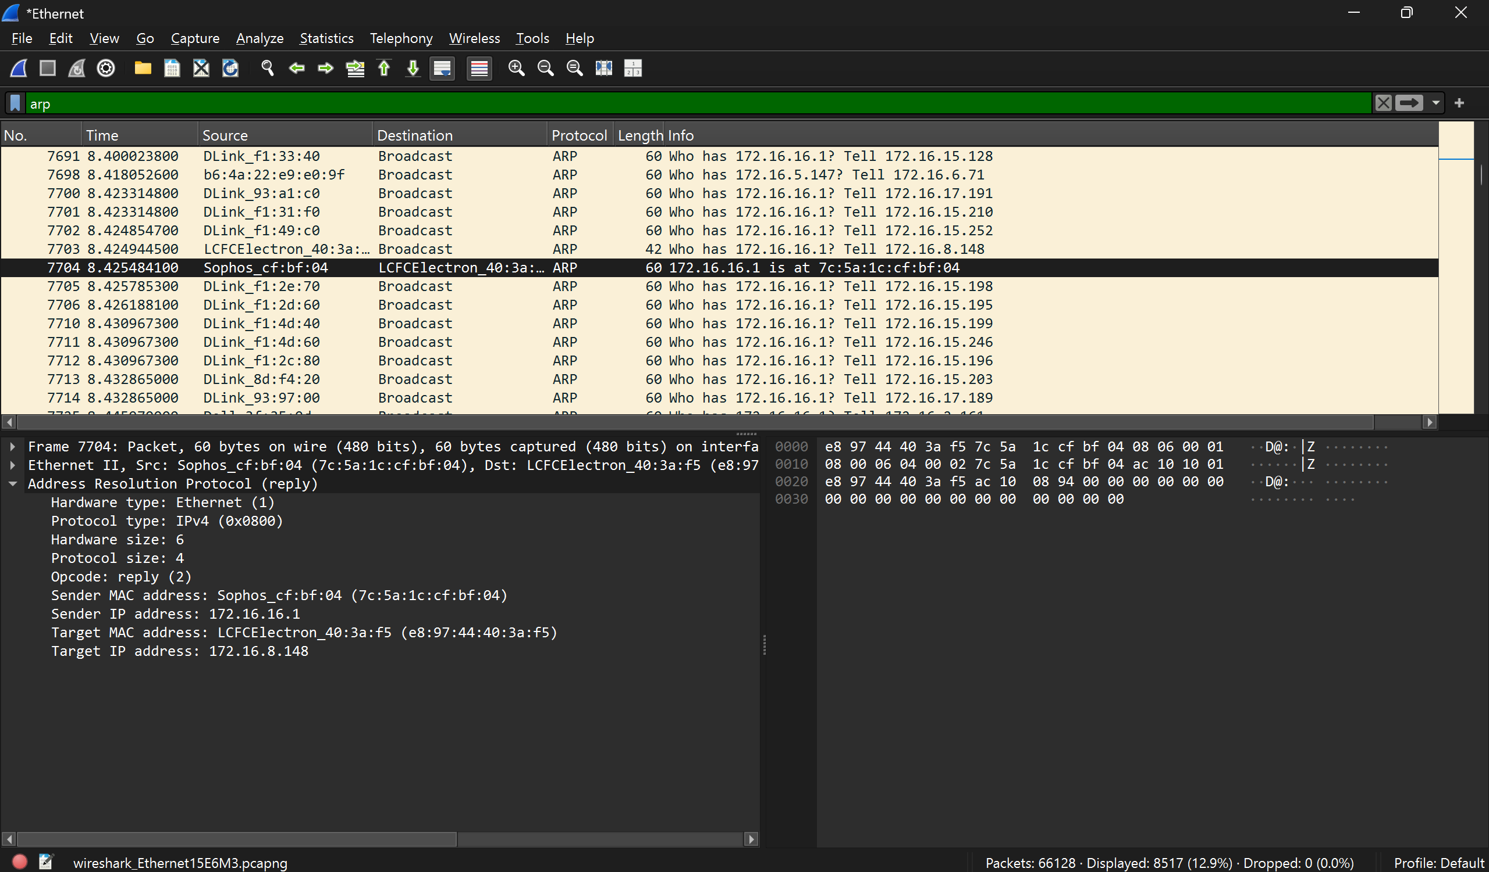
Importance of ARP in Packet Forwarding
ARP plays a critical role in networking:
- IP → MAC Mapping
  - Devices communicate using IP addresses
  - But actual delivery happens using MAC addresses
  - ARP bridges this gap
- Enables Local Network Communication
  - Without ARP, your device cannot send packets to:
    - Router
    - Other devices in LAN
- Required for Internet Access
  - When sending data outside the network:
    - Packet goes to default gateway (router)
    - ARP finds router’s MAC
- Improves Efficiency
  - ARP cache avoids repeated broadcasts
  - Speeds up communication
- Foundation for Higher Protocols
  - Protocols like TCP/IP depend on ARP for actual delivery

2. Manually configure static routes on a router to direct packets to different subnets. Use the ip route command and verify connectivity using ping and traceroute.
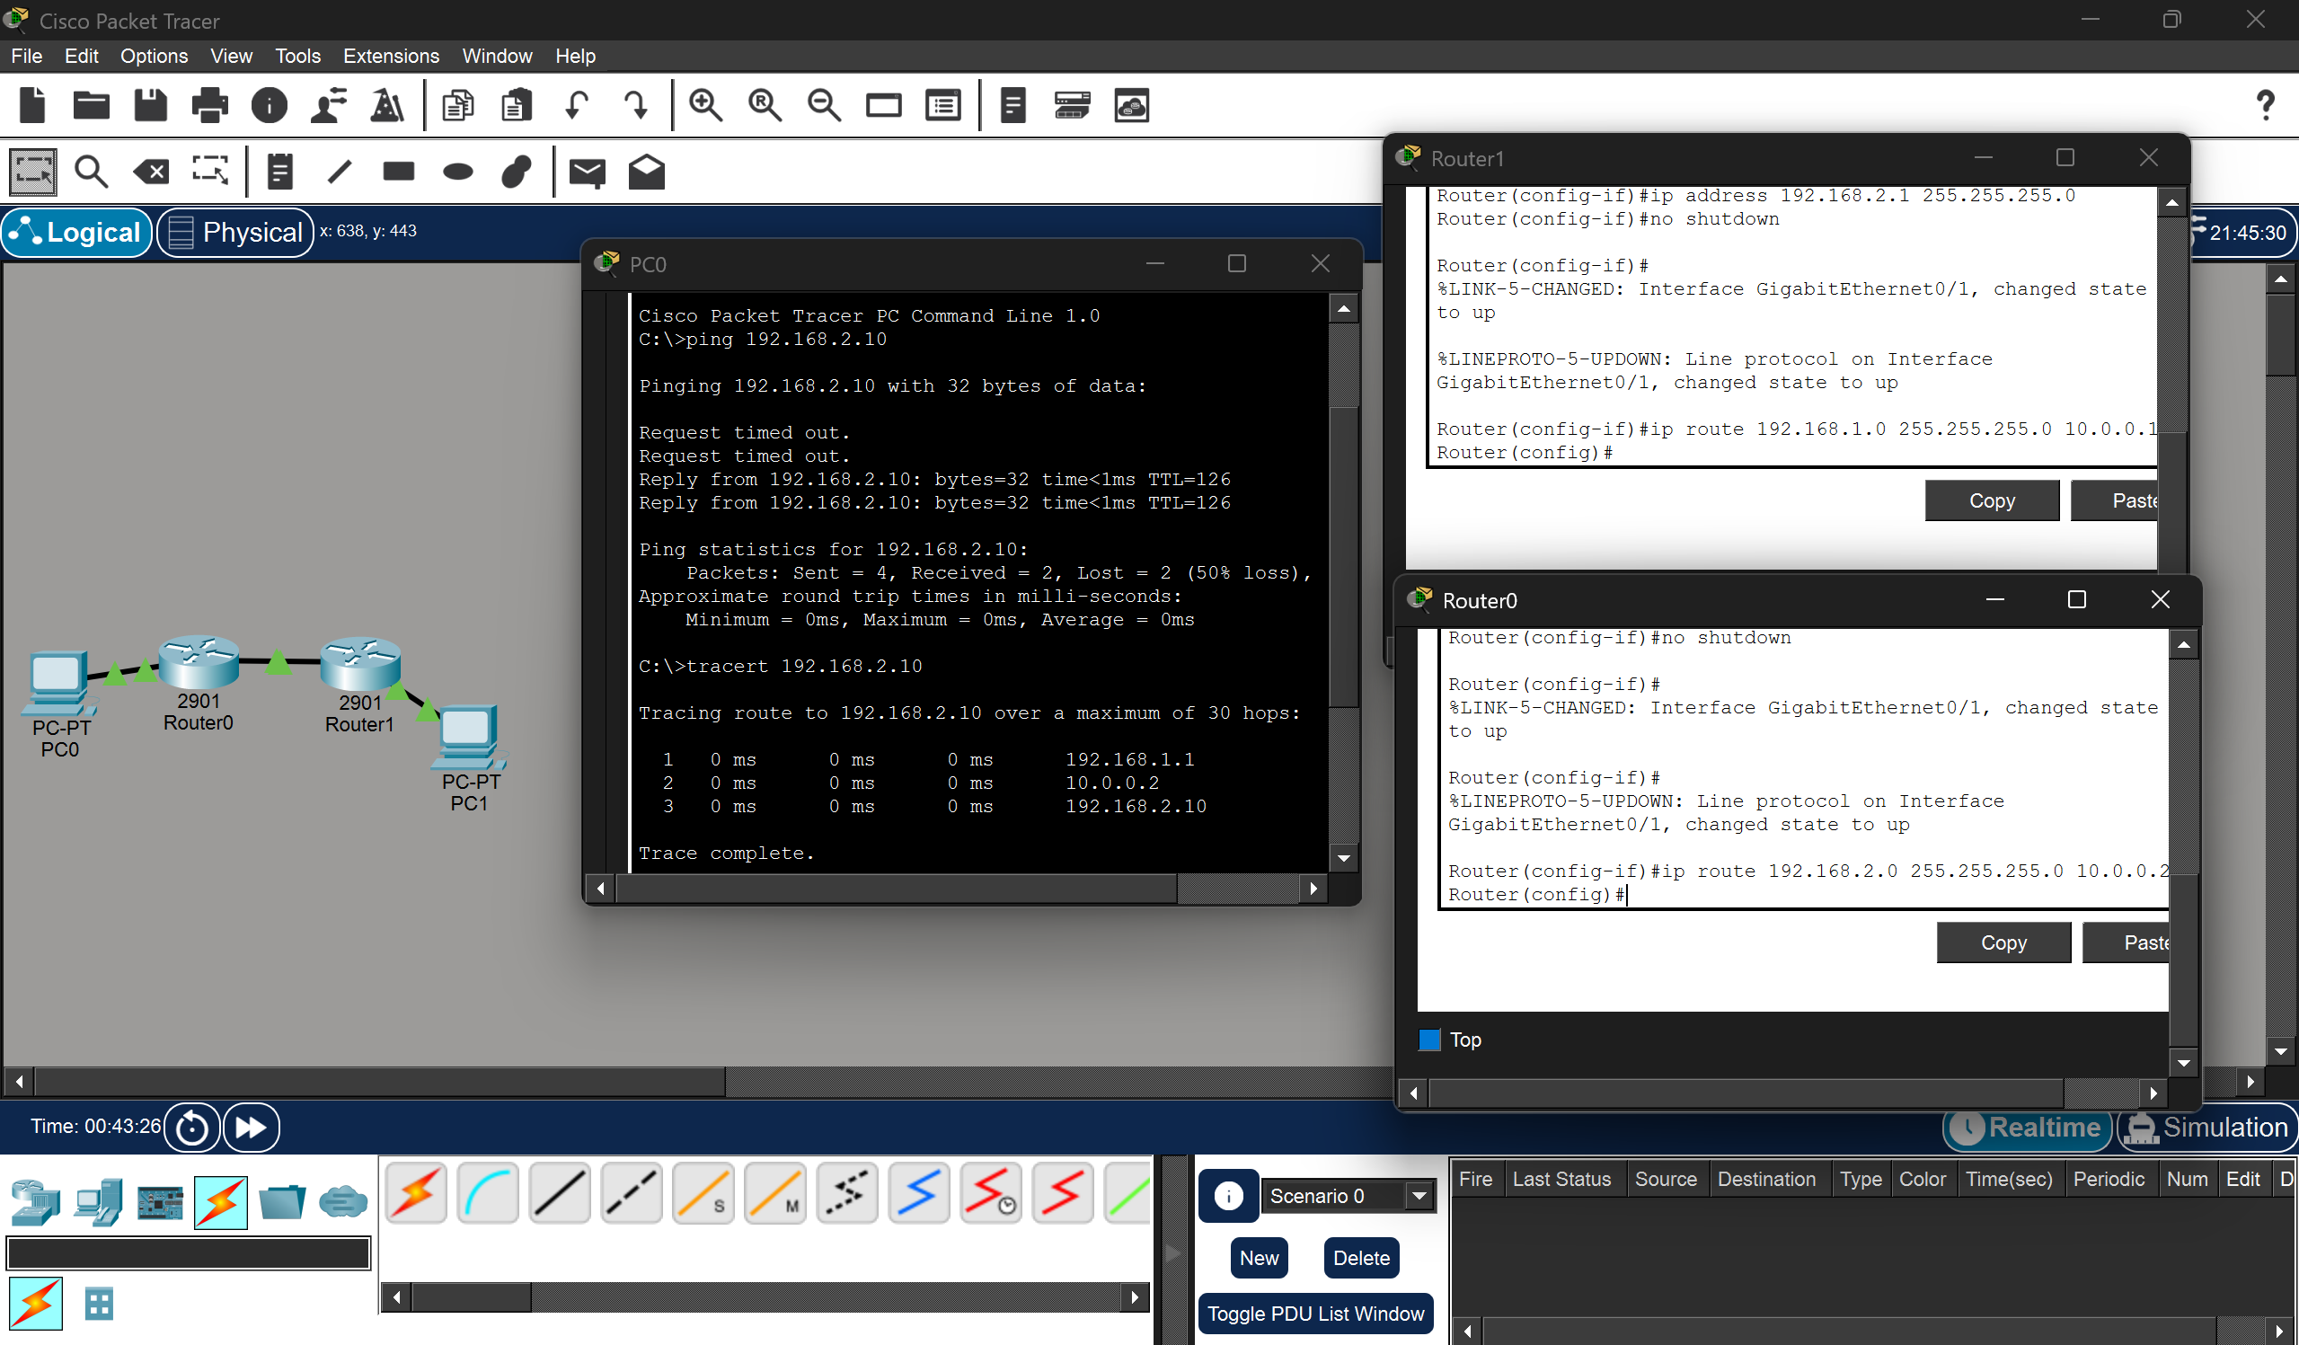
3. Given a network address of 10.0.0.0/24, divide it into 4 equal subnets. Calculate the new subnet mask. Determine the valid host range for each subnet. Assign IP addresses to devices in Packet Tracer and verify connectivity.

New Subnet Mask: 255.255.255.192
Subnet No. | Network Address | First Host | Last Host | Broadcast Address
1 | 10.0.0.0/26 | 10.0.0.1 | 10.0.0.62 | 10.0.0.63
2 | 10.0.0.64/26 | 10.0.0.65 | 10.0.0.126 | 10.0.0.127
3 | 10.0.0.128/26 | 10.0.0.129 | 10.0.0.190 | 10.0.0.191
4 | 10.0.0.192/26 | 10.0.0.193 | 10.0.0.254 | 10.0.0.255

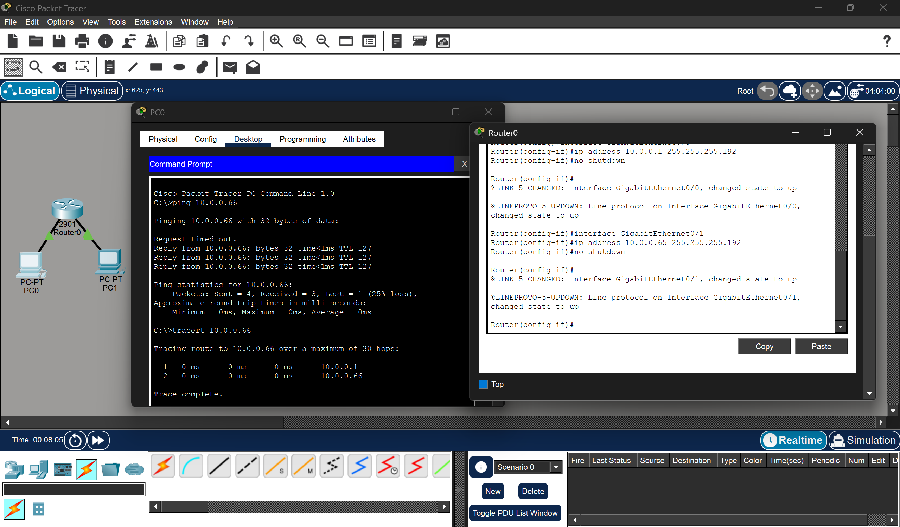

4. You are given three IP addresses: 192.168.10.5, 172.20.15.1, and 8.8.8.8. Identify the class of each IP address. Determine if it is private or public. Explain how NAT would handle a private IP when accessing the internet.

IP Address | Class | Private / Public
192.168.10.5 | Class C | Private
172.20.15.1 | Class B | Private
8.8.8.8 | Class A | Public

- 192.168.10.5 → Falls in 192.168.x.x, which is a private range (Class C)
- 172.20.15.1 → Falls in 172.16.0.0 – 172.31.255.255, private range (Class B)
- 8.8.8.8 → Not in any private range, so it is a public IP

NAT Working:
When a device with a private IP (like 192.168.10.5) tries to access the internet:
- The packet goes to the router
- The router replaces the private IP with its public IP (using NAT)
- The request is sent to the internet
- The response comes back to the router’s public IP
- The router maps it back to the original private IP and sends it to the device

- In Cisco Packet Tracer, configure NAT on a router to allow internal devices (192.168.1.x) to access the internet. Test connectivity by pinging an external public IP. Capture the traffic in Wireshark and analyze the source IP before and after NAT translation.

