MODULE – 5
1) Capture and analyze ARP packets using Wireshark

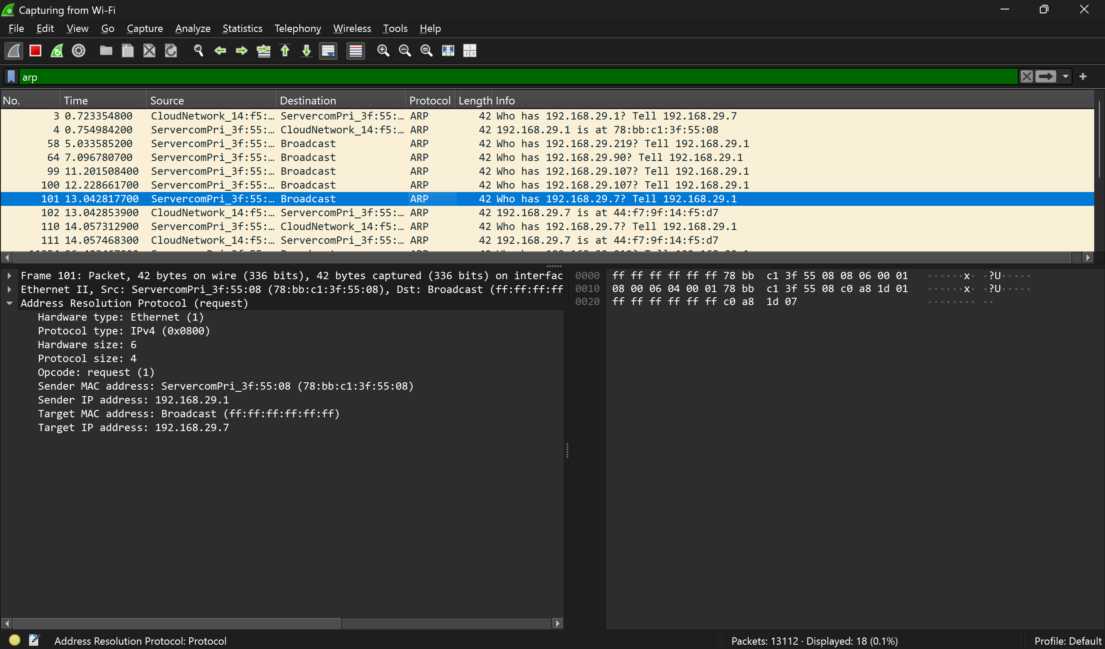

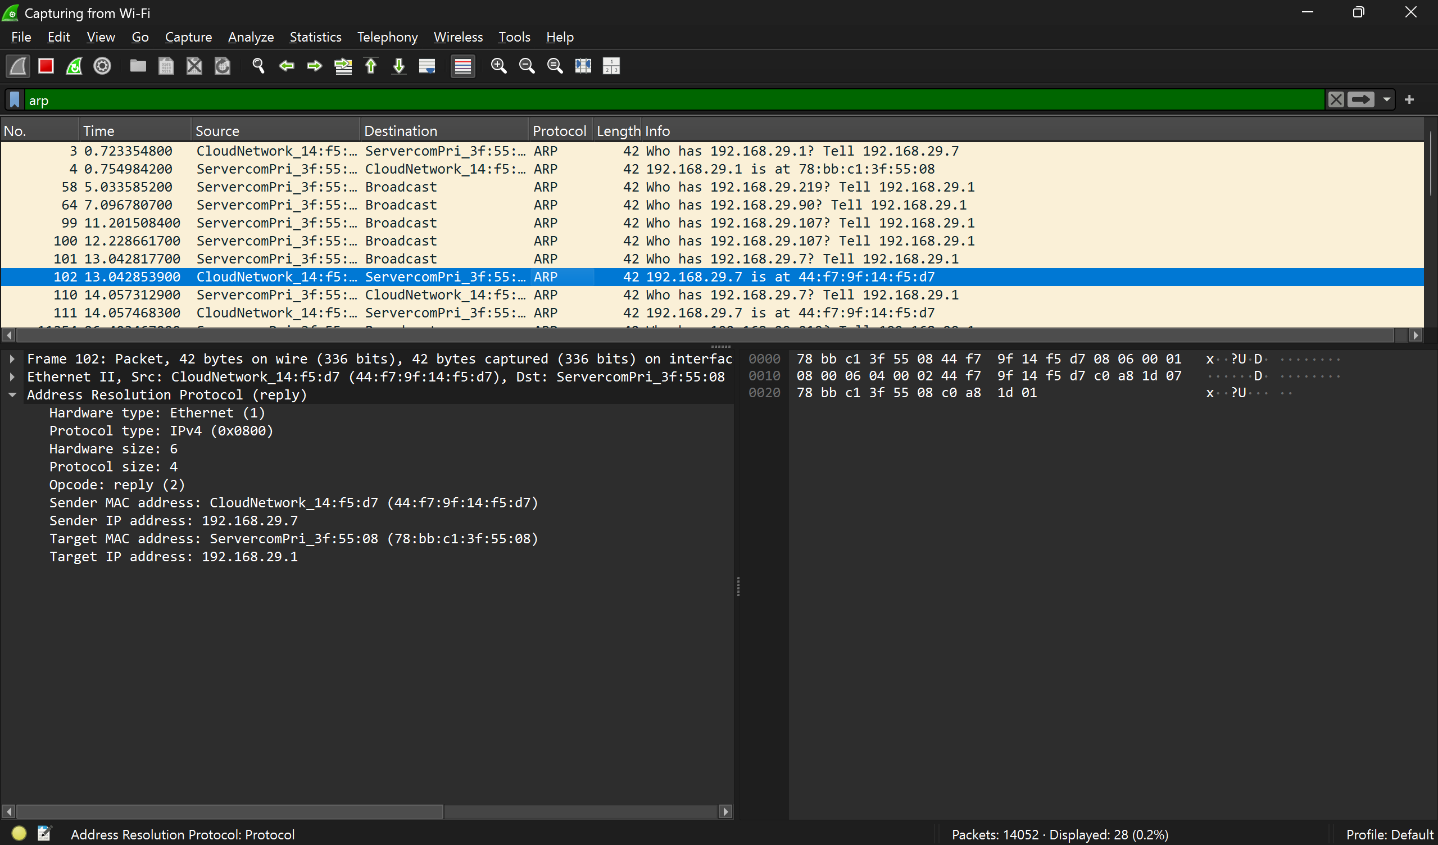
2) Simulate an ARP Spoofing attack using Cisco Packet Tracer and analyze behavior

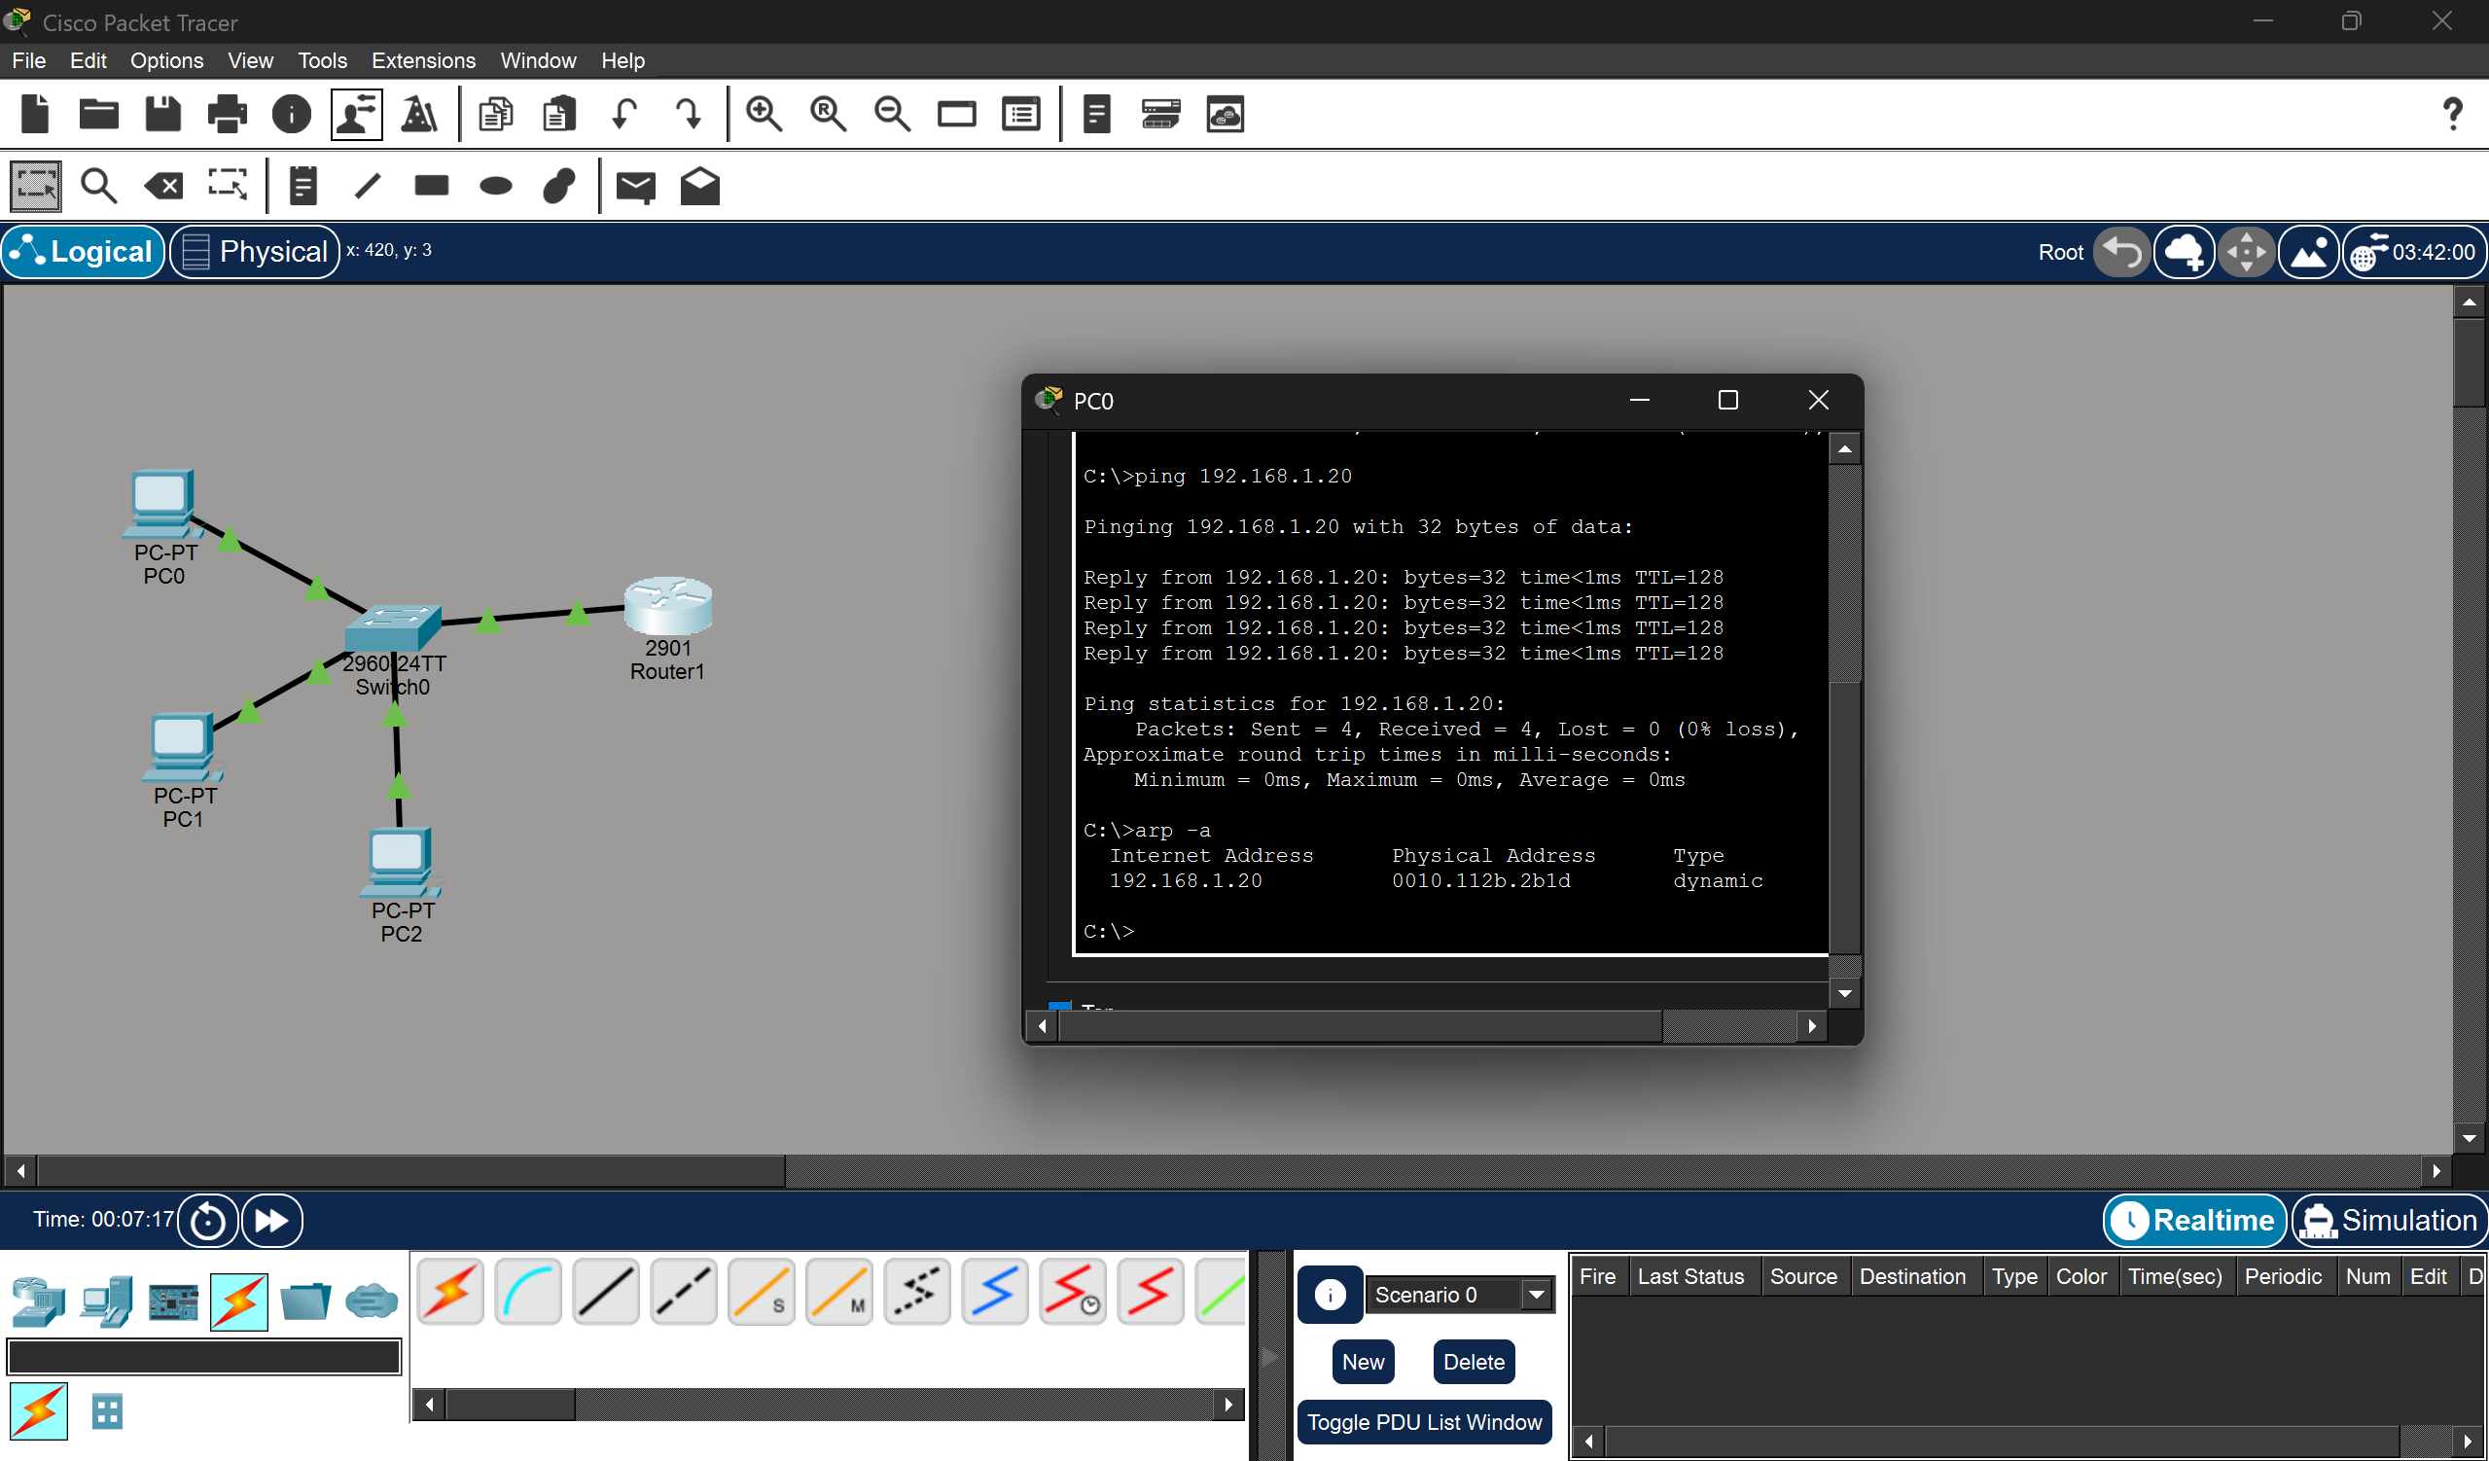

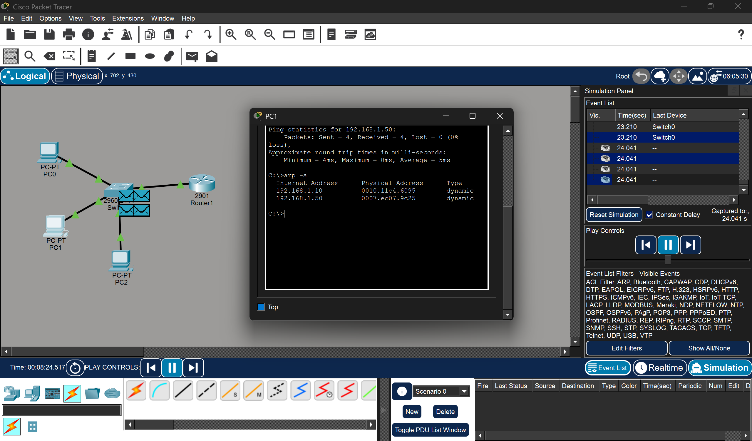

3) Manually configure static IPs on client devices and verify connectivity using ping

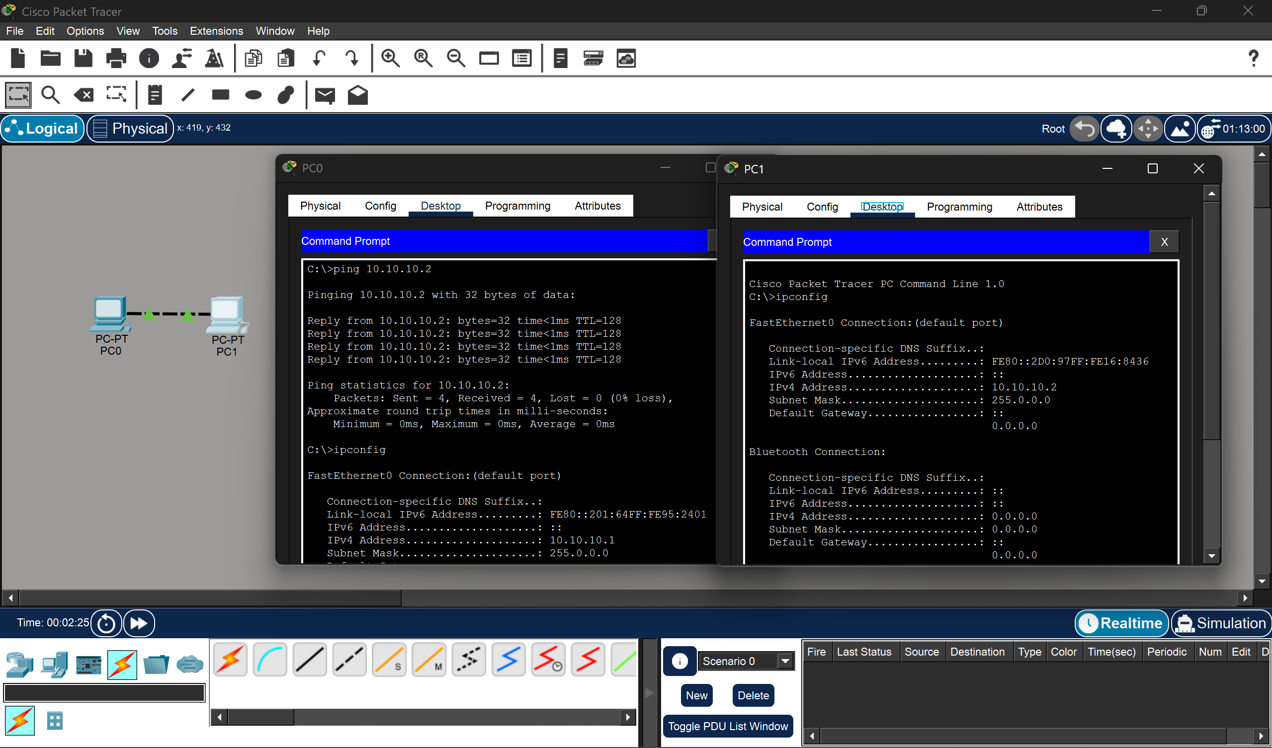

4) Capture DHCP Discover, Offer, Request, Acknowledge using Wireshark and explain the process
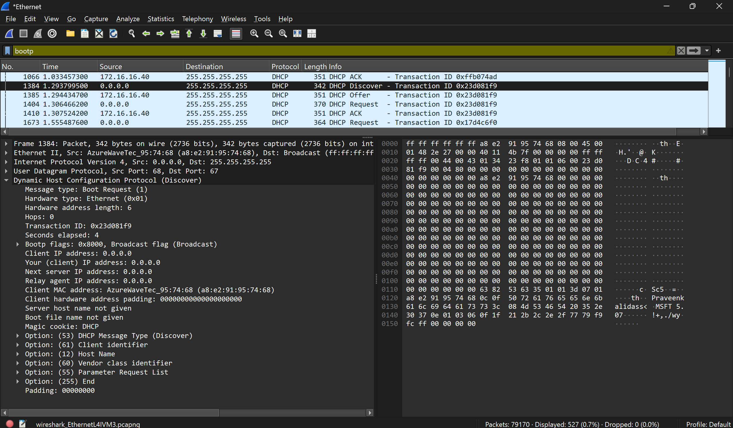

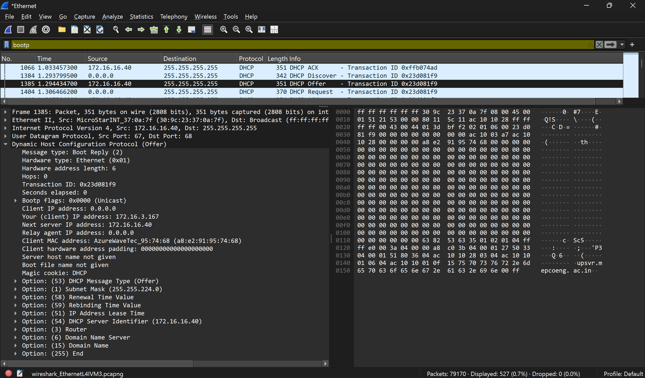

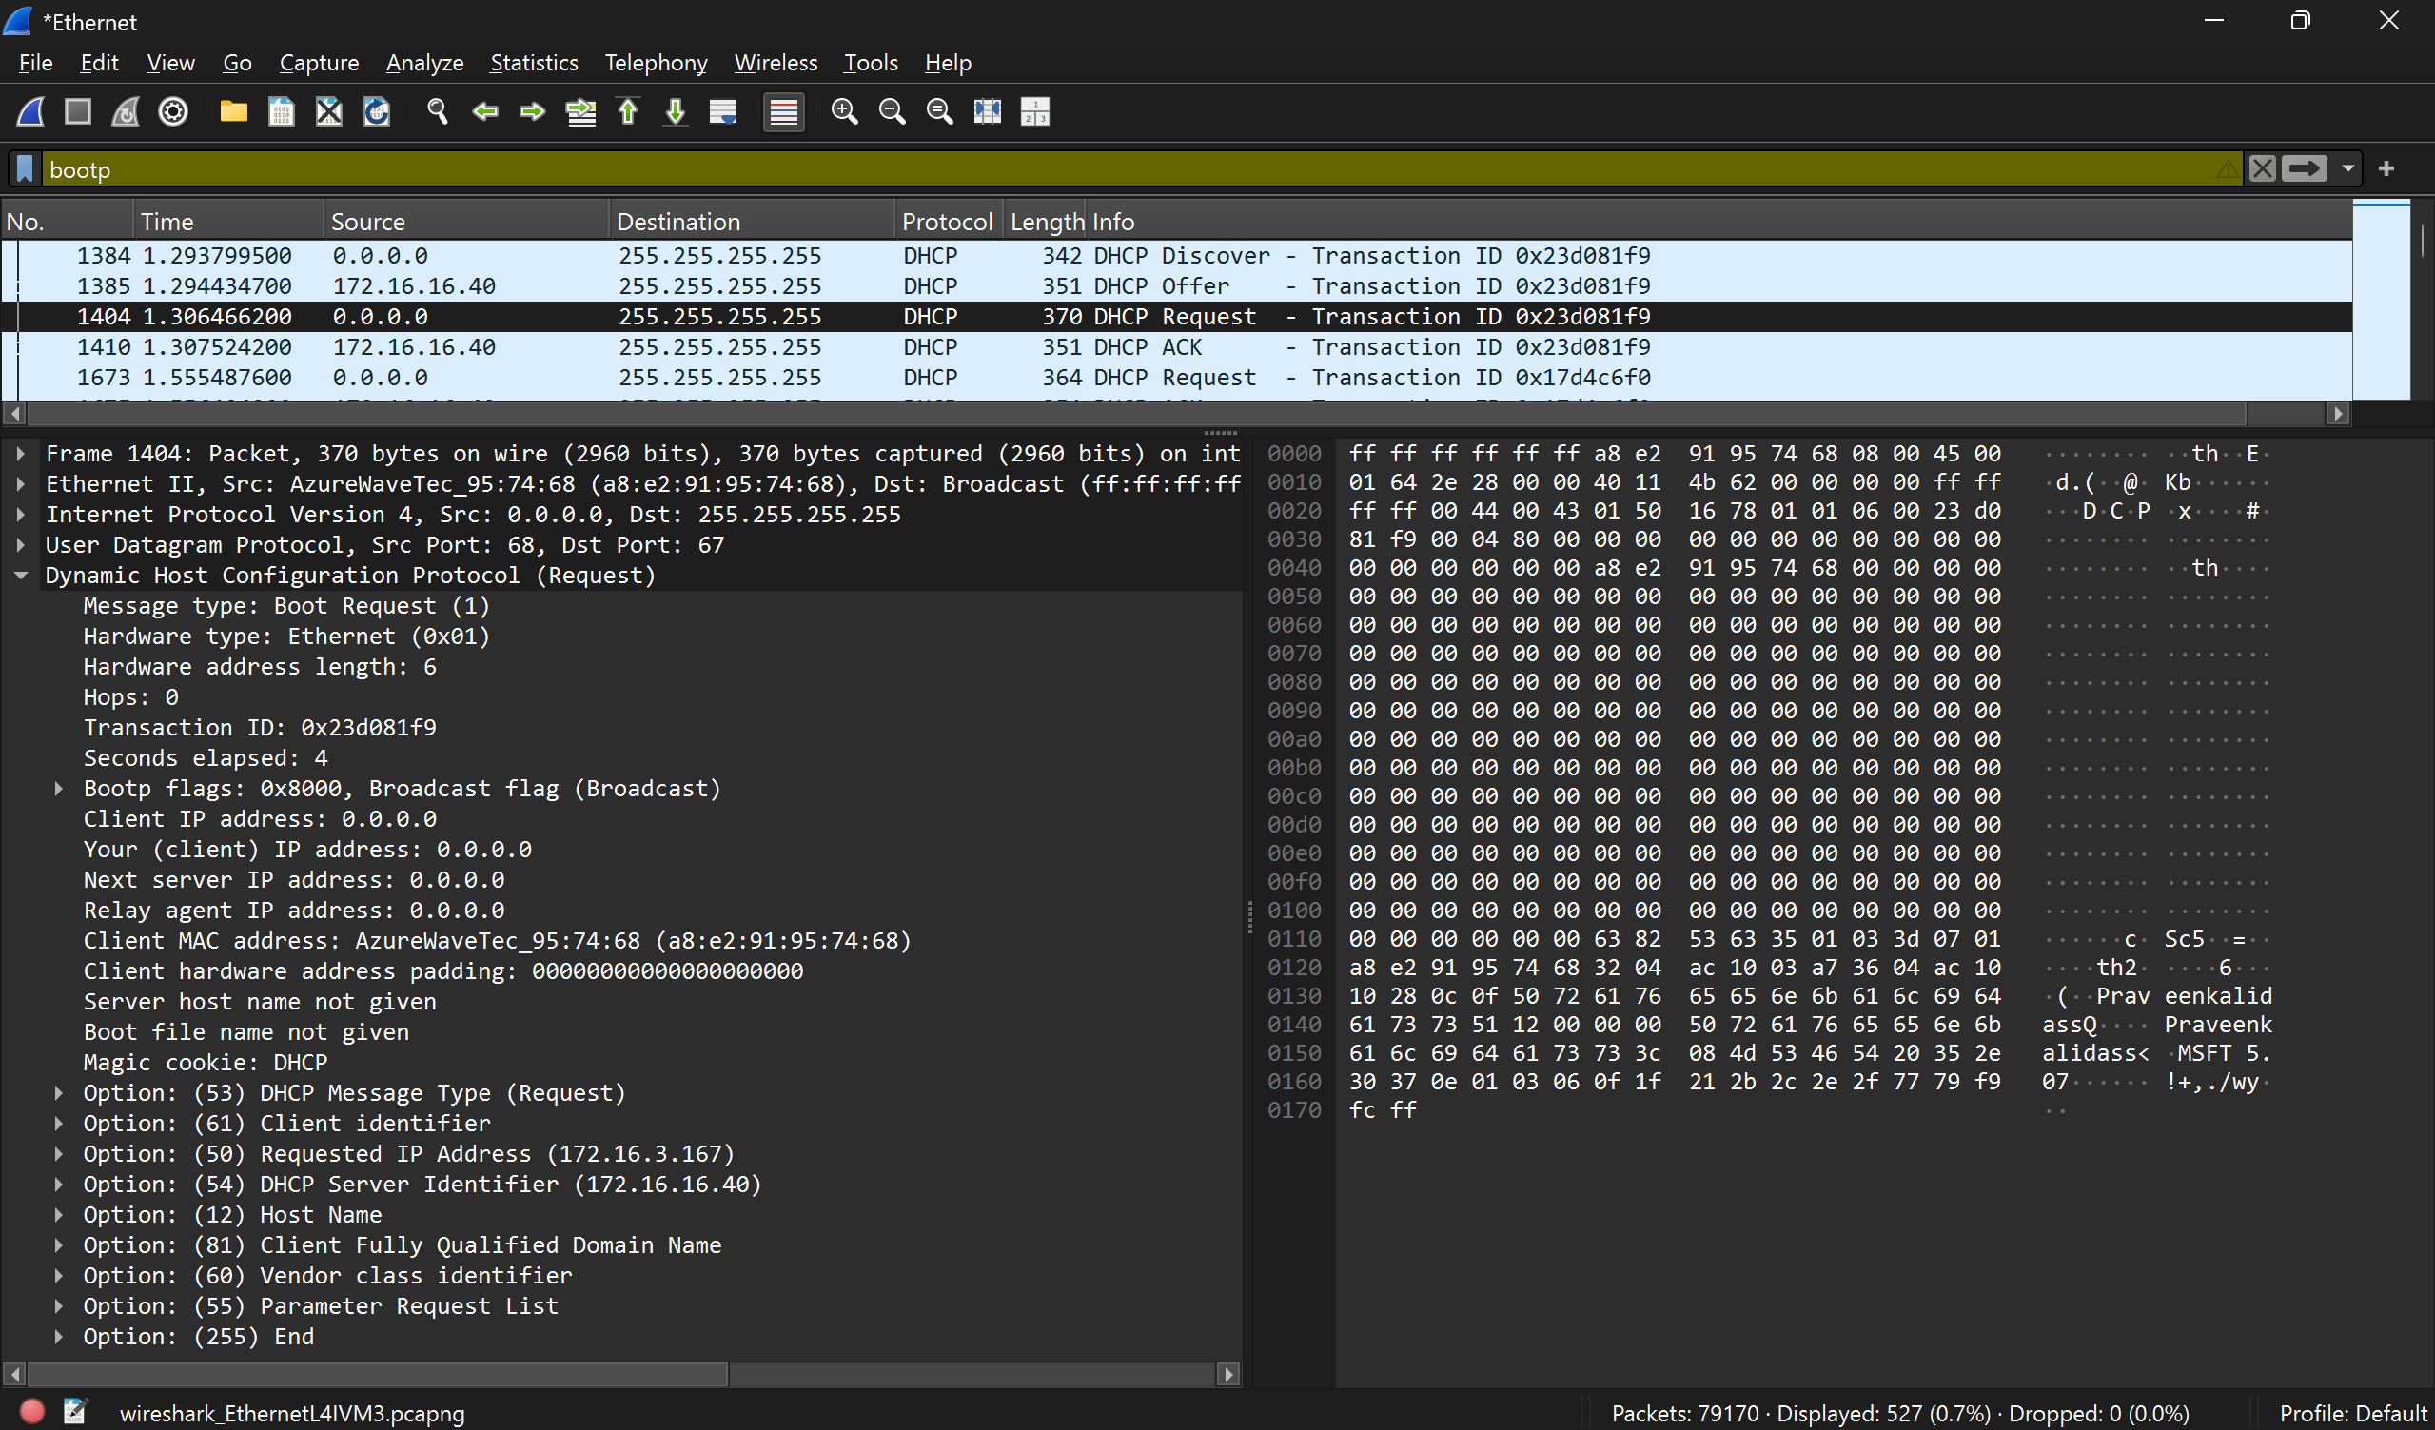
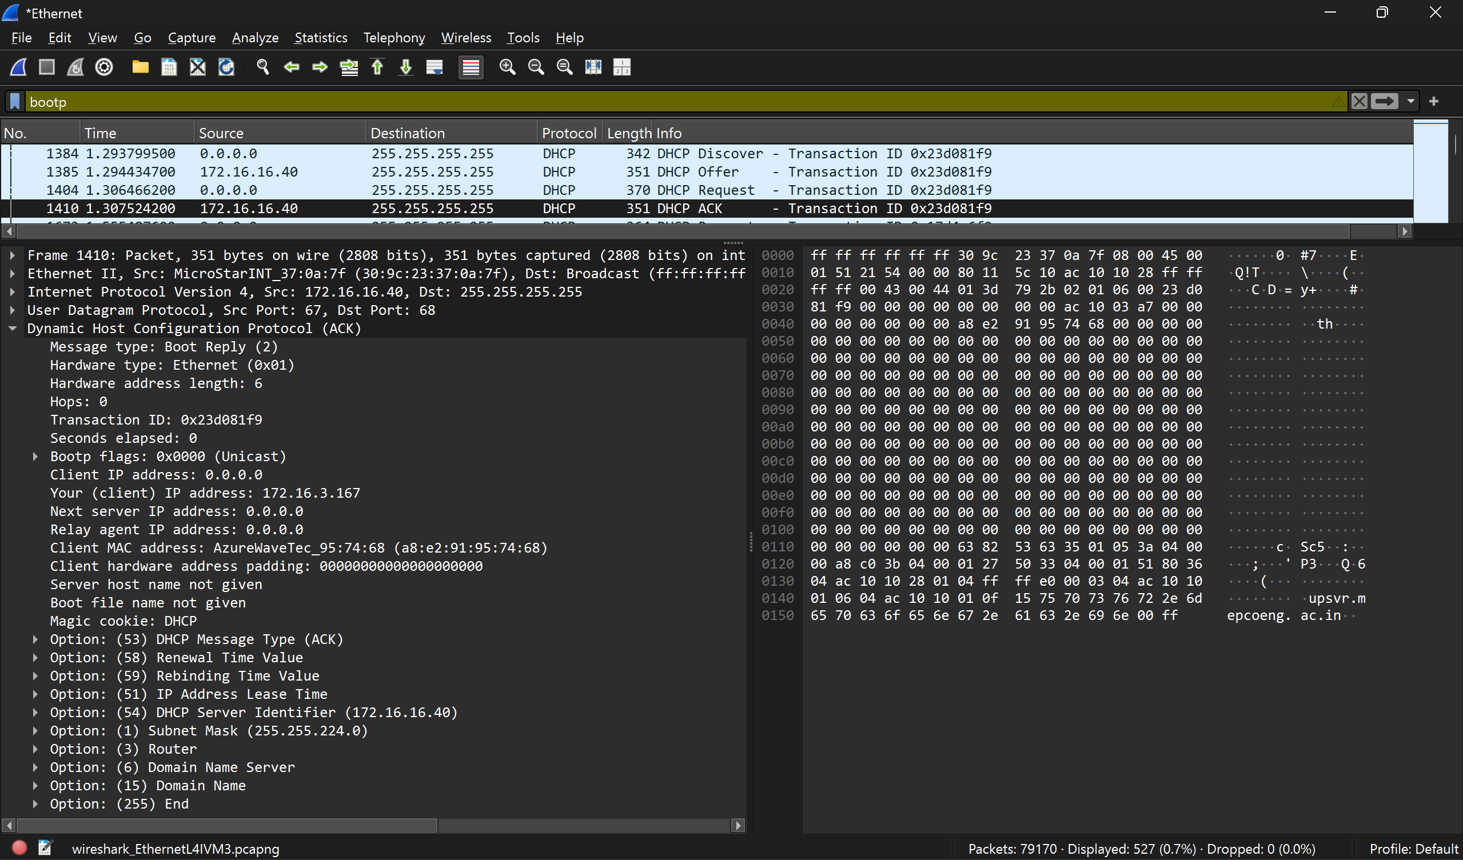

DORA Process:
- Discover – The device (client) sends a broadcast message to find available DHCP servers in the network.
- Offer – The DHCP server replies with an available IP address and network details.
- Request – The device sends a request to accept the offered IP address from the server.
- Acknowledge (ACK) – The server confirms the request and assigns the IP address to the device.

5) Divide 192.168.1.0/24 into 4 subnets and find valid IP ranges
Subnet No. | Network Address | First Valid IP | Last Valid IP | Broadcast Address
1 | 192.168.1.0/26 | 192.168.1.1 | 192.168.1.62 | 192.168.1.63
2 | 192.168.1.64/26 | 192.168.1.65 | 192.168.1.126 | 192.168.1.127
3 | 192.168.1.128/26 | 192.168.1.129 | 192.168.1.190 | 192.168.1.191
4 | 192.168.1.192/26 | 192.168.1.193 | 192.168.1.254 | 192.168.1.255

6) Identify the class of IP address 192.168.10.10 and explain IP address classes
The IP address 192.168.10.10 belongs to Class C. IP addresses are divided into different classes (A, B, C, D, and E) based on their range and purpose. Class A is used for very large networks, Class B for medium-sized networks, and Class C for smaller networks like home or office networks. Since 192.168.10.10 falls in the range 192.0.0.0 to 223.255.255.255, it is a Class C address. Class C networks typically use the subnet mask 255.255.255.0 and support up to 254 devices. Also, the 192.168.x.x range is a private IP range, meaning it is used inside local networks and not directly accessible from the internet.

7) Configure NAT in Cisco Packet Tracer and analyze source IP before and after NAT

