MODULE – 3 and 4
- Simulate a LAN with a switch, observe MAC table, and analyze Ethernet frames

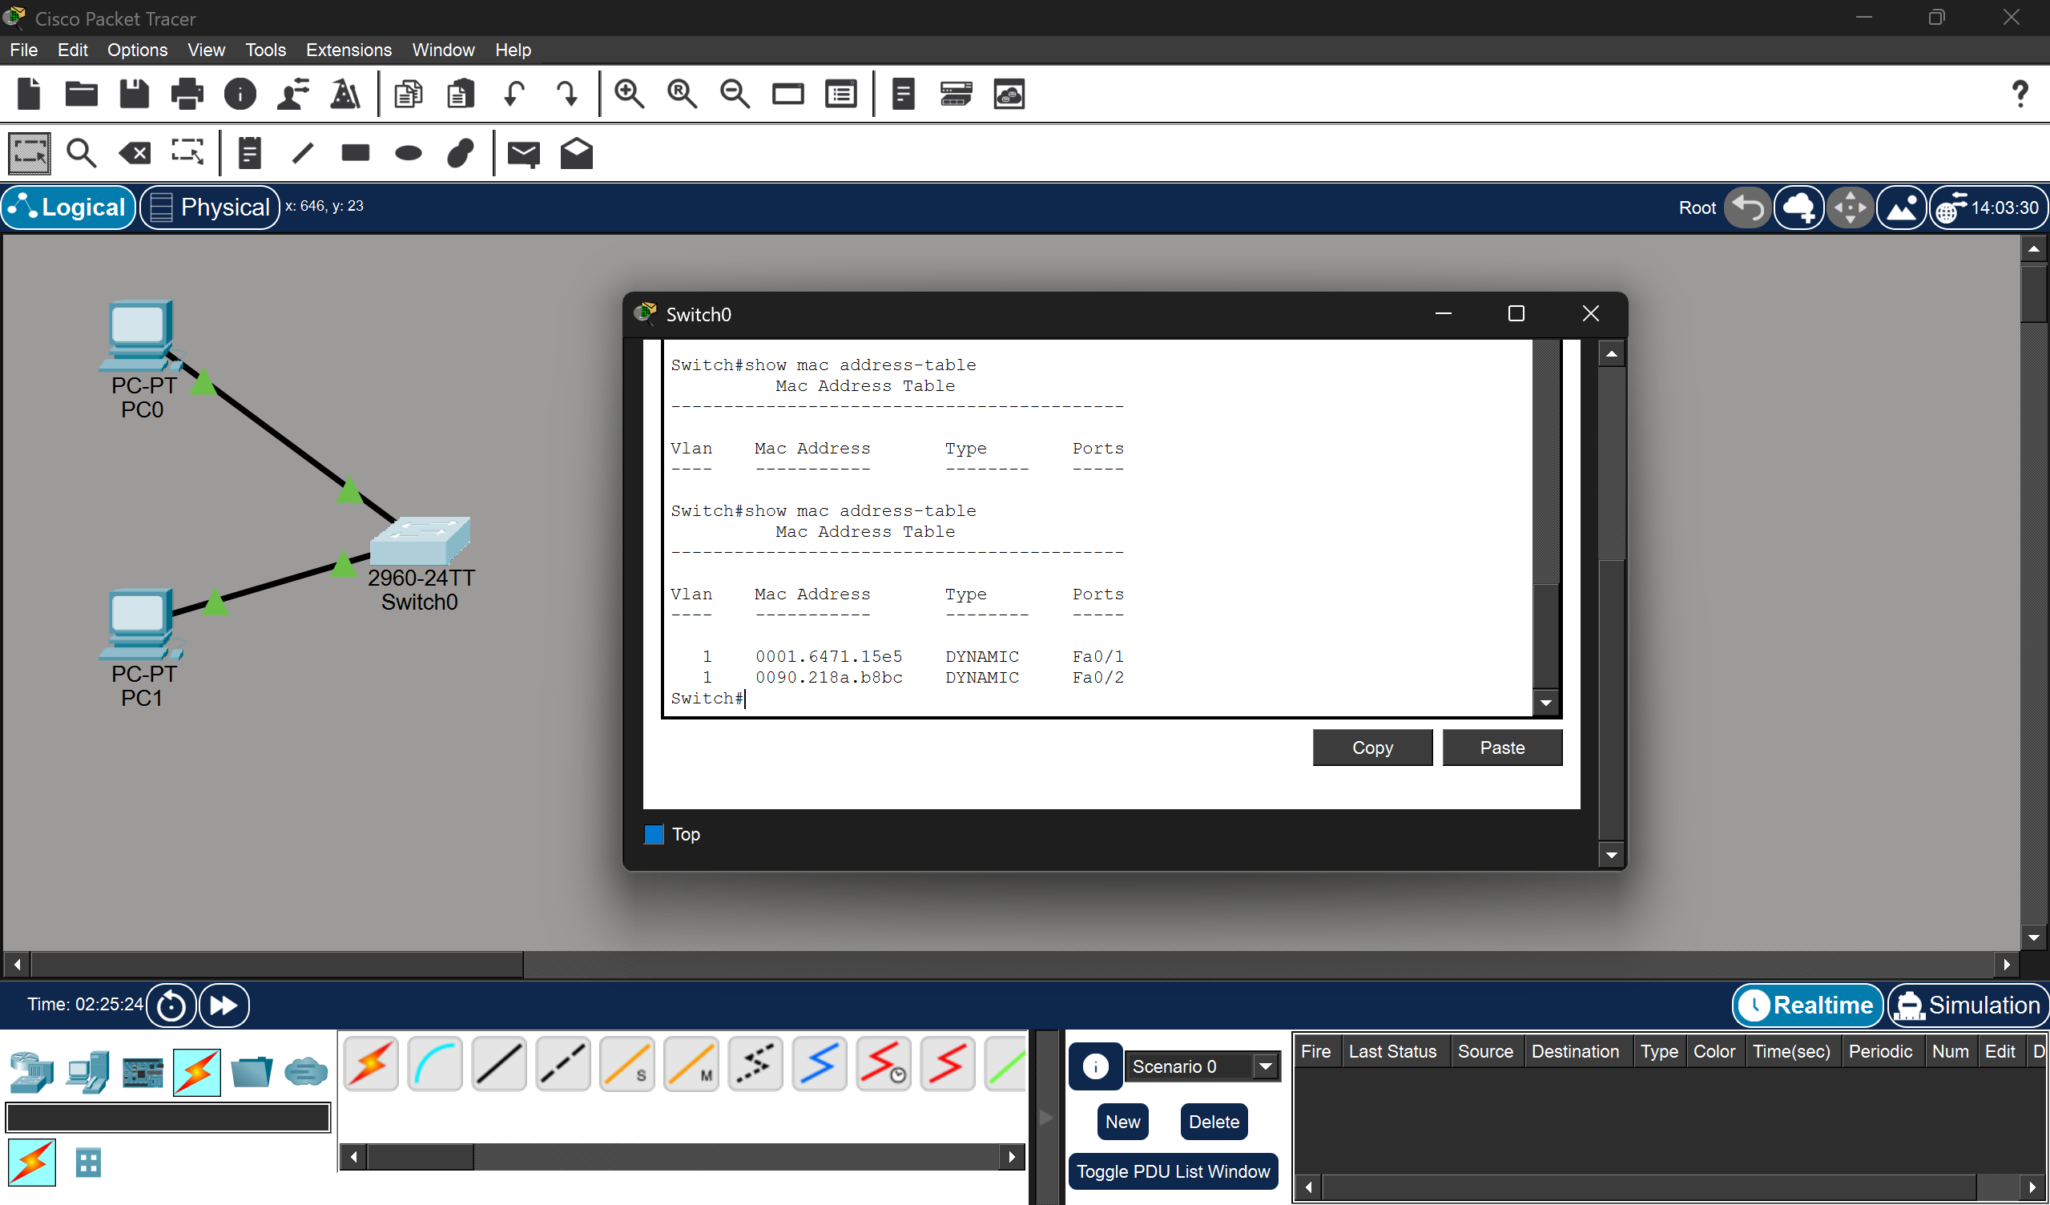

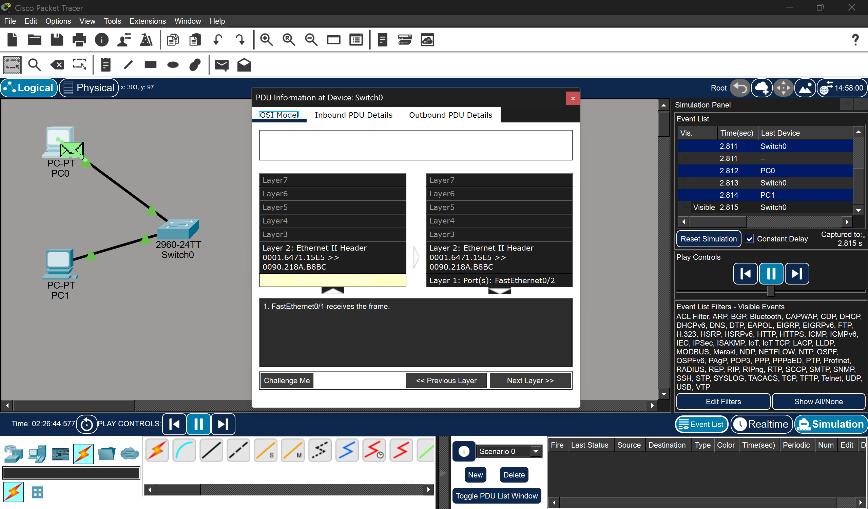

- Switch learns MAC addresses dynamically
- First packet is broadcast (ARP)
- Later packets are unicast (ICMP)
- Ethernet frame contains MAC-level communication
- Capture and analyze Ethernet frames and explain frame structure

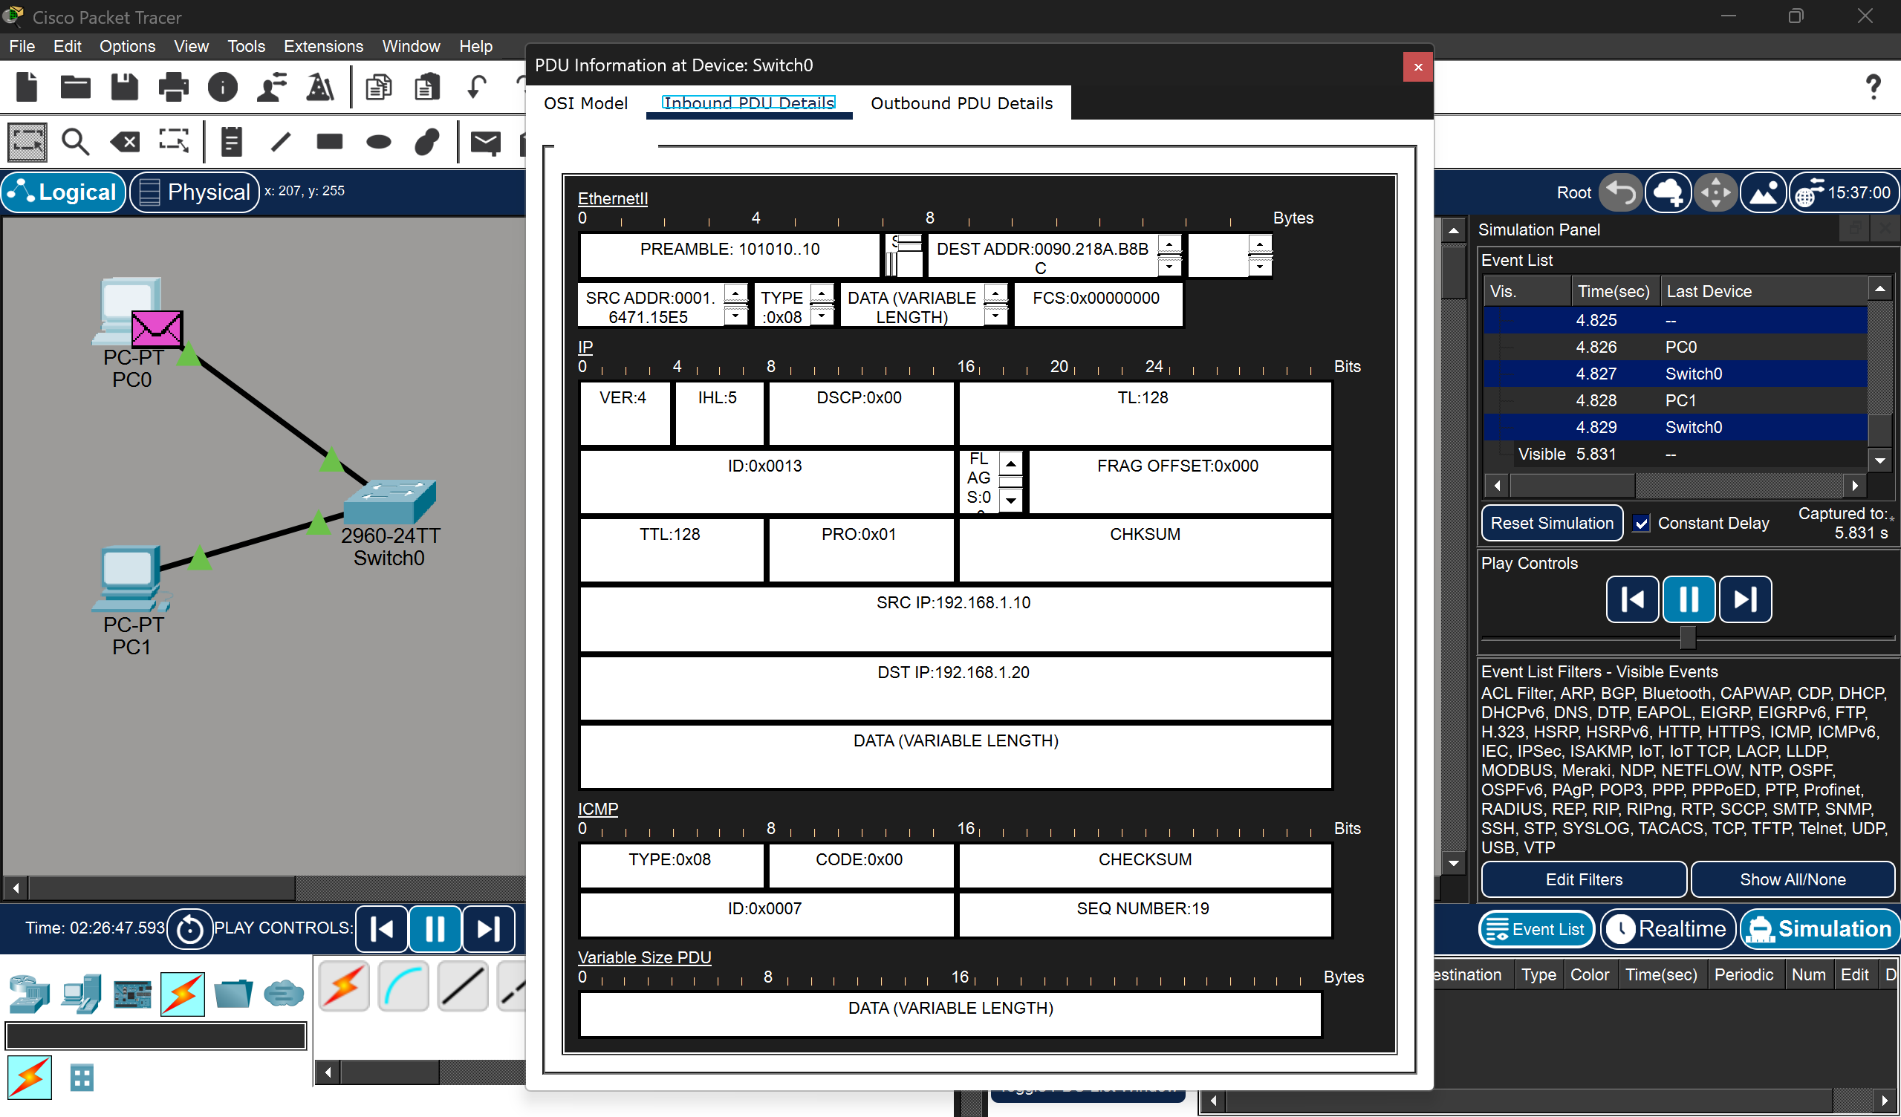

A LAN was simulated using a switch and multiple devices. The switch learned MAC addresses dynamically and forwarded frames efficiently. Ethernet frames were captured and analyzed, showing the role of MAC addressing in communication.
Ethernet Frame Structure
A frame is the data unit sent at the Data Link Layer. It has these main parts:
- Preamble - Used for synchronization between sender and receiver
- Destination MAC Address - Address of the receiver device
- Source MAC Address - Address of the sender device
- Type (Protocol) - Tells which protocol is inside (like IP, ARP)
- Data (Payload) - Actual data being sent (IP packet, ICMP, etc.)
- FCS (Frame Check Sequence)
Here,
SRC IP: 192.168.1.10
DST IP: 192.168.1.20
Protocol: ICMP (Ping)
Each frame contains source and destination MAC addresses, EtherType, payload, and FCS. These components enable reliable and efficient data transmission at the data link layer.

- Configure static IP, modify MAC address, and verify connectivity

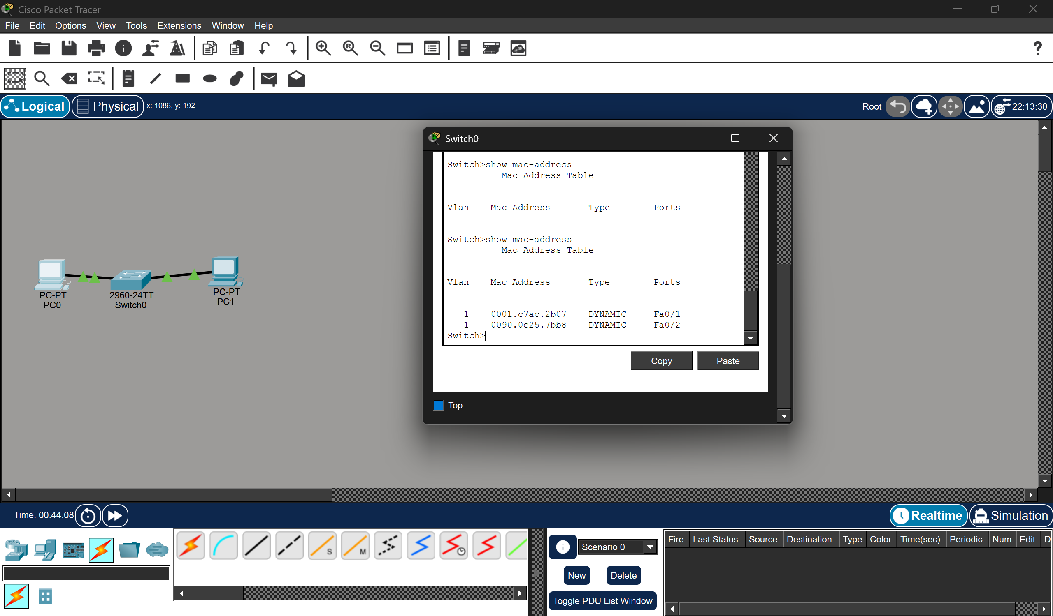

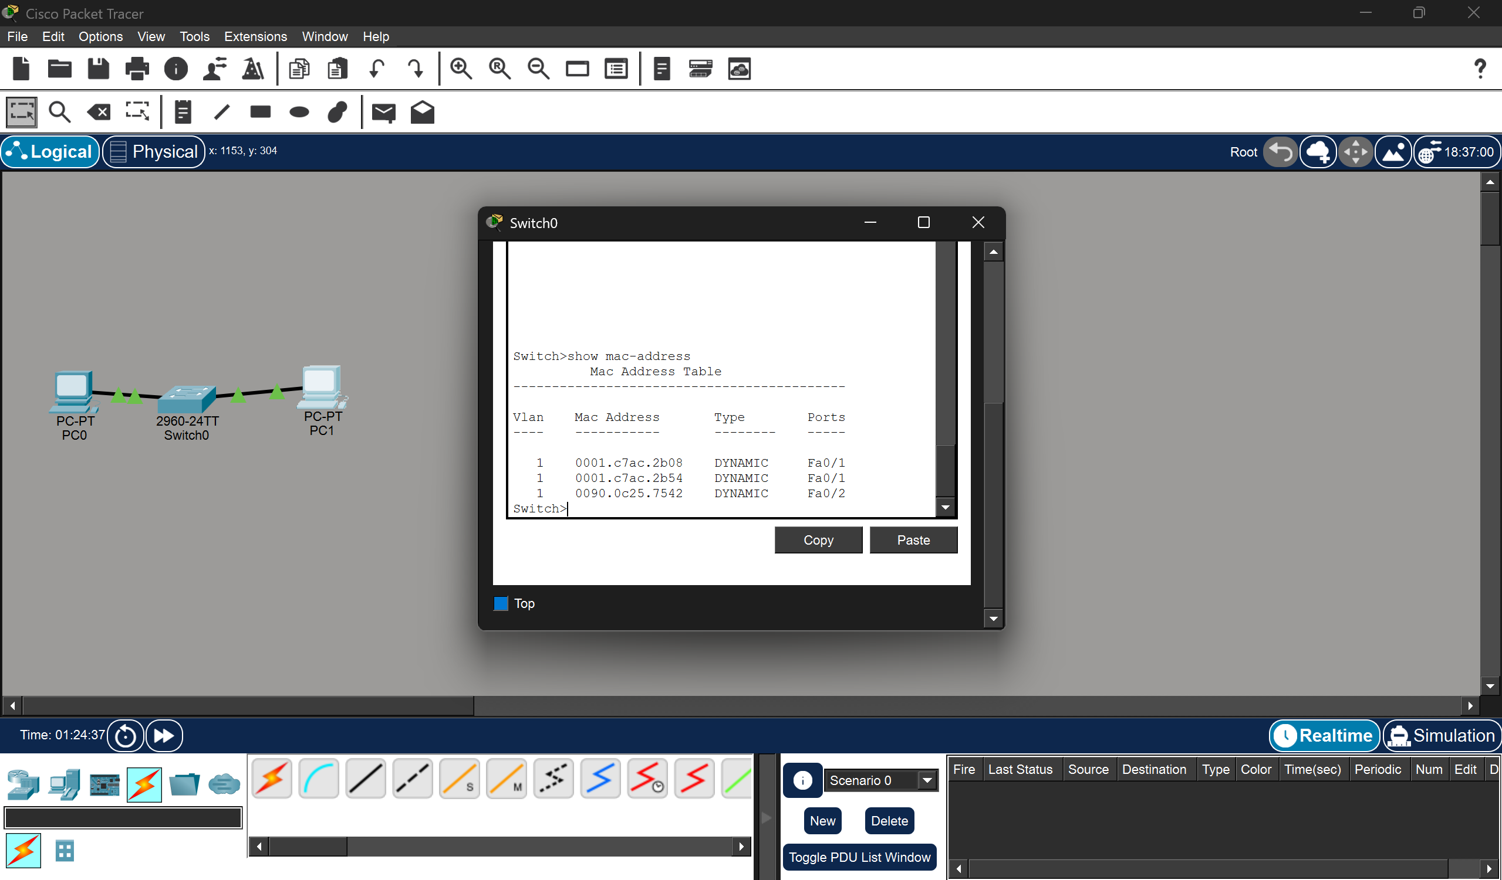
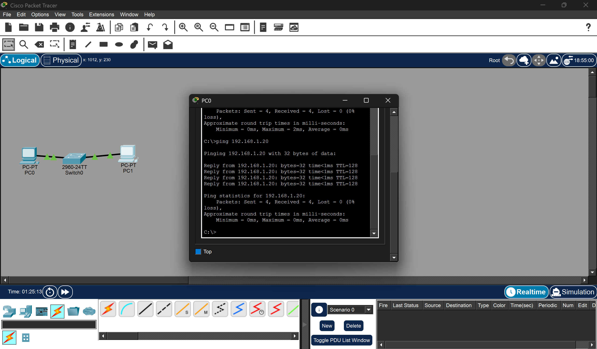

- IP address is logical address
- MAC address is physical (hardware) address
- MAC address can be changed
- Network still works after MAC change

- Troubleshoot Ethernet communication using ping and traceroute (Cisco Packet Tracer)

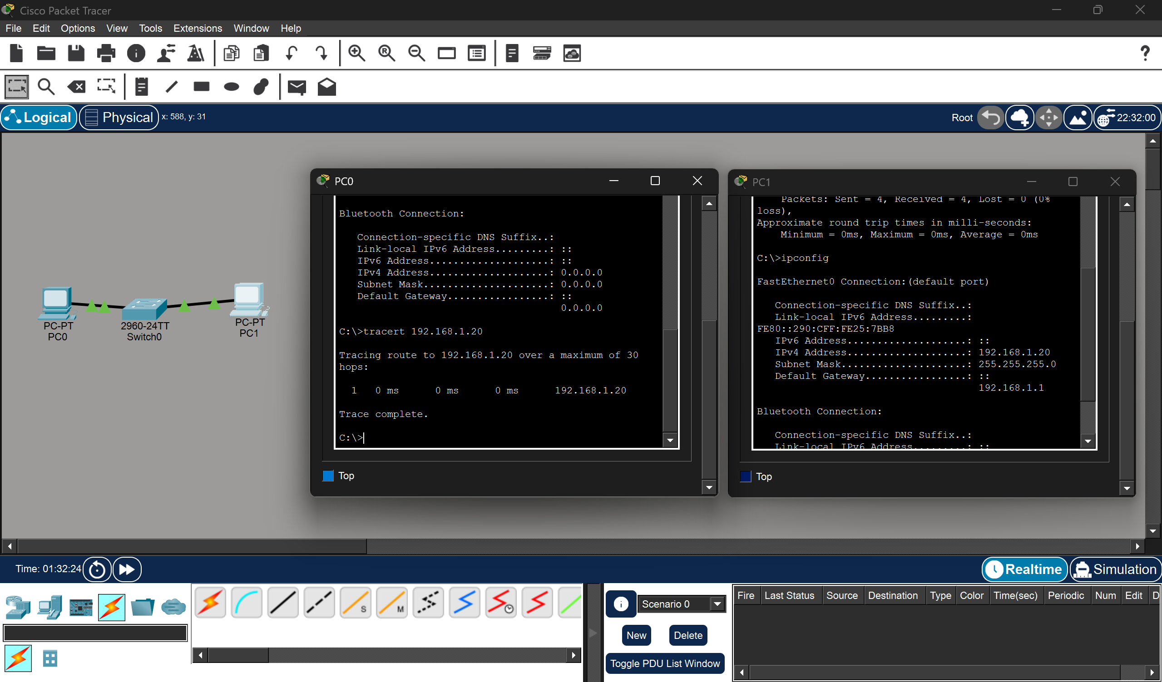
- ping checks connectivity
- traceroute shows path
- Errors help identify problem location
- Most issues are configuration mistakes
Ethernet communication was tested and troubleshot using ping and traceroute. Issues such as incorrect IP configuration and network connectivity were identified and resolved using systematic troubleshooting techniques.

- Create a simple LAN with two Linux machines via switch

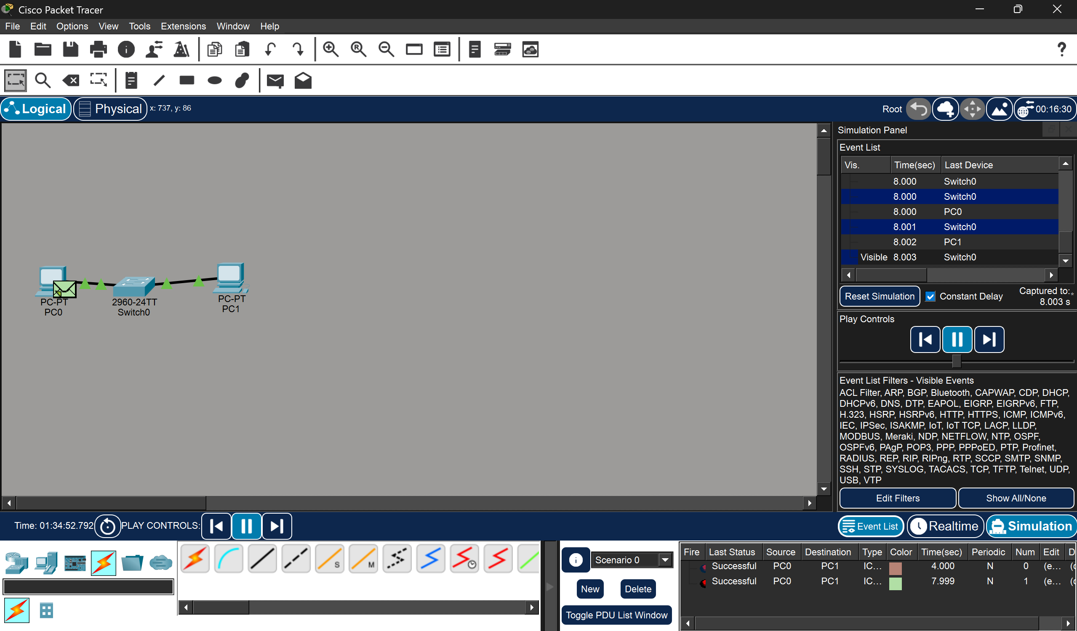

A simple LAN was successfully created using two Linux machines connected via a switch. The connection between the two Linux machines have been tested using the ping command and ensured.

- Linux Kernel’s handling of Ethernet devices

Linux Kernel Support for Ethernet Communication
The Linux kernel provides robust support for Ethernet communication through a modular and layered networking architecture.
a) Network Device Abstraction
- The kernel represents each network interface (e.g., eth0, enp0s3) as a network device (net_device).
- This abstraction allows uniform handling of different hardware (Ethernet, Wi-Fi, etc.).
b) Device Drivers
Ethernet hardware is managed by device drivers in the kernel.
These drivers:
- Handle packet transmission and reception
- Communicate with NIC (Network Interface Card)
- Use interrupts or polling (NAPI – New API)
c) Networking Stack Layers
Linux follows a layered architecture similar to the OSI model:
- Application Layer
- Transport Layer (TCP/UDP)
- Network Layer (IP)
- Data Link Layer (Ethernet)
- Physical Layer
Ethernet operates at the Data Link Layer. Frames are encapsulated/decapsulated here.
d) Packet Flow in Linux
- Outgoing packets:
Application → TCP/UDP → IP → Ethernet → NIC
- Incoming packets:
NIC → Ethernet → IP → TCP/UDP → Application
e) Socket Interface
- Applications interact with the kernel using sockets API.
- The kernel handles routing, fragmentation, and delivery.
f) Kernel Features Supporting Ethernet
- ARP (Address Resolution Protocol) – maps IP to MAC
- Bridging & Switching – via bridge module
- Traffic Control (tc) – QoS support
- Netfilter – firewall (iptables/nftables)

- Basic LAN interface using the ip command in Linux

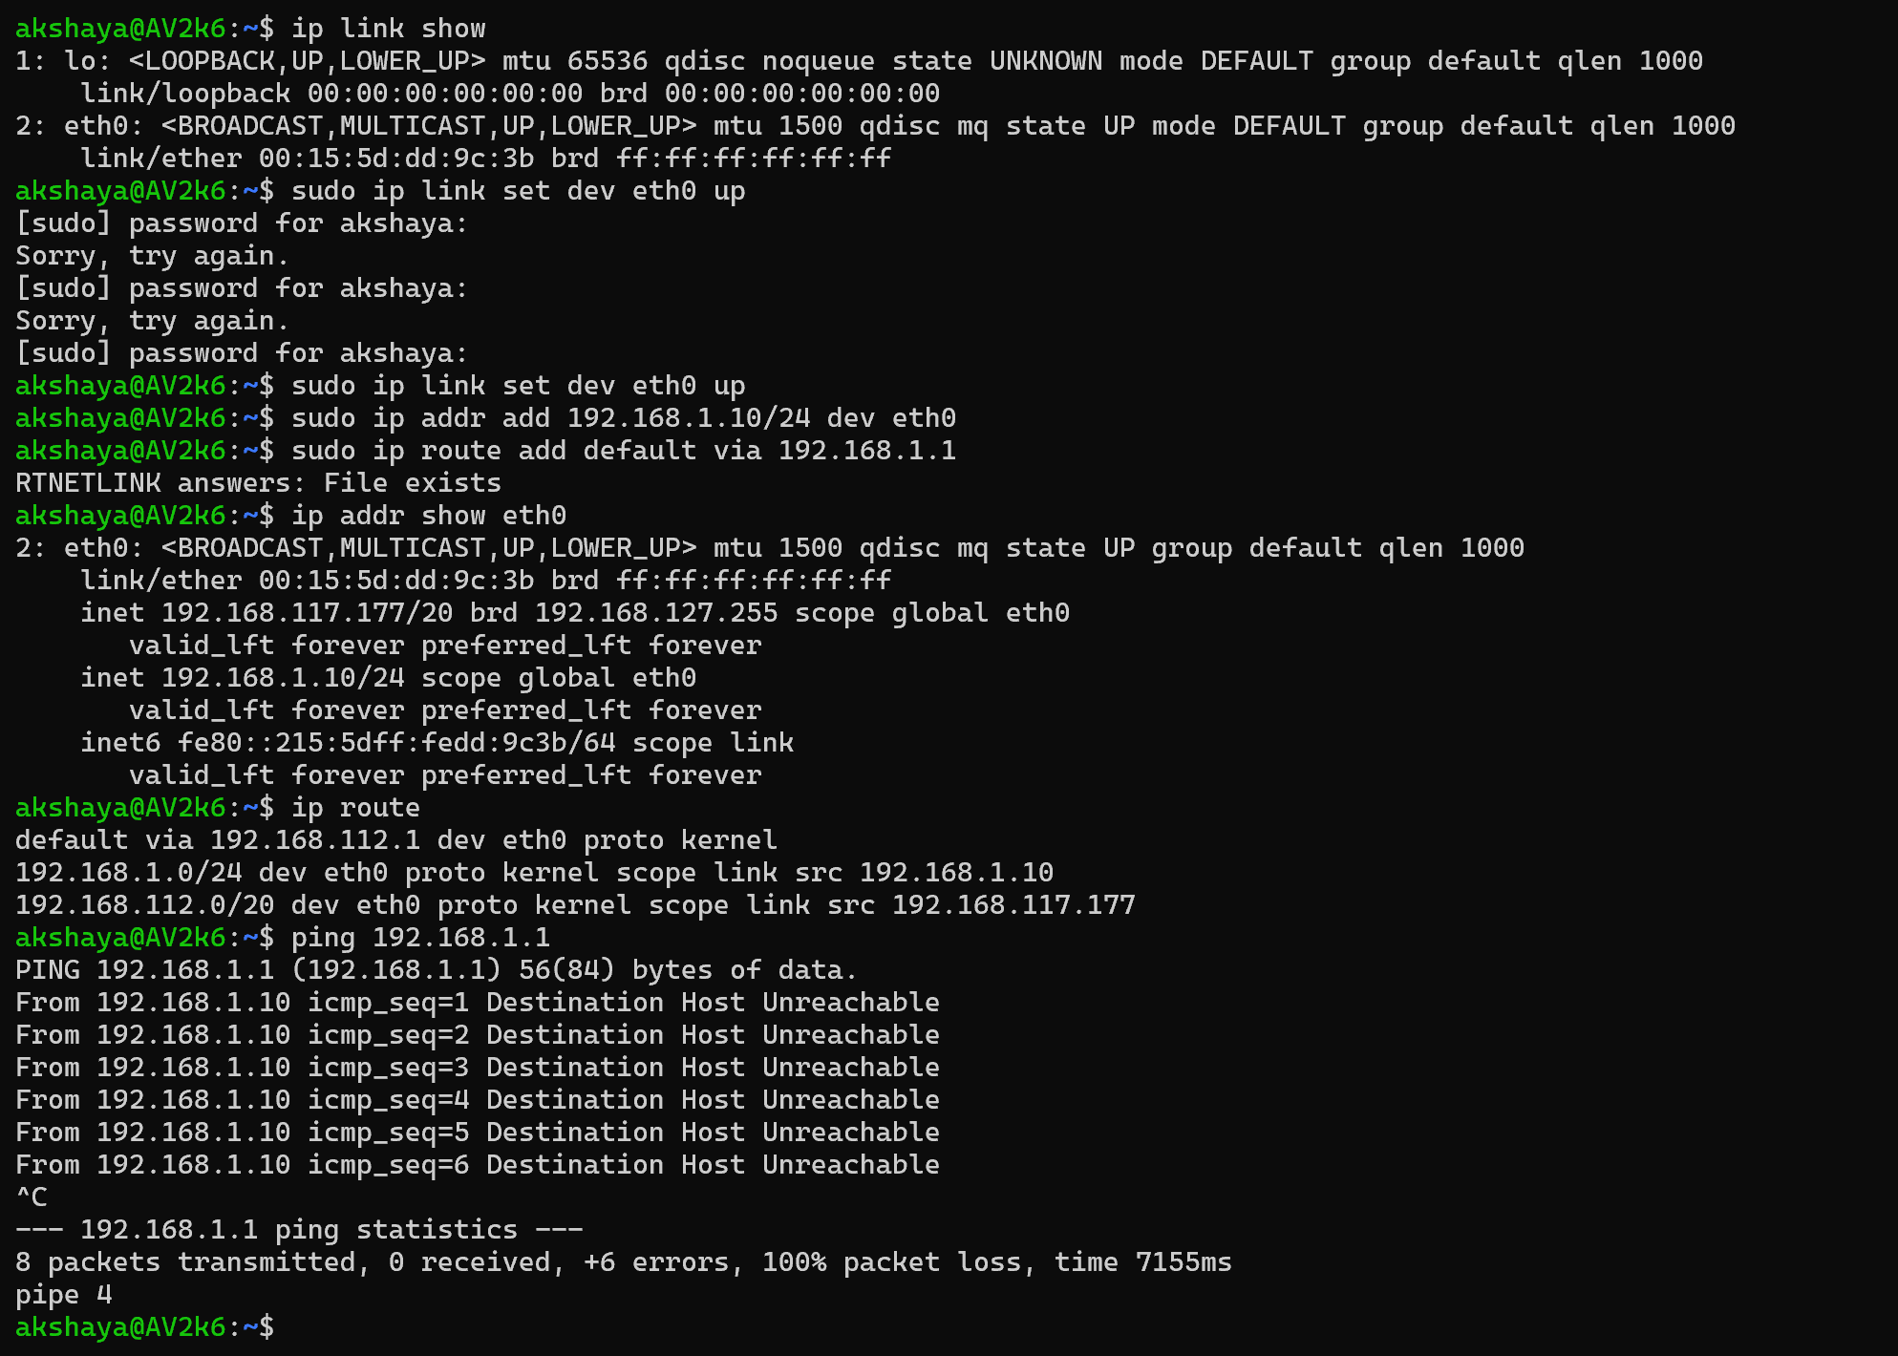

To configure a basic LAN interface using the ip command in Linux, you use a series of commands to set the IP address, bring the interface up, and add a default route. Changes made with the ip command are temporary and will be lost after a system reboot.

  - Linux kernel provides efficient Ethernet handling via modular drivers and networking stack.
  - The ip tool simplifies network configuration compared to older tools (ifconfig).
  - Linux bridges act like software switches:
    - Learn MAC addresses dynamically
    - Maintain forwarding tables
  - MAC tables improve efficiency by reducing unnecessary broadcasts.

- MAC address table of a switch

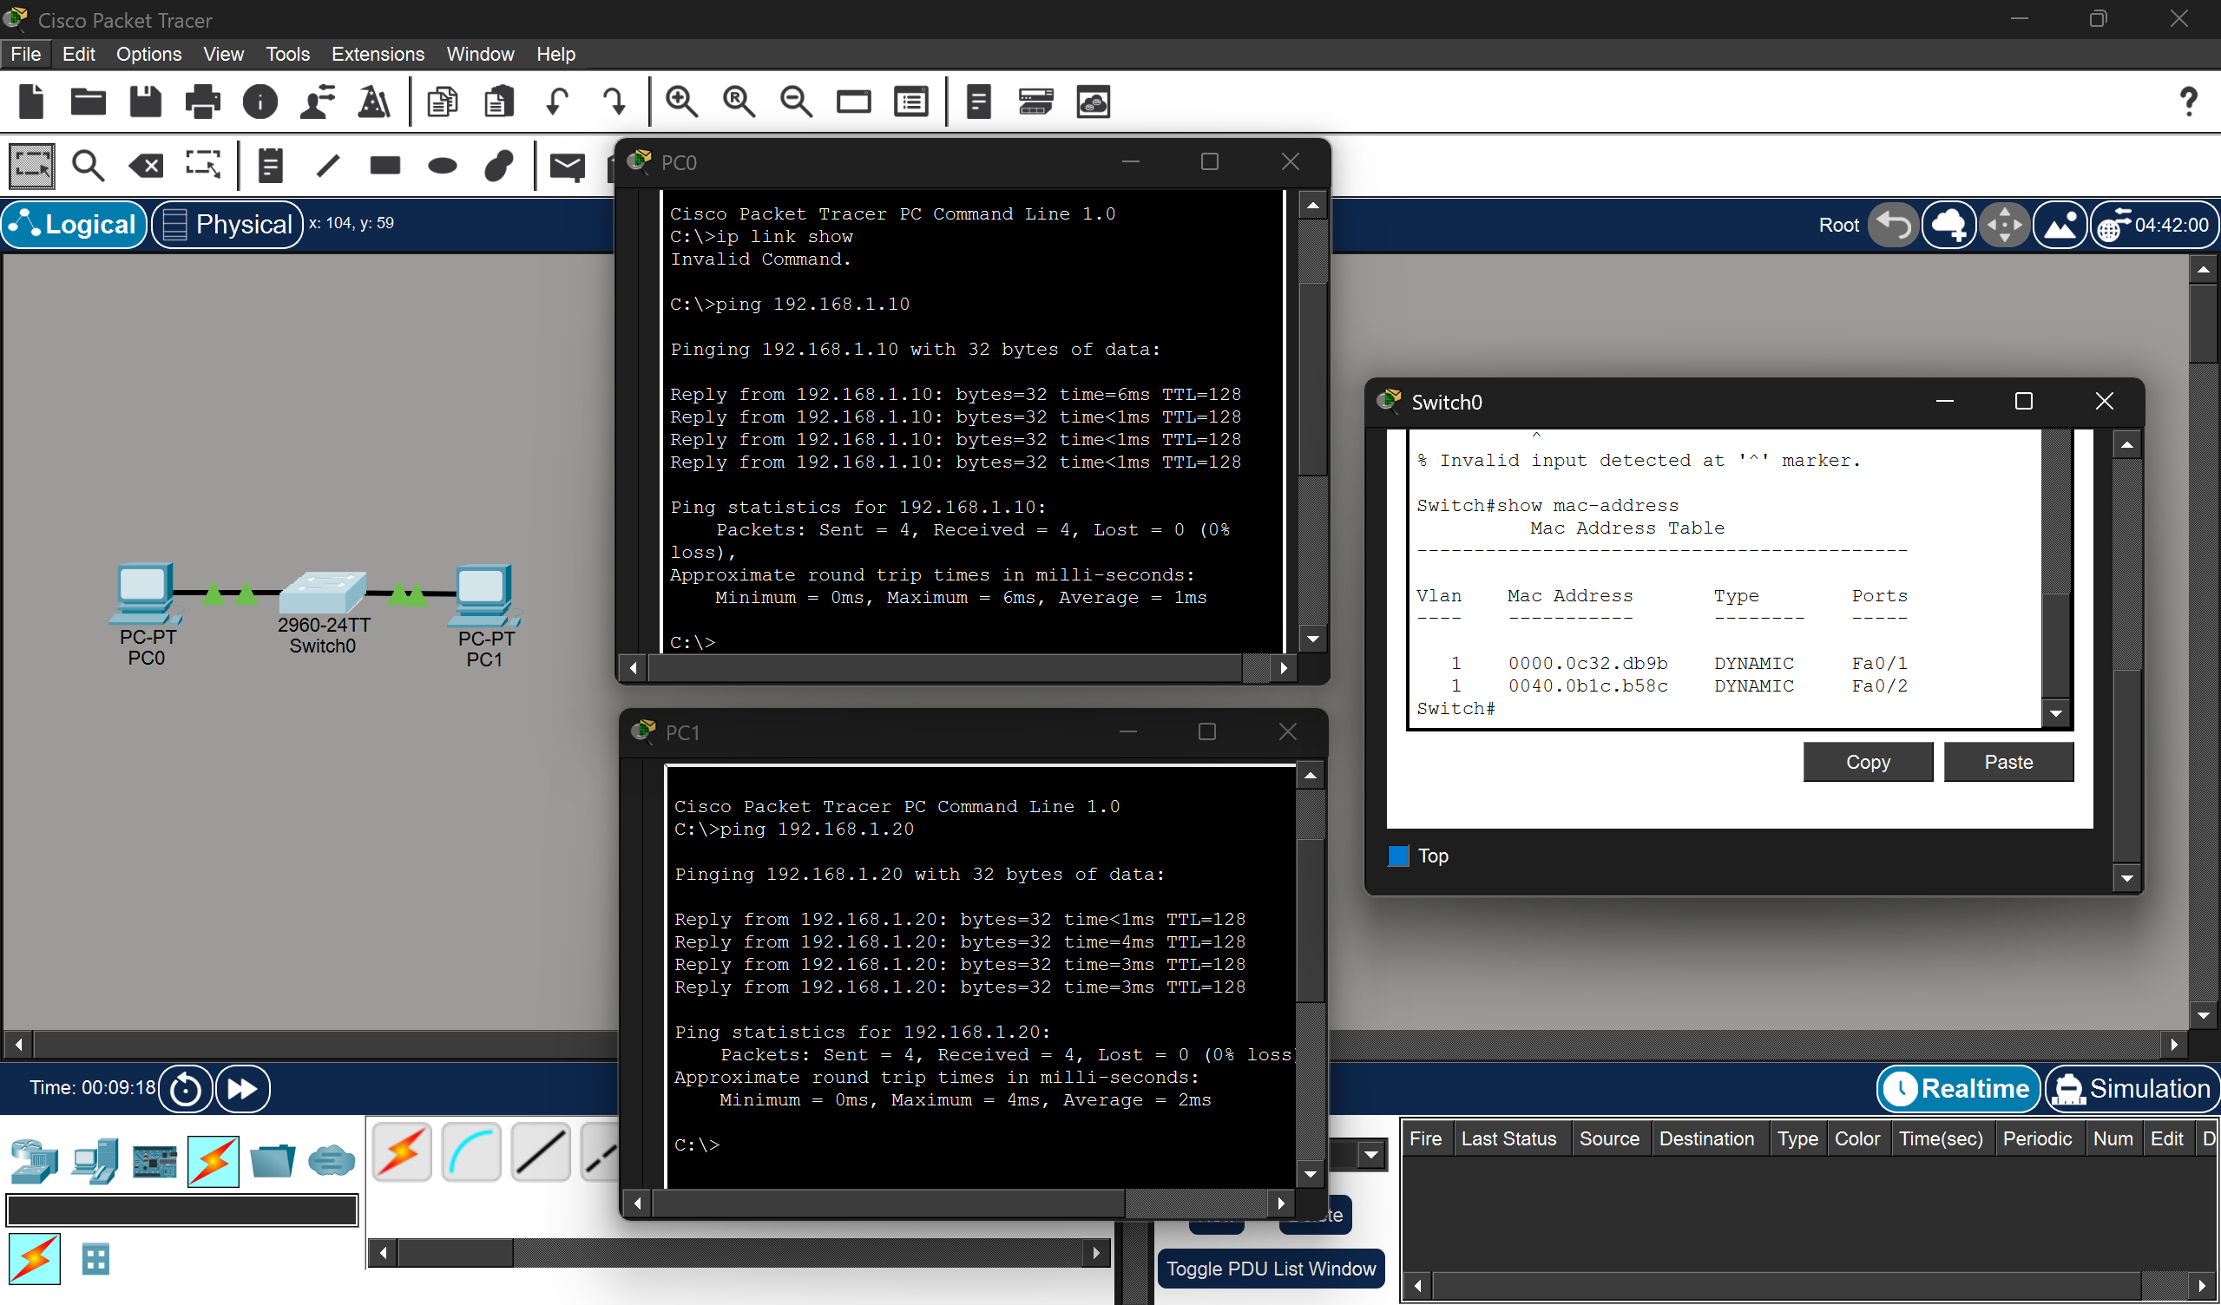

A switch's MAC address table is a dynamic database stored in memory that maps connected device MAC addresses to specific physical ports and VLANs. It enables efficient Layer 2 unicast forwarding, preventing network flooding. The switch populates this table by observing the source MAC address of incoming frames.

