Week 2 Report
Exploratory Data Analysis & Visualization
Junior Data Analyst - Agribusiness Virtual Internship
Name: Akshaya

1. Introduction
Exploratory Data Analysis (EDA) is the step where an analyst looks at cleaned data to understand its shape, spot trends and find unusual values before any modelling is done. In agribusiness, this helps answer practical questions such as which regions produce the most, which seasons perform best and how land area relates to output.
This report builds on the cleaned dataset prepared in Week 1. It presents seven visualizations, each with a caption and commentary, and combines the findings into a short narrative with business implications.

2. Review of the Cleaned Dataset
The dataset used is the cleaned India crop production data from Week 1. Key variables are listed below.
Variable | Type | Meaning
state_name | Categorical | State where the crop was grown
district_name | Categorical | District within the state
crop_year | Numeric (year) | Year of the record
season | Categorical | Growing season (Kharif, Rabi, Whole Year, etc.)
crop | Categorical | Name of the crop
area | Numeric | Land area under the crop
production | Numeric | Quantity produced
yield | Numeric (derived) | production divided by area, a measure of productivity

3. Key Areas of Analysis and Hypotheses
Before creating charts, I decided on four key areas and formed a preliminary hypothesis for each:
No. | Area | Hypothesis
H1 | Distribution of production | Production is highly skewed: most records are small and a few are very large.
H2 | Seasonal performance | Yield differs between seasons, so some seasons are more productive.
H3 | Regional concentration | A small number of states contribute most of the total production.
H4 | Trend over time | Total production changes over the years rather than staying constant.
H5 | Area and production | Larger area is associated with higher production, but not perfectly.

Methodology: Python (pandas for summaries, Matplotlib and Seaborn for charts) in Google Colab. Large skewed values were viewed on a log scale, and a few extreme yield values were hidden in the box plot for readability only (the data itself was not changed).

4. Visualizations and Analysis
Each visualization below includes the code used, the chart, a caption and commentary.

4.1 Distribution of Production
Chart type: Histogram. Related hypothesis: H1.
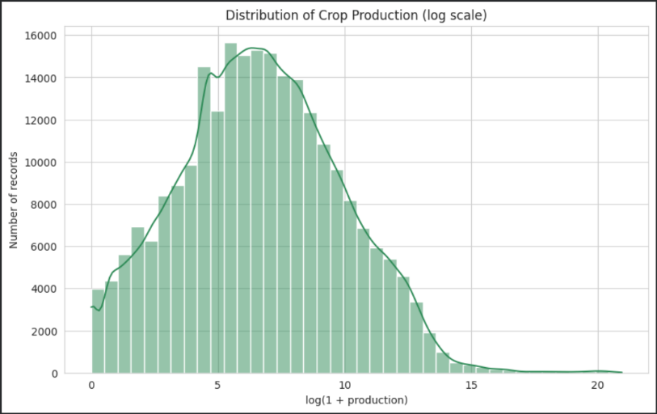
sns.histplot(np.log1p(df['production']), bins=40, kde=True)
Figure 1: Distribution of crop production (log scale).

4.2 Yield by Season
Chart type: Box plot. Related hypothesis: H2.
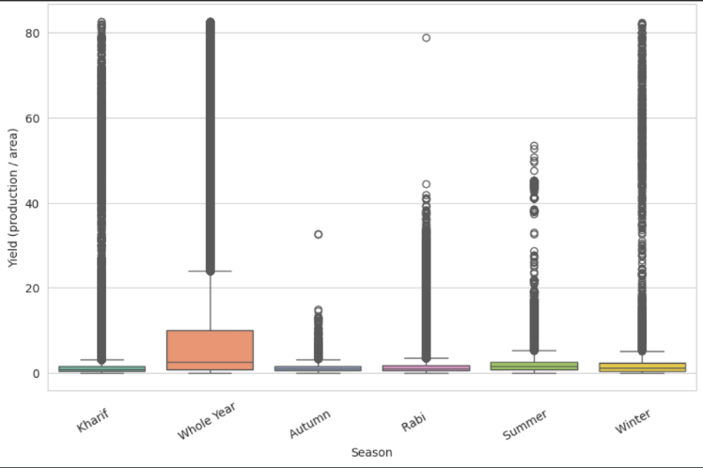
sns.boxplot(data=plot_df, x='season', y='yield')
Figure 2: Yield compared across growing seasons.

4.3 Top 10 States by Total Production
Chart type: Horizontal bar chart. Related hypothesis: H3.
top_states = df.groupby('state_name')['production'].sum().sort_values(ascending=False).head(10)
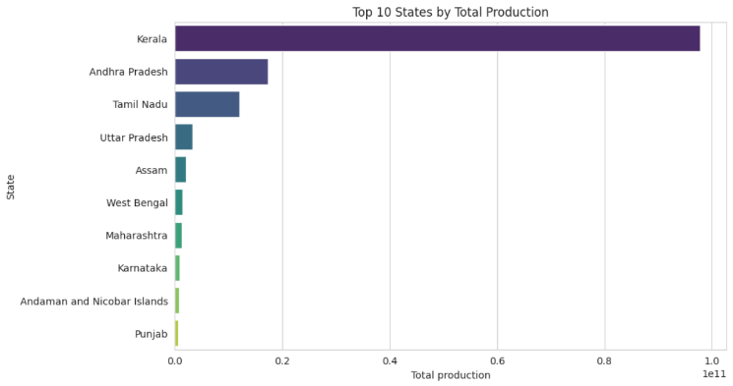
Figure 3: Ten states with the highest total production.

4.4 Production Trend Over the Years
Chart type: Line graph. Related hypothesis: H4.
yearly = df.groupby('crop_year')['production'].sum()
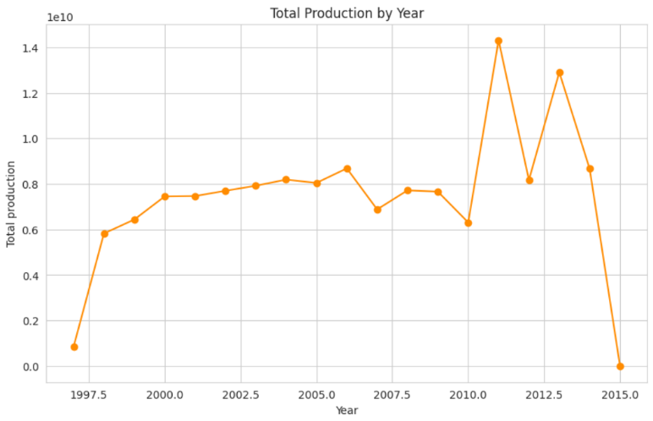
plt.plot(yearly.index, yearly.values, marker='o')
Figure 4: Total production by year.

4.5 Area vs Production
Chart type: Scatter plot. Related hypothesis: H5.
sns.scatterplot(data=sample, x='area', y='production', alpha=0.4)
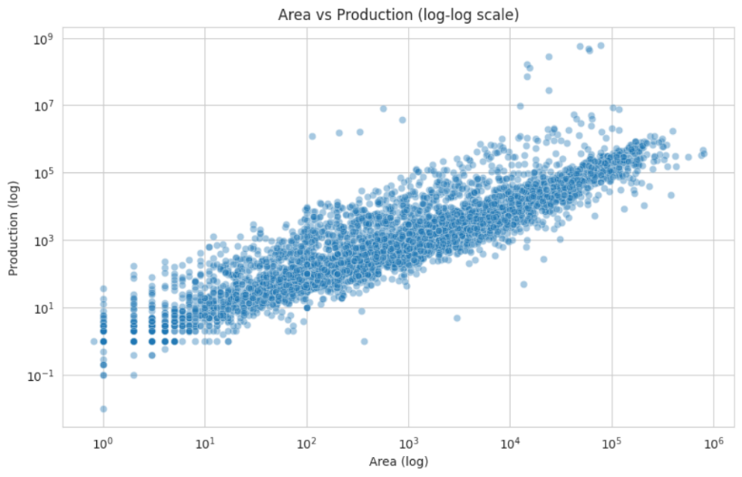
plt.xscale('log'); plt.yscale('log')
Figure 5: Relationship between cultivated area and production (log-log).

4.6 Correlation Matrix
Chart type: Heatmap. Related hypothesis: H5.
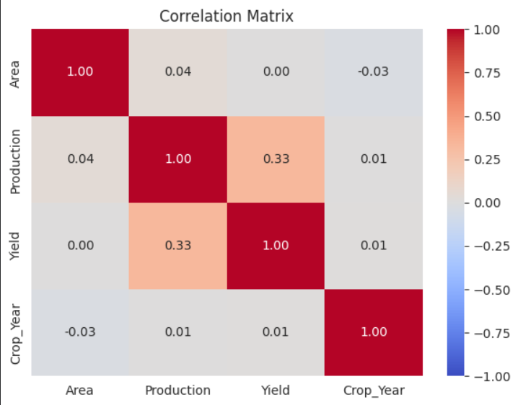
sns.heatmap(num.corr(), annot=True, cmap='coolwarm', vmin=-1, vmax=1)
Figure 6: Correlation between area, production, yield and year.

4.7 Average Yield of Common Crops
Chart type: Horizontal bar chart. Related hypothesis: H2.
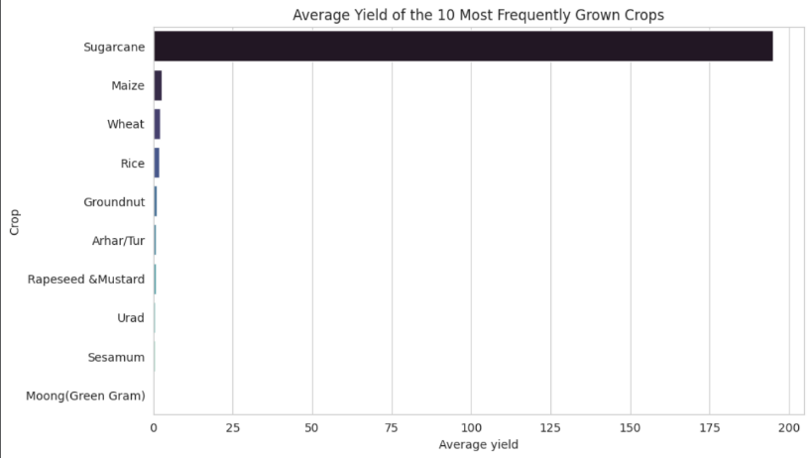
avg_yield = df[df['crop'].isin(top_crops)].groupby('crop')['yield'].mean().sort_values(ascending=False)
Figure 7: Average yield of the ten most frequently recorded crops.

5. Summary of Findings
No. | Hypothesis | Result (fill from your charts)
H1 | Production is highly skewed | [SUPPORTED / NOT SUPPORTED, and why]
H2 | Yield differs by season | [SUPPORTED / NOT SUPPORTED, and why]
H3 | A few states dominate production | [SUPPORTED / NOT SUPPORTED, and why]
H4 | Production changes over time | [SUPPORTED / NOT SUPPORTED, and why]
H5 | Area is linked to production | [SUPPORTED / NOT SUPPORTED, and why]

Narrative: [WRITE ONE PARAGRAPH CONNECTING YOUR CHARTS INTO A STORY, e.g. which states, seasons and crops matter most, and how production has changed over time.]

6. Anomalies and Patterns Observed
- [ANOMALY 1, e.g. a year with unusually low production and whether it is due to fewer records]
- [ANOMALY 2, e.g. a crop with extremely high yield and possible reason such as different measurement units]
- [PATTERN, e.g. one season producing far more than the others]

7. Business Implications
[WRITE 3 TO 4 SENTENCES: how an agribusiness could use these findings, for example focusing supply chains on high-producing states, planning inventory around the strongest season, or investigating low-yield crops for improvement.]

8. Challenges Faced
- Heavily skewed values made normal charts unreadable, so log scales were used.
- A few extreme values squeezed the box plot, so the top 1 percent of yield was hidden in that chart only.
- Too many points in the scatter plot, so a random sample of records was plotted.
- [ADD ANY CHALLENGE YOU PERSONALLY FACED]

9. Conclusion
This EDA used seven visualizations to examine distribution, seasonality, regional concentration, time trends and the relationship between area and production. The analysis confirmed which patterns are present in the data, highlighted anomalies that need care when interpreting results, and prepared a clear base for deeper analysis in the following weeks.

10. References
- Cleaned dataset from Week 1: cleaned_crop_production.csv
- Matplotlib documentation: https://matplotlib.org
- Seaborn documentation: https://seaborn.pydata.org
- pandas documentation: https://pandas.pydata.org/docs

