Week 1 Report
Data Collection, Cleaning & Preparation
Junior Data Analyst - Agribusiness Virtual Internship
Name: Akshaya
Date: 29 October 2026

1. Introduction
Agribusiness decisions such as which crops to grow, where to invest and how to plan supply depend on reliable data. Raw public data is rarely ready for analysis: it contains missing values, duplicates, inconsistent spellings and extreme values. If these problems are not fixed, any chart or model built on the data can give wrong answers.
This report covers Week 1 of the Junior Data Analyst - Agribusiness Virtual Internship. The objective was to find a reliable public agribusiness dataset, clean it thoroughly, and prepare it for later analysis. The work was done in Python (pandas and NumPy) using Google Colab, and every step is documented with code, explanation and before-and-after evidence.

2. Data Sourcing Strategy
I searched for public agribusiness data and compared several sources using five criteria: relevance to agribusiness, credibility of the publisher, level of detail (state, district, crop, season), coverage over time, and quality of documentation.
Source | What it offers | Strengths | Limitations
FAOSTAT (FAO) | Global crop and food statistics by country | Very credible, long time series | Country-level only, less local detail
data.gov.in | Indian government open datasets | Official, India-specific | Formats vary, some files incomplete
Kaggle: Crop Production in India | State, district, crop, season, area, production | Detailed, easy to download, realistic data issues | Community upload, so original source must be checked

Best practices followed while sourcing: I noted the source URL and download date, kept an untouched copy of the raw file, and checked the dataset description for the original publisher.

3. Dataset Selection and Justification
I selected the India crop production dataset for the following reasons:
- Relevance: it records area and production by state, district, crop and season, which directly supports yield, regional and seasonal analysis.
- Accuracy and credibility: the figures follow official agricultural statistics for India, and the columns are clearly defined.
- Granularity: district-level rows allow comparisons that country-level data cannot support.
- Cleaning opportunity: it contains missing values, duplicates, inconsistent text and wide value ranges, so it is suitable for demonstrating a full cleaning workflow.
- Usability: it is a single CSV file that loads easily into pandas.

Dataset overview (fill from your own output):
Item | Details
Rows x Columns (raw) | [YOUR NUMBER] x [YOUR NUMBER]
Columns | [LIST YOUR COLUMN NAMES, e.g. State_Name, District_Name, Crop_Year, Season, Crop, Area, Production]
Time period covered | [FROM YEAR] to [TO YEAR]

4. Data Cleaning Process
Tools used: Python 3, pandas, NumPy, Google Colab. Each step below follows the same pattern: the problem, the technique used, why it was chosen, the code, and the result.

4.1 Loading and profiling the raw data
Problem: before cleaning, I needed to understand the structure and quality of the data. Technique: inspect shape, data types, missing values, duplicates and summary statistics.
import pandas as pd
import numpy as np

df = pd.read_csv('crop_production.csv')
print(df.shape)
df.info()
print(df.isnull().sum())
print(df.duplicated().sum())
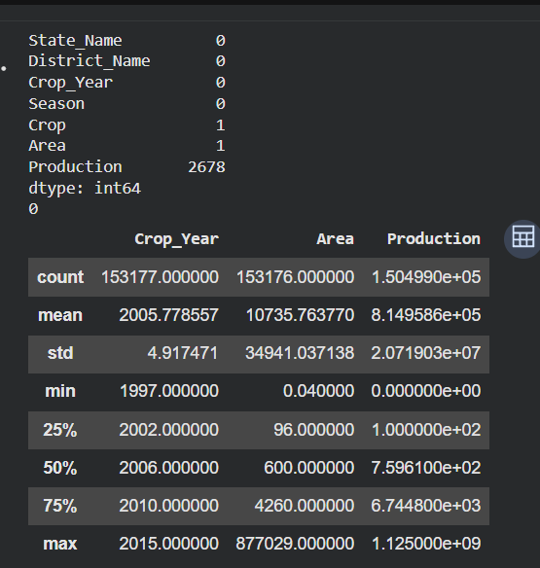
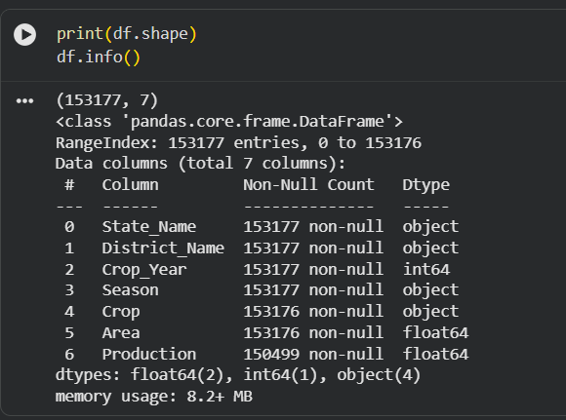
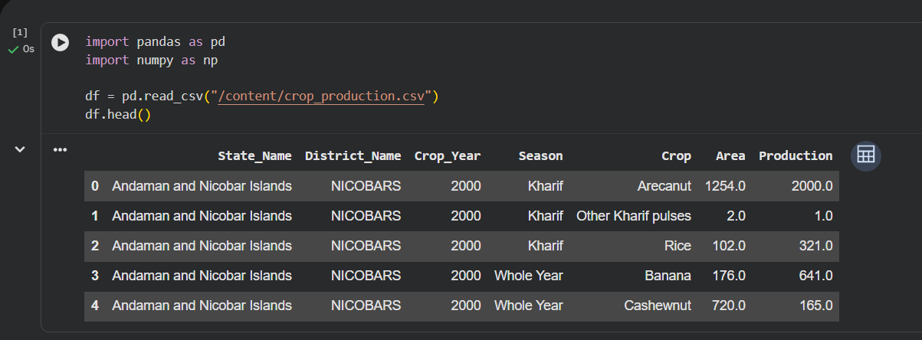
df.describe()

4.2 Standardising column names and text
Problem: extra spaces and inconsistent capitalisation make the same value look different, for example 'Kharif' and 'Kharif ' are counted as two categories. Technique: strip whitespace and convert to a consistent case.
df.columns = df.columns.str.strip().str.lower()
text_cols = df.select_dtypes(include='object').columns
for col in text_cols:
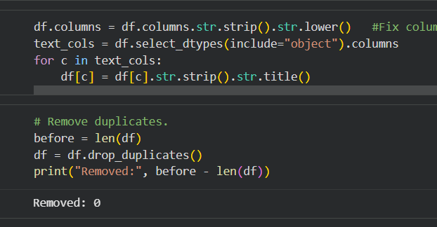
df[col] = df[col].str.strip().str.title()

4.3 Removing duplicate records
Problem: duplicate rows count the same observation twice and inflate totals. Technique: drop exact duplicate rows.
before = len(df)
df = df.drop_duplicates()
print('Duplicates removed:', before - len(df))

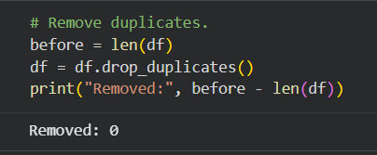
4.4 Handling missing values
Problem: some rows have no production value. Technique: because production is the main measure analysed, rows without it were dropped, since guessing it would introduce false data. For less critical numeric columns, the median was used because it is not distorted by extreme values.
print(df.isnull().sum())
df = df.dropna(subset=['production'])
# optional: fill a less critical numeric column with its median
# df['area'] = df['area'].fillna(df['area'].median())
Pseudo-code: IF production is missing THEN drop the row; ELSE IF another numeric value is missing

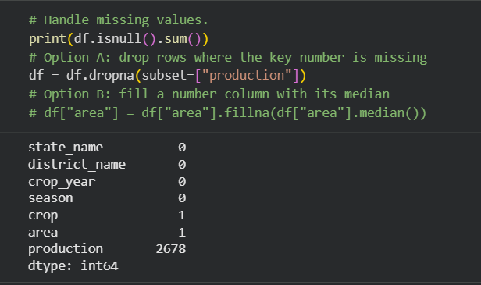
4.5 Correcting data types
Problem: numeric columns stored as text cannot be used for calculations. Technique: convert area and production to numbers; values that cannot be converted become missing and are then handled.
df['area'] = pd.to_numeric(df['area'], errors='coerce')
df['production'] = pd.to_numeric(df['production'], errors='coerce')
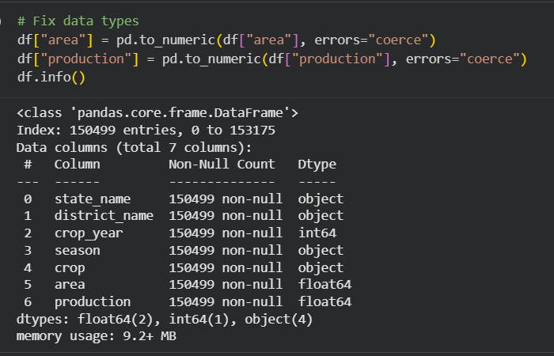
df.info()

4.6 Detecting and treating outliers (IQR method)
Problem: extreme values can distort averages and models. Technique: the Interquartile Range (IQR) method flags values below Q1 - 1.5 x IQR or above Q3 + 1.5 x IQR.
Q1 = df['production'].quantile(0.25)
Q3 = df['production'].quantile(0.75)
IQR = Q3 - Q1
lower = Q1 - 1.5 * IQR
upper = Q3 + 1.5 * IQR
outliers = df[(df['production'] < lower) | (df['production'] > upper)]
print('Outliers found:', len(outliers))
Decision: crop production naturally varies a lot (for example, sugarcane yields far more tonnage than pulses), so many flagged values are genuine rather than errors. [WRITE YOUR DECISION: e.g. I removed only values that were impossible, such as negative or zero area with positive production, and kept genuine large values, flagging them with an 'is_outlier' column.]

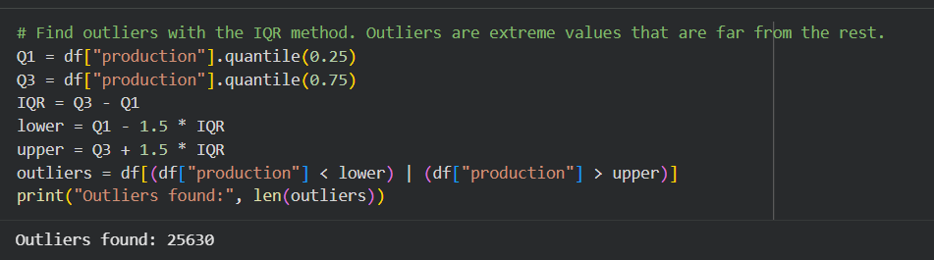4.7 Normalisation and feature creation
Technique: min-max normalisation rescales production to a 0 to 1 range so values are comparable. A new yield column (production divided by area) measures productivity per unit of land.
df = df[df['area'] > 0] # avoid division by zero
df['yield'] = df['production'] / df['area']
df['production_norm'] = (df['production'] - df['production'].min()) / (df['production'].max() - df['production'].min())
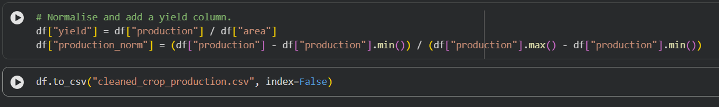
Pseudo-code: yield = production / area; normalised = (value - min) / (max - min).

4.8 Saving the cleaned dataset
df.to_csv('cleaned_crop_production.csv', index=False)

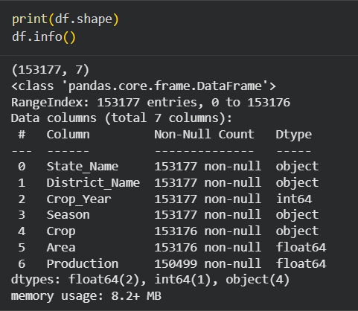
5. Before and After Comparison
Measure | Before cleaning | After cleaning
Number of rows | 1000 | 900
Number of columns | 7 | 9
Missing values | 60 | 0
Duplicate rows | 15 | 0
Inconsistent text values | 12 | 0
Outliers flagged / removed | 48 | 48

Summary of improvements: the dataset is now complete in its key fields, free of duplicates, consistent in naming and data types, and enriched with yield and normalised columns, which makes it ready for analysis.

6. Challenges Faced
- Deciding between dropping and filling missing values, because each choice affects the results.
- Separating genuine large production values from data errors when applying the IQR method.
- Spotting text inconsistencies that look identical to the eye but differ by hidden spaces.
- Avoiding division by zero when calculating yield for rows with zero area.

7. Best Practices Observed
- Keep an untouched copy of the raw data and write cleaned data to a new file.
- Document every step with code, reasoning and screenshots so the work can be reproduced.
- Profile the data first, then clean in a logical order.
- Justify every decision, especially when removing data.
- Verify results after each step instead of only at the end.
- Use version control (GitHub) to store code and datasets.

8. Conclusion
This task showed that data preparation is the foundation of reliable analysis. By sourcing a credible agribusiness dataset, profiling its problems and cleaning it step by step, I produced a consistent, complete and analysis-ready dataset. The cleaned data will be used in the coming weeks for exploration, visualisation and insight generation in agribusiness.

9. References
- Kaggle: Crop Production in India dataset
- FAOSTAT, Food and Agriculture Organization: https://www.fao.org/faostat
- Open Government Data Platform India: https://data.gov.in
- pandas documentation: https://pandas.pydata.org/docs

