**1.Create a new React Application with the name “myfirstreact”, Run the application to print “welcome to the first session of React” as heading of that page.**

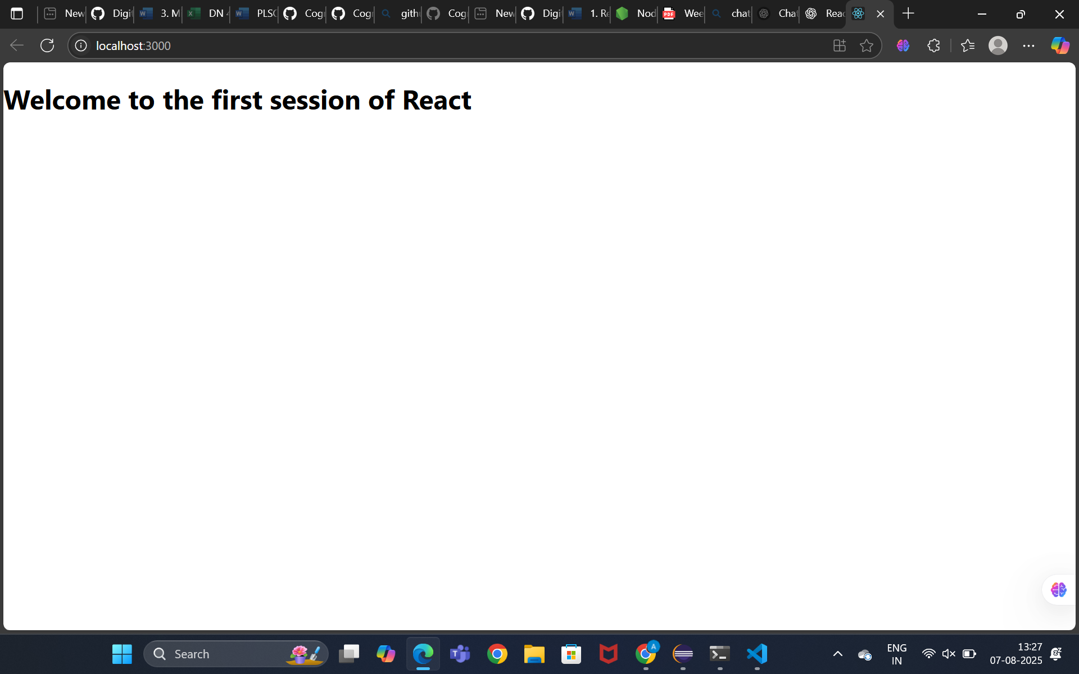

App.js   
import React from 'react';

function App() {

  return (

    <div>

      <h1>Welcome to the first session of React</h1>

    </div>

  );

}

export default App;

**2.Create a react app for Student Management Portal named StudentApp and create a component named Home which will display the Message “Welcome to the Home page of Student Management Portal”. Create another component named About and display the Message “Welcome to the About page of the Student Management Portal”. Create a third component named Contact and display the Message “Welcome to the Contact page of the Student Management Portal”. Call all the three components.**

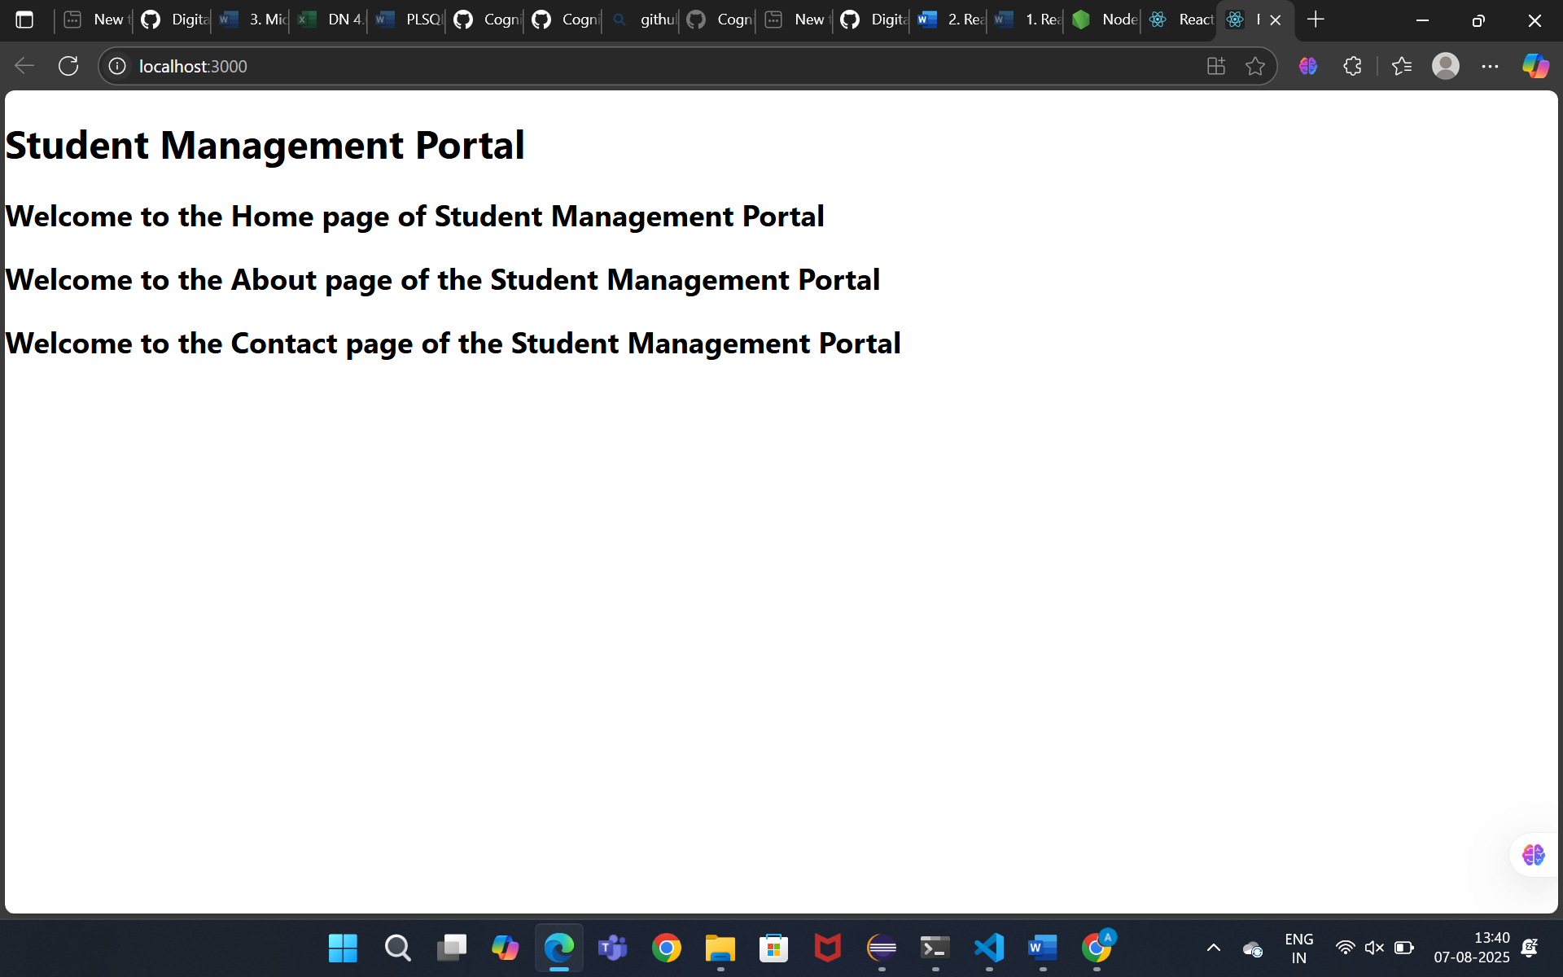

Home.js  
import React from 'react';

function Home() {

  return (

    <div>

      <h2>Welcome to the Home page of Student Management Portal</h2>

    </div>

  );

}

export default Home;

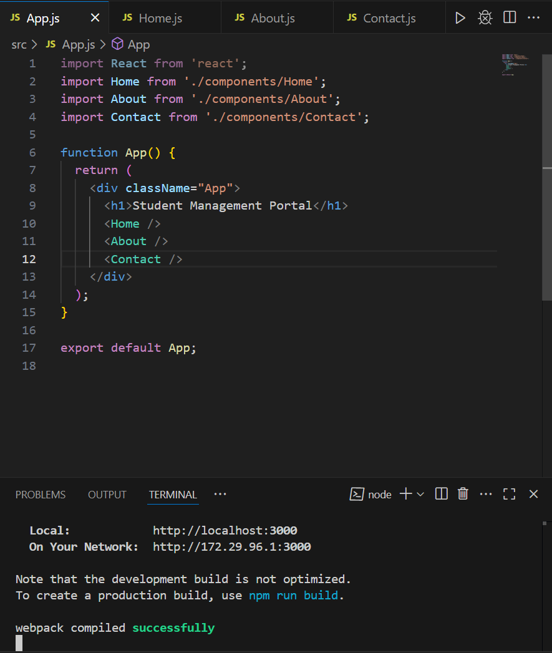

**3.Estimated time to complete this lab: 30 minutes.**

**Create a react app for Student Management Portal named scorecalculatorapp and create a function component named “CalculateScore” which will accept Name, School, Total and goal in order to calculate the average score of a student and display the same.**

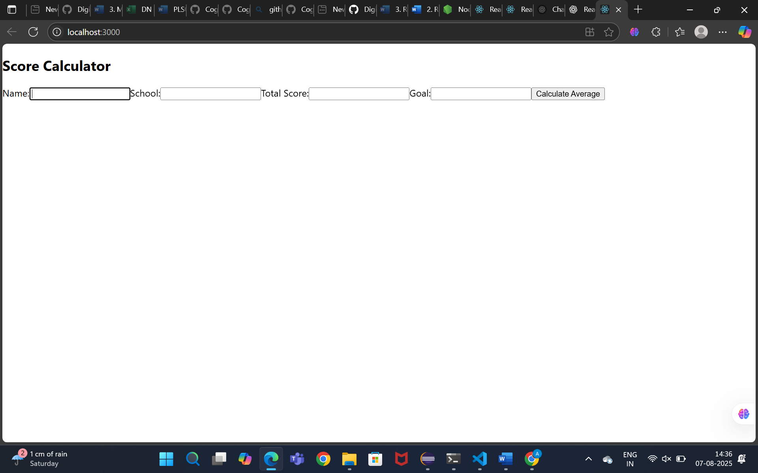

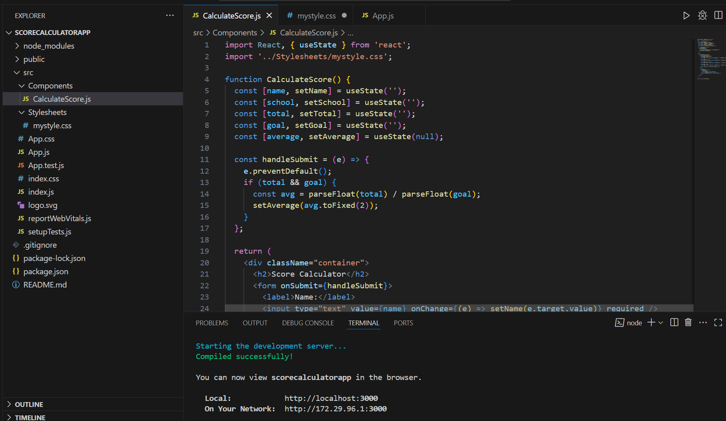

**4. Create a new react application using create-react-app tool with the name as “blogapp”the application using VS Code Create a new file named as Post.js in src folder with following properties**

// src/App.js

import React from 'react';

import './App.css';

import Posts from './Posts';

function App() {

return (

<div className="App">

<h1>My Blog App</h1>

<Posts />

</div>

);

}

export default App;

