**Project Title:**

E-HOSPITAL

**Team Members:**

Abhishek T – 18MIS1078

Akshayavarshini S – 18MIS1009

SubhaShri S – 18MIS1088

**E-HOSPITAL**

**Abstract:**

e-hospital is an online registration services framework portal. People can avail online services like registration and appointment, pay fees, view diagnostics reports and check for the supply of blood in government hospitals and use it for emergency purpose. Many people found helpful in using e-hospital as their source of communication in emergency situation. Through this type of service, securing a meeting in outpatient department (OPD), lab reports, availability of blood are often checked online. It has eased out the hardship undergone by a private , who otherwise has got to run from one pillar to a different pillar to secure blood during the hospitalization period.

**Introduction:**

eHospital Systems may be a customizable, comprehensive, and integrated Hospital Management System designed to manage all hospital operations. Multi-Location functionality allows your hospitals and medical stores to be interconnected. Traditional approaches takes longer time than these way. The customizable alert software sends the text and email reminders and improves the quality of patient care. This hospital management software helps you to remember of revenue streams, patient records, and other critical metrics in real-time at your fingertips. It allows electronic sharing of patient records with doctors and medical applications and manages the general health of patients and they can see lab results and history online, schedule the next appointment. We have designed this portal in such a way that any patient can view his medical report, fix appointments online and he/she can find medical discounts.

**How does eHospital works?**

This portal’s main objective is to give patients satisfaction by providing what they want. We have introduced many new features that help patients to get what they want at their place. So Online Reservation System made it easy to achieve our goals. Online Registration System is being implemented in hospitals where the counter-based outpatient department registration and appointment-based system through Hospital Management Information System &#40;HMIS&#41; has been digitized.

**Software used for the development:**

• **Html** for the describe the structure of information on the portal.

• Together, HTML, CSS, and JavaScript make up the essential building blocks of the portal.

• **CSS** controlling a page’s appearance.

• **JavaScript** programming for the functionality.

• **Php** for forms.

• **MySQL** for database connectivity.

**Hospital Management tasks and features:**

To carve out a comprehensive E Hospital management / Hospital information systems model, a number of the varied E – Hospital management system tasks are discussed and summarized within the context of the current study. The most important tasks in hospital information systems are often summarized as follows, (PayamHomayounfar (2012)):

• Storage and monitoring of patient ‘s condition:

• Accurate and electronically stored medical records of patients (e.g. drug allergies) are provided

• Visual and auditory warning systems are generated within the event of abnormal test results or other important data

• Time intervals and / or testing periods for tests on patients to be specified

• Data Processing and analysis for statistical purposes and research-oriented purposes (2) Management and Data Flow:

• Support automated patient data transfers between departments and institutions

• Enable graphic or digitized diagnostic images from the hospital database supported the integrated retrieval system

• Digital signatures, so as to make internal orders electronically

• Communication by Laboratory Information System

• Registration of human resources and their properties (3) Financial Aspects:

• Efficient administration of finances

• Use and monitoring of medicines and effectivity of the ordering process

• Expected and actual treatment costs are listed and reported

• Automated representation of the requirements of the nursing staff

• Status analysis of bed occupancy and overall performance within the hospital data system within the public sector domain, a number of the successful e - hospital management solutions include that of the, e-Hospital solution by National Informatics Centre, India (NIC, 2013). It is a Hospital Management System that's a workflow-based ICT solution for Hospitals specifically meant for the hospitals in Government Sector. This is a generic software which covers major functional areas like patient care, laboratory services, work flow based document/information exchange, human resource and medical records management of a Hospital. It is a patient-centric system instead of a series of add-ons to a economic system. E Hospital management solution (E-HMS) is meant for multispecialty hospitals, to hide a good range of hospital administration and management processes. It is an integrated end-to-end Hospital Management System that gives relevant information across the hospital to support effective deciding for patient care, hospital administration and important financial accounting, in a seamless flow.

**Features in existing E-Hospital portal:**

There are so many facilities provided to the patients by many private as well as government eHospital portals. Let’s list all those facilities,

• Can fix appointments in government hospitals

• Can check your diagnosis report

• In-patient management system

• Billing facility

• Pharmacy – order medicines

• Patient’s record management

**Features included in our e-hospital portal:**

Though there are so many features in other portals, people always tend to have some more features. So, we have included some features apart the existing portals features. Let’s take a look of that,

* Fix appointments for consultations
* Link to an govt and private hostipal in every area
* Free health checkup for every 6 months
* No pay for consultations
* Ambulance service 24/ 7 hours
* Based on your profile discount amount will be provided for emergency treatments

**UML Approach:**

We prepare UML diagrams to know the system during a better and straightforward way. A single diagram isn't enough to hide all the aspects of the system. UML defines various sorts of diagrams to hide most of the aspects of a system.

**Use Case Diagram:**

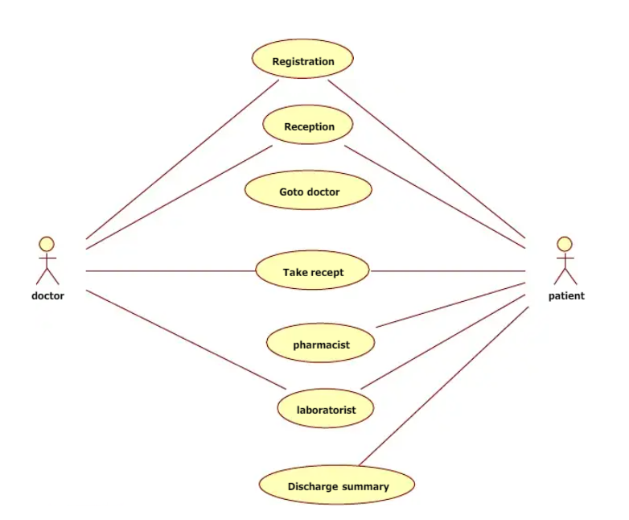

**Sequence Diagram:**

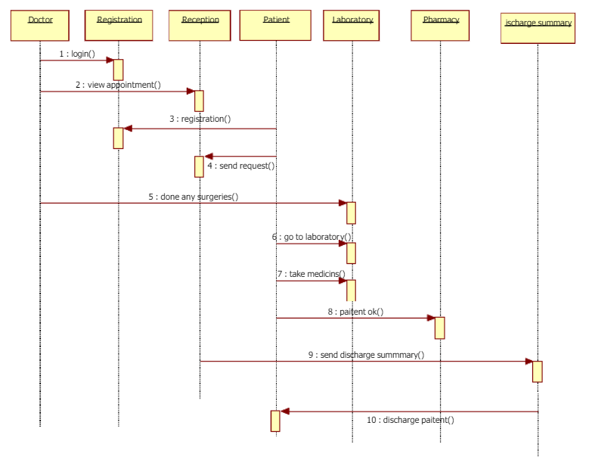

**Conclusion:**

Using this portal, we can retrieve patient’s history with a single click. Thus, processing information will be faster. It guarantees accurate maintenance of Patient details. It easily reduces burden of duplication and thus reduces the human effort and increases accuracy speed.