**QUE:1**

**QUE:2**

**QUE:4**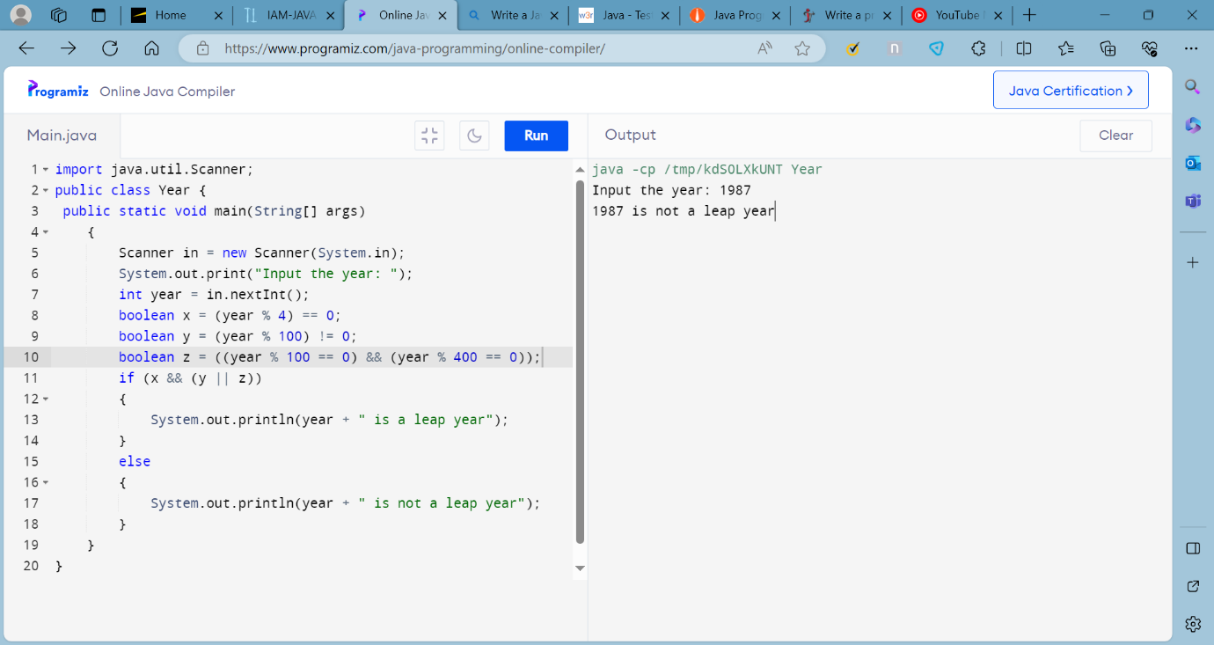

**QUE:5**