**QUE:1**

**QUE:2**

**QUE:3**

**QUE:5**

**QUE:6**

**QUE:7**

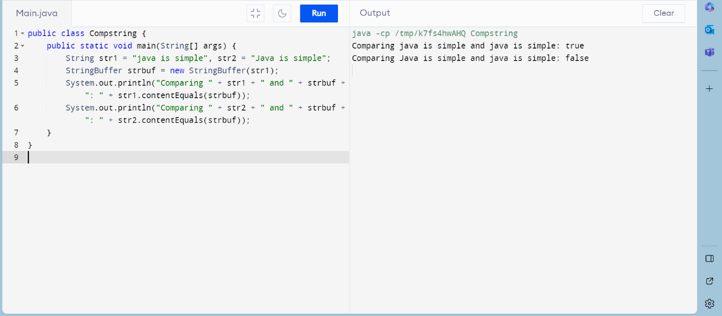

**QUE:8**

**QUE:9**

**QUE:10**

**QUE:11**

**QUE:12**

**QUE:13**

**QUE:14**

