Project Report Template
Title of Project: Metro rail
Name of the Innovator: Akshaya ys
Start Date: 27-10-2025
End Date: 31-10-2025

Day 1: Empathise & Define
Step 1: Understanding the Need
- Which problem am I trying to solve?
The metro rail project addresses the challenges of urban congestion and pollution by offering a fast, reliable, and eco-friendly public transport system. It aims to improve connectivity, reduce travel time, and support sustainable city growth.
- Who is affected by this problem?
- How did I find out about this? [Select whichever is applicable]
- Interviews
- Observation
- Online Research
- AI Tools
Step 2: What is the problem?
The core problem a metro rail project seeks to solve is the growing urban congestion and pollution caused by over-reliance on road transport. It also addresses inadequate public transit infrastructure by introducing a fast, reliable, and sustainable alternative for daily commuting.

Why is this problem important to solve?
Solving urban congestion and pollution is critical because it directly affects public health, economic productivity, and quality of life. Without efficient transport solutions like metro rail, cities face worsening air quality, longer commute times, and reduced access to jobs and services, especially for lower-income populations.Take-home task
Ask 2-3 people what they think about the project:
- 1. Marketing Executive:
“The metro has completely changed my commute. I used to spend over an hour in traffic every day — now it’s just 20 minutes. I hope they expand it to more areas soon.”
- 2. Auto Driver:
“It’s good for the city, but it’s affected my earnings. Fewer people need autos now, especially near metro stations. I think the government should support drivers like us too.”
- 3. College Student:
“I love how affordable and clean the metro is. It’s way better than crowded buses, and I feel safer traveling late in the evening.”
AI Tools you can use for Step 1 and 2:
AI Tools Used:
1. Meta MGX
- Used as a no-code development tool to build and manage Metro Rail digital systems.
- Enabled creation of passenger interfaces, ticketing workflows, and real-time tracking dashboards.
- Ideal for integrating location-based alerts, train schedules, and station data modules.
2. ChatGPT
- Used for generating automated announcements and commuter interaction scripts
- Helped design chatbot conversations for route planning, fare queries, and service updates.
- Also useful for drafting FAQs, multilingual guidance, and emergency instructions..
3. Chatbot References (Structure Design):
To design the AI virtual assistant, you can take reference from:
- Google Dialogflow – for travel intent detection and dynamic response flow.
- IBM Watson Assistant – Structured Q&A, personalized guidance, and enterprise-grade security.
- Microsoft Bot Framework – Conversation trees, user profile integration, and multi-channel support.
Day 2: Ideate
Step 3: Brainstorming solutions
- List at least 5 different solutions (wild or realistic):
- MetroConnect Chatbot– AI-powered virtual assistant for metro commuters.
- MetroSkill Academy– Online platform offering skill-building courses for metro staff and youth
- Urban Mobility Awareness Camps– Offline and online workshops in schools and colleges. Educates students on sustainable transport, metro careers, and safety practices.
- MetroScholar App – Mobile app that sends alerts about scholarships, internships, and metro-related job openings
- Local Mentor Network– Connects students with metro professionals, engineers, and planners
- MetroFutures Platform– All-in-one digital hub built using Meta MGX Combines AI career guidance, skill-building modules, and metro job listingsDesigned to empower urban and rural youth with location-based opportunities
Step 4: My favourite solution:
A complete digital platform built using Meta MGX that combines AI-powered career guidance, skill development modules, and location-based job and scholarship opportunities—designed to empower rural youth with personalized, actionable support.Built using Meta MGX, the app is easy to access,
Step 5: Why am I choosing this solution?
I chose the CareerPath Platform because it empowers rural youth with personalized AI career guidance, skill development, and location-based opportunities—all in one accessible digital solution.
AI Tools you can use for Step 3-5:
AI Tools for Step 3–5
1. Meta MGX
• Used to design and build metro rail digital systems without coding
• Helps create passenger interfaces, ticketing workflows, and location-based service dashboards
2. ChatGPT
• Assists in brainstorming commuter solutions and generating service ideas
• Structures chatbot conversations for route planning, fare queries, and emergency guidance
• Writes content for FAQs, multilingual support, and station announcements
3. AI Chatbot References (for design and flow)
• Dialogflow – Detects travel intent and manages dynamic commuter interactions
• IBM Watson Assistant – Builds structured Q&A for personalized metro support
• Microsoft Bot Framework – Connects user inputs with real-time data and service actions
4. AI Research Tools
• Google Scholar / Research AI – Explores global innovations in smart transport and metro systems
• AI Text & Summarization Tools – Summarizes commuter feedback, compares solutions, and presents insights clearly

AI Tools you can use for the take-home task:
Canva AI/CoPilot AI/Meta AI Use these mobile-based tools to generate concept images, interface mockups, and visual assets for the metro rail solution you want to design—ideal for showcasing commuter apps, station layouts, or chatbot interfaces
Day 3: Prototype & Test
Step 6: Prototype – Building my first version
What will my solution look like?
- Hom • Home Screen: A clean, mobile-friendly dashboard with options like “Career Guidance,” “Skill Builder,” “Scholarship Alerts,” and “Mentor Connect.”
- AI Career Assistant: A chatbot powered by ChatGPT and Dialogflow that asks students about their interests, strengths, and goals, then suggests career paths and relevant job roles.
- Skill Modules: Interactive lessons on communication, aptitude, and soft skills—each with progress tracking and quizzes.
- Location-Based Alerts: A section that shows nearby job fairs, internships, and government schemes using GPS integration.
- Scholarship Feed: Real-time updates on scholarships and financial aid, filtered by age, education level, and location.
- Mentor Directory: A searchable list of local professionals and alumni who can offer guidance, with chat or call options.
- Built Using: Meta MGX for no-code development, Canva AI for visuals, and ChatGPT for content and conversation flow.
Design Style:
- Simple, intuitive, and easy to navigate for commuters of all backgrounds, especially rural youth.
- Bright and engaging visuals with clear icons and color-coded routes to make travel planning and service updates fun and accessible.
- Mobile-friendly layout optimized for low-bandwidth smartphones, with swipeable cards, voice support, and offline access to key features.
Prototype Tools:
- Built using Meta MGX, a no-code platform that enables the creation of interactive and testable metro rail features such as passenger dashboards, ticketing workflows, and real-time service alerts—without writing a single line of code..
What AI tools will I need to build this?
AI Tools Needed to Build CareerPath
- Meta MGX
• No-code platform to design and build the entire prototype
• Enables creation of passenger dashboards, ticketing workflows, and location-based service modules
- ChatGPT
• Generates content for announcements, FAQs, and chatbot conversations
• Helps brainstorm commuter-friendly features and write multilingual scripts
- Dialogflow
• Detects user intent and manages dynamic conversation flows for the AI assistant
• Ideal for travel queries, fare assistance, and emergency guidance
- IBM Watson Assistant
• Structures Q&A for personalized commuter support
• Useful for building scalable virtual assistants with contextual memory
- Microsoft Bot Framework
• Connects user inputs with backend actions and real-time data
• Supports multi-channel deployment and user profile integration
- Canva AI / Copilot AI / Meta AI
• Mobile-friendly tools to generate concept images, interface mockups, and visual assets
• Useful for showcasing app screens, station layouts, and chatbot designs

What AI tools I finally selected to build this solution?
- Chat GPT
- Metamgx

< Build The Innovation>
<DASHBOAD OF THE TOOL>
Tool Link: https://mgx-vnov0255jat.mgx.world

Internal Working of tool:
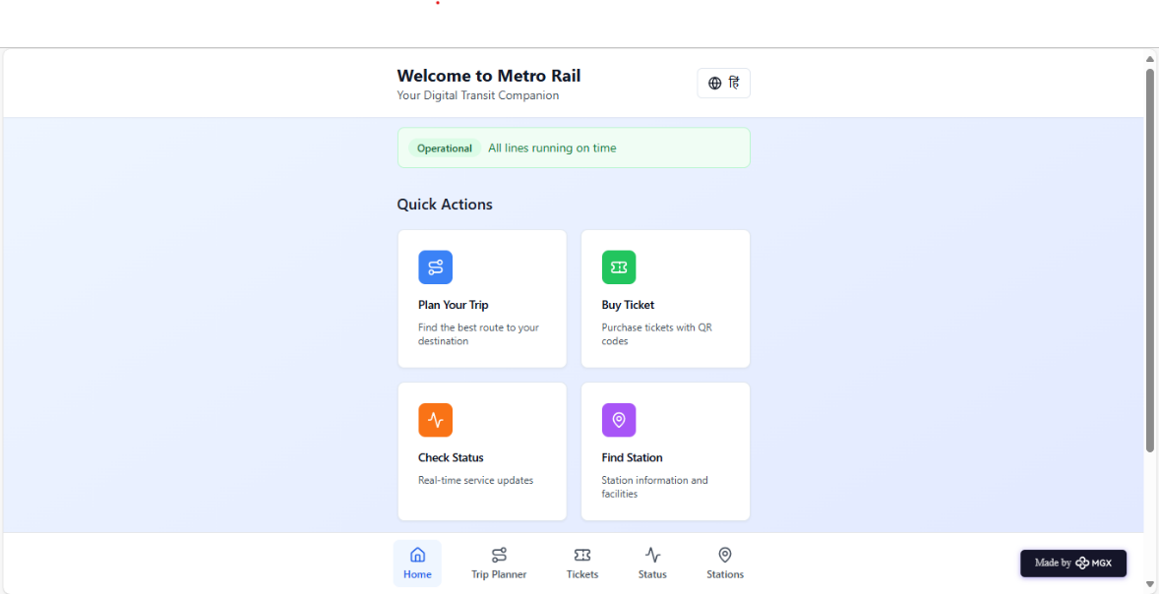
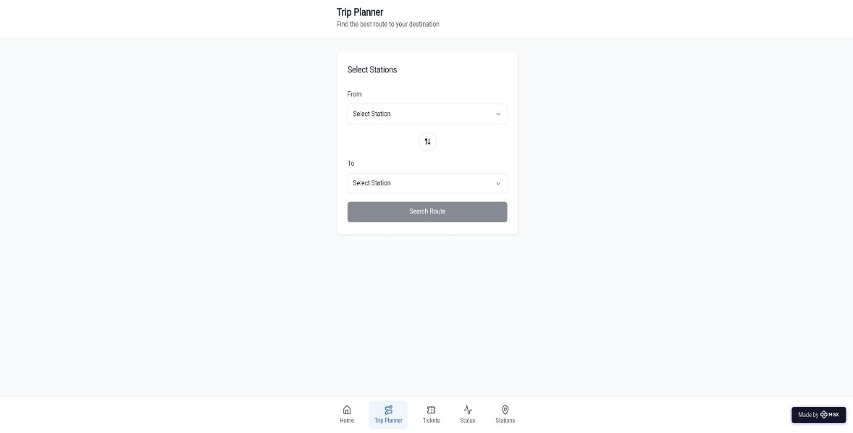
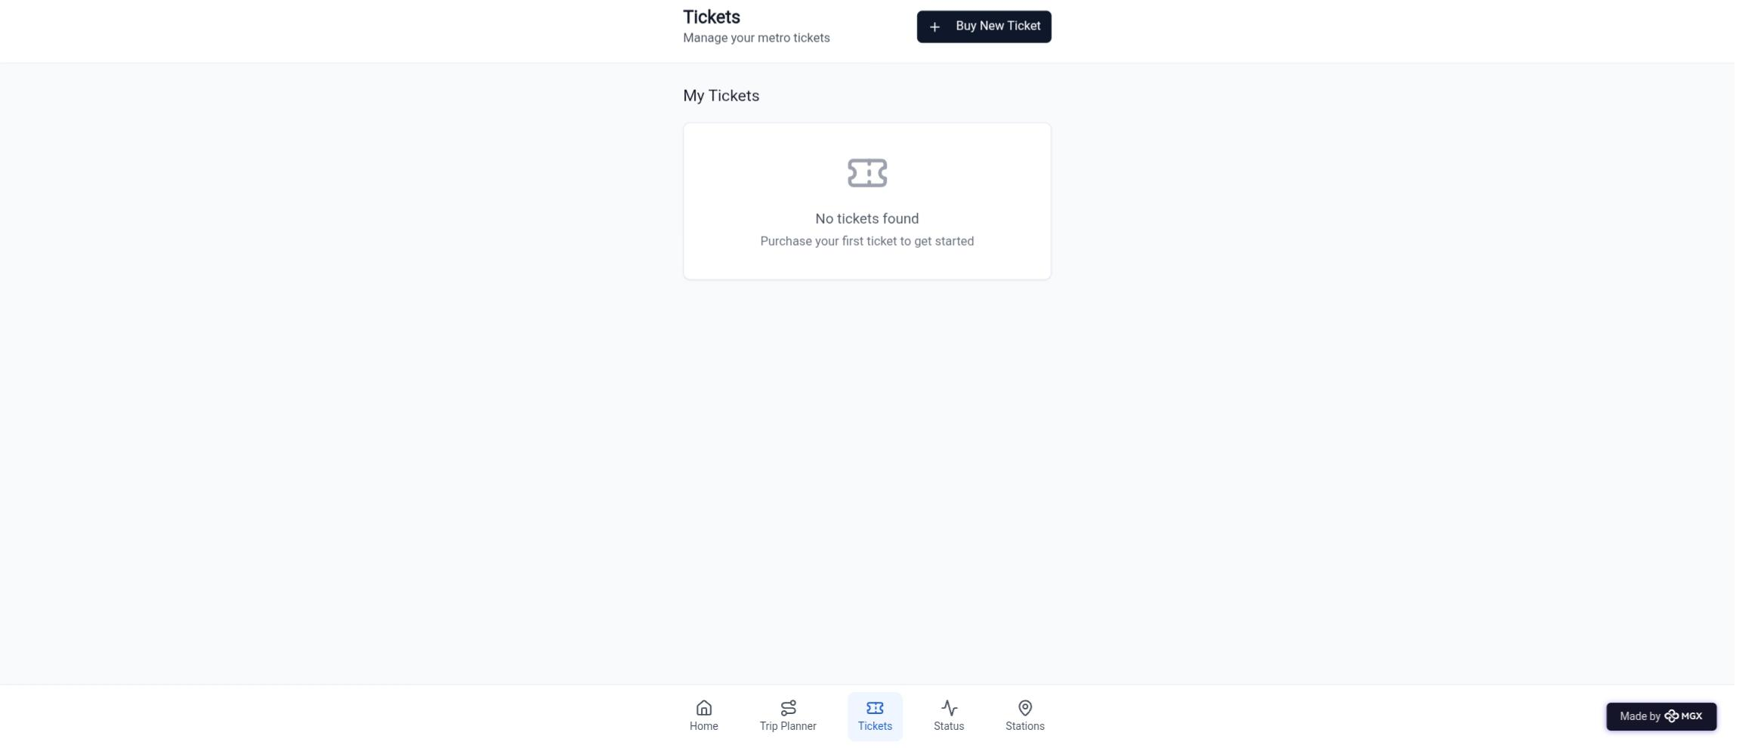
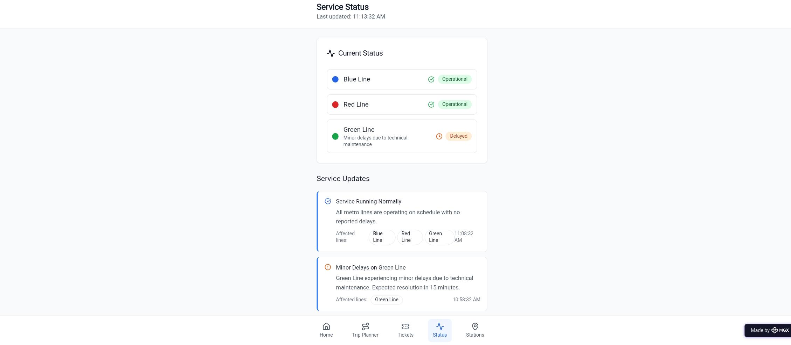

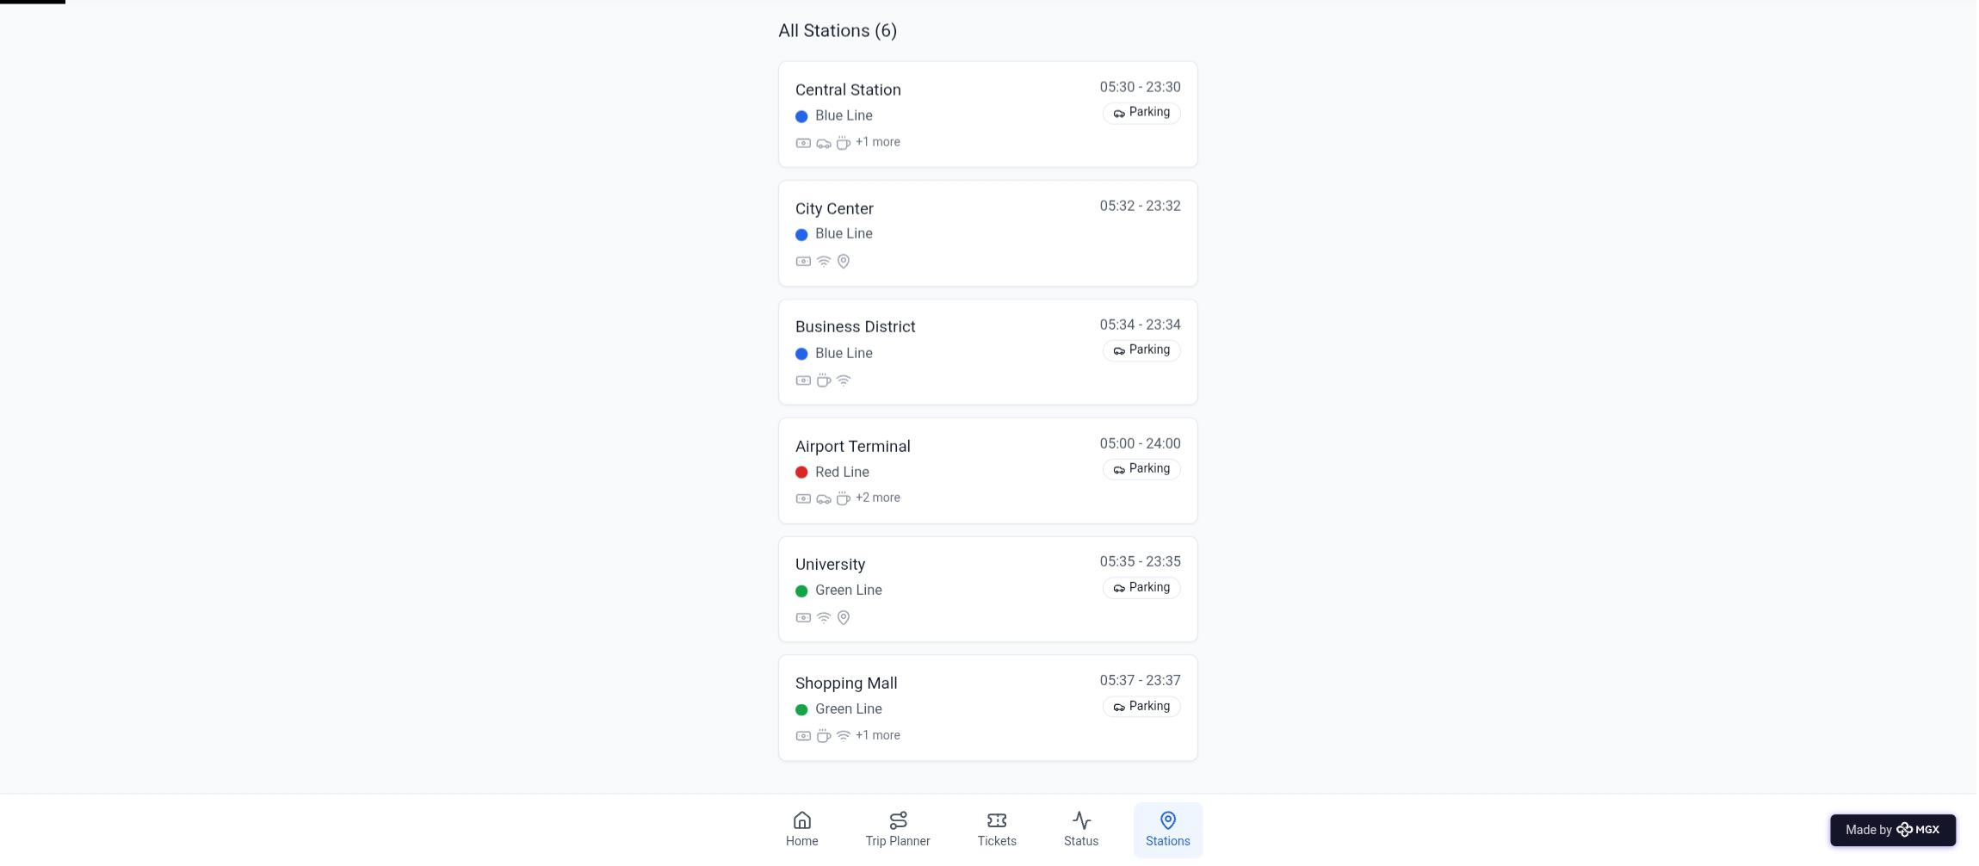

Step 7: Test – Getting Feedback
- Who did I share my solution with?
I shared my Metro Rail Smart System solution with:
- Daily commuters and metro passengers – to gather feedback on convenience, safety, and ease of use.
- Metro staff and operators – to understand how the system supports operational efficiency and passenger management.
- Urban transport planners and engineers – to get insights on integration with existing transport infrastructure.
- Students and peers in engineering – for suggestions on improving technical design, automation, and sustainability.
- Mentors and faculty members – for feedback on innovation, feasibility, and impact on urban mobility.
What feedback did I receive?
Feedback: Pros and Cons
Pros (Positive Insights from Feedback):
- Passengers appreciated the smart ticketing system and real-time train tracking for improving travel convenience.
- Energy-efficient and automated operations were recognized as innovative and eco-friendly.
- Metro staff found the monitoring and safety alert features useful for ensuring smooth operations.
- Reviewers liked the integration of IoT and AI for predictive maintenance and efficient crowd management.

Cons (Areas to Improve Noted in Feedback):
- Some users suggested adding multi-language support for better accessibility to diverse commuters.
- Prototype simulation lacked full real-time data, limiting the accuracy of certain features.
- The user interface could be made more intuitive and visually clear for first-time users.
- Additional security and emergency alert options were recommended for passenger safety.
My Response for The Feedback:
The Metro Rail Smart System is currently developed as a prototype, focusing on automation, passenger safety, and operational efficiency. As it is an early-stage model, certain real-time integrations and large-scale data connections are limited. To implement all features — such as live tracking, AI-based predictive maintenance, and full IoT connectivity — we would require collaboration with metro authorities, smart infrastructure providers, and data management platforms.

The current version effectively demonstrates the concept’s potential, feasibility, and future Impact on urban transportation by showcasing how technology can improve efficiency, safety, and commuter experience in metro rail systems.
👍 What works well:
What Works Well
- Automation and Efficiency: The system automates key metro operations such as ticketing, train scheduling, and passenger flow management, reducing human error.
- Real-Time Monitoring: IoT sensors and dashboards enable live tracking of trains, equipment status, and crowd density for better control.
- Energy Optimization: Smart energy management features help minimize power consumption and support sustainable urban transport.
- Safety and Security: Integrated alert systems and surveillance monitoring enhance passenger safety and rapid emergency response.
- AI-Based Predictive Maintenance: The use of AI helps identify potential equipment failures in advance, reducing downtime and maintenance costs.
- User-Friendly Interface: The design is intuitive and accessible, allowing passengers and staff to easily interact with system features.
- Scalability and Integration: The prototype can be expanded to integrate with city-wide smart transport networks in the future.

🔧 What needs improvement:
- Real-Time Data Integration: The prototype currently uses simulated data; live integration with metro networks would make monitoring and tracking more accurate.
- User Interface Design: The dashboard and passenger app could be enhanced with more intuitive navigation and better visual clarity.
- Multilingual Support: Adding regional language options would make the system more inclusive for all passengers.
- Security Features: Incorporating advanced alert systems and biometric access could further strengthen passenger safety.
- Hardware and Sensor Expansion: Wider deployment of IoT devices is needed to improve system reliability and coverage.
- Collaboration with Metro Authorities: Partnerships with transport organizations are essential to implement the system on a real operational scale.

AI Tools you can use for Step 6-7:
ChatGPT/Perplexity AI/Claude AI/Canva AI/Chatling AI/Figma AI/Metamgx/Gamma AI: You can use these tools to build solutions/models or mock-up dummy prototypes

Day 4: Showcase
Step 8: Presenting my Innovation:
I am presenting the Metro Rail Smart System, an AI- and IoT-integrated solution designed to enhance urban transportation efficiency, safety, and passenger experience. It features:
- Smart Automation and Monitoring: Real-time tracking of trains, crowd management, and operational control using IoT sensors.
- AI-Based Predictive Maintenance: Early detection of faults in metro systems to reduce downtime and maintenance costs.
- Smart Ticketing and Passenger Assistance: Automated ticketing, AI chat assistance, and live schedule updates for commuters.
- Energy-Efficient Operations: Optimized power usage through smart energy management and regenerative braking.
- Safety and Emergency Response: Integrated alert systems and surveillance for quick incident response.
- User-Friendly Dashboard: Designed for both passengers and metro staff, ensuring simple navigation and real-time insights.
Impact: The Metro Rail Smart System improves the efficiency, safety, and sustainability of urban transportation. It enhances passenger experience through automation and real-time information, supports metro staff with smart monitoring and maintenance tools, and promotes eco-friendly, data-driven mobility in cities. Overall, it contributes to building a smarter, safer, and more connected urban transport ecosystem.
<SHOWCASE YOUR INNOVATION TO YOUR PEERS>

Step 9: Reflections
- What did I enjoy the most during this project-based learning activity?
I enjoyed developing the Metro Rail Smart System prototype and seeing how technology like AI and IoT can transform public transportation. It was exciting to design features such as real-time monitoring, smart ticketing, and predictive maintenance, and to visualize how these innovations could make metro travel safer, smarter, and more efficient for passengers and operators alike.

What was my biggest challenge during this project-based learning activity?
My biggest challenge was integrating multiple technologies—such as AI, IoT sensors, and real-time data systems—into a single functional Metro Rail Smart System prototype. Ensuring smooth coordination between features like smart ticketing, live tracking, and predictive maintenance with limited resources and simulated data required careful planning and testing. Despite the challenges, it provided valuable learning in system integration and practical problem-solving.
Take-home task
https://github.com/Akshayays/Metro-rail-
AI Tools you can use for Step 8:
Canva AI: You can use this to design your pitch document. Download your pitch document as a PDF file and upload on GitHub

