192312464
Akshay Deep

Simulation Task4: Simulation of Carrier Aggregation Performance in LTE-Advanced
Aim: To simulate the performance of single, dual, and triple carrier aggregation in LTE-Advanced under varying bandwidth and SNR using MATLAB
Program:
clc;
clear;
close all;

% Carrier Aggregation Simulation

SNR = 0:5:30; % SNR (dB)
Bandwidth = [5 10 15 20 25 30]; % MHz

% Throughput (Mbps)
Single = 5*log2(1+10.^(SNR/10));
Dual = 10*log2(1+10.^(SNR/10));
Triple = 15*log2(1+10.^(SNR/10));

figure;

% Graph 1: Throughput vs SNR
subplot(2,1,1)
plot(SNR,Single,'-o','LineWidth',2)
hold on
plot(SNR,Dual,'-s','LineWidth',2)
plot(SNR,Triple,'-^','LineWidth',2)
grid on
xlabel('SNR (dB)')
ylabel('Throughput (Mbps)')
title('Carrier Aggregation Throughput vs SNR')
legend('Single Carrier','Dual Carrier','Triple Carrier','Location','northwest')

% Graph 2: Throughput vs Bandwidth
subplot(2,1,2)
plot(Bandwidth,Bandwidth*5,'-o','LineWidth',2)
hold on
plot(Bandwidth,Bandwidth*8,'-s','LineWidth',2)
plot(Bandwidth,Bandwidth*10,'-^','LineWidth',2)
grid on
xlabel('Bandwidth (MHz)')
ylabel('Throughput (Mbps)')
title('Carrier Aggregation Throughput vs Bandwidth')
legend('Single Carrier','Dual Carrier','Triple Carrier','Location','northwest')

Output1:
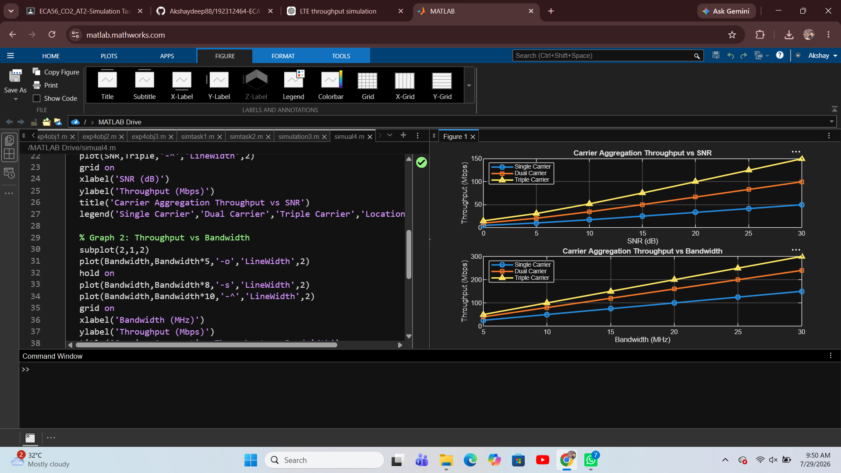

Result:
The MATLAB simulation was successfully completed. The graphs show that throughput increases with increasing SNR and bandwidth, and triple carrier aggregation provides the highest throughput compared to dual and single carrier aggregation.

