192312464
Akshay Deep

Simulation Task5: Simulation of MU-MIMO Throughput Comparison
Aim: To simulate the performance of MU-MIMO under varying user count, antenna count, SNR, modulation, and interference using MATLAB.
Program:
clc;
clear;
close all;

% MU-MIMO Simulation

Users = [5 10 15 20 25 30];
SNR = 0:5:30;

% Throughput vs User Count (Mbps)
Tx2 = [20 35 48 58 65 70]; % 2 Antennas
Tx4 = [30 50 68 82 92 100]; % 4 Antennas
Tx8 = [40 65 88 108 122 135]; % 8 Antennas

figure;

% Graph 1: Throughput vs User Count
subplot(2,1,1)
plot(Users,Tx2,'-o','LineWidth',2)
hold on
plot(Users,Tx4,'-s','LineWidth',2)
plot(Users,Tx8,'-^','LineWidth',2)
grid on
xlabel('Number of Users')
ylabel('Throughput (Mbps)')
title('MU-MIMO Throughput vs User Count')
legend('2 Antennas','4 Antennas','8 Antennas','Location','northwest')

% Graph 2: Throughput vs SNR
subplot(2,1,2)
plot(SNR,8*log2(1+10.^(SNR/10)),'-o','LineWidth',2)
hold on
plot(SNR,10*log2(1+10.^(SNR/10)),'-s','LineWidth',2)
plot(SNR,12*log2(1+10.^(SNR/10)),'-^','LineWidth',2)
grid on
xlabel('SNR (dB)')
ylabel('Throughput (Mbps)')
title('MU-MIMO Throughput vs SNR')
legend('Low Interference','Medium Interference','High Capacity','Location','northwest')
Output1:

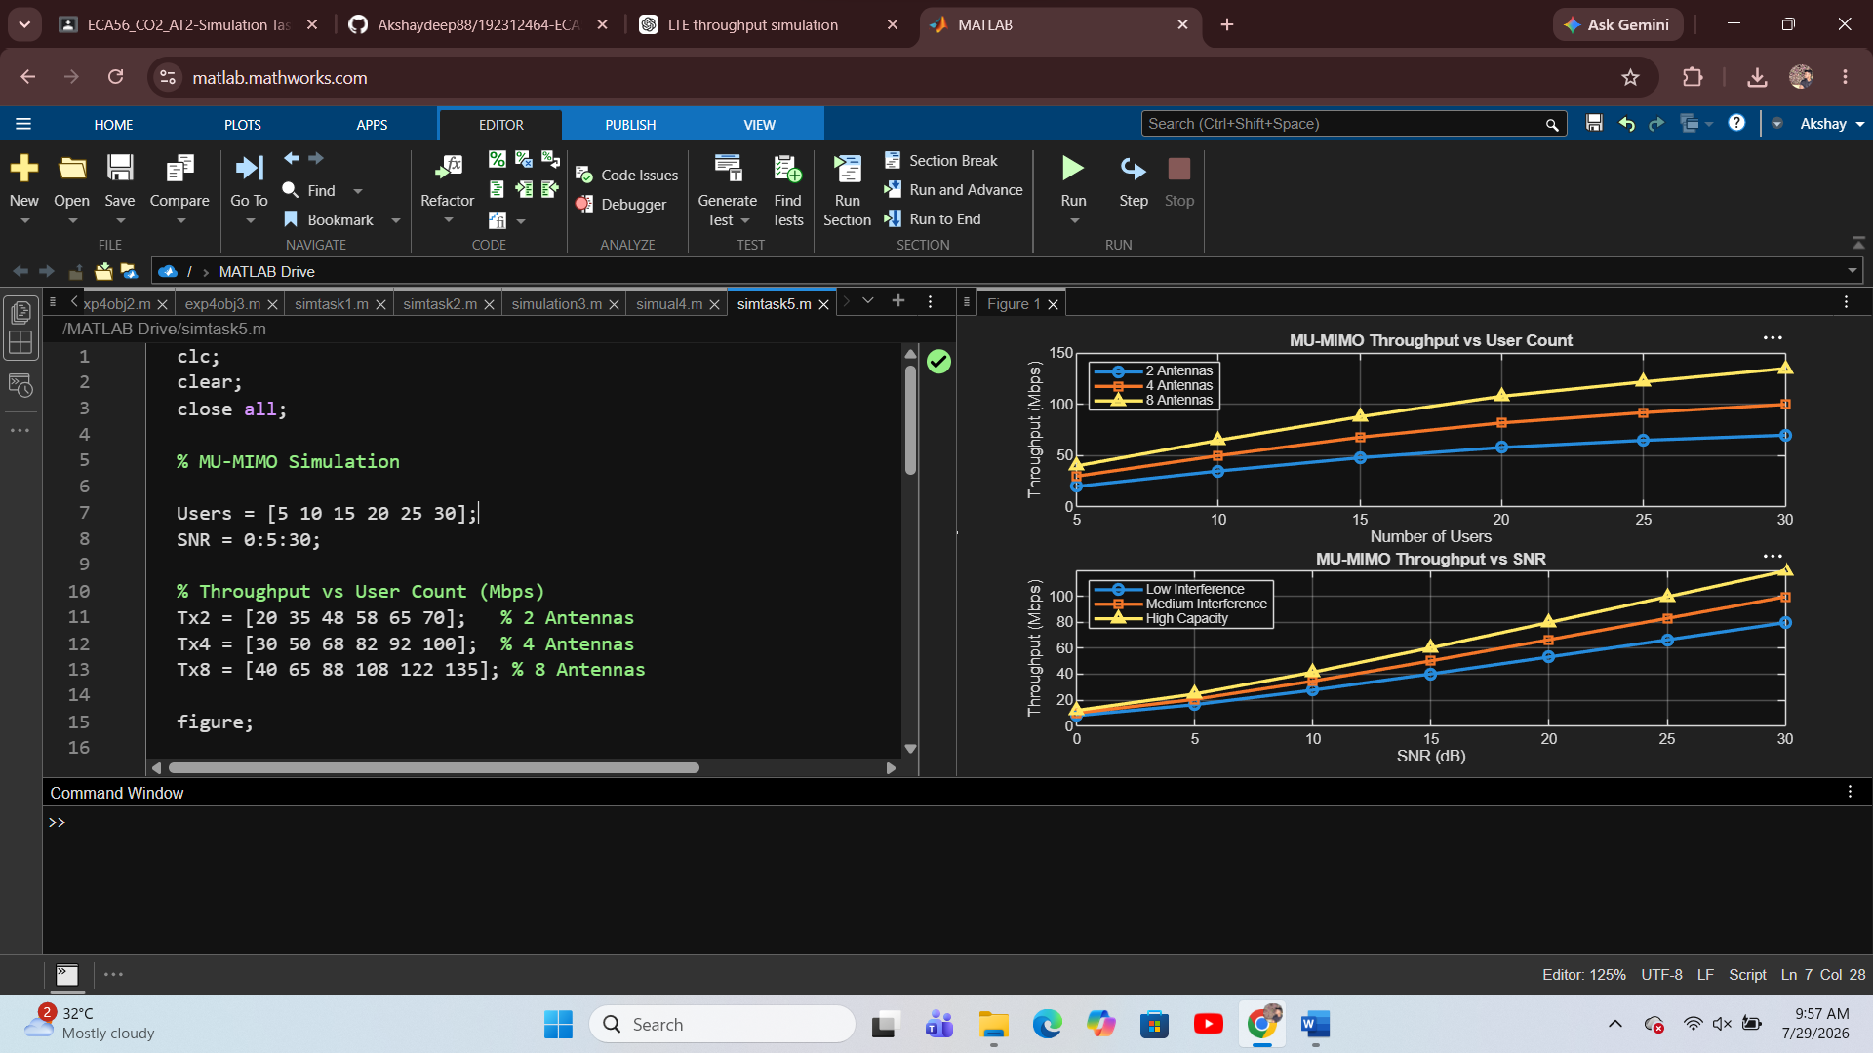

Result:
The MATLAB simulation was successfully completed. The results show that throughput increases with higher SNR and more antennas, while increased user count improves system capacity. MU-MIMO provides better overall network performance by serving multiple users simultaneously.

