

PROJECT REPORT

ON

“ROUTE MAPPING”

SUBMITTED IN PARTIAL FULFILLMENT OF THE DEGREE

OF

BACHELOR OF TECHNOLOGY

IN

INFORMATION TECHNOLOGY

Submitted By:
Name: Gurvinder Singh
College Roll No.: IT/06/6535
University Roll No.: 6170810750

Under the Guidance of:
Name: Manjit Singh

Submitted To:
H.O.D IT Dept.

ACKNOWLEDGEMENT

The first and foremost to influence and direct the course of our studies has been Mr. Manjit Singh under whose supervision we have been able to accomplish our project on time. We would also like to thank her for her ample guidance and support. We are immensely grateful to her for the inspiration, able guidance, and valuable suggestion at every stage of work.We would like to convey our sincere thanks for her constructive and glowing inspiration.
We owe regards to the entire faculty of the department of computer science and information technology at IET BHADDAL from where we have learnt the basics of Computer Science and whose informal discussions and able guidance became light for us in the entire duration of this work.

PREFACE

In B.Tech course it is an obligatory part of every student to prepare a project report for the partial fulfillment of the requirement of their degree.

The purpose of this report is to assemble under one cover a sufficient body of knowledge about management and developing a successful software engineering project. This report assembles various functions like planning, organizing, designing, testing, and maintenance of the software developed during the Last Semester.

We have prepared project report titled “ROUTE MAPPING”. It uses Swing JDBC, Event Handling, JAVA applets and AWT and other java utilities. We chose java because it is platform and machine independent. This project can also run on diiferent OS and machines.

We have made an honest try to make it up to date.

Index

- Front page
- Acknowledgement
- Preface
- Contents:
- Introduction to Assigned Project

- Why java programming language is used?

- System Development Life Cycle

- Modular description of the Project

- Snapshots of the Project

- Coding

- Conclusion and Future Work

PROJECT DETAILS

Project Name:
ROUTE MAPPING
Project head:
Mr. Manjit Singh
Project Team:
It comprises of the following members:
- Gurvinder Singh

Company Profile

COMPANY PROFILE

OopsInfo Solutions was established in 2009. Its foundation and purpose is to provide and construct programs for existing companies and provide new and exciting updates to primitive bases technology. Opps InfoTech started in Mohali which is situated in Punjab India and was the one of the first to be opened in the vicinity. OopsInfo Solutions first started with the education in India, through their curriculum we were able to negotiate a service that was accessible to all students and post Graduates (this continued with great success). We also provide study materials i.e. program languages C, C++, Visual C++, PHP, VB, VB.Net, ASP.Net, XML, Oracle 9i, Sql Server 2000, ASP, Java, and Advance Java, Multimedia (Flash MX, Director MX, Fireworks MX, and Dreamweaver MX). We now expand our network to other countries such as England, USA. This has been met with much appreciation & support. OopsInfo Solutions now in entering its 1st successful year.

OBJECTIVE

- Encourage and promote the development and progress of electronic Data Processing towards achieving self-reliance in the field of computer sciences and technology for scientific research and development, educational governmental commercial and industrial applications both for indigenous utilization as well as for export.

- Advance interdisciplinary co-operation amongst scientists, technologists, engineers, administrators and commercial entrepreneurs for the growth of teaching research and practice of Electronic Data Processing Systems and allied subjects in Academic Institutions, Centre and State Govts, Industrial, Commercial and Research and Development Organizations.

- Disseminate knowledge on all aspects of Electronic Data Processing Systems and allied subjects, and to foster the development of this specialized branch of technology.

Stimulate and offer aid for research and development of the benefit of manufactures End users Electronic Data Processing Systems.

- Provide support for software development on consultancy basis.
- Establish, manage and operate sub-Centre for all or any of the objectives of the Centre.

In pursuit of these objectives, the Centre may engage in the following activities.

  - Setup Advisory and Consultancy Services.
  - Organize study programmers, symposia, conferences, lectures.
  - Maintain contacts with other learned and professional organizations.
  - Support publication activities.
  - Make available facilities of the Centre for the users.

1. INTRODUCTION TO ASSIGNED PROJECT

1.1 Route Mapping

Route Mapping is a project based on JAVA technology. As the name says the project is to map the route
or path. For the illustration we took the Chandigarh city.A whole map for the city is drawn including all
the sectors along with individual blocks in the sectors. The database used for storing all the paths is MS
Access. There are two forms used, one is login form and another one is jmap form. Login form is a user
Authentication form which is used to check the unauthorized use of the system. The another form is jmap
form which includes the whole city map. All the sectors are there with their respective blocks and paths
which connect them to each other. This form provides a graphical interface to the user to select the sector
for which the path is required. User just has to click the sector on the screen and the required path will be
highlighted. No other information is needed. The calculated path got stored in the database. The other
techniques used are Swing JDBC, Event Handling, JAVA applets and AWT etc. This software reduces the
user overheads to a great extent and provides a very interactive interface. There are different modules used
such as to draw the sectors, to draw the image, calculate the path and then store the path in the database.
These modules help to provide user with the whole city map in a graphical manner from which user can
select the required sectors for which the path has to be find. Then the software provides the user with the
required path by highlighting the specific area in the city map. All the paths are stored in the database
using MS Access.

1.2 Product Function
Various aspects of system use are to be taken into accounts for designing and coding. Necessary checks are to be implemented wherever required to eliminate the possibility of improper use of the system. The user authentication is needed every time somebody tries to access the software. It provides proper user interaction and all the necessary help a specific user wants.The user will thus find lots of convenience, ease, and reliability while working with the system. As this is to offer a complete automation facility, it will be user friendly with its flexible approach to the future modifications, enhancement, and curtailments suiting the future requirements.

User Characteristics: The software doesn’t require user to have some specific educational or
Technical skills. Even user who is new to Computers can use software very easily with a bit of training. User has just to be acquainted with the terms and processes being used in the respective department.

External Interface: Initially a login form is displayed on the screen. Interfaces in the form of the Forms are provided to the user, which allow them to feed in the required details as per the login id & passwords provided. Different types of Forms are provided to different users as each user has different work culture. These details are necessary for record keeping purposes. Input is received through the console, mouse and to be filled by the user. Output is displayed on the screen or the hard copy of the outputs can be obtained. In some cases output of the process is addition or updation of some record in the database. After completion of the processing proper messages is to be given to user for guiding the future course of action.

2. WHY JAVA PROGRAMMING LANGUAGE?
The Java programming language is a high-level language that can be characterized by all of the following buzzwords:
- Simple
- Object oriented
- Robust
- Secure
- Architecture neutral
- Portable
- High performance
- Multithreaded
- Dynamic
With most programming languages, you either compile or interpret a program so that you can run it on your computer. The Java programming language is unusual in that a program is both compiled and interpreted. With the compiler, first you translate a program into an intermediate language called Java bytecodes —the platform-independent codes interpreted by the interpreter on the Java platform. The interpreter parses and runs each Java bytecode instruction on the computer. Compilation happens just once; interpretation occurs each time the program is executed. The following figure illustrates how this works.
You can think of Java bytecodes as the machine code instructions for the Java Virtual Machine (Java VM). Every Java interpreter, whether it's a development tool or a Web browser that can run applets, is an implementation of the Java VM.
Java bytecodes help make "write once, run anywhere" possible. You can compile your program into bytecodes on any platform that has a Java compiler. The bytecodes can then be run on any implementation of the Java VM. That means that as long as a computer has a Java VM, the same program written in the Java programming language can run on Windows 2000, a Solaris workstation, or on an iMac.

2.1 The Java Platform
A platform is the hardware or software environment in which a program runs. We've already mentioned some of the most popular platforms like Windows 2000, Linux, Solaris, and MacOS. Most platforms can be described as a combination of the operating system and hardware. The Java platform differs from most other platforms in that it's a software-only platform that runs on top of other hardware-based platforms.
The Java platform has two components:
- The Java Virtual Machine (Java VM)
- The Java Application Programming Interface (Java API)
The Java API is a large collection of ready-made software components that provide many useful capabilities, such as graphical user interface (GUI) widgets. The Java API is grouped into libraries of related classes and interfaces; these libraries are known as packages.
Native code is code that after you compile it, the compiled code runs on a specific hardware platform. As a platform-independent environment, the Java platform can be a bit slower than native code. However, smart compilers, well-tuned interpreters, and just-in-time bytecode compilers can bring performance close to that of native code without threatening portability. The Java compiler allows you to cascade references to class and instance methods and variables together, resulting in constructs like the one that appears in the sample program.

2.2 Inheritance
Generally speaking, objects are defined in terms of classes. You know a lot about an object by knowing its class. Even if you don't know what a penny-farthing is, if I told you it was a bicycle, you would know that it had two wheels, handle bars, and pedals.
Object-oriented systems take this a step further and allow classes to be defined in terms of other classes. For example, mountain bikes, racing bikes, and tandems are all kinds of bicycles. In object-oriented terminology, mountain bikes, racing bikes, and tandems are all subclasses of the bicycle class. Similarly, the bicycle class is the superclass of mountain bikes, racing bikes, and tandems.
This relationship is shown in the following figure.
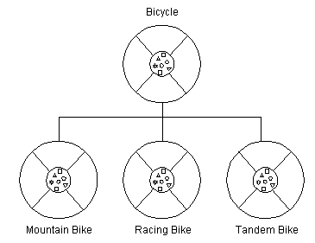
Relationship Object Oriented

Each subclass inherits state (in the form of variable declarations) from the superclass. Mountain bikes, racing bikes, and tandems share some states: cadence, speed, and the like. Also, each subclass inherits methods from the superclass. Mountain bikes, racing bikes, and tandems share some behaviors: braking and changing pedaling speed, for example.

However, subclasses are not limited to the state and behaviors provided to them by their superclass. Subclasses can add variables and methods to the ones they inherit from the superclass. Tandem bicycles have two seats and two sets of handle bars; some mountain bikes have an extra set of gears with a lower gear ratio.
Subclasses can also override inherited methods and provide specialized implementations for those methods. For example, if you had a mountain bike with an extra set of gears, you would override the "change gears" method so that the rider could use those new gears.
You are not limited to just one layer of inheritance. The inheritance tree, or class hierarchy, can be as deep as needed. Methods and variables are inherited down through the levels. In general, the farther down in the hierarchy a class appears, the more specialized its behavior.
The Object class is at the top of class hierarchy, and each class is its descendant (directly or indirectly). A variable of type Object can hold a reference to any object, such as an instance of a class or an array. Object provides behaviors that are required of all objects running in the Java Virtual Machine. For example, all classes inherit Object's to String method, which returns a string representation of the object.
Inheritance offers the following benefits:
- Subclasses provide specialized behaviors from the basis of common elements provided by the superclass. Through the use of inheritance, programmers can reuse the code in the superclass many times.
- Programmers can implement superclasses called abstract classes that define "generic" behaviors. The abstract superclass defines and may partially implement the behavior, but much of the class is undefined and unimplemented. Other programmers fill in the details with specialized subclasses

2.3 Interface
In English, an interface is a device or a system that unrelated entities use to interact. According to this definition, a remote control is an interface between you and a television set, the English language is an interface between two people, and the protocol of behavior enforced in the military is the interface between people of different ranks. Within the Java programming language, an interface is a device that unrelated objects use to interact with each other. An interface is probably most analogous to a protocol (an agreed on behavior). In fact, other object-oriented languages have the functionality of interfaces, but they call their interfaces protocols.
The bicycle class and its class hierarchy defines what a bicycle can and cannot do in terms of its "bicycleness." But bicycles interact with the world on other terms. For example, a bicycle in a store could be managed by an inventory program. An inventory program doesn't care what class of items it manages as long as each item provides certain information, such as price and tracking number. Instead of forcing class relationships on otherwise unrelated items, the inventory program sets up a protocol of communication. This protocol comes in the form of a set of constant and method definitions contained within an interface. The inventory interface would define, but not implement, methods that set and get the retail price, assign a tracking number, and so on.
To work in the inventory program, the bicycle class must agree to this protocol by implementing the interface. When a class implements an interface, the class agrees to implement all the methods defined in the interface. Thus, the bicycle class would provide the implementations for the methods that set and get retail price, assign a tracking number, and so on.
You use an interface to define a protocol of behavior that can be implemented by any class anywhere in the class hierarchy. Interfaces are useful for the following:
- Capturing similarities among unrelated classes without artificially forcing a class relationship.
- Declaring methods that one or more classes are expected to implement.
- Revealing an object's programming interface without revealing its class.

2.4 Object
Objects are key to understanding object-oriented technology. You can look around you now and see many examples of real-world objects: your dog, your desk, your television set, your bicycle.
These real-world objects share two characteristics: They all have state and behavior. For example, dogs have state (name, color, breed, hunger) and behavior (barking, fetching, and wagging tail). Bicycles have state (current gear, current pedal cadence, two wheels, number of gears) and behavior (braking, accelerating, slowing down, changing gears). Software objects are modeled after real-world objects in that they too have state and behavior. A software object maintains its state in one or more variables. A variable is an item of data named by an identifier. A software object implements its behavior with methods. A method is a function (subroutine) associated with an object.
Definition: An object is a software bundle of variables and related methods.

You can represent real-world objects by using software objects. You might want to represent real-world dogs as software objects in an animation program or a real-world bicycle as software object in the program that controls an electronic exercise bike. You can also use software objects to model abstract concepts. For example, an event is a common object used in GUI window systems to represent the action of a user pressing a mouse button or a key on the keyboard.

The following illustration is a common visual representation of a software object:
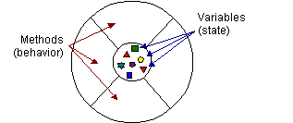

Visual Representation of software object

Everything that the software object knows (state) and can do (behavior) is expressed by the variables and the methods within that object. A software object that modeled your real-world bicycle would have variables that indicated the bicycle's current state: its speed is 10 mph, its pedal cadence is 90 rpm, and its current gear is the 5th gear. These variables are formally known as instance variables because they contain the state for a particular bicycle object, and in object-oriented terminology, a particular object is called an instance.

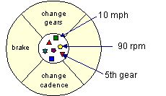
Bicycle modeled as a software object
In addition to its variables, the software bicycle would also have methods to brake, change the pedal cadence, and change gears. (The bike would not have a method for changing the speed of the bicycle, as the bike's speed is just a side effect of what gear it's in, how fast the rider is pedaling, whether the brakes are on, and how steep the hill is.) These methods are formally known as instance methods because they inspect or change the state of a particular bicycle instance.
The object diagrams show that the object's variables make up the center, or nucleus, of the object. Methods surround and hide the object's nucleus from other objects in the program. Packaging an object's variables within the protective custody of its methods is called encapsulation this conceptual picture of an object-a nucleus of variables packaged within a protective membrane of methods-is an ideal representation of an object and is the ideal that designers of object-oriented systems strive for. However, it's not the whole story. Often, for practical reasons, an object may wish to expose some of its variables or hide some of its methods. In the Java programming language, an object can specify one of four access levels for each of its variables and methods. The access level determines which other objects and classes can access that variable or method. Variable and method access in Java is covered in Controlling Access to Members of a Class.
Encapsulating related variables and methods into a neat software bundle is a simple yet powerful idea that provides two primary benefits to software developers:
- Modularity: The source code for an object can be written and maintained independently of the source code for other objects. Also, an object can be easily passed around in the system. You can give your bicycle to someone else, and it will still work.
- Information hiding: An object has a public interface that other objects can use to communicate with it. The object can maintain private information and methods that can be changed at any time without affecting the other objects that depend on it. You don't need to understand the gear mechanism on your bike to use it.

2.5 Class
In the real world, you often have many objects of the same kind. For example, your bicycle is just one of many bicycles in the world. Using object-oriented terminology, we say that your bicycle object is an instance of the class of objects known as bicycles. Bicycles have some state (current gear, current cadence, two wheels) and behavior (change gears, brake) in common. However, each bicycle's state is independent of and can be different from that of other bicycles.
When building bicycles, manufacturers take advantage of the fact that bicycles share characteristics, building many bicycles from the same blueprint. It would be very inefficient to produce a new blueprint for every individual bicycle manufactured.
In object-oriented software, it's also possible to have many objects of the same kind that share characteristics: rectangles, employee records, video clips, and so on. Like the bicycle manufacturers, you can take advantage of the fact that objects of the same kind are similar and you can create a blueprint for those objects. A software blueprint for objects is called a class.
Definition: A class is a blueprint, or prototype, that defines the variables and the methods common to all objects of a certain kind.

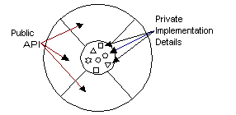

Class Implementation

2.6 Objects vs. Classes

You probably noticed that the illustrations of objects and classes look very similar. And indeed, the difference between classes and objects is often the source of some confusion. In the real world, it's obvious that classes are not themselves the objects they describe: A blueprint of a bicycle is not a bicycle. However, it's a little more difficult to differentiate classes and objects in software. This is partially because software objects are merely electronic models of real-world objects or abstract concepts in the first place. But it's also because the term "object" is sometimes used to refer to both classes and instances.
In the figures, the class is not shaded, because it represents a blueprint of an object rather than an object itself. In comparison, an object is shaded, indicating that the object exists and that you can use it.

2.7 Message
A single object alone is generally not very useful. Instead, an object usually appears as a component of a larger program or application that contains many other objects. Through the interaction of these objects, programmers achieve higher-order functionality and more complex behavior. Your bicycle hanging from a hook in the garage is just a bunch of titanium alloy and rubber; by itself, the bicycle is incapable of any activity. The bicycle is useful only when another object (you) interacts with it (pedal).
Software objects interact and communicate with each other by sending messages to each other. When object A wants object B to perform one of B's methods, object A sends a message to object B
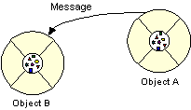
Sending of message between objects
Sometimes, the receiving object needs more information so that it knows exactly what to do; for example, when you want to change gears on your bicycle, you have to indicate which gear you want. This information is passed along with the message as parameters.
The next figure shows the three components that comprise a message:
- The object to which the message is addressed (Your Bicycle)
- The name of the method to perform (change Gears)
- Any parameters needed by the method (lower Gear)

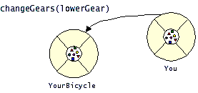

Components of a message

These three components are enough information for the receiving object to perform the desired method. No other information or context is required.
Messages provide two important benefits.
- An object's behavior is expressed through its methods, so (aside from direct variable access) message passing supports all possible interactions between objects.
Objects don't need to be in the same process or even on the same machine to send and receive messages back and forth to each other.

3. SYSTEM DEVELOPMENT LIFE CYCLE
3.1 System/Information Engineering and Modeling
As software is always of a large system (or business), work begins by establishing the requirements for all system elements and then allocating some subset of these requirements to software. This system view is essential when the software must interface with other elements such as hardware, people and other resources. System is the basic and very critical requirement for the existence of software in any entity. So if the system is not in place, the system should be engineered and put in place. In some cases, to extract the maximum output, the system should be re-engineered and spruced up. Once the ideal system is engineered or tuned, the development team studies the software requirement for the system.
In case of our project we studied many existing file transfer systems and were ultimately able to design our project ‘ROUTE MAPPING’ which includes features like: Encryption during file transfer, user authentication and security while file transfer.
3.2 Software Requirement Analysis
This process is also known as feasibility study. In this phase, the development team visits the customer and studies their system. They investigate the need for possible software automation in the given system. By the end of the feasibility study, the team furnishes a document that holds the different specific recommendations for the candidate system. It also includes the personnel assignments, costs, project schedule, target dates etc.... The requirement gathering process is intensified and focussed specially on software. To understand the nature of the program(s) to be built, the system engineer or "Analyst" must understand the information domain for the software, as well as required function, behavior, performance and interfacing. The essential purpose of this phase is to find the need and to define the problem that needs to be solved .
After the feasibility study, we opted for JAVA as front-end for our project and ORACLE for back-end. The reasons for opting JAVA :
- Platform independent
- Machine independent
3.3 System Analysis and Design
In this phase, the software development process, the software's overall structure and its nuances are defined. In terms of the client/server technology, the number of tiers needed for the package architecture, the database design, the data structure design etc... are all defined in this phase. A software development model is thus created. Analysis and Design are very crucial in the whole development cycle. Any glitch in the design phase could be very expensive to solve in the later stage of the software development. Much care is taken during this phase. The logical system of the product is developed in this phase.

DATA FLOW DIAGRAM

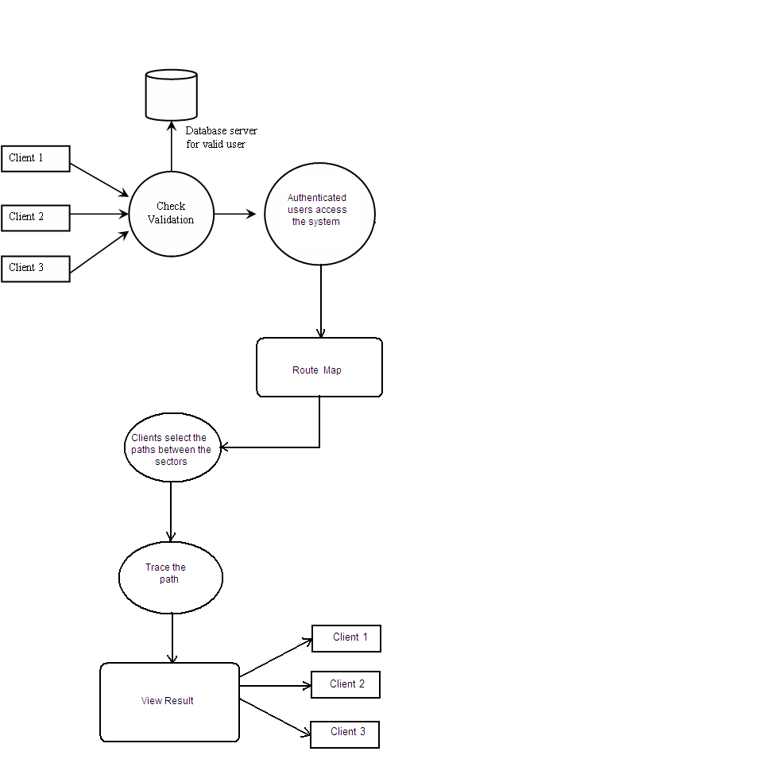

3.4 Code Generation
The design must be translated into a machine-readable form. The code generation step performs this task. If the design is performed in a detailed manner, code generation can be accomplished without much complication. Programming tools like compilers, interpreters, debuggers etc... are used to generate the code. Different high level programming languages like C, C++, Pascal, Java are used for coding. With respect to the type of application, the right programming language is chosen i.e JAVA in case of our project.
3.5 Testing
Once the code is generated, the software program testing begins. Different testing methodologies are available to unravel the bugs that were committed during the previous phases. Different testing tools and methodologies are already available. Some companies build their own testing tools that are tailor made for their own development operations.
3.6 Maintenance
The software will definitely undergo change once it is delivered to the customer. There can be many reasons for this change to occur. Change could happen because of some unexpected input values into the system. In addition, the changes in the system could directly affect the software operations. The software should be developed to accommodate changes that could happen during the post implementation period.

4. MODULAR DESCRIPTION

There are four modules being used in this project:
4.1 To draw the sector:
First the whole city map is drawn and all the sectors are defined there along with paths connecting to each other. The each sector is drawn with individual blocks and all the paths are also defined properly. The user mentions the sector for which the path is required. User just has to enter the sector number and no other information is required.

4.2 To draw the image:
After the path information and sectors are drawn the images are defined in this module to provide the user with a graphical picture. After the authentication form the another form appears on the screen is jmap form. This displays an image containing whole city map with all the sectors along with individual blocks in these sectors.
4.3 To calculate the path:
This module is used for calculating the path for the user. User just has to click the sectors for which he needs the path on the jmap form. After that with help of this module the jmap got refreshed and the next image appears on the screen with the required path highlighted in the jmap form.
4.4 To store the path:
Once the path is calculated this module is used to store the path and show it to user.

5. SNAPSHORTS OF THE PROJECT

5.1 Set a DSN name using this procedure :

Click Start and select Control Panel

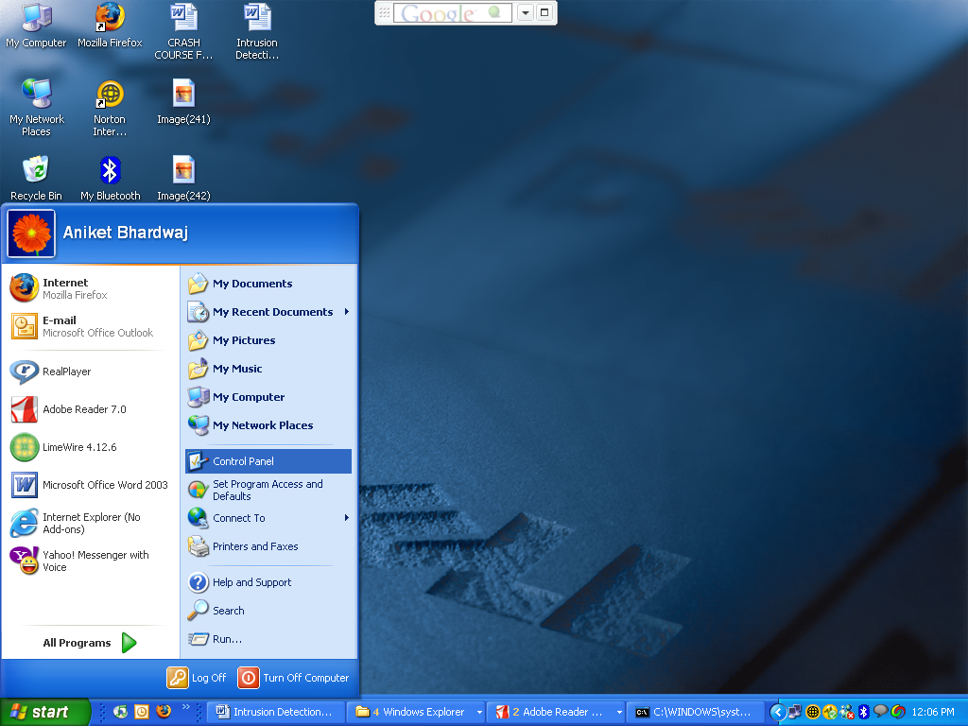

Window displayed when we click on start and select control Pane

Then from control panel select administrative tool

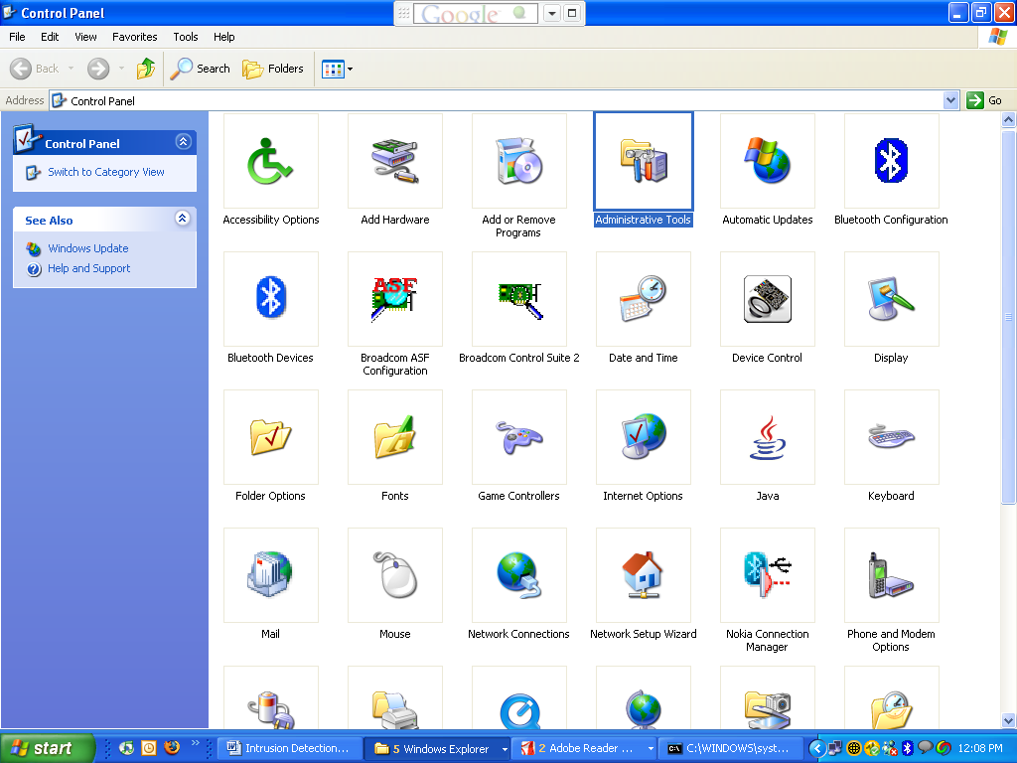

Window displayed when selecting administrative tools

Then from Administrative Tools select Data Sources (ODBC)

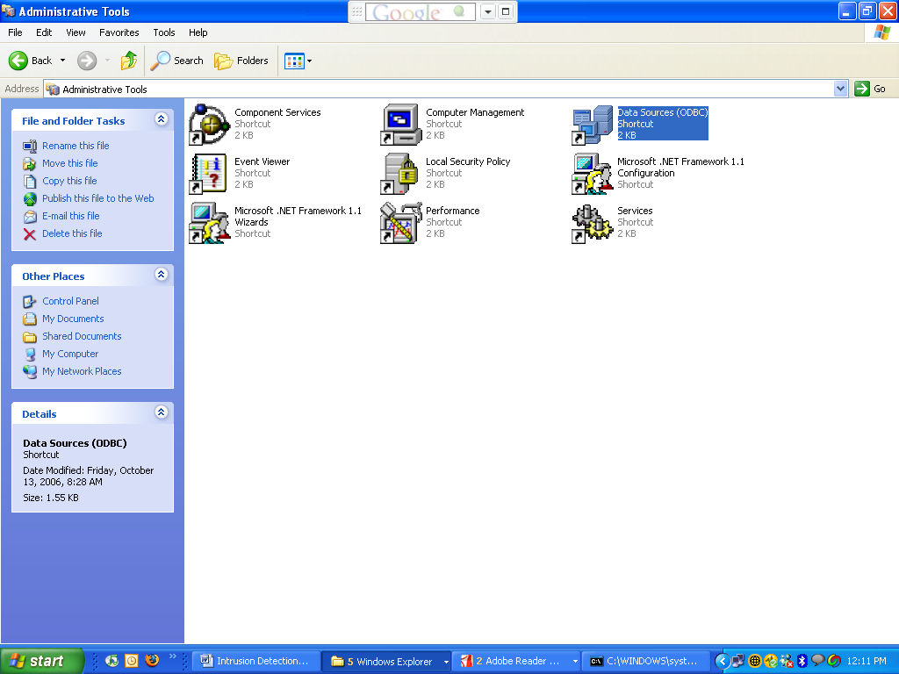

Window displayed when selecting Data Sources from administrative tools.

Now after we click on Data Sources (ODBC), the following window is displayed and in order to register a new database named ‘abc’, click on ‘ADD’.

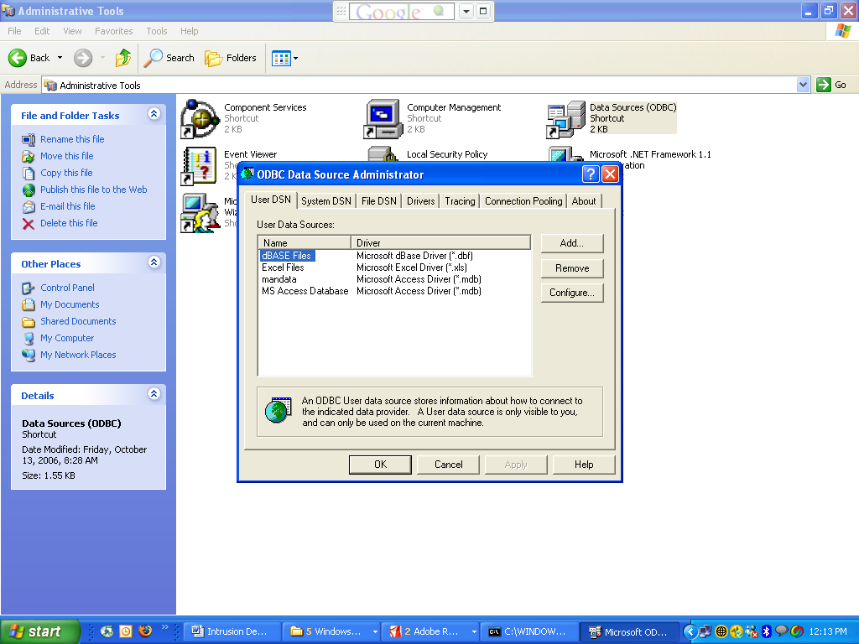

Window displayed while selecting a new database while clicking add.

After you click on add the following window is displayed and then from the drop down list displayed select the MICROSOFT ACCESS driver and then click on Finish.

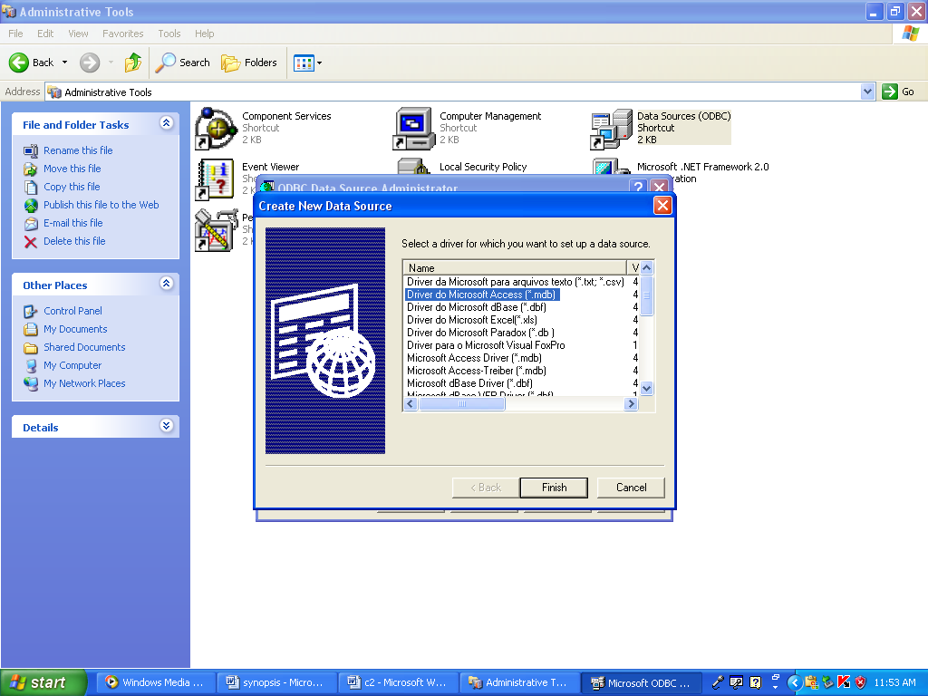

5.2 Detail of the project files

All the file of the project including the database are shown in the window below.

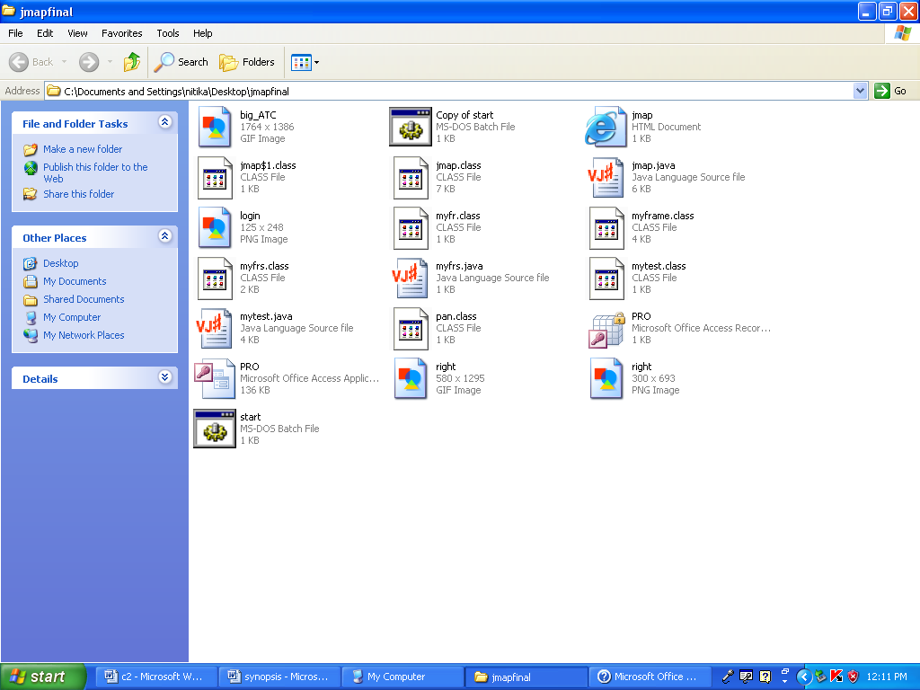

Window displayed where the files of the project is stored.

  - Procedure of compilation and running of project

Window displayed when compiling the files

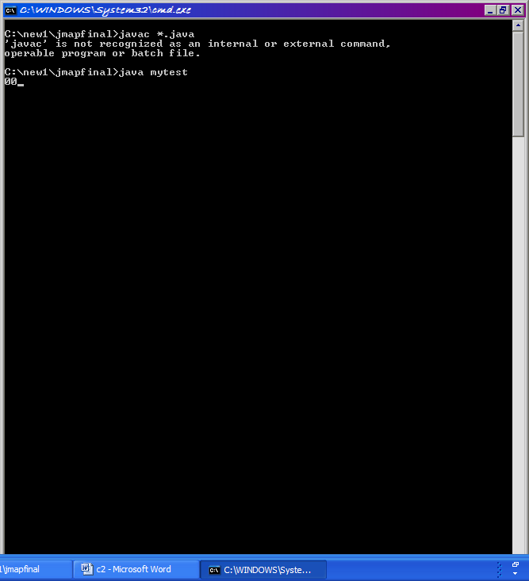

  - Front screen of running project

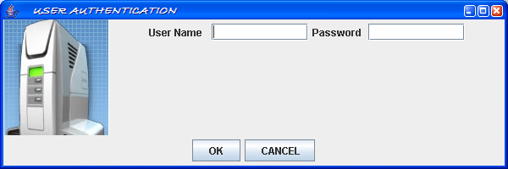

Window displayed when an invalid user attempts to logon to the system

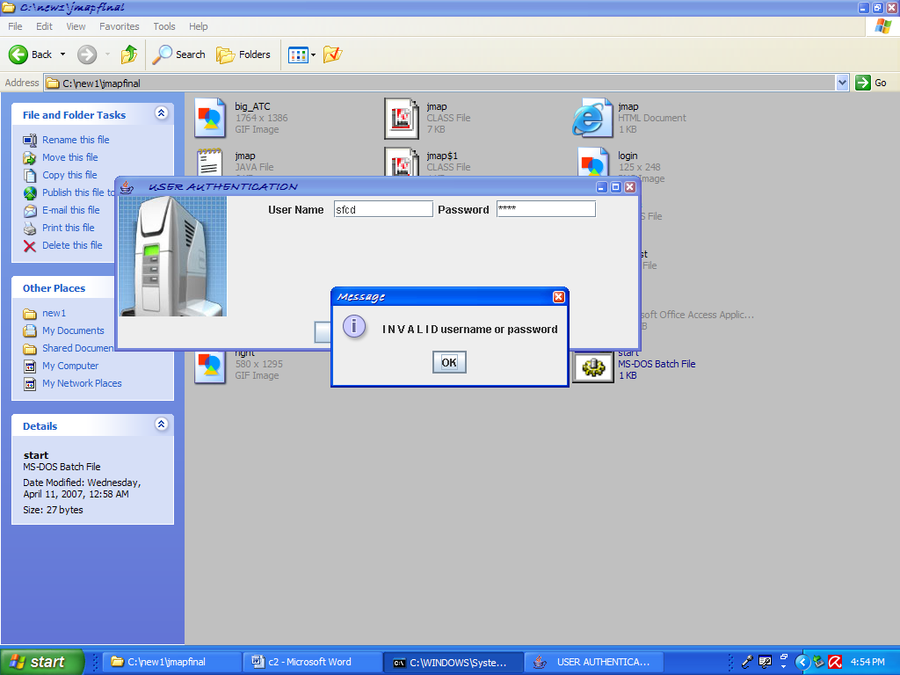

Windows displayed when valid users attempt to logon

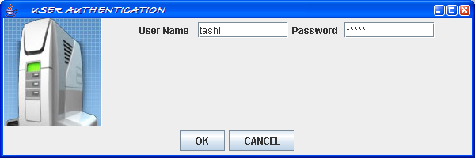

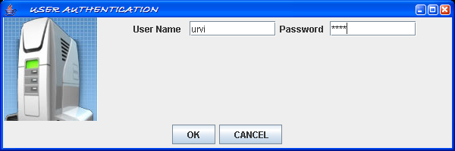

Window displayed when valid client is registered

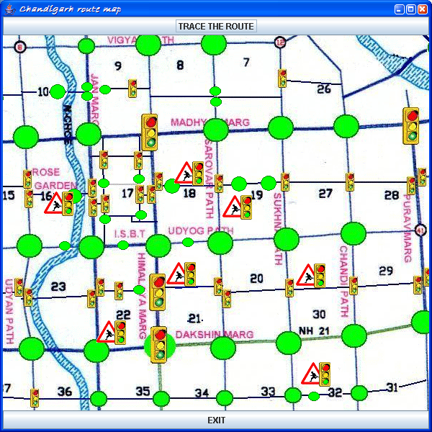

Window displayed when user attempt to trace the path by clicking on TRACE THE ROUTE button.

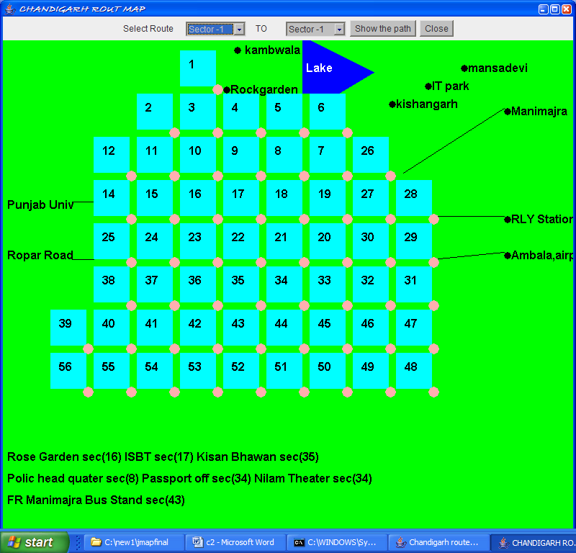

Window displayed when a client enters the sector numbers for which the path is to be found
In case below the user is attempting to find the route from sector 8 to sector 40

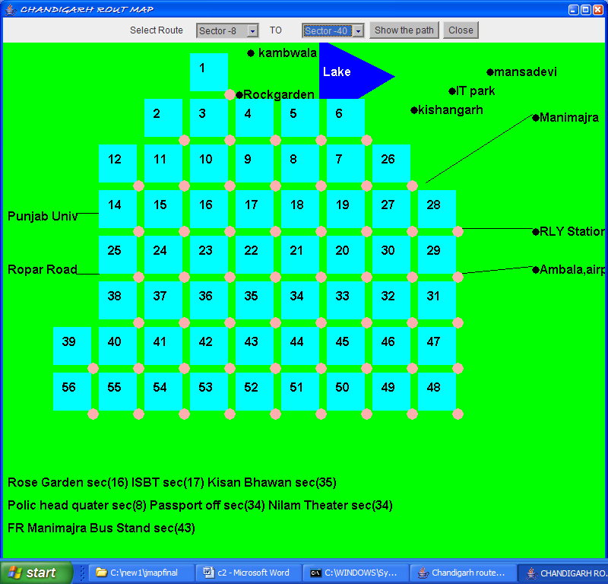

After specifying the sectors user has to click ‘Show the path’ button and path will be displayed on the screen as shown below

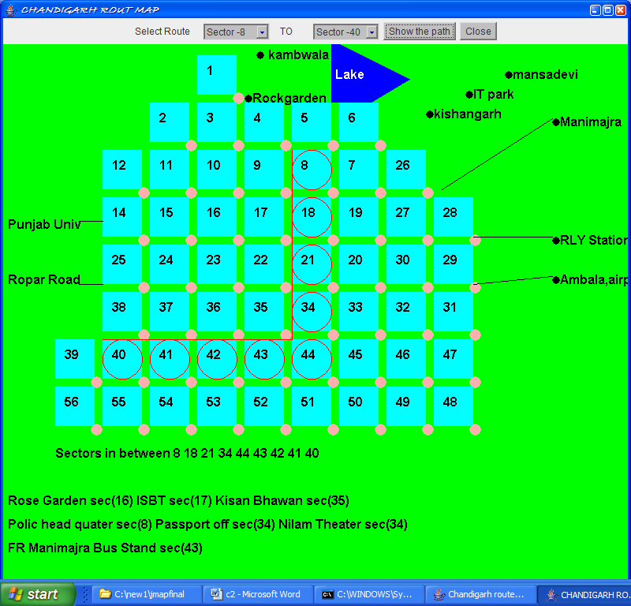

When the same user enters another set of sectors to find the route a new window is displayed with the desired path

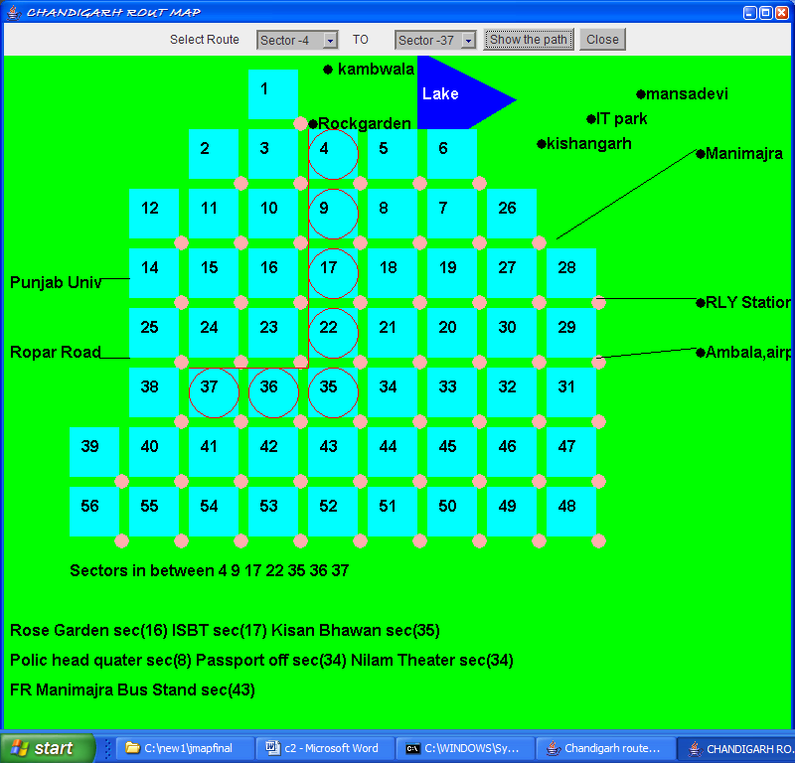

For a new user current window can be closed by clicking on ‘Close’ button

SOFTWARE DEVELOPMENT LIFECYCLE

A software development process is a structure imposed on the development of a software product. Synonyms include software life cycle and software process. There are several models for such processes, each describing approaches to a variety of tasks or activities that take place during the process.
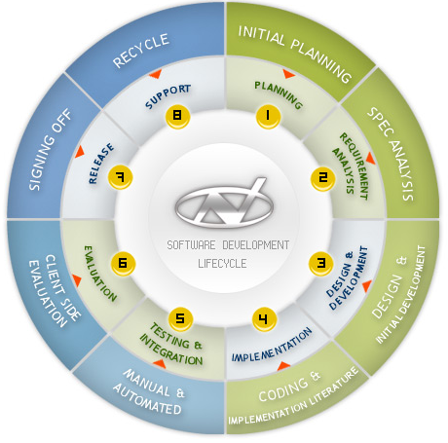
Six Sigma is a methodology to manage process variations that uses data and statistical analysis to measure and improve a company's operational performance.
Domain Analysis
Software Elements Analysis
The most important task in creating a software product is extracting the requirements.
Specification
Specification is the task of precisely describing the software to be written, possibly in a rigorous way.
Software architecture
The architecture of a software system refers to an abstract representation of that system.
Implementation (or coding)
Reducing a design to code may be the most obvious part of the software engineering job, but it is not necessarily the largest portion.
Testing
Testing of parts of software, especially where code by two different engineers must work together, falls to the software engineer.
Documentation
An important (and often overlooked) task is documenting the internal design of software for the purpose of future maintenance and enhancement. Documentation is most important for external interfaces.
Software Training and Support
Maintenance
Maintaining and enhancing software to cope with newly discovered problems or new requirements can take far more time than the initial development of the software.

The waterfall model
The waterfall model is a sequential software development model (a process for the creation of software) in which development is seen as flowing steadily downwards (like a waterfall) through the phases of requirements analysis, design, implementation, testing (validation), integration, and maintenance. The origin of the term "waterfall" is often cited to be an article published in 1970 by W. W. Royce, although Royce did not use the term "waterfall" in this article. Ironically, Royce was actually presenting this model as an example of a flawed, non-working
model. 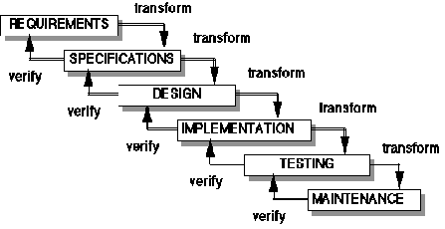
The unmodified "waterfall model". Progress flows from the top to the bottom, like a waterfall.

In Royce's original waterfall model, the following phases are followed in order:
- Requirements specification
- Design
- Construction (AKA implementation or coding)
- Integration
- Testing and debugging (AKA validation)
- Installation
- Maintenance
To follow the waterfall model, one proceeds from one phase to the next in a purely sequential manner. For example, one first completes "requirements specification" — they set in stone the requirements of the software. When the requirements are fully completed, one proceeds to design. The software in question is designed and a "blueprint" is drawn for implementers (coders) to follow — this design should be a plan for implementing the requirements given. When the design is fully completed, an implementation of that design is made by coders. Towards the later stages of this implementation phase, disparate software components produced by different teams are integrated. After the implementation and integration phases are complete, the software product is tested and debugged; any faults introduced in earlier phases are removed here. Then the software product is installed, and later maintained to introduce new functionality and remove bugs.
Thus the waterfall model maintains that one should move to a phase only when its preceding phase is completed and perfected. Phases of development in the waterfall model are discrete, and there is no jumping back and forth or overlap between them.
However, there are various modified waterfall models (including Royce's final model) that may include slight or major variations upon this process.

Usage
The waterfall model is widely used, including by such large software development houses as those employed by the US Department of Defense and NASA (see "DEAD LINK the waterfall model") and upon many large government projects (see "the standard waterfall model" on the Internet Archive). Those who use such methods do not always formally distinguish between the "pure" waterfall model and the various modified waterfall models, so it can be difficult to discern exactly which models are being used to what extent.

SPIRAL LIFECYCLE
The spiral model starts with an initial pass through a standard waterfall lifecycle,
using a subset of the total requirements to develop a robust prototype. After an
evaluation period, the cycle is initiated again, adding new functionality and
releasing the next prototype. This process continues, with the prototype becoming
larger and larger with each iteration. Hence, the “spiral.”
The theory is that the set of requirements is hierarchical in nature, with additional
functionality building on the first efforts. This is a sound practice for systems
where the entire problem is well defined from the start, such as modeling and
simulating software. Business-oriented database projects do not enjoy this
advantage. Most of the functions in a database solution are essentially
independent of one another, although they may make use of common data. As a
result, the prototype suffers from the same flaws as the prototyping lifecycle
described below. For this reason, the software development team has decided
against the use of the spiral lifecycle for database projects.

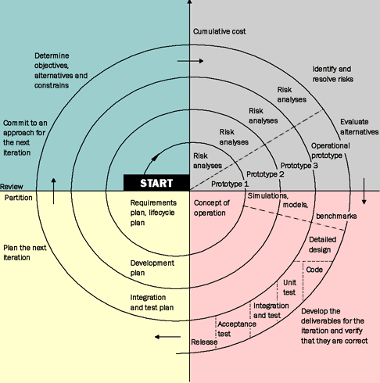

RAPID APPLICATION DEVELOPMENT (RAD) / PROTOTYPING LIFECYCLE
RAD is, in essence, the “try before you buy” approach to software development.
The theory is that end users can produce better feedback when examining a live
system, as opposed to working strictly with documentation. RAD-based
development cycles have resulted in a lower level of rejection when the
application is placed into production, but this success most often comes at the
expense of a dramatic overruns in project costs and schedule.
The RAD approach was made possible with significant advances in software
development environments to allow rapid generation and change of screens and
other user interface features. The end user is allowed to work with the screens
online, as if in a production environment. This leaves little to the imagination, and
a significant number of errors are caught using this process.
The down side to RAD is the propensity of the end user to force scope creep into
the development effort. Since it seems so easy for the developer to produce the
basic screen, it must be just as easy to add a widget or two. In most RAD lifecycle
failures, the end users and developers were caught in an unending cycle of
enhancements, with the users asking for more and more and the developers trying
to satisfy them. The participants lost sight of the goal of producing a basic, useful system in favor of the siren song of glittering perfection.

Software testing
Software testing is the process used to measure the quality of developed computer software. Usually, quality is constrained to such topics as correctness, completeness, security, but can also include more technical requirements as described under the ISO standard ISO 9126, such as capability, reliability, efficiency, portability, maintainability, compatibility, and usability. Testing is a process of technical investigation, performed on behalf of stakeholders, that is intended to reveal quality-related information about the product with respect to the context in which it is intended to operate .

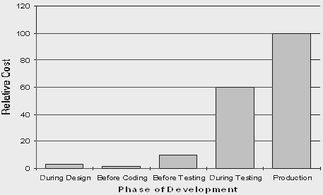

White box, black box, and grey box testing
White box and black box testing are terms used to describe the point of view that a test engineer takes when designing test cases. Black box testing treats the software as a black-box without any understanding as to how the internals behave. Thus, the tester inputs data and only sees the output from the test object. This level of testing usually requires thorough test cases to be provided to the tester who then can simply verify that for a given input, the output value (or behavior), is the same as the expected value specified in the test case.
White box testing, however, is when the tester has access to the internal data structures, code, and algorithms. For this reason, unit testing and debugging can be classified as white-box testing and it usually requires writing code, or at a minimum, stepping through it, and thus requires more skill than the black-box tester. If the software in test is an interface or API of any sort, white-box testing is almost always required.
In recent years the term grey box testing has come into common usage. This involves having access to internal data structures and algorithms for purposes of designing the test cases, but testing at the user, or black-box level. Manipulating input data and formatting output do not qualify as grey-box because the input and output are clearly outside of the black-box we are calling the software under test. This is particularly important when conducting integration testing between two modules of code written by two different developers, where only the interfaces are exposed for test.
Grey box testing could be used in the context of testing a client-server environment when the tester has control over the input, inspects the value in a SQL database, and the output value, and then compares all three (the input, sql value, and output), to determine if the data got corrupt on the database insertion or retrieval.
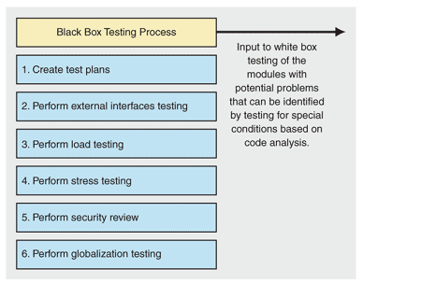

Verification and validation
Software testing is used in association with verification and validation (V&V). Verification is the checking of or testing of items, including software, for conformance and consistency with an associated specification. Software testing is just one kind of verification, which also uses techniques such as reviews, inspections, and walkthroughs. Validation is the process of checking what has been specified is what the user actually wanted.
- Verification: Have we built the software right? (i.e. does it match the specification).
- Validation: Have we built the right software? (i.e. Is this what the customer wants?)

Levels of testing
- Unit testing tests the minimal software component, or module. Each unit (basic component) of the software is tested to verify that the detailed design for the unit has been correctly implemented. In an Object-oriented environment, this is usually at the class level, and the minimal unit tests include the constructors and destructors.
- Integration testing exposes defects in the interfaces and interaction between integrated components (modules). Progressively larger groups of tested software components corresponding to elements of the architectural design are integrated and tested until the software works as a system.
- Functional testing tests at any level (class, module, interface, or system) for proper functionality as defined in the specification.
- System testing tests a completely integrated system to verify that it meets its requirements.
- System integration testing verifies that a system is integrated to any external or third party systems defined in the system requirements.
- Acceptance testing can be conducted by the end-user, customer, or client to validate whether or not to accept the product. Acceptance testing may be performed as part of the hand-off process between any two phases of development.

  - Alpha testing is simulated or actual operational testing by potential users/customers or an independent test team at the developers' site. Alpha testing is often employed for off-the-shelf software as a form of internal acceptance testing, before the software goes to beta testing.
  - Beta testing comes after alpha testing. Versions of the software, known as beta versions, are released to a limited audience outside of the company. The software is released to groups of people so that further testing can ensure the product has few faults or bugs. Sometimes, beta versions are made available to the open public to increase the feedback field to a maximal number of future users.
It should be noted that although both Alpha and Beta are referred to as testing it is in fact use immersion. The rigors that are applied are often unsystematic and many of the basic tenets of testing process are not used. The Alpha and Beta period provides insight into environmental and utilization conditions that can impact the software.
After modifying software, either for a change in functionality or to fix defects, a regression test re-runs previously passing tests on the modified software to ensure that the modifications haven't unintentionally caused a regression of previous functionality. Regression testing can be performed at any or all of the above test levels. These regression tests are often automated.
SMOKE TESTING
Smoke testing is a term used in plumbing, woodwind repair, electronics, and computer software development. It refers to the first test made after repairs or first assembly to provide some assurance that the system under test will not catastrophically fail. After a smoke test proves that the pipes will not leak, the keys seal properly, the circuit will not burn, or the software will not crash outright, the assembly is ready for more stressful testing.
- In plumbing, a smoke test forces actual smoke through newly plumbed pipes to find leaks, before water is allowed to flow through the pipes.
- In woodwind instrument repair, a smoke test involves plugging one end of an instrument and blowing smoke into the other to test for leaks. (This test is no longer in common use)

- In electronics, a smoke testing is the first time a circuit is attached to power, which will sometimes produce actual smoke if a design or wiring mistake has been made.
- In computer programming and software testing, smoke testing is a preliminary to further testing, which should reveal simple failures severe enough to reject a prospective software release. In this case, the smoke is metaphorical.

6. CODING:

6.1 For User authentication:
import javax.swing.*;
import java.awt.*;
import java.awt.event.*;
import java.sql.*;
import java.util.*;
class mytest
{
public static void main(String s[ ])
{
myframe f1 = new myframe(" USER AUTHENTICATION");
f1.setSize(600,200);
f1.setLocation(130,200);
f1.setVisible(true);
}
}

class myframe extends JFrame implements ActionListener
{
int f=1;
int r=1;
int s=1;
JPasswordField t1;
JTextField t2,t3;
JButton b1,b2;

myframe(String s)
{
super(s);
Container con=getContentPane();
con.setLayout(new BorderLayout());
t1 = new JPasswordField(10);
t2 = new JTextField(10);
t3 = new JTextField(10);
b1= new JButton(" OK ");
b2= new JButton(" CANCEL");
b1.addActionListener(this);
b2.addActionListener(this);
JPanel p1,p2,p3,p4;
p1=new JPanel();
p2=new JPanel();
p3=new JPanel();
p4=new JPanel();

ImageIcon c1 = new ImageIcon("login.png");
JLabel m1 = new JLabel(c1);

p1.add(m1);
con.add(m1,BorderLayout.WEST);

p2.add(new JLabel("User Name "));
p2.add(t2);
p2.add(new JLabel("Password "));
p2.add(t1);
con.add(p2,BorderLayout.CENTER);

p4.add(b1);
p4.add(b2);

con.add(p4,BorderLayout.SOUTH);
b1.addActionListener(this);
b2.addActionListener(this);

}
public void actionPerformed(ActionEvent ae)
{
if(ae.getSource() == b1)
{
char a[]=t1.getPassword();
int i;
String s1="";
for(i=0;i< a.length;i++)
{
s1=s1+a[i];
}
Connection con = null;
Statement stmt = null;
ResultSet rs;
try {
Class.forName("sun.jdbc.odbc.JdbcOdbcDriver");
con = DriverManager.getConnection("jdbc:odbc:mandata");
stmt = con.createStatement();
String uname = t2.getText();
String password = s1;

String ss="select * from logins where uname= \'" +uname +"\'" + " and password= \'" + password + "\'" ;
rs=stmt.executeQuery(ss);
System.out.print("" + rs.getRow());
rs.next();
int n= rs.getRow();
if(n>0)
{
if(f==1)
{

Calendar d1 = Calendar.getInstance();
int dow =d1.get(Calendar.DAY_OF_WEEK);
if(!(dow>=2 && dow<=6))
{
if(s==1)
JOptionPane.showMessageDialog(null, "Sorry You Can Not Access at this Day");
if(s==0)
s=1;
else
s=0;
return;
}
int time = d1.get(Calendar.HOUR_OF_DAY);
if(!(time >=9 && time <=17))
{
if(s==1)
JOptionPane.showMessageDialog(null, "Sorry You Can Not Access at this time");
if(s==0)
s=1;
else
s=0;
return;
}
myfrs f1 = new myfrs("Chandigarh route map");
f1.setSize(600,600);
f1.setLocation(200,100);
f1.setVisible(true);
setVisible(false);

f=0;
r=0;
}
}
if( r==1)
{
//myfr m1 = new myfr(" INVALID USER"," I N V A L I D username of password");
//m1.setSize(230,200);
//m1.setLocation(160,250);
//m1.setVisible(true);
if(s==1)
JOptionPane.showMessageDialog(null, "I N V A L I D username or password");
if(s==0)
s=1;
else
s=0;

}
}catch(Exception e) {}
}
}
}

class myfr extends JFrame implements ActionListener
{
JButton b1;

myfr(String s,String m)
{
super(s);
b1 = new JButton( " O K ");
Container con=getContentPane();
con.setLayout(new BorderLayout());
con.add(new JLabel(m),BorderLayout.CENTER);
con.add(b1,BorderLayout.SOUTH);
b1.addActionListener(this);
}
public void actionPerformed(ActionEvent ae)
{
setVisible(false);
}

}

6.2 For Route Map:
import java.awt.*;
import java.awt.event.*;
import java.applet.*;
import javax.swing.*;
class myfrs extends JFrame implements ActionListener
{
JButton b1,b2;
myfrs(String s)
{
super(s);
b1 = new JButton( " TRACE THE ROUTE ");
b2 = new JButton( " EXIT");
ImageIcon c1 = new ImageIcon("big_ATC.gif");
JLabel m1 = new JLabel(c1);
Container con=getContentPane();
con.setLayout(new BorderLayout());
con.add(b1,BorderLayout.NORTH);
con.add(m1,BorderLayout.CENTER);
con.add(b2,BorderLayout.SOUTH);
b1.addActionListener(this);
b2.addActionListener(this);
}
public void actionPerformed(ActionEvent ae)
{
if(ae.getSource()==b1)
{
jmap p1 = new jmap("CHANDIGARH ROUT MAP");
p1.setSize(800,900);
p1.show();

}
else
System.exit(0);
}
}

6.3 For Path calculation:

import java.awt.*;
import java.awt.event.*;
import java.applet.*;
import java.applet.Applet;
import javax.swing.*;

class jmap extends JFrame implements ActionListener
{
int i=0;
int j=0;
int fl=0;
int x=0,y=0;
int x1=0,y1=0;
String s="";
Choice c1,c2;
Button b1,b2;
boolean f=false;
int p1=0,p2=0;
jmap(String s1)
{
super(s1);
b1=new Button("Show the path");
b2=new Button("Close");
c1 = new Choice();
c2= new Choice();
int i;
for(i=1;i<=56;i++)
{
c1.add("Sector -"+i);
c2.add("Sector -"+i);
}

setLayout(new BorderLayout());
Panel p1 = new Panel();
p1.add(new Label("Select Route"));
p1.add(c1);
p1.add(new Label(" TO "));
p1.add(c2);
p1.add(b1);
p1.add(b2);
b2.addActionListener(this);
b1.addActionListener(this);
add(p1,BorderLayout.NORTH);

s="hello";
Font f1 = new Font("Arial",Font.BOLD,16);
setFont(f1);
setBackground(Color.green);

addWindowListener(new WindowAdapter()
{
public void windowClosing(WindowEvent we)
{
setVisible(false);
}});

}

public void actionPerformed(ActionEvent ae)
{

if(ae.getSource()==b2)
{
setVisible(false);
}

f=true;
String s1,s2;
s1 = c1.getSelectedItem();
s2= c2.getSelectedItem();
System.out.println(s1+" "+s2);
int n = s1.indexOf("-");

s1=s1.substring(n+1,s1.length());
System.out.println(s1);
n = s2.indexOf("-");
s2=s2.substring(n+1,s2.length());
p1=Integer.parseInt(s1);
p2=Integer.parseInt(s2);
repaint();
}

public void update(Graphics g)
{
paint(g);
}

public void paint(Graphics g)

{
int m[][] = {
{0,0,0,1},
{0,0,2,3,4,5,6},
{0,12,11,10,9,8,7,26},
{0,14,15,16,17,18,19,27,28},
{0,25,24,23,22,21,20,30,29},
{0,38,37,36,35,34,33,32,31},
{39,40,41,42,43,44,45,46,47},
{56,55,54,53,52,51,50,49,48}
};
int b[];
b=new int[20];
int l=0,k=0,n=0,r=0,s=0;

int num=5;
int xx[]={420,420,470,520,420};
int yy[]={90,130,130,100,50};
g.setColor(Color.blue);
g.fillPolygon(xx,yy,num);
g.setColor(Color.white);
g.drawString("Lake",425,100);
g.setColor(Color.black);
g.fillOval(325,65,10,10);
g.drawString("kambwala",340,75);

g.fillOval(310,120,10,10);
g.drawString("Rockgarden",320,130);

g.fillOval(550-10,150-10,10,10);
g.drawString("kishangarh",550,150);

g.fillOval(590,115,10,10);
g.drawString("IT park",600,125);

g.fillOval(640,90,10,10);
g.drawString("mansadevi",650,100);

g.fillOval(700,150,10,10);
g.drawString("Manimajra",710,160);
g.drawLine(560,240,700,150);

g.fillOval(700,300,10,10);
g.drawString("RLY Station",710,310);
g.drawLine(600,300,700,300);

g.fillOval(700,350,10,10);
g.drawString("Ambala,airport,nh21",710,360);
g.drawLine(600,360,700,350);

g.drawLine(100,280,130,280);
g.drawString("Punjab Univ",10,290);

g.drawLine(100,360,130,360);
g.drawString("Ropar Road",10,360);

g.drawString("Rose Garden sec(16) ISBT sec(17) Kisan Bhawan sec(35)",10, 640);
g.drawString("Polic head quater sec(8) Passport off sec(34) Nilam Theater sec(34)",10, 670);
g.drawString("FR Manimajra Bus Stand sec(43)",10, 700);

//g.drawString("p1="+p1+" p2= "+p2,550,530);

if(!f)
{

x=70;
y=70;
for(i=0;i<m.length;i++)
{
x=70;
for(j=0;j<m[i].length;j++)
{
if(m[i][j]==0)
{x=x+60;
continue;
}
g.setColor(Color.cyan);
g.fillRect(x,y,50,50);
g.setColor(Color.black);
g.drawString(""+m[i][j],x+12,y+25);
g.setColor(Color.pink);
g.fillOval(x+45,y+47,15,15);
g.setColor(Color.black);
x=x+60;
try {
Thread.sleep(20);
}catch(Exception e){}
}
y=y+60;
}
}
else
{
if(p1>p2)
{
int t=p1;
p1=p2;
p2=t;
}

if(p1<=p2)
{
for(i=0;i<m.length;i++)
{
for(j=0;j<m[i].length;j++)
{
if(m[i][j]==p1)
{
l=i;
n=j;
}

if(m[i][j]==p2)
{
k=i;
r=j;
}
}
}
}

s=0;
for(;l<k;l++)
b[s++]=m[l][n];

fl=0;
if(r>n)
{
for(;n<=r;n++)
{
b[s++]=m[l][n];
fl=2;
}
}

else
{
for(;n>=r;n--)
{
b[s++]=m[l][n];
fl=1;
}

}

n--;
String sd="";

for(i=0;i<s;i++)
sd=sd+ " " + b[i];
g.setColor(Color.black);
g.drawString("Sectors in between"+sd,70,580);

if(fl==2)
{
x=70;
y=70;
r=0;
for(i=0;i<m.length;i++)
{
x=70;
for(j=0;j<m[i].length;j++)
{
g.setColor(Color.red);
if(b[r]==0)
{
x=x+60;
continue;
}
if(m[i][j]==b[r])
{
if(b[r] == b[r+1])
r++;
g.drawOval(x,y,50,50);
if(x1>0)
g.drawLine(x1,y1,x,y);
x1=x;y1=y;
r++;
try {
Thread.sleep(50);
}catch(Exception e){}

}
x=x+60;

}
y=y+60;
}
}

if(fl==1)
{
x=70;
y=70;
r=0;
System.out.println("Entered in loop");
for(i=0;i<m.length;i++)
{
x=70;
for(j=0;j<m[i].length;j++)
{
g.setColor(Color.red);
if(m[i][j]==b[r])
{
//if(b[r] == b[r+1])
//r++;
g.drawOval(x,y,50,50);
if(x1>0)
g.drawLine(x1,y1,x,y);
x1=x;y1=y;
r++;
try {
Thread.sleep(50);
}catch(Exception e){}

}
x=x+60;

}
y=y+60;
}

x=70;
y=70;
x1=0;
y1=0;
int h=b.length-1;

for(i=b.length-1;i>0;i--)
{
if(b[i]!=0)
break;
System.out.print(b[i]);
}

h=i;

System.out.println("Entered in loop h="+h);
for(i=0;i<m.length;i++)
{
x=70;
for(j=0;j<m[i].length;j++)
{
g.setColor(Color.red);

if(m[i][j]==b[h])
{
System.out.print(b[h]+"h="+h);
//if(b[r] == b[r+1])
//r++;
g.drawOval(x,y,50,50);
if(x1>0)
g.drawLine(x1,y1,x,y);
x1=x;y1=y;
h--;
try {
Thread.sleep(50);
}catch(Exception e){}
}
x=x+60;
}
y=y+60;
}

}

}

f=false;
}
}

7.CONCLUSION AND FUTURE WORK

6.1Conclusion
We have successfully implemented a prototype of File Resource authentication protocol on a single system and on the Network as well. With the help of various security constraints we have been also able to provide security and also in our attempt to trap the various intrusions possible by unauthenticated users. We have also provided a secured communication between two users with the help of authentication file server and surely with encryption and decryption with the help of Caesar Cipher.

6.2 Future Work
This project has number of future applications.The same procedure can be used to make the route map of
Some other city by small amendments.So this project can become the basis of new software to be
designed. Further more applications can be added in this project like route once traced can be stored for
future reference.This project provides a Graphic User Interface which makes it more flexible and user
friendly.

8.REFERENCES

[1]. S. P. Miller, B. C. Neuman, J. I. Schiller, and J. H. Saltzer, Section E.2.1: Authentication and Authorization System, M.I.T. Project Athena, Cambridge, Massachusetts
(December 21, 1987).

[2]. E. Balkovich, S. R. Lerman, and R. P. Parmelee, ‘‘Computing in Higher Education:
The Athena Experience,’’ Communications of the ACM 28(11), pp. 1214-1224, ACM
(November, 1985).

[3]. R. M. Needham and M. D. Schroeder, ‘‘Using Encryption for Authentication in
Large Networks of Computers,’’ Communications of the ACM 21(12), pp. 993-999
(December, 1978).

[4]. V. L. Voydock and S. T. Kent, ‘‘Security Mechanisms in High-Level Network Protocols,’’
Computing Surveys 15(2), ACM (June 1983).

