How Our Model Is Trained
Fine-tuning Qwen3-VL-8B for insurance document extraction: architecture, data, LoRA, training mechanics and evaluation

Project: Fideon L3: insurance document extraction (repo Akshayi2i/fine-tuning)
Model: Qwen3-VL-8B-Instruct, fine-tuned with LoRA on a frozen bf16 base
Scope of this document: how the model is built, trained, fed and evaluated, and why each choice was made
Based on: the repository at commit f352228 (main), its configs, specs SPEC_00-15 and architecture v2.1
Date: 4 October 2026

How to read this document
This is a study guide to the training side of the project. It explains what the model is, what we teach it, with which data, using which technique and tools, how one training step actually works, and how we decide whether a trained model is good enough to ship. Every number in it was read from the repository's configs and code, and the important ones carry a file reference so you can check them.
Each topic is written in layers, so you can stop at the depth you need:
IN PLAIN ENGLISH
A short explanation with an everyday analogy. Read these first; together they tell the whole story.

DEEP DIVE
The mechanism: equations, dimensions, memory arithmetic, step-by-step internals.

IN OUR REPO
Where the setting or behaviour lives in the code, as path/to/file.py:line.

WHY WE CHOSE THIS
The reason the project made a choice, usually quoting the comment or spec that records it.

GENERAL ML CONTEXT (NOT A REPO DECISION)
Background from the wider ML field. Used where the repo does not itself discuss an alternative, so you can tell a project decision from general knowledge.

WATCH OUT
A pitfall the project has already hit, or a gap between the documentation and the code.

Two kinds of statement are kept apart throughout. What the repo states or does is cited. General ML context (for example, how DoRA or Donut work, or why a framework is popular) is marked as such, because the repo never evaluated those options and it would be wrong to present a reason as the project's when it is not.
CURRENT STATUS
No trained model has been scored yet. The plumbing is built and tested (all ten build phases done, 1,800+ CPU tests). A first smoke run on the GPU pod (late September 2026) proved the path end to end and led to several fixes described in chapter 15, but on a handful of documents its scores mean nothing. The Phase 0 spike is still listed as pending, the pilot protocol has not run, and pre-training work is parked until the new training set is delivered. So this document explains how accuracy will be measured; it cannot report what the accuracy is.

Contents
1 Executive summary 7
1.1 The story in twelve steps 7
1.2 Key numbers 8
2 The problem we are solving 9
2.1 What goes in and what comes out 9
2.2 Where the model sits: Fideon L3 10
2.3 Three ways the model may have to read a page 10
2.4 Why a vision-language model, and not rules or a text-only model 10
2.5 Why fine-tune instead of only prompting 11
2.6 What 'good enough' means 11
3 The pipeline at a glance 13
3.1 Environments and machines 14
3.2 Rules that are not style preferences 14
4 Transformer fundamentals 15
4.1 Tokens and embeddings 15
4.2 Self-attention 15
4.3 Multi-head and grouped-query attention (GQA) 16
4.4 The MLP (SwiGLU feed-forward) 16
4.5 Residual stream and normalisation 16
4.6 From the last layer to the next token 17
4.7 Encoders, decoders, and what our model has 17
5 Qwen3-VL-8B-Instruct, in detail 19
5.1 From a page to visual tokens 19
5.2 DeepStack: fine detail without training the vision encoder 20
5.3 Positions: Interleaved-MRoPE and page markers 20
5.4 The language decoder 21
5.5 Where the 8.8 billion parameters are 21
5.6 What one training row costs 21
5.7 Pinning and loading 22
6 Why Qwen3-VL-8B as the base model 23
6.1 How the model fits the requirements 23
6.2 The alternatives, in context 23
7 Ways to adapt a pre-trained model 25
7.1 Supervised fine-tuning (SFT), the stage we are at 25
7.2 What can be changed, and how much 25
8 LoRA, explained properly 26
8.1 The idea 26
8.2 The mathematics 26
8.3 Initialisation: why the model starts exactly as the base 27
8.4 Why a low-rank change is enough 27
8.5 Rank, alpha and the scale factor 27
8.6 Dropout on the adapter path 28
8.7 Where the adapters go 28
8.8 Memory: why LoRA fits and full fine-tuning would not 28
8.9 Merging: zero cost at serving time 29
8.10 Our LoRA configuration, line by line 29
9 The alternatives, and why we did not choose them 30
9.1 Full fine-tuning 30
9.2 QLoRA (4-bit base) and how the project moved away from it 30
9.3 DoRA (weight-decomposed LoRA) 30
9.4 Higher or lower rank, and rsLoRA 31
9.5 LoRA on the vision merger or the vision encoder 31
9.6 One unified adapter vs a foundation plus per-type adapters 31
9.7 Prompt tuning, prefix tuning, bottleneck adapters, IA3 32
9.8 Decision matrix 32
10 What is trained and what stays frozen 33
10.1 Why the decoder is the right place 33
10.2 The escalation path: training/vit_gate.py 33
11 The training data I: where it comes from 35
11.1 The delivery 35
11.2 From delivery to bundles: prepare_bundles 36
11.3 The bundles 36
12 The training data II: the labels 38
12.1 The canonical schema 38
12.2 The value envelope: canonical form vs model form 38
12.3 What a golden label looks like 39
12.4 Completing the twins' labels: fill_synthetic_labels 39
12.5 Checking labels against the pages 39
12.6 How labels will be produced for new data 40
13 The training data III: what the model actually sees 41
13.1 OCR with MinerU 41
13.2 The three modalities, and how they are mixed 41
13.3 Windowing: how a long policy becomes several rows 42
13.4 Anatomy of one training row 44
13.5 Byte-identical prompts in training and serving 46
13.6 Sequence caps: reject, never truncate 47
13.7 Splits, families and the frozen eval set 48
13.8 Balancing small lines 48
13.9 What is written, and what is still open 49
14 The trainer and the training mechanism 50
14.1 The trainer stack 50
14.2 Why ms-swift, and the alternatives 50
14.3 How a run is launched 51
14.4 Checks before any GPU time is spent 51
14.5 The objective: what the loss is 52
14.6 One optimizer step, end to end 53
14.7 Memory and speed techniques 54
14.8 Epochs are files 54
14.9 Every hyperparameter, and why 54
14.10 GPUs, data parallelism and DeepSpeed 55
14.11 Checkpoints, evaluation cadence and resume 56
14.12 Time and cost 56
14.13 Hyperparameter sweeps (written, deferred) 56
15 How the model learns, and why it beats the base model 57
15.1 What 'learning' means mechanically 57
15.2 What the base model brings, and what fine-tuning adds 57
15.3 Why the improvement should generalise, not memorise 58
15.4 The interaction with constrained decoding: a real lesson 58
15.5 Other lessons from the smoke run 59
15.6 What fine-tuning cannot fix 59
15.7 How 'better than the base' will be shown 59
16 How training is evaluated 60
16.1 Why training loss does not choose the model 60
16.2 Checkpoint selection 60
16.3 The metrics 61
16.4 When is a value 'correct'? 61
16.5 The golden eval set 62
16.6 The promotion gate 62
16.7 Calibration: a confidence for every field 63
16.8 Auto-accept thresholds: a promise backed by evidence 64
16.9 The pilot protocol 64
17 After training: merge, package, serve 65
17.1 Merge and formats 65
17.2 The serving pipeline 65
17.3 One base, several adapters 65
18 Status, open items and recommendations 67
18.1 Build status 67
18.2 Before the long training run 67
18.3 Recommendations from this review 67
Appendix A Glossary 69
Appendix B Key numbers 71
Appendix C Where each setting lives 72
Appendix D Operator commands 73
Appendix E Where the documentation and the code disagree 74

1 Executive summary
We take an open, pre-trained vision-language model, Qwen3-VL-8B-Instruct, and teach it one job: read the pages of an insurance policy and write the client's canonical JSON for that line of business, giving for every value what was printed, a normalised form of it, and the page it came from. We teach it with supervised fine-tuning (SFT) using LoRA adapters on a frozen bf16 copy of the model, trained by ms-swift on H200 GPUs, and we judge the result on generated output, not on training loss.

1.1 The story in twelve steps
- The job. Fideon's L0-L2 layers handle documents they can parse with rules. L3, this repo, is the fallback for the hard ones: scanned pages, unknown carriers, layouts where structure inference failed.
- The model. Qwen3-VL-8B-Instruct: a 27-layer vision encoder (ViT) reads the page image, a merger turns every 32x32-pixel patch into one token, and a 36-layer Qwen3 language decoder reads those tokens together with the prompt and the OCR text and writes the answer token by token. About 8.8 billion parameters in all.
- The data. A delivery of 192 real source policies, each with 10 synthetic twins, became 1,702 training bundles (PDF + golden JSON + metadata) across seven personal lines: 1,329 train, 186 validation, 187 test.
- The labels. Each value is an envelope {raw, parsed, page_ref} in the client's canonical schema (e.g. 532 fields for homeowners). Synthetic twins inherit the reviewed gold of their source.
- The input. Pages are OCR'd by MinerU on GPU and rendered as images at a fixed pixel budget (2,483,200 px, about 2,425 visual tokens per page). Each training row shows the model images and, depending on the mode, clean OCR text (50%), deliberately corrupted OCR text (20%) or no text at all (30%).
- The windows. A long policy is read in windows: a section group (declarations, schedules, the line's own block, document detail) over a handful of pages. One document becomes about 5.4 rows per mode.
- The technique. LoRA rank 64, alpha 128, dropout 0.10 on the seven attention and MLP projections of every decoder layer: about 175 million trainable parameters, 2% of the model. The vision encoder, the mergers, the embeddings and the LM head stay frozen. The base is held in bf16, exactly as it is served.
- The trainer. ms-swift 3.12.6 (swift sft) on top of the Hugging Face Trainer, PEFT and PyTorch 2.8, with flash-attention 2, gradient checkpointing and padding-free batching, data-parallel over every GPU on the pod.
- The objective. Ordinary next-token cross-entropy, computed only on the assistant's JSON and its end token; every prompt, image and OCR token is masked out (label -100).
- The schedule. Learning rate 1e-4, 10 warm-up steps, cosine decay, AdamW, no weight decay, effective batch 8, three passes over the documents (three epoch files, each with a fresh modality draw), seed 42.
- The selection. After training, the last three checkpoints and the best-loss one generate answers in vLLM on a 400-row validation sample; the one with the highest field accuracy is merged into the base.
- The release. The merged model is calibrated (confidence per field), scored on a frozen golden eval set in all three modes through the real serving pipeline, and must pass a 15-metric promotion gate before it is packaged.

1.2 Key numbers
Table 1. The facts most worth remembering.
Item | Value | Where it is set
Base model | Qwen/Qwen3-VL-8B-Instruct, revision 0c351dd0... (2025-10-15, 17.5 GB) | configs/base_model.yaml:7-10
Fine-tuning method | LoRA on a frozen bf16 base (QLoRA only as an opt-in flag) | configs/base_model.yaml:38-39
LoRA rank / alpha / dropout | 64 / 128 / 0.10, bias none, rsLoRA off | configs/training/unified.yaml:26-53
LoRA targets | q, k, v, o, gate, up, down projections in all 36 decoder layers | configs/training/unified.yaml:48
Trainable parameters | 174.6 M of about 8.77 B (2.0%) | computed from the model config
Frozen | vision encoder, patch merger, DeepStack mergers, embeddings, LM head, norms | training/train.py:517-518
Trainer | ms-swift 3.12.6 -> HF Trainer (transformers 4.57.6), PEFT 0.18.1, torch 2.8.0 | requirements-train.lock
Learning rate / schedule | 1e-4, cosine, 10 warm-up steps | unified.yaml:58-64
Batch | 1 row per GPU, effective batch 8 (accumulation adjusts to GPU count) | unified.yaml:82-89
Epochs | 3 document passes (3 epoch files, num_train_epochs: 1 over them) | train.py:449-481
Max sequence | 32,768 tokens; over-long rows refused, never truncated | configs/shared/sequence.yaml
Image budget | max 2,483,200 px = 2,425 visual tokens per page | configs/shared/vision.yaml:30
Modality mix | OCR+image 50% · noisy OCR+image 20% · image only 30% | common/constants.py:105-109
Corpus | 1,702 documents: 1,329 / 186 / 187 (152 originals) | data/bundles (git-ignored)
Hardware | RunPod H200 SXM 141 GB; all visible GPUs, data-parallel | unified.yaml:177-181
Checkpoint selection | best generated field_normalized_match among last 3 + best-loss | evaluation/checkpoint_eval.py
Release gate | 15 metrics; e.g. normalised match >= 0.85, schema validity >= 0.98 | evaluation/gating.py:166-180

2 The problem we are solving
Before the mechanics: what goes in, what must come out, where this model sits in the larger system, and why the answer to 'how do we do this?' turned out to be 'fine-tune a vision-language model'.

2.1 What goes in and what comes out
Input: the PDF of an insurance policy. In the current scope (personal_lines) that means homeowners, personal auto (Hagerty classic-car policies included, since classic auto was merged into personal auto on 2026-10-01), dwelling fire, ocean marine, motorcycle, recreational vehicle and personal umbrella. Flood is excluded. In the training delivery every document is a scan: the audit found 0 digital and 1,702 scanned PDFs.
Output: one JSON object in the client's canonical schema for that line of business. The schema is owned by Fideon SPEC_00, not by this repo; the files in configs/canonical schema/LOB Schema/ are read-only. Each leaf value is a small envelope:
One field in the served output (canonical FieldValue envelope)
"effective_date": {
"raw": "06/15/2026", <- exactly as printed
"parsed": "06/15/2026", <- normalised (dates MM/DD/YYYY, numbers as digits)
"page_ref": [1], <- the page(s) it was read from
"confidence": {"score": 0.97, "source": "vlm"}, <- added after generation, by calibration
"flagged": false <- true = send to human review
}

The model itself only ever writes raw, parsed and page_ref. Confidence and the review flag are computed afterwards from the model's token probabilities (chapter 16), and a final post-process adds every schema key the model did not emit as an empty envelope, so a consumer always receives the full key set (common.canonical.with_all_keys, applied at the end of serving.pipeline.extract).
IN PLAIN ENGLISH
Think of the model as a very fast junior underwriter who has read millions of documents but never seen our forms. Fine-tuning is the induction course: here is our checklist (the schema), here is how we want each answer written (the envelope), here is how to cite your page, and here is what to do when the scan and the typed text disagree.

2.2 Where the model sits: Fideon L3
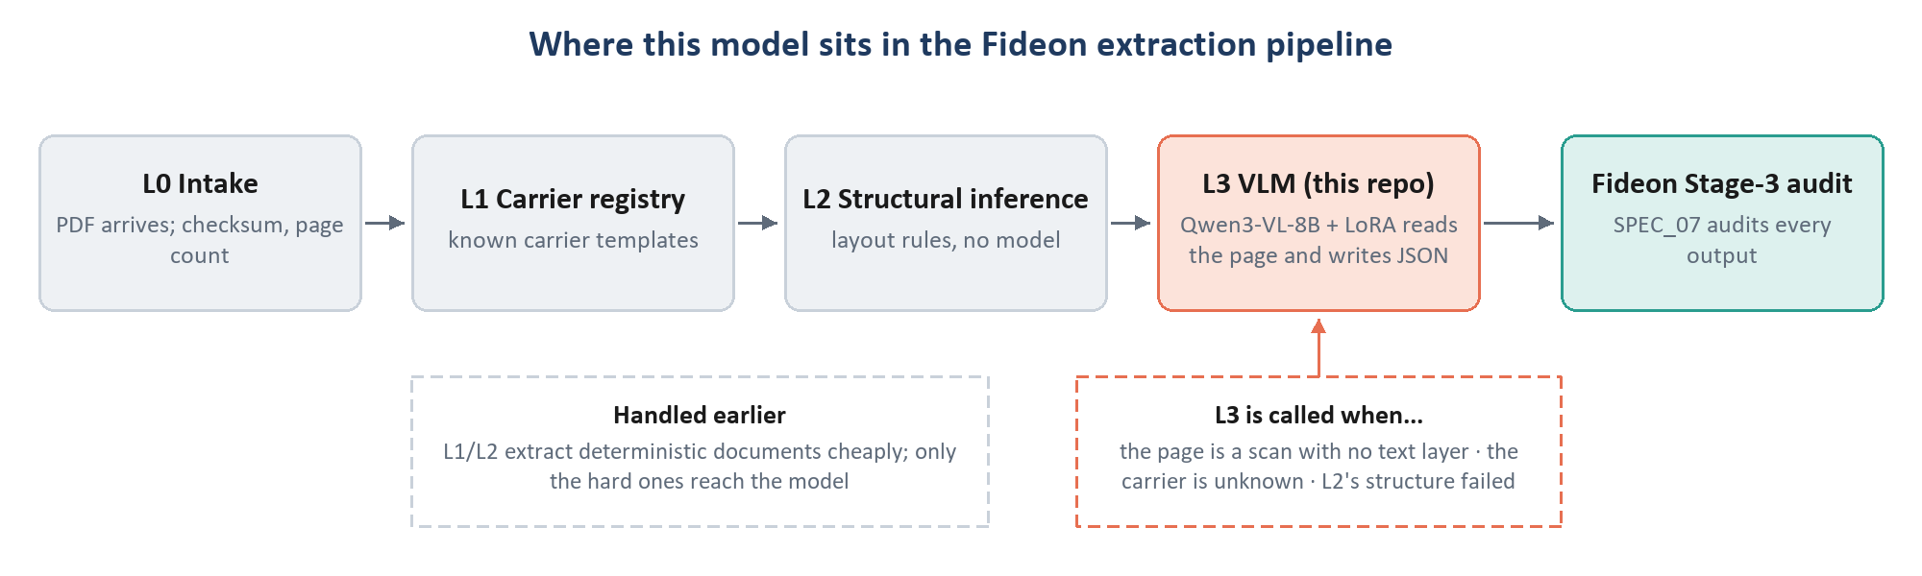
Figure 1. Fideon's layers. L3 (this repo) is only called for the documents the cheaper, deterministic layers cannot handle, and everything it produces is audited downstream.
Fideon processes documents in layers of increasing cost. L1 looks the carrier up in a registry of known templates; L2 infers structure from layout rules. Both are cheap and deterministic. L3 is invoked when the input is a scan, the carrier is unknown, or structural inference failed (SPEC_00 section 1.1). Its obligations are fixed by the larger system: its output must follow the Fideon schema, a schema change means rebuilding the corpus and retraining, and every output is audited by Fideon SPEC_07 Stage 3.

2.3 Three ways the model may have to read a page
Table 2. The three modalities (common/constants.py:99-109). Production serves the first and the third.
Mode | What the model receives | Why it exists | Share of training
ocr_plus_image | page images, each followed by that page's MinerU OCR markdown | the normal production path | 50%
noisy_ocr_image | the same, but the OCR text has been deliberately corrupted (O/0, l/1, merged table cells, dropped headers...) | teaches 'where text and image disagree, trust the image' | 20%
image_only | page images and <page N of M> markers, no OCR text | the must-work-without-OCR production path: the vision encoder does all the reading | 30%

2.4 Why a vision-language model, and not rules or a text-only model
- A scan has no text to apply a rule to. The README puts it plainly: in image_only mode 'there is no text for a rule to read', which is why a rule-based label mapper cannot serve this system.
- Layout carries meaning. Which column a number sits in decides whether it is a limit, a deductible or a premium. OCR flattens tables and merges columns; the image keeps the geometry. The system prompt makes the image the authority on layout and on any character where the two disagree.
- Wording varies without limit. Carriers phrase the same role in different words and the same words for different roles. The repo forbids runtime alias lookup (tests/test_no_runtime_aliases.py): the alias registry is labelling and evaluation material only, and 'the model does the semantic mapping'.

2.5 Why fine-tune instead of only prompting
Qwen3-VL-8B can already read documents. What it does not know is our contract, and the contract is strict:
- a canonical schema of hundreds of fields per line (homeowners: 532 fields, 17 top-level sections) whose meanings depend on insurance roles (named insured vs producer, policy period vs issue date, limit vs deductible vs premium);
- an exact envelope (raw character-for-character, parsed in fixed formats, page_ref from the page markers);
- sparse emission: write only what the document states, never invent, never derive; omit absent fields;
- domain rules such as 'the declarations layer wins' and 'extract every table row, including closed or zero rows';
- image-over-OCR arbitration on noisy scans, and stopping cleanly at the end of the JSON.
A long prompt carries all of these rules, and the system prompt does (about 20,000 characters for the declarations group). But a prompt states rules; it does not make a model follow them consistently over 500 fields and 30-page documents. Supervised examples do. Fine-tuning turns the rules into behaviour.
WHY WE CHOSE THIS
- Privacy. Policies carry personal data. SPEC_00 does not allow it to go to third-party APIs, so a closed frontier model is allowed only as a one-time labelling helper, with compliance approval and a zero-retention endpoint (data_pipeline/labeling/pre_annotate.py refuses otherwise). The production model must run on our own GPU.
- Open weights are what make LoRA, logprob-based calibration, version pinning and on-pod serving possible.
- Measured, not assumed. The pilot protocol's Experiment A runs the untuned base model on 10 documents per type first. Above 0.70 field accuracy: proceed; 0.40-0.70: proceed with targeted data; below 0.40: fix the prompt and schema before spending on annotation (pilot/zero_shot_baseline.py:53-108).

GENERAL ML CONTEXT (NOT A REPO DECISION)
Prompting, retrieval (RAG) and fine-tuning solve different problems. Prompting changes the instructions; RAG changes the facts the model can see; fine-tuning changes the model's habits. Our problem is mostly habits: output format, field semantics, evidence arbitration. There is no external knowledge base to retrieve from, since everything needed is on the page.

2.6 What 'good enough' means
Architecture v2.1 section 0d sets the pilot-exit targets. They are implemented as the gate's floors (evaluation/gating.py:166-180). Production values are to be set by the product owner at pilot exit.
Table 3. What success means, in numbers.
Requirement | Pilot-exit target | Gate metric
Identifier, money, date values match | >= 0.85 | field_exact_match, field_normalized_match
Table rows found (list recall) | >= 0.75 | list_field_recall
Output is valid against the schema | >= 0.98 | schema_validity_rate
Value put in the wrong look-alike field | <= 5% | confusable_misattribution_rate
Line of business detected | >= 0.85 | lob_detection_accuracy
Wrong values among auto-accepted ones | <= 2% | auto_accept_error_rate
Image-only accuracy vs OCR+image | within 15% (pilot criterion) | image_only_accuracy (non-inferiority)
Latency and GPU cost per document | measured; owner to set | not gated yet

3 The pipeline at a glance
Training is one stage of thirteen. Everything around it exists to make sure the model trains on the right data, that the run is reproducible, and that only a model that measurably works is released.
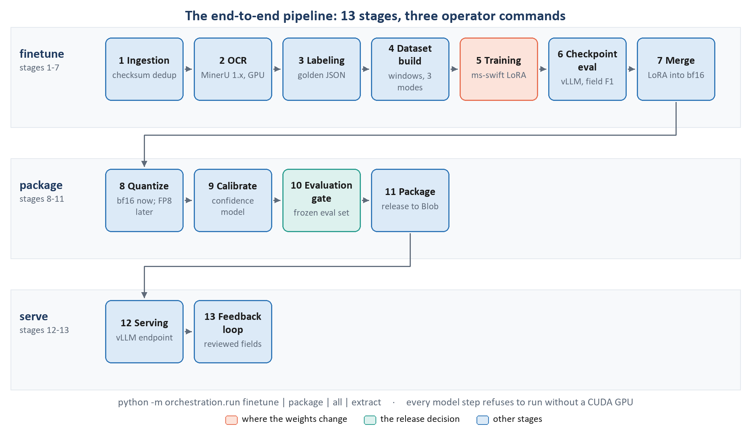
Figure 2. The thirteen stages and the operator commands that run them (orchestration/pipeline_dag.py:2275-2298).
Table 4. The stages, in order.
# | Stage | What it does | Command
1 | Ingestion | Registers each PDF by checksum (duplicates skipped). | finetune
2 | Preprocessing (OCR) | MinerU 1.x on GPU: per-page markdown and page images, in its own Python environment. | finetune
3 | Labeling | Reports the unlabelled backlog; golden labels come from the reviewed gold. | finetune
4 | Dataset build | Splits by family, draws modalities, cuts policies into windows, applies caps, writes JSONL. | finetune
5 | Training | One unified LoRA trained by ms-swift on the bf16 base. | finetune
6 | Checkpoint eval | Candidate checkpoints generate in vLLM; best field accuracy wins. | finetune
7 | Merge | The chosen adapter is merged into bf16 weights. | finetune
8 | Quantize | bf16 today; FP8 / AWQ INT4 only after the Phase 0 spike verifies them. | package
9 | Calibrate | Fits per-field-type confidence models and auto-accept thresholds. | package
10 | Evaluation gate | Golden eval on the frozen set; 15-metric promotion gate. | package
11 | Package | Pushes weights, calibrators and the gate decision to Blob as a release bundle. | package
12 | Serving | vLLM endpoint (RunPod backend not yet wired; runs on the pod). | deploy-endpoint
13 | Feedback loop | Reviewed fields flow back as future training data. | extract

Operator commands (README)
# 1 ingest -> OCR -> corpus -> train -> select checkpoint -> merge (on the pod)
python -m orchestration.run finetune --scope personal_lines --corpus-version v1 --out-version v1

# 2 quantize -> calibrate -> GATE -> push weights + release bundle to Azure Blob
python -m orchestration.run package --version v1 --release-id release-2026.11.1 --formats bf16

# 3 extraction with a chosen model (base, or a trained version)
python -m orchestration.run extract --model base|v1 --input testing/test_data/

# once, from the first real corpus build: freeze the gate's eval set
python -m orchestration.run freeze-eval-set --corpus v1

3.1 Environments and machines
Table 5. Python environments on the RunPod pod (README; pyproject.toml).
Environment | Used for | Key pins | Why separate
/workspace/venv (train) | training, finetune, package, vLLM generation for selection and calibration | torch 2.8.0, transformers 4.57.6, ms-swift 3.12.6, PEFT 0.18.1, vLLM 0.11.0, flash-attn 2 | -
/workspace/venv-ocr | MinerU OCR only | magic-pdf 1.3.12, torch 2.8.0 | MinerU 1.x cannot share an environment with vLLM 0.11
serve | the serving pod | vLLM 0.11.0, identical to train | calibration is fitted on the logprobs this exact build produces
quantize | FP8 / AWQ export (later) | llmcompressor | its datasets/transformers ranges conflict with ms-swift and vLLM

3.2 Rules that are not style preferences
The README lists invariants that the tests enforce, because breaking any of them degrades the model silently, with nothing visible in the training curves:
- The repo never stores weights, corpora or PDFs. Data and artifacts move through artifact_registry/ to Azure Blob.
- Training and inference prompts render byte-identically. One function (inference_core/input_builder.build_messages) builds messages for the corpus, evaluation and serving.
- The image budget is identical in corpus preparation, training and serving (configs/shared/vision.yaml, one file, three readers).
- Loss is computed only on assistant tokens, verified before every launch.
- The alias registry is never used at inference.
- Every model step refuses to run without a CUDA GPU (common/gpu.py): a CPU fallback 'turns hours into days while looking healthy', and for OCR it would even change the output distribution.
- The promotion gate has no override flag; the only exception is a recorded, written override with a named approver.

4 Transformer fundamentals
Everything later in this document (what LoRA attaches to, why the loss is masked, why sequence length is the main cost) follows from how a transformer works. This chapter builds that up from tokens to generation, using our model's real dimensions.
IN PLAIN ENGLISH
A transformer reads a sequence of pieces (tokens) and, layer after layer, lets every piece look at the other pieces and update its own understanding. At the end, the last piece's understanding is turned into a guess about what comes next. Writing a JSON answer is just making that guess over and over: one token, append it, guess again.
Two operations alternate in every layer: attention (gather information from other tokens) and the MLP (process what was gathered). Training adjusts the numbers inside those two operations.

4.1 Tokens and embeddings
Text is split into tokens by a tokenizer with a fixed vocabulary; Qwen3's has 151,936 entries. A token is often a word piece: effective may be one token and _date another; digits are usually single tokens, which is why the repo's length estimator counts every digit as one token and other text at about 3.5 characters per token (data_pipeline/dataset_builder/cap_check.py:168-180).
Each token id is looked up in an embedding table and becomes a vector of 4,096 numbers. From here on the model only ever handles vectors. Images become vectors too, through the vision encoder (chapter 5), and are placed in the same sequence at the image positions.

4.2 Self-attention
For each token vector x, three projections produce a query q, a key k and a value v. A token's query is compared with every key; the similarities become weights; the token's output is the weighted average of the values. In matrix form, for the whole sequence X:
Q = X·W_q K = X·W_k V = X·W_v
Attention(Q, K, V) = softmax( Q·Kᵀ / √d_head + M ) · V
d_head is the size of one attention head (128 here); dividing by √d_head keeps the softmax from saturating. M is the causal mask: minus infinity above the diagonal, so a token can only attend to itself and to earlier tokens. That is what makes the model a left-to-right generator, and it is why the answer can attend to the whole prompt (images, OCR, schema) while the prompt never sees the answer. The output passes through one more projection, W_o, back to the 4,096-wide stream.
DEEP DIVE
Attention cost grows with the square of sequence length: a 32,768-token row has about 1.07 billion query-key pairs per head per layer. Flash-attention 2 computes the same result in tiles without ever storing the full attention matrix, which is what makes 32k-token training rows affordable (configs/base_model.yaml:48-51).
This is also where image-over-OCR arbitration physically happens: the image tokens of a page and that page's OCR tokens sit in the same sequence, and attention lets an output token weigh one against the other. That is the project's argument for putting LoRA in the decoder rather than on the vision side (chapter 10).

4.3 Multi-head and grouped-query attention (GQA)
The model runs 32 attention heads in parallel, each 128 wide (32 x 128 = 4,096), so different heads can track different relationships: one may link a value to its column header, another a page marker to its text. To save memory, Qwen3 uses grouped-query attention: the 32 query heads share only 8 key/value heads (4 queries per KV head). That is why q_proj maps 4,096 to 4,096 but k_proj and v_proj map 4,096 to only 1,024 (8 x 128), and why the KV cache at serving time is four times smaller than it would be with full multi-head attention.

4.4 The MLP (SwiGLU feed-forward)
After attention, each token passes through a feed-forward network independently. Qwen3 uses the SwiGLU form:
MLP(x) = W_down · ( SiLU(W_gate · x) ⊙ (W_up · x) )
gate_proj and up_proj widen the vector from 4,096 to 12,288; the SiLU-activated gate decides, feature by feature, how much of the 'up' signal passes (⊙ is element-wise multiplication); down_proj brings it back to 4,096. These three matrices hold about 78% of each decoder layer's weights, and a large share of what the model 'knows' about formats and terminology is stored here.

4.5 Residual stream and normalisation
Neither block replaces the token's vector; each adds to it. The vector that flows through the network is called the residual stream:
x ← x + Attention( RMSNorm(x) ) x ← x + MLP( RMSNorm(x) )
RMSNorm rescales the vector before each block so values stay in a stable range (epsilon 1e-6). Because every block only adds a correction, a small learned change in a block (exactly what LoRA provides) shifts behaviour smoothly without destroying what the rest of the network computes.
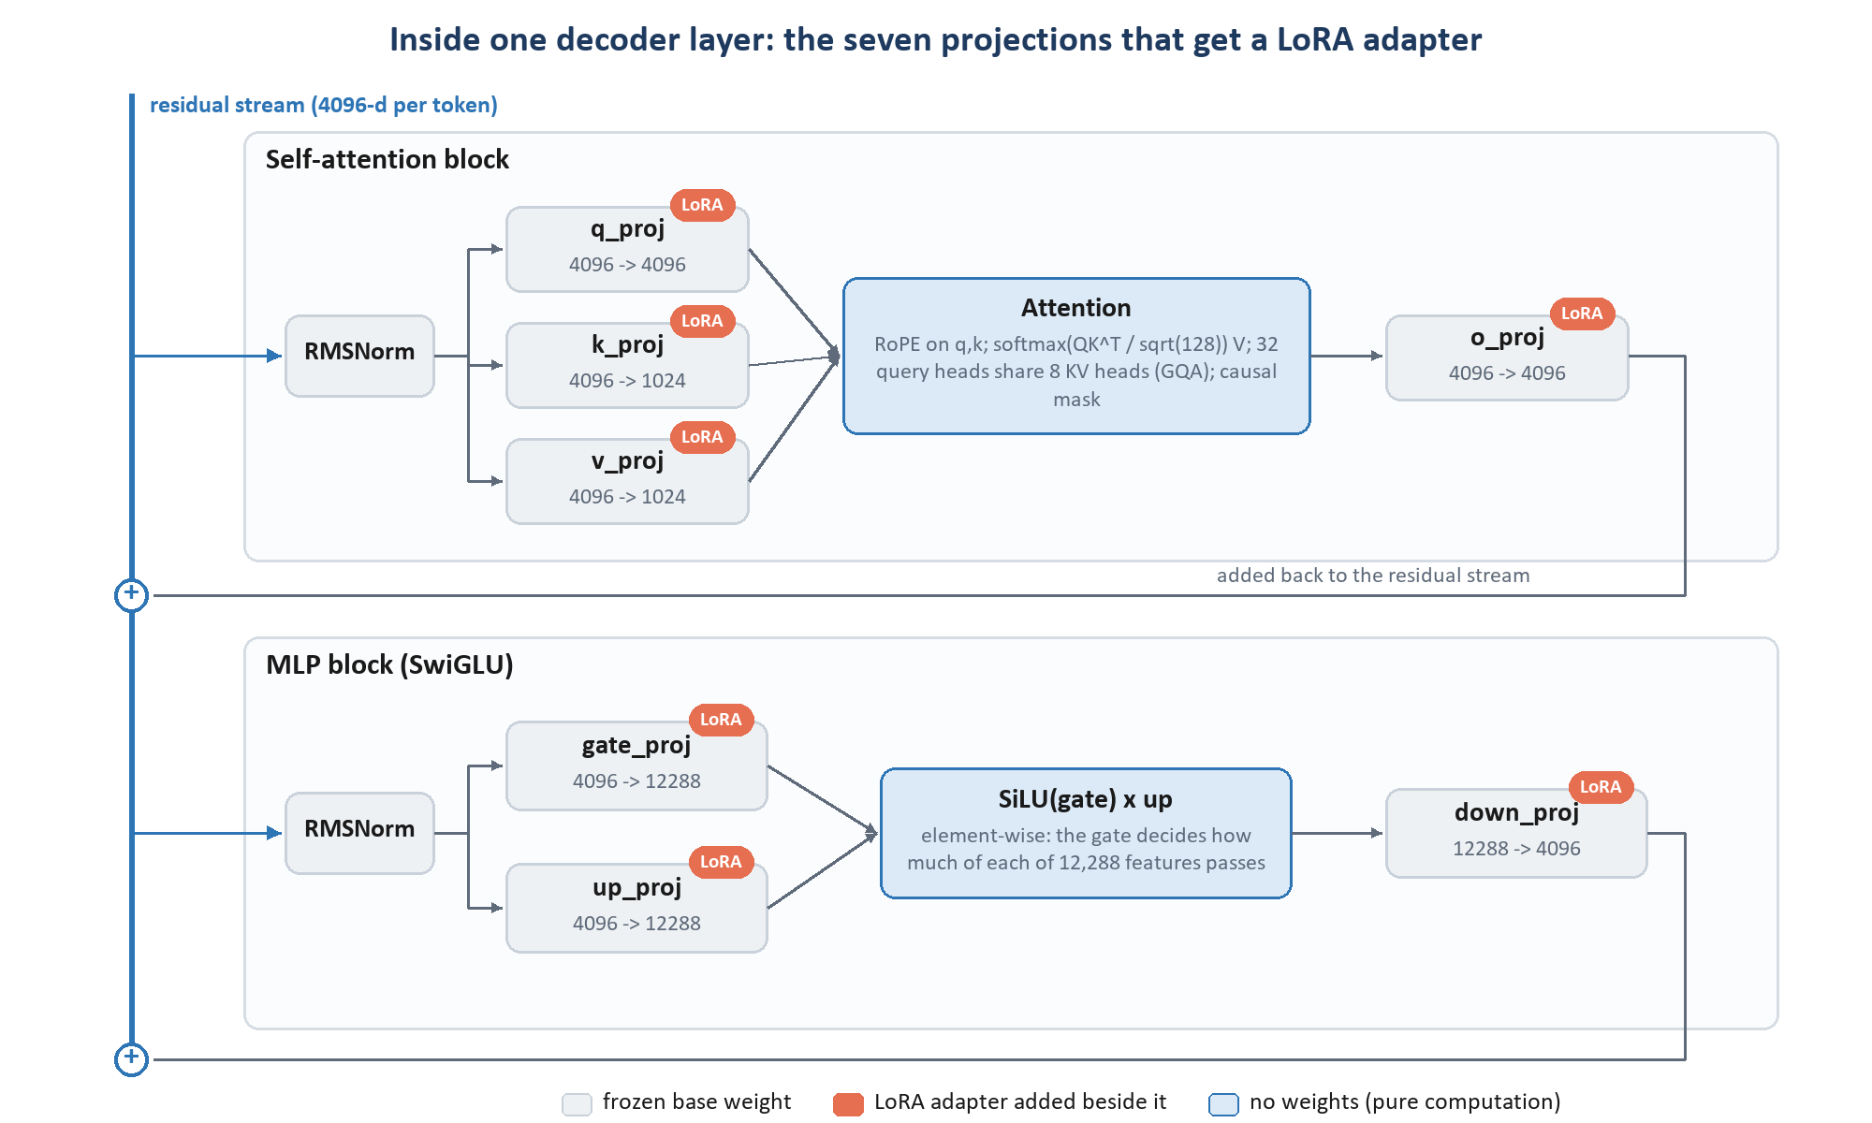
Figure 3. One of the 36 decoder layers, with the dimensions of Qwen3-VL-8B. The seven projection matrices (grey) are the only places where LoRA adapters are attached.

4.6 From the last layer to the next token
After 36 layers, the final vector at each position is multiplied by the LM head (a 4,096 x 151,936 matrix) to give one score (logit) per vocabulary entry, and softmax turns the scores into probabilities:
p( next token = w | everything so far ) = softmax( W_lm · h_t )_w
Training pushes up the probability of the correct next token at every supervised position. Generation picks a token (we use greedy decoding, temperature 0, so the most probable one), appends it and repeats until the end-of-turn token <|im_end|>. At serving time, a grammar (xgrammar) additionally forbids any token that would make the JSON invalid against the schema.
DEEP DIVE
During training, the model does not generate. It reads the whole correct answer at once (teacher forcing) and, thanks to the causal mask, computes the next-token prediction at every position of the answer in a single forward pass. A 2,500-token answer therefore yields 2,500 training signals from one pass. The repo's use_logits_to_keep setting computes the 151,936-wide logits only at those answer positions instead of at all 32,768 positions, which on its own saves a large share of activation memory (configs/training/unified.yaml:100-104).

4.7 Encoders, decoders, and what our model has
'Transformer' covers three families, and our model uses two of them:
Table 6. Transformer families.
Family | Attention | Typical job | Examples | In our model?
Encoder-only | bidirectional: every token sees every token | understand / classify / tag a fixed input | BERT, LayoutLMv3, ViT | Yes, for images: the 27-layer vision encoder is a ViT
Decoder-only | causal: left to right | generate text token by token | GPT, Llama, Qwen3 | Yes, the core: the 36-layer Qwen3 language decoder
Encoder-decoder | encoder bidirectional + decoder causal with cross-attention | translate an input into an output | T5, Donut, Florence-2 | No

So the precise answer to 'what are the encoders in our model?' is: there is one encoder, for vision. It turns pixels into vectors. There is no text encoder: the prompt and the OCR text go straight into the decoder as tokens, and the decoder reads image tokens and text tokens in one sequence with ordinary self-attention. A vision-language model of this kind is 'a vision encoder bolted onto a decoder-only LLM'.

5 Qwen3-VL-8B-Instruct, in detail
The base model is pinned to one exact Hugging Face commit and loaded from the pod's own disk. This chapter follows a page through it, gives the real dimensions (read from that commit's config.json), and works out what a training row costs in tokens.
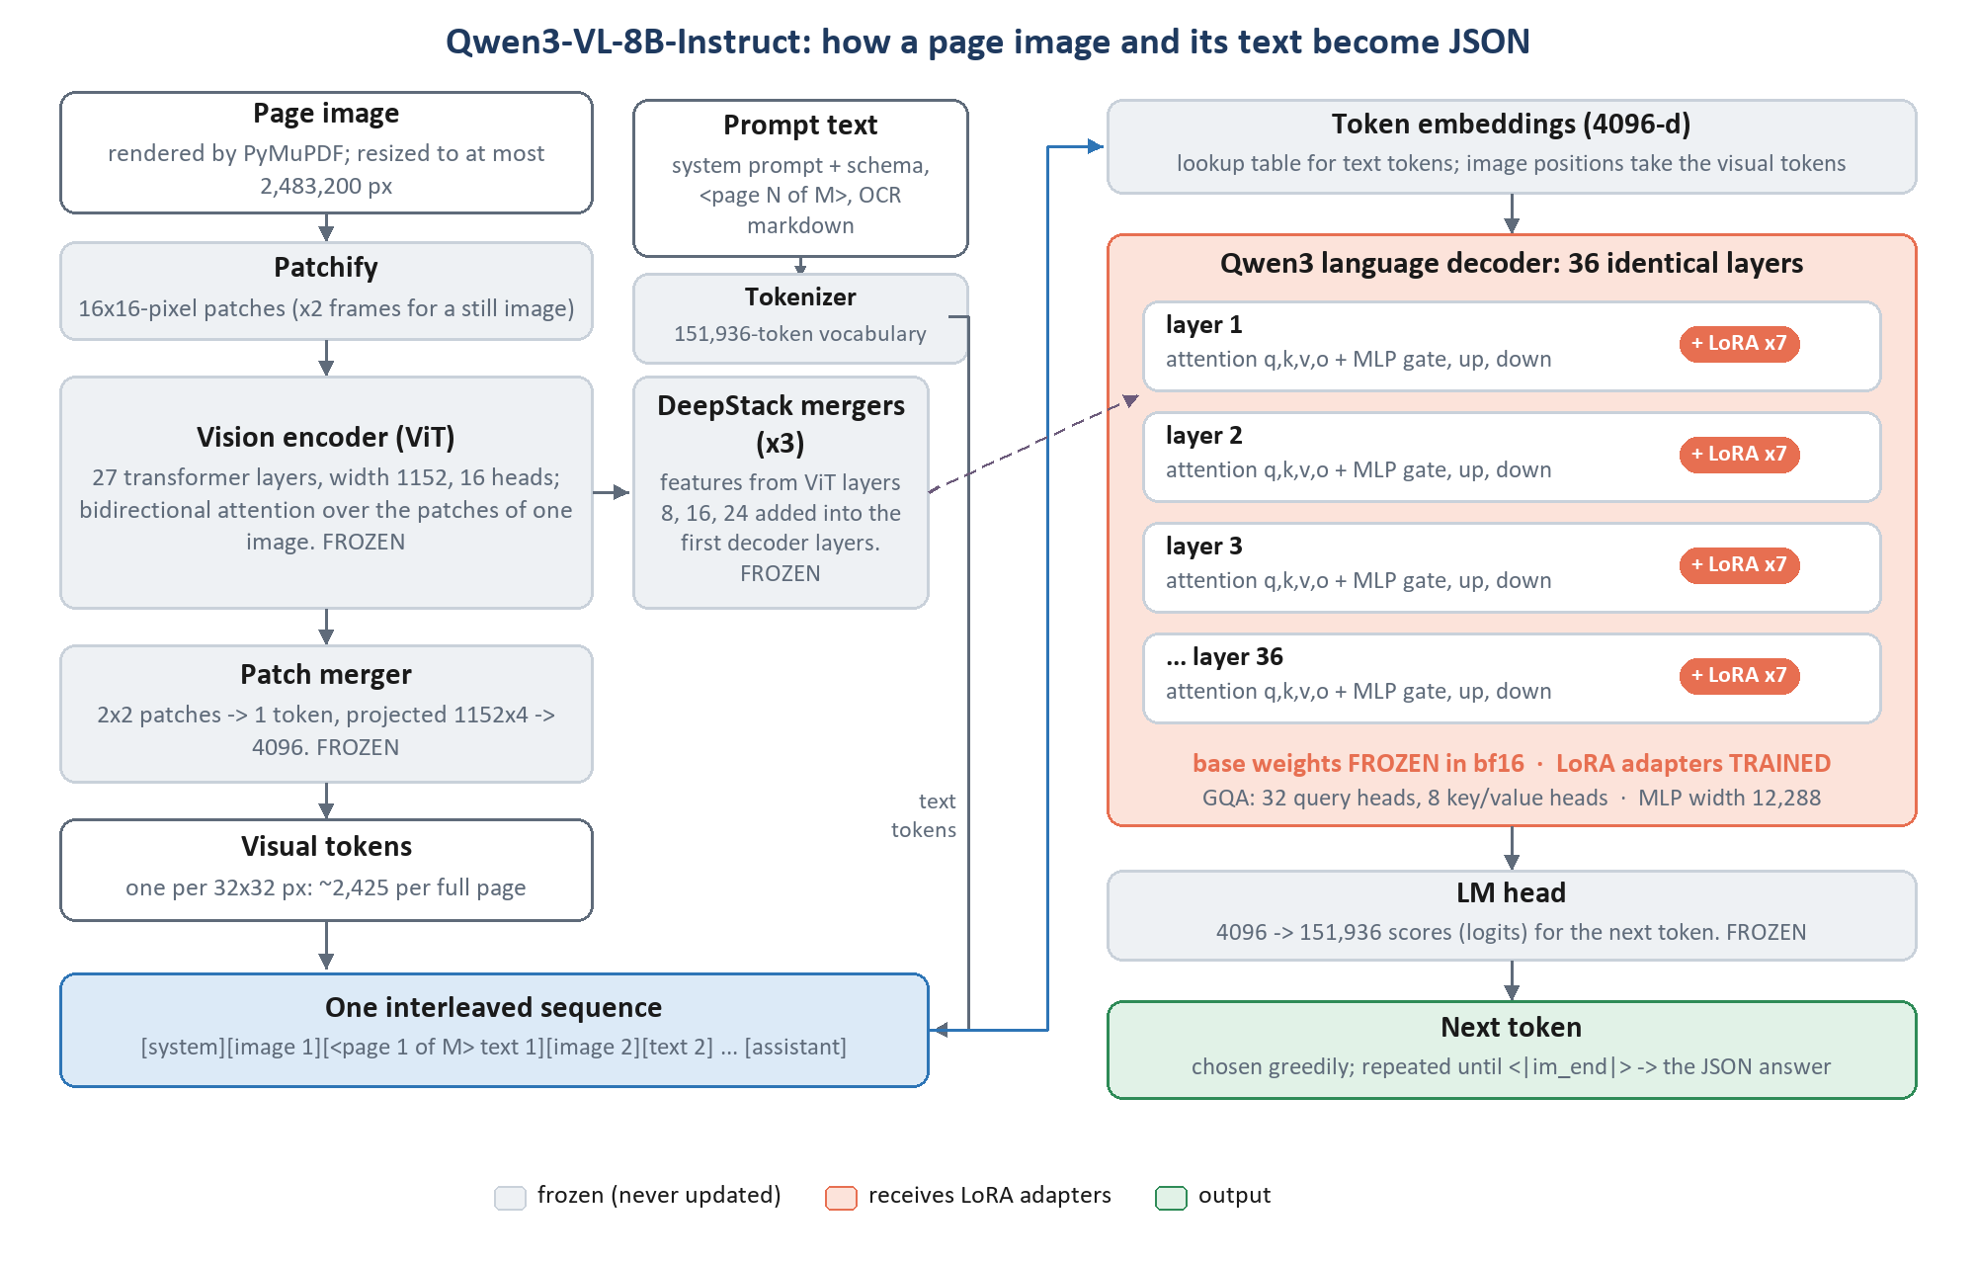
Figure 4. The path from page image and prompt text to the generated JSON. Grey parts are frozen during our training; the orange decoder receives the LoRA adapters.

5.1 From a page to visual tokens
- Render. PyMuPDF renders each PDF page so its long side is 1,792 px (data_pipeline/ocr/render_only.py). A US-Letter page becomes about 1,792 x 1,385 px, roughly 163 DPI.
- Resize to the budget. The Qwen-VL processor rounds each side to a multiple of 32 and keeps the pixel count between min_pixels 200,704 and max_pixels 2,483,200 (configs/shared/vision.yaml). The Letter page becomes 1,792 x 1,376.
- Patchify. The image is cut into 16 x 16-pixel patches (112 x 86 = 9,632 patches). A still image is treated as two identical video frames (temporal patch size 2), so each patch is 2 x 16 x 16 x 3 = 1,536 numbers, linearly projected to 1,152.
- Encode. 27 ViT layers (width 1,152, 16 heads, MLP 4,304, bidirectional attention) let every patch see every other patch of the same image.
- Merge. The patch merger concatenates each 2 x 2 block of neighbouring patch vectors (4 x 1,152 = 4,608 numbers) and maps them through a small MLP to 4,096, the decoder's width. One visual token therefore covers 32 x 32 pixels: 56 x 43 = 2,408 visual tokens for the Letter page. The budget allows at most 2,425; an A4 page comes to about 2,240.
WHY WE CHOSE THIS
Why a pixel budget instead of a long-side cap. 'A long-side cap gives a landscape page a fraction of the tokens a portrait page gets, for the same document' (vision.yaml:7-11). v1 capped the long side at 1,792 px, so landscape Loss Runs were quietly cheaper and worse. A pixel budget treats both orientations the same.
Why min_pixels. 'An upscaled 200-DPI fax does not become more legible; it just costs more.'
Why multiples of 32x32. The old 2,483,712 was a 28x28 multiple from Qwen2.5-VL; under Qwen3-VL's 32x32 geometry it named a different budget from the token count. common.config.pixel_budget now refuses a value that is not a multiple.
Why it must never drift. 'A resolution the model never trained at is a correctness bug, not a tuning difference' (vision.yaml:4-5). Dataset build, training (via MAX_PIXELS / IMAGE_MAX_TOKEN_NUM) and serving (vLLM mm_processor_kwargs) all read the same file.

5.2 DeepStack: fine detail without training the vision encoder
A plain VLM hands the decoder only the ViT's last layer. Qwen3-VL also takes the features of ViT layers 8, 16 and 24, passes each through its own merger, and adds them to the decoder's hidden states at the image positions in the first decoder layers. Early ViT layers keep fine, local detail (strokes, small digits, check boxes) that the last layer has abstracted away. The architecture document draws the training consequence: fine visual detail 'is available even with a frozen ViT' (v2.1 section 3).

5.3 Positions: Interleaved-MRoPE and page markers
Transformers need to be told where each token is. Qwen3-VL uses rotary position embeddings (RoPE): each query and key vector is rotated by an angle that depends on its position, so attention scores depend on relative distance. For images the rotation is split three ways (time, height, width; mrope_section 24/20/20 of the 64 frequency pairs, interleaved across the spectrum) so a visual token knows its row and column. Text tokens use ordinary one-dimensional positions. The base frequency is 5,000,000 and the model supports 262,144 positions; we use at most 32,768.
Positions say where a token is in the sequence, but not which page of a 30-page policy it came from. That is why every page's text starts with an explicit <page N of M> marker, the image and the text of the same page are always adjacent, and page_ref values are taught from those markers.

5.4 The language decoder
Table 7. Qwen3-VL-8B text configuration (config.json at the pinned revision).
Property | Value | What it means
Layers | 36 | identical decoder blocks (attention + MLP)
Hidden size | 4,096 | width of the residual stream
Attention heads | 32 query, 8 key/value (GQA), head size 128 | q_proj 4096->4096; k/v_proj 4096->1024; o_proj 4096->4096
MLP | SwiGLU, intermediate 12,288, SiLU | gate/up 4096->12288; down 12288->4096
Normalisation | RMSNorm, eps 1e-6 | before attention and before MLP
Vocabulary | 151,936 | embedding table and LM head (not tied)
Positions | Interleaved-MRoPE, theta 5,000,000, up to 262,144 | we cap rows at 32,768
Special tokens | <|im_start|>, <|im_end|> (EOS id 151645), vision start/end | ChatML-style turns

5.5 Where the 8.8 billion parameters are
Table 8. Parameter budget, computed from the configuration (approximate; norms and biases omitted).
Component | Approx. parameters | Share | Status in our training
Decoder attention projections (36 layers) | 1.51 B | 17% | frozen + LoRA
Decoder MLP projections (36 layers) | 5.44 B | 62% | frozen + LoRA
Token embeddings | 0.62 B | 7% | frozen
LM head | 0.62 B | 7% | frozen
Vision encoder (27 layers + patch embedding) | 0.42 B | 5% | frozen
Patch merger + 3 DeepStack mergers | 0.16 B | 2% | frozen
Total | about 8.77 B | 100% | LoRA adds 0.175 B trainable (2.0%)

DEEP DIVE
How these are computed: one decoder layer's attention is 4096 x (4096 + 1024 + 1024 + 4096) = 41.9 M weights and its MLP is 3 x 4096 x 12288 = 151.0 M, so 192.9 M per layer and 6.94 B for 36 layers. The embedding table and the untied LM head are each 151,936 x 4,096 = 0.62 B. Each ViT layer is about 15.2 M (attention 5.3 M + MLP 9.9 M), 0.41 B for 27 layers; each merger is about 40 M. In bf16 (2 bytes per weight) 8.77 B parameters are 17.5 GB, which is exactly the size base_model.yaml records for the pinned checkpoint.

5.6 What one training row costs
A row's length is the sum of its parts, and every part is budgeted (configs/shared/sequence.yaml):
Table 9. Sequence composition of a policy row.
Part | Typical size | Notes
System prompt + schema slice | 4,400-7,600 tokens | 15,300-26,600 characters depending on the section group
Each page: image | up to 2,425 tokens | the pixel budget
Each page: OCR text | about 700 tokens | none in image_only rows
Chat template overhead | 64 tokens | role markers, page markers
Reserved for the answer | 3,072-8,192 tokens | declarations 4,096; schedules 8,192 (output-bound)
Cap | 32,768 tokens | the largest task cap; also the trainer's max_length

This is how the window planner decides how many pages fit. For the declarations group: room = 32,768 - 4,096 (answer) - 64 - about 5,965 (prompt) = 22,643 tokens; at about 3,125 tokens per page (2,425 + 700) that is 7 pages. For the homeowners line block, whose prompt is longer, it is 5.
WATCH OUT
Images dominate. A seven-page window carries about 17,000 visual tokens against about 6,000 prompt tokens and 4,000 answer tokens. The pixel budget is therefore 'the single biggest cost/latency lever' (configs/base_model.yaml:54), and changing it means rebuilding the corpus and retraining, which is why lowering image resolution is listed among the latency options that need a new training run.

5.7 Pinning and loading
- The model id and revision (Qwen/Qwen3-VL-8B-Instruct @ 0c351dd01ed87e9c1b53cbc748cba10e6187ff3b, the Hub commit of 2025-10-15) are the model's identity, recorded in every run manifest. 'A floating revision means two training runs can silently use different weights, which makes a regression impossible to attribute.'
- scripts/pod_bootstrap.sh downloads exactly that revision into /workspace/models and verifies every file's size and SHA-256. Training, the tokenizer, the merge and vLLM all load from there, never from the Hub.
- Models are placed with device_map="cuda", never "auto", which would quietly offload layers to the CPU when memory runs short.

6 Why Qwen3-VL-8B as the base model
The repo treats the base model as a fixed decision: 'The base model is locked to Qwen/Qwen3-VL-8B-Instruct; no alternative or smaller base model is trained or evaluated' (architecture v2.1). This chapter collects the reasons the repo gives, then puts the alternatives in context, clearly marked as general knowledge.

6.1 How the model fits the requirements
Table 10. Requirements and fit.
Requirement | How Qwen3-VL-8B meets it | Evidence in the repo
Must read scans with no OCR (image_only) | native-resolution ViT with DeepStack; strong pretrained document and OCR ability | base_model.yaml:21-25 ('strong document pretraining'); vit_gate.py
Must combine image and OCR text | image tokens and text tokens interleaved in one decoder sequence | input_builder.py page pairing; Phase 0 spike check_interleaved_content
Long, multi-page inputs | 262k-position context; we use 32k | sequence.yaml caps
Large nested JSON output | an instruction-tuned 8B decoder; output constrained by xgrammar at serving | inference_core/model_runner.py:188
Data must stay on our infrastructure | open weights, run on our own GPU | SPEC_00 (no PII to third-party APIs)
Serve fast, with adapters | first supported in vLLM 0.11, with LoRA hot-swap and guided decoding | pyproject.toml serve group comment
Train within one GPU's memory | bf16 base 17.5 GB; a 32k-token row peaks at 99 GB on an H200 | sequence.yaml:87-91
Calibrated confidence | token log-probabilities available from our own vLLM | calibration/

6.2 The alternatives, in context
GENERAL ML CONTEXT (NOT A REPO DECISION)
The repo does not compare base models; the comparison below is general background, so you can see why an 8B open vision-language model is a reasonable point in the design space. Treat it as reasoning, not as a record of experiments.

Table 11. Base-model alternatives (general context, not evaluated in the repo).
Alternative | Strengths | Weaknesses for this job
Larger Qwen3-VL (32B dense; 30B-A3B or 235B-A22B mixture-of-experts) | more capacity; likely higher zero-shot accuracy | several times the GPU memory and latency per page; multi-GPU serving; LoRA on mixture-of-experts is more complex; our pages are image-heavy, so cost scales badly
Smaller Qwen3-VL (2B, 4B) | cheaper and faster | less capacity for 500-field schemas, long windows and insurance-role reasoning; the same image-token cost per page
Qwen2.5-VL-7B (the predecessor) | mature tooling | 28x28 token geometry and no DeepStack; the repo explicitly migrated its budgets from 28x28 to 32x32 for Qwen3-VL
Other open VLMs (InternVL, Llama vision, Pixtral, Gemma 3 ...) | comparable size class | tooling: the stack depends on ms-swift's Qwen3-VL template and vLLM's Qwen3-VL support; a switch means re-validating templates, masking and serving
Document specialists, encoder-only (LayoutLMv3) | small and fast at tagging tokens | needs OCR words and boxes as input, so it cannot do image_only; tags tokens rather than writing nested JSON with normalised values
OCR-free encoder-decoders (Donut, Florence-2) | read pixels directly, small | small decoders and short outputs; weak at a 500-key schema over 30-page documents and at instruction-following
Closed frontier APIs | strongest zero-shot reading | policy data may not leave our infrastructure; per-page cost; no weight access for LoRA, version pinning or our own logprob calibration

WHY WE CHOSE THIS
The deciding properties, in the repo's own terms: open weights that run on one GPU we control, native-resolution vision strong enough for image-only reading, first-class support in the two tools the whole stack is built on (ms-swift for training, vLLM for serving), and a size at which LoRA training on 32k-token multimodal rows fits on a single H200.

7 Ways to adapt a pre-trained model
'Fine-tuning' is a family of techniques. This chapter lays out the family so the choice in chapter 8, supervised fine-tuning with LoRA, can be seen against its neighbours.

7.1 Supervised fine-tuning (SFT), the stage we are at
Supervised fine-tuning shows the model input-output pairs (here: page images + OCR + instructions -> the gold JSON) and trains it to produce the output. It is the right stage when we have correct answers to imitate, which we do: reviewed golden labels. Later stages that some projects add, such as preference optimisation (DPO, RLHF, GRPO), need pairs of better and worse answers or a reward signal, and refine behaviour that SFT already established. Nothing in the repo uses them, and nothing in the current plan needs them.

7.2 What can be changed, and how much
Table 12. Adaptation approaches (general overview).
Approach | What is trained | Trainable share | Strengths | Weaknesses
Prompting / few-shot | nothing; instructions and examples only | 0% | instant; no training data | does not make a model follow 500-field rules consistently; examples cost context
Full fine-tuning | every weight | 100% | maximum capacity to change | most memory (gradients and optimizer state for 8.8 B weights); risks damaging pretrained skills; one full model copy per version
LoRA | low-rank update matrices beside chosen weights | ~0.1-3% | small memory; can be merged; one base, many adapters; strong results for behaviour/format adaptation | capacity limited by rank; needs choice of targets
QLoRA | LoRA, with the frozen base stored in 4-bit NF4 | ~0.1-3% | base needs about a third of the memory | train/serve mismatch if served in bf16; slower steps (de-quantising)
DoRA | LoRA on the weight's direction + a magnitude vector | ~LoRA + tiny | often slightly better than LoRA at the same rank | slower; extra serving complexity
Bottleneck adapters | small new layers inserted in each block | ~1-5% | modular | add inference latency; cannot be merged away
Prefix / prompt tuning | learned 'virtual tokens' prepended to the input | <0.1% | tiny | weak for complex structured outputs; uses up context
IA3 / BitFit | per-feature scaling vectors / bias terms only | <0.1% | tiny | too little capacity for a new output contract

IN PLAIN ENGLISH
Full fine-tuning rewrites the whole textbook. LoRA leaves the textbook untouched and adds a thin booklet of corrections that is read alongside it, which can later be printed into the textbook if you want one volume. QLoRA does the same, but works from a photocopied, compressed textbook to save shelf space.

8 LoRA, explained properly
LoRA (Low-Rank Adaptation, Hu et al., 2021) is the technique this project trains with. This chapter explains what it does mathematically, why such a small change is enough, how it is initialised and trained, how much it costs, and exactly how it is configured here.

8.1 The idea
IN PLAIN ENGLISH
A weight matrix in the model is a large table of numbers that transforms one vector into another. Fine-tuning wants to nudge that table. LoRA's bet is that the useful nudge is simple: it can be described by a few directions, not by changing all 16.8 million numbers of the table independently.
So instead of learning a full-size correction, LoRA learns two thin matrices whose product is the correction. With rank 64, a 4,096 x 4,096 correction is built from a 4,096 x 64 matrix times a 64 x 4,096 matrix: 0.52 million numbers instead of 16.8 million.

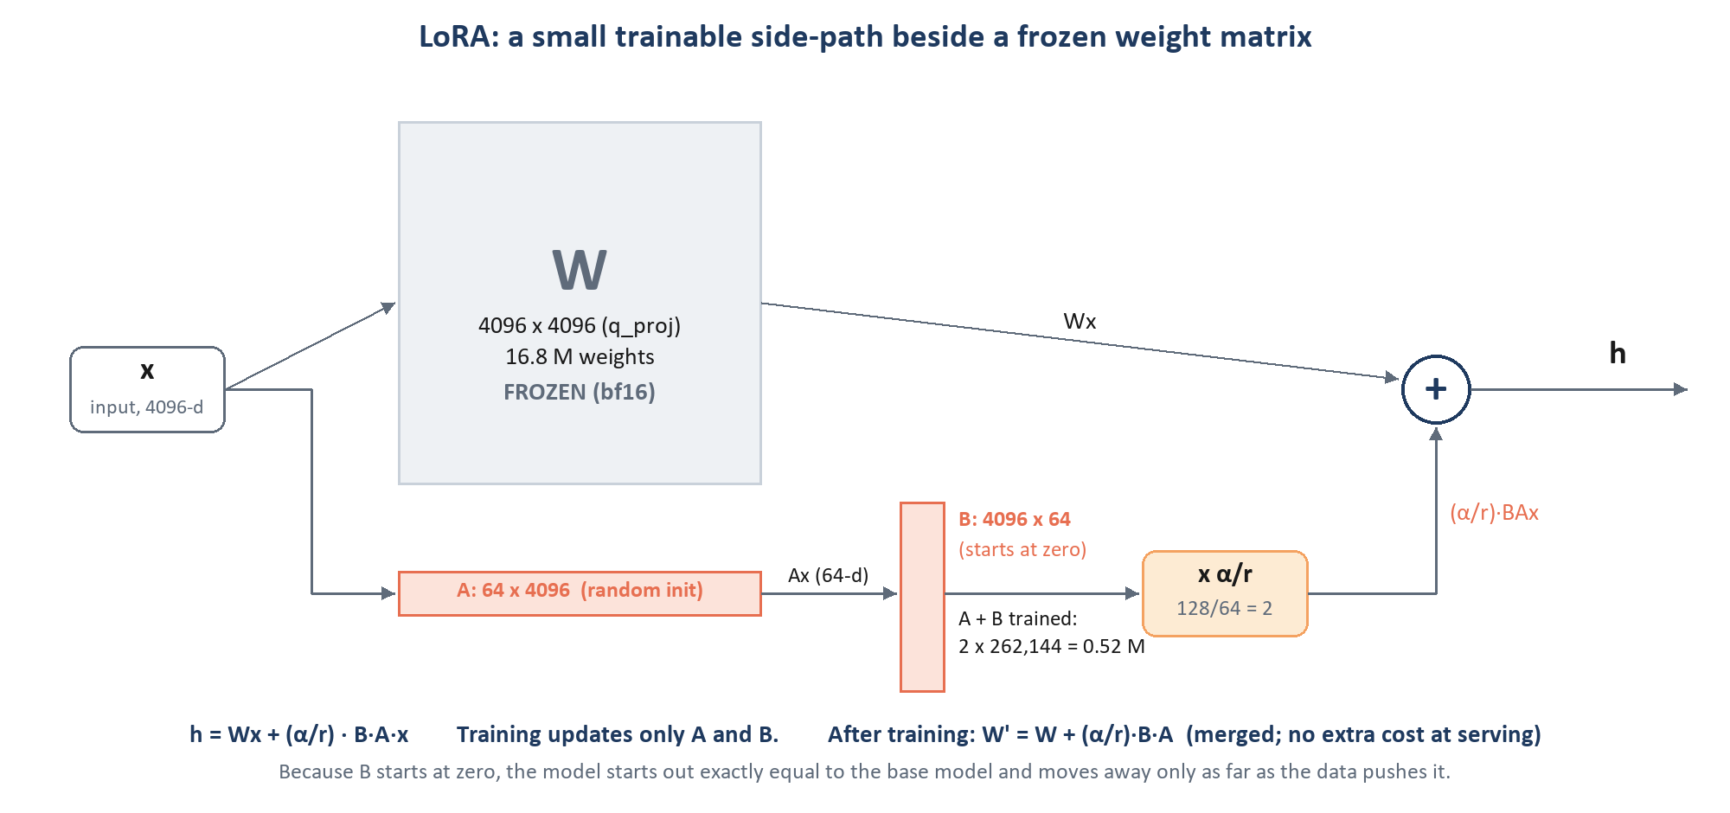
Figure 5. LoRA on one projection (q_proj shown). The frozen weight W and the trainable low-rank path B·A run side by side and their outputs are added.

8.2 The mathematics
Take a frozen weight W with d outputs and k inputs (W ∈ ℝ^(d x k)). LoRA adds a trainable update with rank r much smaller than d and k:
ΔW = B · A B ∈ ℝ^(d x r), A ∈ ℝ^(r x k), r ≪ min(d, k)
h = W·x + (α / r) · B·A·x
A first squeezes the input x down to r numbers, B expands them back to d. The scalar α/r controls how strongly the update is applied. Only A and B receive gradients; W never changes. Trainable parameters per matrix fall from d·k to r·(d + k):
Table 13. Where the ~175 M trainable parameters come from (matches architecture v2.1's '~175 M').
Projection | Shape of W (d x k) | Full weights | LoRA weights at r = 64 | Ratio
q_proj | 4096 x 4096 | 16,777,216 | 64 x (4096 + 4096) = 524,288 | 3.1%
k_proj | 1024 x 4096 | 4,194,304 | 64 x (1024 + 4096) = 327,680 | 7.8%
v_proj | 1024 x 4096 | 4,194,304 | 327,680 | 7.8%
o_proj | 4096 x 4096 | 16,777,216 | 524,288 | 3.1%
gate_proj | 12288 x 4096 | 50,331,648 | 64 x (12288 + 4096) = 1,048,576 | 2.1%
up_proj | 12288 x 4096 | 50,331,648 | 1,048,576 | 2.1%
down_proj | 4096 x 12288 | 50,331,648 | 1,048,576 | 2.1%
One layer |  | 192,937,984 | 4,849,664 | 2.5%
36 layers |  | 6.95 B | 174,587,904 (174.6 M) | 2.0% of the whole model

8.3 Initialisation: why the model starts exactly as the base
PEFT initialises A with small random values (Kaiming-uniform) and B with zeros. So at step 0, B·A = 0 and the adapted model is bit-for-bit the base model. Training then moves it only as far as the data pushes it.
DEEP DIVE
The gradients show how training gets going. With g = ∂L/∂h the gradient arriving at the layer's output:
∂L/∂B = (α/r) · g · (A·x)ᵀ ∂L/∂A = (α/r) · Bᵀ · g · xᵀ
At step 0, B = 0, so ∂L/∂A = 0 but ∂L/∂B is not zero (A·x is a random projection of the input). The first update moves B; from then on both matrices learn. Note that g itself is computed by back-propagating through the frozen weights of all later layers. Frozen weights still pass gradients through; they just never store or apply their own.

8.4 Why a low-rank change is enough
Research on fine-tuning found that the weight changes a pre-trained model needs to adapt to a task have low 'intrinsic dimension': a few directions explain most of the change. The repo states the same reasoning for this task in configs/base_model.yaml:
WHY WE CHOSE THIS
'This is behavior/format adaptation on a model that already has strong document pretraining, not new-knowledge injection, which is what makes low-rank adaptation the right technique in the first place.' The model already knows how to read, what a date or an address is, and what JSON looks like. We teach it which field a value belongs to, how to write it, and when to stay silent.

8.5 Rank, alpha and the scale factor
- Rank r = 64. The capacity of the update. One adapter has to learn every line of business and every section group at once (the 'unified' adapter, section 9.6), so it gets a generous rank. v1 planned rank 16 for per-type adapters, which no longer exist. A rank sweep over [32, 64, 128] is written but deferred until there are at least 200 documents per type (configs/sweeps/phase3_rank.yaml, not run by default).
- Alpha α = 128, so α/r = 2. The update's output is doubled. Keeping α = 2r is a common convention that makes the effective learning rate of the update roughly independent of how A and B happen to be scaled.
- rsLoRA (off). Rank-stabilised LoRA scales by α/√r instead of α/r (128/8 = 16 at r = 64), which keeps update sizes comparable across ranks. The repo turns it on only for the rank sweep, 'so the learning rate transfers across ranks instead of needing a re-sweep at every rank' (unified.yaml:51-53). Note: the sweep file does not actually set it yet (Appendix E).

8.6 Dropout on the adapter path
LoRA dropout randomly zeroes parts of the adapter's input during training: h = W·x + (α/r)·B·A·dropout(x). It is regularisation: the update cannot rely on any single feature. The repo uses 0.10 at pilot scale and plans 0.05 from 200 documents per type: 'A rank-64 adapter on ~25 documents per type will memorise them at 0.05; the higher rate is the cheapest regularisation available and costs nothing once data arrives' (unified.yaml:30-33).

8.7 Where the adapters go
Adapters are attached to all seven linear projections of every language-decoder layer: q_proj, k_proj, v_proj, o_proj (attention) and gate_proj, up_proj, down_proj (MLP). That is 7 x 36 = 252 adapted matrices. Attention adapters change what each token looks at (for example, linking a figure to the right column header or preferring the image over a garbled OCR digit); MLP adapters change what is computed from it (formats, field semantics, insurance vocabulary).
GENERAL ML CONTEXT (NOT A REPO DECISION)
Early LoRA work adapted only q and v. Later results, notably the QLoRA paper, found that adapting all linear layers was needed to match full fine-tuning quality. Targeting all seven projections is now the standard choice for instruction and format tuning.

8.8 Memory: why LoRA fits and full fine-tuning would not
Table 14. Memory comparison. LoRA and QLoRA figures from base_model.yaml and architecture v2.1; full fine-tune figures are standard mixed-precision arithmetic.
Memory item | Full fine-tune (bf16 + AdamW) | LoRA on bf16 base (ours) | QLoRA (NF4 base)
Base weights | 17.5 GB, trainable | 17.5 GB, frozen | about 5.5 GB, frozen
Gradients | about 17.5 GB (all weights) | about 0.7 GB (adapters only) | about 0.7 GB
AdamW state (2 moments, fp32) | about 70 GB, plus fp32 master weights in mixed precision | about 1.4 GB | about 1.4 GB
Activations (32k-token row) | large; same for all three | the dominant term | same
Measured / expected peak | beyond one 141 GB GPU without sharding | 99 GB on one H200 at 32,768 tokens (measured) | lower, but slower

Architecture v2.1 states the full fine-tune case as 'roughly 16 GB weights + 16 GB gradients + 32-64 GB optimizer state' before activations. With LoRA, the optimizer only tracks 175 M numbers: about 1.4 GB of fp32 AdamW state. Each checkpoint, adapter plus optimizer state, is about 1.8 GB (unified.yaml:129-130).

8.9 Merging: zero cost at serving time
After training, the adapter can be folded into the weight once:
W′ = W + (α / r) · B · A
W′ has exactly the shape of W, so the merged model is an ordinary Qwen3-VL-8B checkpoint, with no extra layers and no extra latency. The repo does this in training/merge.py (PEFT merge_and_unload() in bf16 on the GPU, saved as 5 GB safetensors shards). The alternative is to keep the adapter separate and let vLLM apply it per request (multi-LoRA), which costs a little compute but lets several releases share one base model. The repo uses both: checkpoint selection scores unmerged adapters, a single release serves merged weights, and several releases are served as one LoRA each on the base (chapter 17).

8.10 Our LoRA configuration, line by line
Table 15. LoRA settings (configs/training/unified.yaml, training/train.py:458-518).
Setting | Value | Why (quoting the repo where it explains)
train_type | lora | behaviour adaptation on a strong base; full FT risks the pretrained OCR skill image-only depends on
lora_rank | 64 | one unified adapter for every line and section group; sweep [32, 64, 128] deferred
lora_alpha | 128 | α/r = 2
lora_dropout | 0.10 | pilot-scale regularisation; 0.05 planned at >= 200 documents per type
bias | none | biases stay frozen (recorded in the manifest)
target_modules | q, k, v, o, gate, up, down | attention + MLP of every decoder layer; mergers NOT targeted
use_rslora | false | only for the rank sweep
freeze_vit / freeze_aligner | true / true | vision encoder and mergers frozen (chapter 10)
Base precision | bf16, no quantisation arguments | train on exactly the weights that are served (chapter 9.2)
DoRA | not used | not configured anywhere in the repo

9 The alternatives, and why we did not choose them
For each alternative to our setup: what it is, what it would give us, what it would cost, and the verdict, with the repo's reasoning where it records one and general reasoning, marked as such, where it does not.

9.1 Full fine-tuning
What | Train all 8.8 B weights.
Pros | Maximum capacity; no rank limit; no adapter bookkeeping.
Cons for us | Gradients and optimizer state for every weight (roughly 100+ GB before activations); risks degrading the pretrained OCR ability that image-only mode depends on; every version is a full 17.5 GB model; slower iteration.
Verdict | Rejected. 'LoRA reaches the same behavior on a fraction of the memory with faster cycles' (architecture v2.1 section 9; v1.md:632-634).

9.2 QLoRA (4-bit base) and how the project moved away from it
QLoRA stores the frozen base in 4-bit NormalFloat (NF4) with double quantisation and computes in bf16. The first version of the design used it as the default, with a paged 8-bit AdamW optimizer. The archived snapshot finetuning-architecture-v1.PRE-BF16-LORA.docx still says '9. Fine-Tuning Technique: QLoRA ... 4-bit NF4 quantized base weights'. Its only justification argued for LoRA over full fine-tuning, not for 4-bit; as the v1 notes later put it, 'the 4-bit half was never actually argued. It is now, and it came out the other way.'
Pros | Base weights shrink from about 16 GB to about 5.5 GB; fits smaller GPUs.
Cons for us | Train/serve mismatch: both serving paths hold the base in bf16 (the merged model and vLLM's LoRA hot-swap). 'An adapter trained against a 4-bit base learns a delta that partly compensates for quantization error in weights it is then never served against.' Speed: NF4 de-quantises on every matrix multiply; bf16 runs 20-40% faster per step. Sharding: bitsandbytes 4-bit parameters do not partition cleanly under DeepSpeed ZeRO-3, which is the escape hatch for memory.
Verdict | Replaced by a bf16 base in commit 387e3aa (16 Sep 2026), together with plain adamw_torch instead of paged 8-bit AdamW ('removes a second quantization approximation'). Kept as a flag (quantization.load_in_4bit: true) for a memory-constrained pod; the manifest then records technique QLoRA.

9.3 DoRA (weight-decomposed LoRA)
GENERAL ML CONTEXT (NOT A REPO DECISION)
The repo never mentions DoRA, so this is general reasoning, not a recorded decision.

DoRA splits each weight into a magnitude (one number per output) and a direction, applies LoRA to the direction and trains the magnitude separately. Published results show small, consistent gains over LoRA at the same rank, particularly at low ranks. Against that: each step is slower (the weight norm is recomputed), it adds a second kind of adapter to validate through ms-swift, PEFT and vLLM, and at rank 64 the gap to LoRA tends to be small. With no measured accuracy yet, the first question is whether plain LoRA meets the gate. DoRA is a reasonable later experiment if the rank sweep shows capacity, not data, is the limit.

9.4 Higher or lower rank, and rsLoRA
Rank is a capacity dial. Too low and one shared adapter cannot hold seven lines' worth of field semantics; too high and, at pilot volume, it memorises training documents. The repo fixes 64 and defers the question to the sweep: phase 3 tries [32, 64, 128] only 'if F1 plateaus', with rsLoRA on so the learning rate found in phase 1 still applies. One practical limit: vLLM serving is configured with max_lora_rank: 64, so a rank-128 adapter would need that raised before checkpoint selection could score it.

9.5 LoRA on the vision merger or the vision encoder
v1 targeted the vision-language projector too, calling it 'the highest-leverage LoRA target for teaching trust the image over the OCR text'. v2.1 reversed that (unified.yaml:36-47), for two reasons:
- 'Tower and connector LoRA in vLLM is experimental with known mixed-adapter batching risks, so an adapter targeting them may not serve the way it trained.' (The project then hit a related vLLM 0.11.0 bug that wrapped the vision tower in LoRA by a prefix mismatch; inference_core/vllm_patches.py fixes it.)
- 'Image-vs-OCR arbitration is learned HERE, in the decoder, where image tokens and OCR text tokens attend to each other. The mergers only map visual features and never see OCR text at all.'
Vision-side LoRA survives only as an ablation, triggered when image-only accuracy is more than 15% below OCR+image at >= 200 documents per type, and then merged rather than hot-swapped. A full fine-tune of the ViT is ruled out even then: 'full FT risks degrading the pretrained OCR ability that the image-only pathway depends on' (base_model.yaml:60-63).

9.6 One unified adapter vs a foundation plus per-type adapters
v1 planned a 'Foundation' LoRA (r64) trained on everything, plus a per-type LoRA (r16) per document type stacked on top. v2.1 replaced this with a single unified adapter, for a hard reason and a soft one:
WHY WE CHOSE THIS
- Hard: 'vLLM applies ONE LoRA per request, so a Foundation LoRA and a per-type LoRA cannot both be active. The v1 topology was unservable - not slow, not awkward, unservable.'
- Soft: 'At 25-30 documents per type, separate per-type adapters would memorise their own training documents; the shared skills - insurance terminology, table and checkbox reading, image-over-OCR arbitration, JSON discipline - are learned once here instead of three times badly.' (unified.yaml:8-16)
- Interference between types is controlled by conditioning: the task, document type, line and schema are always in the prompt, so the model is never guessing which output to produce.

Per-type adapters can return only through a graduation gate: at least 500 labelled documents of that type and a measured win of more than 2 points outside the paired-bootstrap 95% confidence interval. Even then they are decoder-only, rank 16, trained on the merged foundation, and served one per request, never stacked.

9.7 Prompt tuning, prefix tuning, bottleneck adapters, IA3
GENERAL ML CONTEXT (NOT A REPO DECISION)
Not discussed in the repo. These methods train far fewer parameters than LoRA, which suits light steering but not teaching a new 500-field output contract with exact formats. Bottleneck adapters also add latency at inference and cannot be merged away. Serving support in vLLM, which the whole release path depends on, is built around LoRA.

9.8 Decision matrix
Table 16. Summary of the technique choice against our requirements.
Option | Fits one H200 | Train = serve weights | Mergeable / vLLM-servable | Capacity for our task | Decision
Full fine-tune | no (without sharding) | yes | yes (full copy per version) | highest | rejected
LoRA, bf16 base | yes (99 GB peak) | yes | yes / yes | high (r = 64) | chosen
QLoRA, NF4 base | yes (smaller) | no (4-bit vs bf16) | yes / yes | high | fallback flag
DoRA | yes | yes | merge yes / to be verified | slightly higher | not evaluated
LoRA + merger/ViT | yes | yes | merge only (hot-swap risky) | adds vision change | ablation only
Foundation + per-type stack | yes | yes | no: one LoRA per request | high | rejected
Prompt/prefix tuning | yes | yes | limited | low | not considered

10 What is trained and what stays frozen
Only the LoRA matrices change. This chapter states exactly which parts of the model those are, why the vision side is left alone, and what would have to happen for that to change.
Table 17. Trainable and frozen parts.
Component | Parameters | State | Set by
Vision encoder (ViT, 27 layers) | ~0.42 B | frozen | freeze_vit: true (train.py:517)
Patch merger + DeepStack mergers | ~0.16 B | frozen | freeze_aligner: true; include_vision_projector: false
Token embeddings | 0.62 B | frozen | not a LoRA target
Decoder attention q/k/v/o (36 layers) | 1.51 B | frozen + LoRA (trained) | target_modules
Decoder MLP gate/up/down (36 layers) | 5.44 B | frozen + LoRA (trained) | target_modules
RMSNorm weights, biases | small | frozen | bias: none
LM head | 0.62 B | frozen | not a LoRA target
LoRA A and B matrices | 174.6 M | trained | rank 64 on 252 matrices

10.1 Why the decoder is the right place
Everything the task needs to learn happens where image tokens, OCR tokens, the schema and the answer meet, which is the decoder. The architecture document lists what is learned there: 'Image-vs-OCR arbitration, field alignment, canonical mapping and JSON discipline are all learned here.' The vision side already produces good visual features (and DeepStack carries fine detail through), so freezing it protects the pretrained OCR skill and keeps the adapter servable through vLLM's standard LoRA path.

10.2 The escalation path: training/vit_gate.py
Freezing the ViT is a default, not a dogma. vit_gate.py reads an evaluation report and recommends whether the vision side should be unfrozen. It never starts training itself. It classifies each error on the image-only and scanned subsets as a perception error (a near miss: Levenshtein distance at most 25% of the length, the model misread characters), a schema-reasoning error (the value belongs to a different field) or an omission:
Table 18. The ViT gate (training/vit_gate.py:36-325).
Outcome | Condition | Recommendation
insufficient_data | a subset unscored or under 30 documents | do not touch the ViT; raise resolution toward 2,048 px; give image_only a larger share
hold (accurate) | image-only and scanned accuracy >= 0.80 | nothing to do
hold (wrong error type) | accuracy low, but < 60% of errors are perception errors | a decoder/data problem, not a vision one
fire | accuracy low and >= 60% perception errors | first resolution and modality mix; then LoRA on the ViT; never a full fine-tune

WATCH OUT
--train-vit is currently refused by train.py (lines 763-774). The decoder's projection names do not match Qwen3-VL's vision blocks, and ms-swift only honours freeze_vit=false when expanding 'all-linear'. The flag therefore used to train the same decoder-only adapter while the manifest recorded the ViT as trainable. The gate itself is also not wired into the pipeline yet; only its error classifier is used by evaluation.

11 The training data I: where it comes from
A model learns what its data shows it, so most of the engineering in this repo is about the data. This chapter follows the delivery from the generator to the 1,702 document bundles that the corpus is built from.
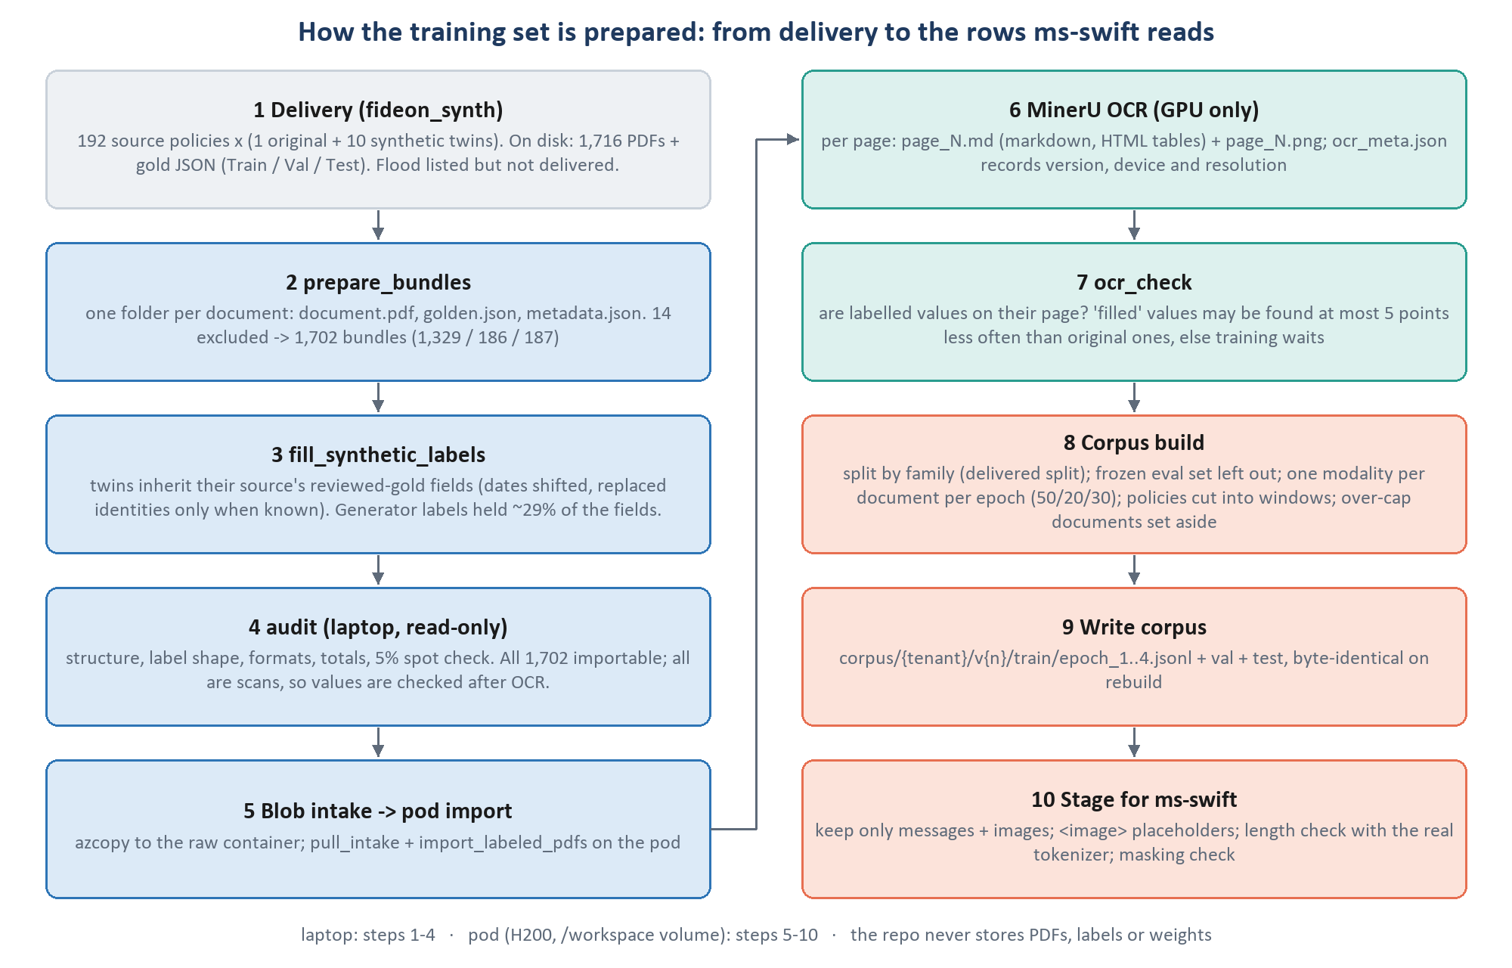
Figure 6. From the generator's delivery to staged training rows. Steps 1-4 run on the laptop, 5-10 on the GPU pod.

11.1 The delivery
The training set is produced by a separate project, fideon_synth (build_dataset.py), and lives in data/training data (Train / Val / Test folders, each with pdfs and gold json, plus manifest.csv and splits.json). It is built around source documents: real policies whose gold labels were reviewed by people. For every source the generator also produces ten synthetic twins: the same policy with identifying values replaced, dates shifted and the pages re-rendered as scans.
Table 19. The delivery. The 396-row gap is flood (36 sources x 11), listed in the manifest but not delivered; it is out of scope anyway.
 | Train | Val | Test | Total
Manifest rows (incl. flood) | 1,650 | 231 | 231 | 2,112 = 192 sources x 11
PDFs actually on disk | 1,342 | 187 | 187 | 1,716
of which originals | 122 | 17 | 17 | 156
of which synthetic twins | 1,220 | 170 | 170 | 1,560

- Lines in the manifest: homeowners 759, flood 396, personal auto 286, recreational vehicle 253, dwelling fire 220, personal umbrella 77, ocean marine 66, motorcycle 55; 23 carriers.
- Size: pages per document from 1 to 85 (median 4); generator field count from 6 to 512 (median 39).
- Twins: rendered 'scanned only' (1,420 at 400 dpi, 130 in grayscale JPEG quality 85); dates shifted by a random -540 to +540 days, never 0; each twin's golden.json carries a fideon:provenance block recording the shift, the scanner profile and which values were replaced.
- Originals: their reviewed gold (reviewed 28-29 September 2026) is the ground truth everything else derives from.
IN PLAIN ENGLISH
Ten twins per real policy multiply the data cheaply: the model sees the same layout with different names, numbers and dates, and with different scan quality, so it learns to read the layout rather than memorise the values. The risk, handled in chapter 13.8, is that a twin of a training document would make a test score meaningless, so a source and all its twins always land in the same split.

11.2 From delivery to bundles: prepare_bundles
python -m data_pipeline.ingestion.prepare_bundles --input "data/training data" --out data/bundles
python -m data_pipeline.audit # read-only; default input data/bundles, scope personal_lines

prepare_bundles writes one folder per document, data/bundles/<document>/{document.pdf, golden.json, metadata.json}, using hard links (seconds, no second copy). For each manifest row it:
- applies line overrides (data/bundle_lob_overrides.csv) and merges classic auto into personal auto;
- skips rows outside the scope (flood for personal_lines), rows the generator flagged, and rows with missing files;
- skips documents listed in data/bundle_exclusions.csv, removing any folder an earlier run made;
- refuses a document named twice, and normalises the split name;
- writes metadata.json from the manifest: lob, synthetic, split, carrier, sample, template_id (the source document, i.e. the family) and source_system.
Fourteen documents are excluded: ten twins hit a generator leap-day bug (the real effective date 02/29/2024 was kept while the policy period became invalid), and four are duplicate original PDFs.

11.3 The bundles
Table 20. Bundle counts (1,716 - 14 exclusions = 1,702; one family per source, 156 families).
 | Total | Train | Val | Test
All bundles | 1,702 | 1,329 | 186 | 187
Originals (__original) | 152 | 119 | 16 | 17
Synthetic twins (__synth_NNN) | 1,550 | 1,210 | 170 | 170

Table 21. Bundles by line.
Line of business | Bundles | Notes
Homeowners | 746 | the largest line: 593 of the 1,329 training documents
Personal auto | 286 | 198 + 88 Hagerty classic-car policies (metadata still says classic_auto; merged at read time)
Recreational vehicle | 252
Dwelling fire | 220 | 134 of 220 labels list two or more dwellings (an open labelling question)
Personal umbrella | 77
Ocean marine | 66
Motorcycle | 55 | the smallest line: 33 training documents

IN OUR REPO
data_pipeline/ingestion/prepare_bundles.py:90-214; common/lob.py:54 (MERGED_LINES = {"classic_auto": "personal_auto"}). data/ is git-ignored: the repo never stores PDFs or labels; they reach the pod through Azure Blob (azcopy sync to the raw container, then pull_intake and import_labeled_pdfs on the pod).

12 The training data II: the labels
The label is the answer the model is trained to write. Its shape is fixed by the client's canonical schema; its completeness and correctness are what this chapter's tooling protects.

12.1 The canonical schema
The schemas live in configs/canonical schema/LOB Schema/: 33 JSON Schema files (one per line, plus _common.json and _fallback.json), delivered by the client and read-only in this repo. Homeowners (schema version 1.4.0) is typical: 532 fields, 110 alias blocks, three required sections (carrier, named_insured, policy) and 17 top-level sections: document, carrier, producer, policy, named_insured, locations, interested_parties, premium, terrorism, billing, forms_and_endorsements, deductibles, loss_history, state_notices, claim_reporting, signature, and the line block homeowners. Personal auto adds the auto block and document_type_detail.

12.2 The value envelope: canonical form vs model form
Table 22. The FieldValue envelope (common/schemas.py:535-557).
Key | In the gold label | Written by the model? | Where it comes from at serving
raw | the text as printed | yes | the model
parsed | normalised value (gold dates ISO, e.g. 2026-06-15) | yes; dates as MM/DD/YYYY, numbers as numbers | the model
page_ref | list of page numbers | yes, from the <page N of M> markers | the model (bounded to 1..page count)
confidence | {score, source} | no | calibration (chapter 16)
flagged | false | no | threshold check: true = human review

The schema shown to the model is a narrowed copy: the envelope is cut to raw, parsed and page_ref with additionalProperties: false, and every fideon:* key (including aliases), $comment, $schema, $id and version are stripped. The model never sees the alias registry.
WHY WE CHOSE THIS
Confidence is never trained. A model asked to write its own confidence learns to write plausible numbers, not calibrated ones. The system prompt says so directly: 'Do not emit confidence scores, probabilities, notes, or source references. Values only.' Confidence is computed afterwards from the model's token probabilities, where it can be checked against reality.

12.3 What a golden label looks like
tests/fixtures/golden/policy_0002.golden.json (abridged; fixture data, not a real policy)
{ "carrier": { "company_name": {"raw": "Northbridge Casualty Company", "parsed": "...", "confidence": {...},
"page_ref": [1], "flagged": false } },
"producer": { "agency_name": {...} },
"policy": { "policy_number": {...}, "effective_date": {...}, "expiration_date": {...} },
"named_insured": { "primary_name": {...}, "mailing_address": { "line_1": {...}, "city": {...}, ... } },
"premium": { "total_policy_premium": {"raw": "$18,900.00", "parsed": 18900.0, ...} },
"homeowners": { ... the line block ... },
"fideon:provenance": {...}, "fideon:filled": {...}, "fideon:absent": [...] <- annotations, never trained
}

Across all bundles there are 324,273 value envelopes. Besides schema sections, labels carry annotation keys (fideon:provenance, fideon:filled, fideon:absent, fideon:unmapped, fideon:unverified) and two non-schema blocks (text_sections, additional_fields). None of these reach a training target: canonical.within_schema drops everything the schema does not define.

12.4 Completing the twins' labels: fill_synthetic_labels
The generator's own labels for a twin held only about 29% of what its source's reviewed gold holds, and 'the model reads an omitted field as not on the page'. Training on them would teach the model to leave out 70% of the fields. fill_synthetic_labels therefore copies each missing field from the source's reviewed gold into the twin's label, conservatively (SPEC_03: the first delivery went from 90,050 to 295,082 fields, with 30,268 deliberately left out):
- a field the twin already has is never changed;
- unchanged text (coverage names, form numbers, the carrier's name and address) is copied as is;
- full dates are shifted by the twin's recorded date_shift_days; month/year edition dates are kept as written;
- an identifying value is copied only when its exact replacement is known from a field both labels share;
- amounts are copied only if every amount the two labels share is equal (the template kept them);
- table rows are matched on anchor values the generator does not change, and never duplicated;
- the merged label must pass the schema, or it is refused; added paths are recorded under fideon:filled.

12.5 Checking labels against the pages
Two checks guard label quality, one before and one after OCR:
Table 23. Label checks.
Check | When | What it verifies | Result on this delivery
data_pipeline.audit | laptop, before upload | folder structure, label shape and schema, page_ref inside the PDF, date/amount formats, totals, a 5% spot-check sample per line | 1,702 importable, 0 blockers; all scans, so 294,505 values await OCR to be checked
data_pipeline.ocr_check | pod, after MinerU | is each labelled value found on its page's OCR text? compares filled values with original ones | fails if filled values are found > 5 points less often (--max-gap 0.05) or the overall found rate is < 50%

At corpus build a third safeguard applies: a rule-added value (fideon:filled) on a synthetic page is kept only if the clean OCR of that page actually prints it; otherwise it is re-paged or dropped (data_pipeline/dataset_builder/label_verification.py). A label that claims a value the page does not show would teach the model to hallucinate.

12.6 How labels will be produced for new data
For documents without delivered gold, data_pipeline/labeling/ provides the workflow: a draft from a pre-annotation backend (the base Qwen3-VL by default, later our own fine-tuned model; an external frontier model only with explicit compliance flags), human review in Label Studio with a config generated from the schema, 100% review until a type has 25 labels, 15% double annotation, and later active learning (spot-check above 0.90 confidence, review below 0.70). The reviewed result is validated against the schema before it can become a golden label.

13 The training data III: what the model actually sees
A bundle is a PDF and a label. A training row is what the model reads and writes: page images, OCR text, instructions, a schema slice and a target JSON. This chapter covers OCR, the three modalities, windowing, the exact format of a row, and how rows are split, capped and balanced.

13.1 OCR with MinerU
Text comes from MinerU 1.x (magic-pdf[full]), run on the GPU in its own environment (data_pipeline/ocr/run_mineru.py). It is GPU only: MinerU's CPU path uses lighter models and emits different markdown from the same PDF, so a corpus OCR'd on both devices would be built from two distributions. If any page lacks a text layer (under 30 characters), the whole document goes through OCR mode. For each page MinerU's content list becomes markdown: headings with #, tables as HTML (with captions and footnotes), image captions only, blocks joined by blank lines. Outputs per document: page_N.md, page_N.png and ocr_meta.json (MinerU version, device, GPU, resolution cap, checksum, failed pages). A document is skipped when nothing relevant changed.
tests/fixtures/ocr/policy_0002_page_1.md: the OCR markdown of one page (fixture)
# POLICY DECLARATIONS

**Named Insured:** Kestrel Logistics Inc
**Mailing Address:** 77 Harbor Way, Cleveland OH 44113

**Policy Number:** CA-3310945-00
**Policy Period:** 06/15/2026 to 06/15/2027

**Insurer:** Northbridge Casualty Company
**Agency:** Beacon Commercial Brokers

Total Policy Premium: $18,900.00

13.2 The three modalities, and how they are mixed
Every training document is shown in exactly one modality per epoch, drawn deterministically: the hash sha256("{seed}:{epoch}:{source_id}") is compared with the cumulative shares 0.50 / 0.20 / 0.30 (data_pipeline/dataset_builder/sample_modes.py:104-161). The corpus always writes four epoch files, each holding every training document once in that epoch's draw, so a document typically appears in different modalities across epochs. Validation and test rows are written in all three modalities, so image-only accuracy is measured on the full evaluation population.
WHY WE CHOSE THIS
v1 expanded every document into all three modes inside each epoch. That 'produced 33/33/33, not 50/20/30, and tripled effective epochs': a '3-epoch' run was nine passes. Drawing one mode per document per epoch restores both the intended mix and the meaning of an epoch.

Noisy OCR: what the corruption looks like
noisy_ocr_image rows use the same prompt as ocr_plus_image (the noise lives in the data, not the instruction), but their OCR text is corrupted, two corruptions per document or window, chosen by weight:
Table 24. Noise model (data_pipeline/dataset_builder/noisy_ocr_augment.py:34-194).
Corruption | Weight | Example
Character confusion | 0.45 | O<->0, l<->1, S<->5, B<->8, Z<->2, rn->m, cl->d (at most 3 tokens per corruption)
Merged table cells | 0.20 | two adjacent cells fused into one
Dropped header | 0.15 | a table loses its header row
Reading-order swap | 0.10 | two blocks appear in the wrong order
Dropped separator | 0.10 | a column separator disappears

The image is untouched, so the correct answer is always visible in the picture. The model can only get these rows right by preferring the image where the text is wrong, which is the behaviour the system prompt asks for.
WATCH OUT
The table corruptions (merged cells, dropped separator) operate on pipe-style markdown tables, but real MinerU 1.x output uses HTML tables. On real OCR about 30% of the corruption weight therefore finds nothing to corrupt and falls back to character confusion. The test fixtures use pipe tables, which hides this. Worth fixing before the long run (Appendix E).

13.3 Windowing: how a long policy becomes several rows
A policy can run to 85 pages and its full schema to more than 500 fields; one call cannot hold all of it, and 'a 6-page routed read of [a 60-page policy] silently drops everything past the sixth page' (sequence.yaml). Every canonical policy is therefore read in windows: a section group over a set of pages. Each window is one training row (and, at serving time, one model call; the results are merged).
Table 25. Section groups (configs/schema_sections.yaml:34-91).
Group | Task budget | Pages it reads | Schema sections
decl | policy_declarations | the declarations pages | document, carrier, producer, policy, named_insured, premium, terrorism, billing, claim_reporting, signature
arrays | policy_schedule | all routed pages | locations, interested_parties, forms_and_endorsements, deductibles, loss_history, state_notices
lineblk | policy_schedule | all routed pages | the line's own block (homeowners, auto, dwelling_fire, watercraft, ...)
dtd | policy_endorsements | the declarations pages | document_type_detail (ocean marine, personal auto, umbrella)

- Declarations pages = pages 1-3 plus the detected declarations page.
- Routed pages: documents of 5 pages or fewer read every page; longer ones keep pages whose OCR text carries field-bearing keyword signals (score >= 2.0), always including page 1. This reuses serving's own page router, so training and serving choose pages the same way. In image_only rows there is no text to route on, so every page is read.
- Packing: declarations pages first; consecutive runs of pages stay together when they fit; an over-long run is split evenly (7 pages at a limit of 6 -> 4 + 3).
- Capacity is computed per line and group from the sequence budget (section 5.6): declarations 7 pages, arrays 6, line block 5-6, document detail 3.
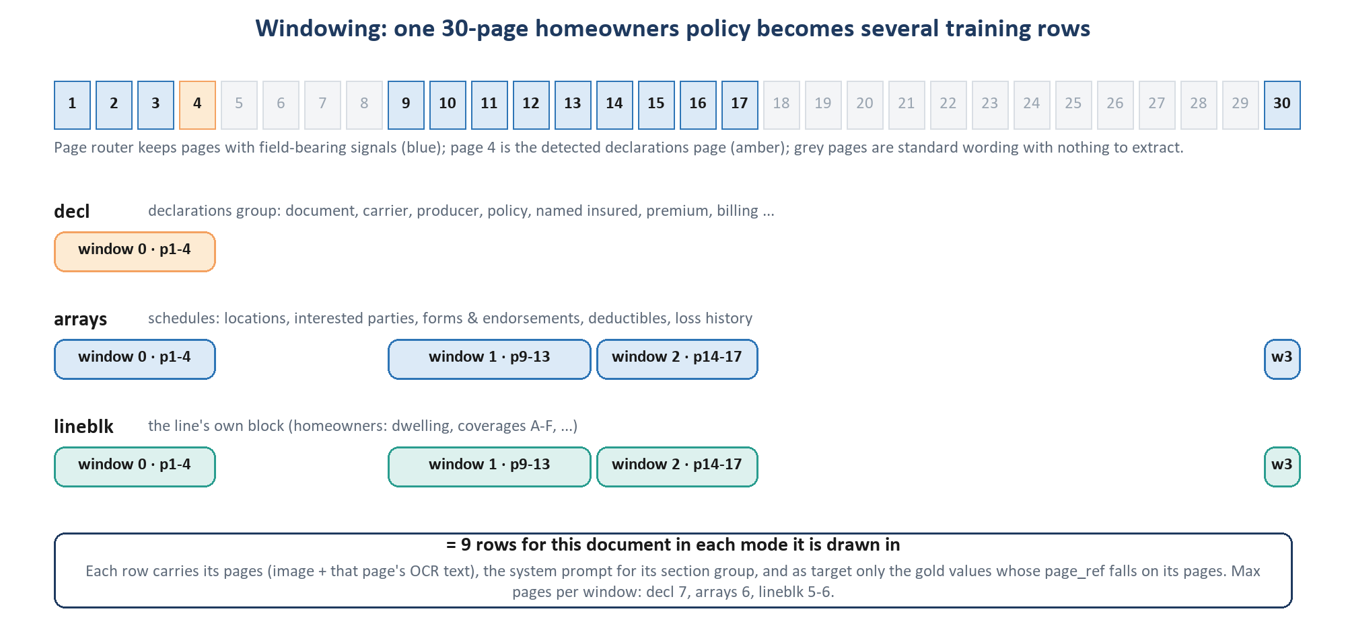
Figure 7. The planner's real output for a homeowners policy whose routed pages are 1-4, 9-17 and 30 with the declarations page at 4: one declarations window, four schedule windows, four line-block windows.

The target of each window
Each window's target is a slice of the gold label: only the window's sections, and within them only values whose page_ref falls on the window's pages. Required sections are emitted as {} when empty. The slice is converted to model form (raw, parsed with dates as MM/DD/YYYY, page_ref), sparse and in schema key order. A value with no page_ref is assigned a page when it (4+ characters) appears on exactly one OCR page; if it still has none, it is kept in a single-window group and dropped (and reported as 'unplaced') in a multi-window one. Table-row fragments without their row identifier are dropped.
DEEP DIVE
How much can windowing lose? scripts/diagnose_windowing.py replays the gold labels through windowing and the serving merge, with no model in the loop. On all 1,702 documents: 5.4 windows per document and 96.07% value recall (9,866 of 251,191 values lost: 5,174 on pages no window reads, 2,549 unmatched table rows, 1,487 with no page, 656 in the merge). This is a ceiling: a perfect model could not exceed it.
By line: motorcycle 99.83%, umbrella 99.25%, dwelling fire 98.29%, homeowners 97.80%, ocean marine 94.11%, personal auto 93.67%, recreational vehicle 91.15% (9.3 windows per document).
Separately, 21.7% of all stated values (69,623 of 320,814) sit outside the canonical schema and are neither trained nor scored.

13.4 Anatomy of one training row
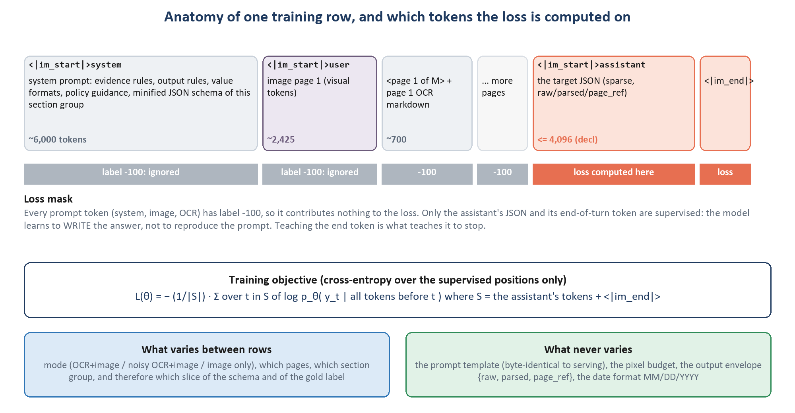
Figure 8. The parts of a row and the loss mask over them.
The example below was rendered with the repo's own corpus builder (expand_document) from the test fixture policy_0002 read as a homeowners policy. It produces three rows per mode (decl, arrays, lineblk), each a single window over page 1. This is the ocr_plus_image declarations row.

Row metadata
{"doc_type": "policy", "acord_form": null, "lob": ["homeowners"], "modality_mode": "ocr_plus_image",
"source_id": "policy_0002", "split": "train", "deidentified": false,
"sections": "decl", "task": "policy_declarations", "window_index": 0, "window_pages": [1],
"epoch": 1, "group_id": "delivered:<template_id>", "synthetic": false,
"messages": [ system, user, assistant ] }

The system message (20,877 characters)
It opens: 'You are an insurance document extraction model. Read the provided Policy document and return a single JSON object that conforms exactly to the schema at the end of this message.' Then come the rule sections, each a short list. Representative lines:
Table 26. Structure of the system prompt (prompts/system_prompt_template.jinja, prompts/doc_types/policy.jinja).
Section | Representative instruction (verbatim)
# Evidence | 'The OCR text is the primary source for dense text, identifiers and amounts.' 'The images are the authority on layout.' 'Where the two disagree on a character or a digit, trust the image.'
(page pairing) | 'Each page is given as its image followed immediately by that page's own text, prefixed <page N of M>.' 'Where the numbers skip, you are seeing selected pages ... absent means null.'
# Output | 'Every field is an object with exactly three keys: raw ... parsed ... page_ref.' 'Emit only the fields the document states, and omit every other field.' 'Do not emit confidence scores ... Values only.'
# Resolving fields | 'Extract by meaning, not by matching words.' 'Do not choose by proximity, by reading order, or by which value appears first.'
# Distinct roles | 'Assigning the nearest candidate is worse than leaving it empty, because a confident wrong answer is not detectable downstream.'
# Value formats | 'Dates: MM/DD/YYYY ... Never invent a day or a month.' 'A figure shown in parentheses is negative.' '0 is a value, not an absence.'
# Absence | 'Do not compute a value the document does not state. Extract, do not derive.'
# Repeating tables | 'Extract every row, in document order.' 'A table continuing across a page break is one table.'
# This document type: Policy | 'The declarations layer wins.' Per-coverage amount insured, deductible and premium 'are the most commonly transposed values ... use the image to confirm which column it is.'
Schema: | the minified JSON Schema slice for this group, starting {"$defs":{"FieldValue":{"additionalProperties":false,...

The user message
[ {"type": "image", "image": "processed/default/policy/policy_0002/page_1.png"},
{"type": "text", "text": "<page 1 of 1>\n\n# POLICY DECLARATIONS\n\n**Named Insured:** Kestrel Logistics Inc\n
**Mailing Address:** 77 Harbor Way, Cleveland OH 44113\n ... Total Policy Premium: $18,900.00\n"} ]

# image_only variant of the same row: the text part is just "<page 1 of 1>",
# and the Evidence section says the model is given page images and no OCR text.

The assistant message: the target
the exact target JSON produced by the builder (re-indented here for reading; the row stores it on one line)
{
"carrier": {
"company_name": {"raw": "Northbridge Casualty Company", "parsed": "Northbridge Casualty Company", "page_ref": [1]}
},
"producer": {
"agency_name": {"raw": "Beacon Commercial Brokers", "parsed": "Beacon Commercial Brokers", "page_ref": [1]}
},
"policy": {
"policy_number": {"raw": "CA-3310945-00", "parsed": "CA-3310945-00", "page_ref": [1]},
"effective_date": {"raw": "06/15/2026", "parsed": "06/15/2026", "page_ref": [1]},
"expiration_date": {"raw": "06/15/2027", "parsed": "06/15/2027", "page_ref": [1]}
},
"named_insured": {
"primary_name": {"raw": "Kestrel Logistics Inc", "parsed": "Kestrel Logistics Inc", "page_ref": [1]},
"mailing_address": {
"line_1": {"raw": "77 Harbor Way", "parsed": "77 Harbor Way", "page_ref": [1]},
"city": {"raw": "Cleveland", "parsed": "Cleveland", "page_ref": [1]},
"state": {"raw": "OH", "parsed": "OH", "page_ref": [1]},
"postal_code": {"raw": "44113", "parsed": "44113", "page_ref": [1]}
}
},
"premium": {
"total_policy_premium": {"raw": "$18,900.00", "parsed": 18900.0, "page_ref": [1]}
}
}

Note what the target teaches: the gold parsed date 2026-06-15 became 06/15/2026 (the trained format); the premium's raw keeps the dollar sign and comma while parsed is the number 18900.0; the address is split into the schema's parts; confidence and flagged are gone. The arrays and line-block rows of this one-page document have the target {}: nothing on the page belongs to those groups, and the model must learn to say so.

The staged form ms-swift reads
training/stage_data.py:76-109: only messages and images survive; one <image> placeholder per page, in order
{"messages": [
{"role": "system", "content": "You are an insurance document extraction model. ..."},
{"role": "user", "content": "<image><page 1 of 1>\n\n# POLICY DECLARATIONS\n..."},
{"role": "assistant", "content": "{\"carrier\": {\"company_name\": ...}}"} ],
"images": ["/workspace/.../processed/default/policy/policy_0002/page_1.png"]}

13.5 Byte-identical prompts in training and serving
One function, inference_core/input_builder.build_messages, assembles messages for the corpus, for evaluation and for serving, from one renderer (common/prompts.py, template version 6.0.0). The schema is serialised with sorted keys and compact separators so the bytes never vary. A prompt_hash covers every template, every schema and schema_sections.yaml; it is stored with each release, and serving refuses to start on a release whose hash differs from its own (serving/vllm_entrypoint.py).
WHY WE CHOSE THIS
'Divergence degrades a fine-tuned model and is invisible in training metrics' (README). A model trained on one wording and served another is being asked a slightly different question than the one it learned. tests/test_parity.py checks that serving's prompt equals the corpus prompt and that reference snapshots match the renderer.

13.6 Sequence caps: reject, never truncate
Table 27. Per-task caps (configs/shared/sequence.yaml).
Task | max_seq_len | max_output_tokens | Used for
policy_declarations | 32,768 | 4,096 | decl windows
policy_schedule | 32,768 | 8,192 | arrays and line-block windows (output-bound)
policy_endorsements | 20,480 | 3,072 | document-type-detail windows
extract (policy) | 32,768 | 3,072 | one-call policy extraction (not windowed)
extract (default) | 24,576 | 2,048 | ACORD forms

The corpus estimates every row's length (digits as one token each, other text at 3.5 characters per token, images as pages x 2,425, plus 64 for the template) and checks prompt and answer separately. If any row of a document exceeds its budget, the whole document is set aside and counted in a report, never cut. Rows containing the trainer's special tags (<image>, <video>, <bbox>, ...) in their text are set aside too. Before any training the preflight builds the corpus in memory and warns above 5% of rows over the caps and fails above 25%. On the pod, training/length_check.py re-measures every staged row with the real tokenizer and image processor before launch.
WHY WE CHOSE THIS
'A truncated Loss Run trains the model to omit claim rows.' Cutting the end of a target teaches the model to stop early; cutting the start removes the system prompt. Both damage the model silently, so the repo makes over-length a hard, visible failure instead (train.py:494-505: truncation_strategy: delete plus strict: true).

WATCH OUT
The smoke run (29 September 2026) showed why the output reserves matter: complete declarations targets reached about 2,550 tokens against the 2,048 first reserved, and a third of the documents were set aside. A schedule window needed 4,444 against 4,096. The reserves were raised to 4,096 and 8,192.

13.7 Splits, families and the frozen eval set
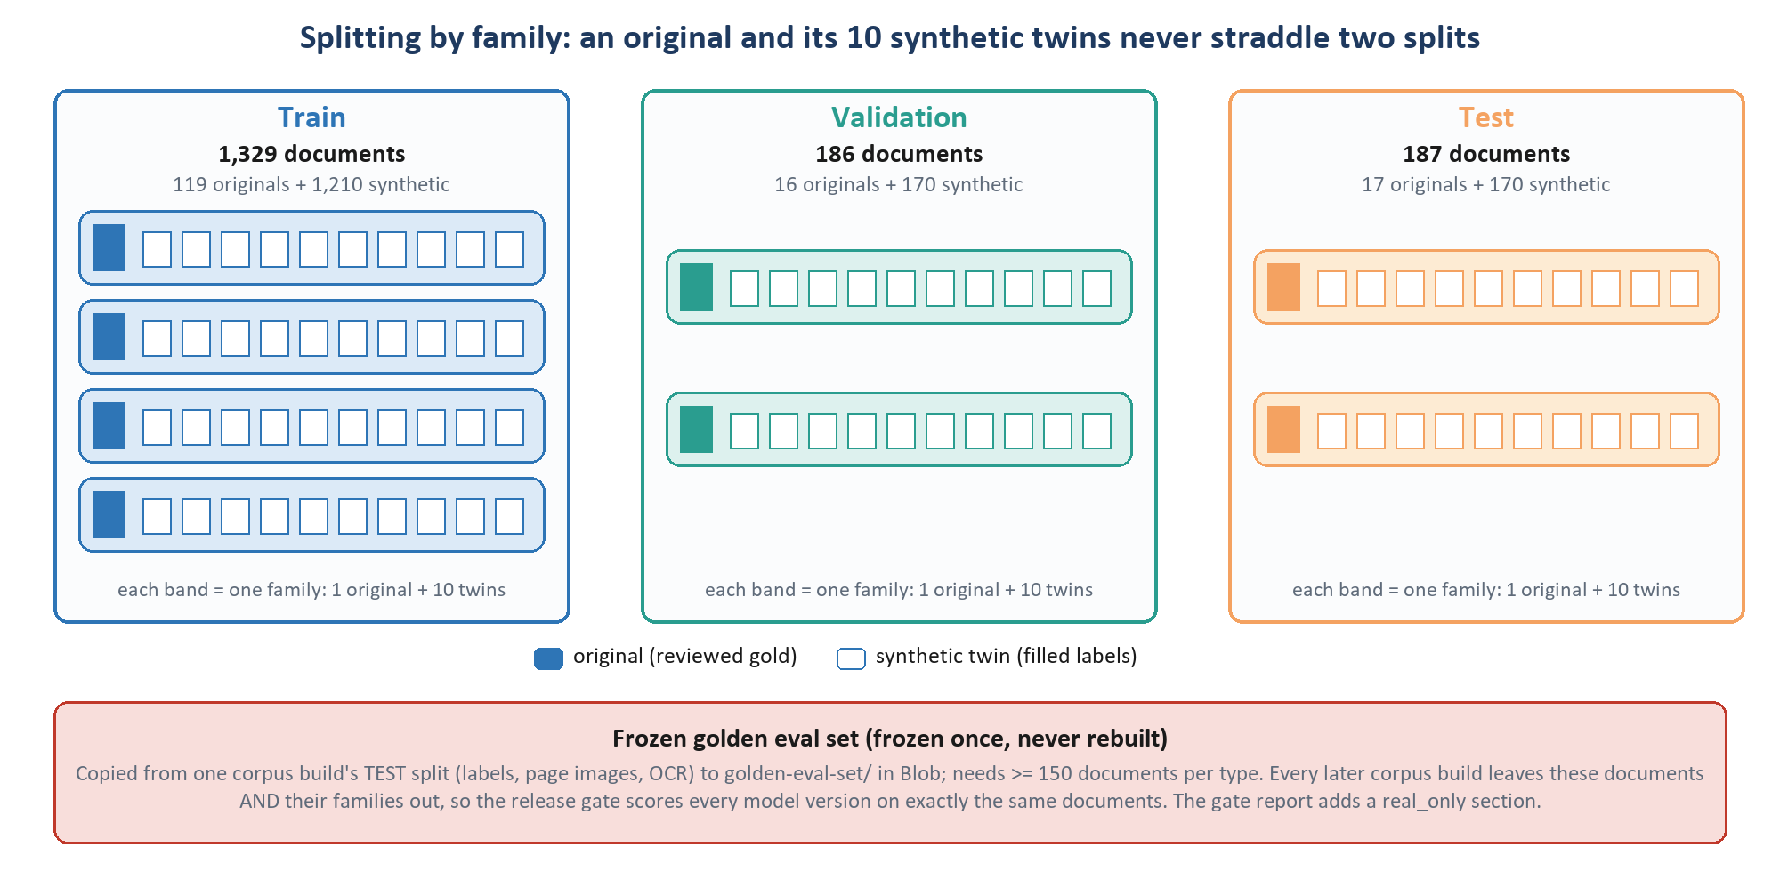
Figure 9. Splitting by family. Twins are near-copies of their source, so a source and its twins must share a split or the test score would measure memorisation.
- The delivered split is used as given (split_groups.assign_delivered_splits). The family of a document is delivered:<template_id>, i.e. its source. A family appearing in two splits is refused; so is an empty validation set.
- Validation is halved by a stable hash into a 'calibration' half and a 'threshold' half, used in chapter 16 to fit confidence and then to choose thresholds on data the calibrator did not see.
- When no split is delivered, a hash-based fallback assigns families per line: 70/18/12 below 200 documents, 75/15/10 below 1,000, 80/10/10 above; lines with fewer than 5 documents train whole; two carriers are held out entirely once there are six or more.
- The frozen golden eval set is created once from a corpus build's test split and never rebuilt. It needs at least 150 documents per type (at 150 documents a rate near 80% has a standard error of about 3 points). Every later build excludes those documents and their families, so every model version is scored on exactly the same documents.
- Synthetic twins in validation and test. Under the delivered split, 340 twins sit in validation and test (the 'synthetic is train-only' rule is deliberately skipped there). The gate report therefore adds a real_only section with the same metrics over real documents alone.

13.8 Balancing small lines
Homeowners supplies 593 of the 1,329 training documents; motorcycle supplies 33. Left alone, the largest line would decide what the model learns about the small ones. For scoped runs (such as personal_lines), a line with fewer than min_documents = 100 training documents is repeated ceil(100 / n) times in every epoch file, at most max_repeat = 3 times. Validation and test are never repeated.
Table 28. Line balancing (configs/training/unified.yaml:159-167; training/corpus_view.py).
Line | Training documents | Repeats per epoch file
Motorcycle | 33 | 3 (ceil(100/33) = 4, capped at 3)
Ocean marine | 44 | 3
Personal umbrella | 55 | 2
Homeowners, personal auto, dwelling fire, RV | 100 or more | 1

13.9 What is written, and what is still open
The corpus lands in Blob as corpus/{tenant}/v{n}/train/epoch_1..4.jsonl, val.jsonl and test.jsonl, sorted so a rebuild is byte-identical, with a manifest. On the delivered corpus the validation split is about 3,300 rows (186 documents x 3 modes x their windows).
CURRENT STATUS
De-identification is blocked. Presidio-based de-identification is specified (SPEC_05 section 1) but not implemented, because text-only redaction would leave the same values visible in the page images and corrupt the training signal. Rows carry deidentified: false and the manifest records image_redaction: unresolved. This must be resolved before production data is used.

14 The trainer and the training mechanism
This chapter covers the software that trains the model, the exact command it runs, the checks made before a GPU hour is spent, what happens inside one optimizer step, every hyperparameter with its reason, and how the run is spread over the GPUs.

14.1 The trainer stack
Table 29. Software layers (requirements-train.lock; training/train.py; SPEC_06).
Layer | Component | Version (lock) | Role
Command line | ms-swift swift sft | 3.12.6 | reads the staged JSONL, applies the Qwen3-VL chat template, builds labels and masks, configures LoRA, launches training
Training loop | swift.trainers.Seq2SeqTrainer | (part of ms-swift) | subclass of the Hugging Face Trainer: batching, optimizer, schedule, eval, checkpoints
Model library | Hugging Face transformers | 4.57.6 | Qwen3-VL model code and image processor
Adapters | PEFT | 0.18.1 | inserts the LoRA A/B matrices; later merge_and_unload()
Distribution | torchrun / Accelerate (DeepSpeed optional) | accelerate 1.15.0, deepspeed 0.19.7 | one process per GPU, gradient all-reduce
Kernels | PyTorch + flash-attention 2 | torch 2.8.0 (CUDA 12.8), flash-attn 2.x | bf16 maths, memory-efficient attention
Generation (selection, calibration) | vLLM | 0.11.0 | fast batched generation with LoRA, logprobs, guided JSON

WATCH OUT
TRL is installed (0.24.0), but only as an ms-swift dependency for its RLHF trainers. It is not the supervised training loop. The v1 documentation said it was, and 'that was wrong' (train.py:8-9).

14.2 Why ms-swift, and the alternatives
ms-swift was chosen because it already does the hard, error-prone parts of multimodal SFT for this exact model: the Qwen3-VL chat template, image placeholders and resizing, building the label mask over a sequence that mixes image tokens and text, padding-free batching, strict handling of over-length rows, sequence parallelism and LoRA configuration. v1 records the decision against the one alternative the repo names: 'Chosen over LLaMA-Factory to standardize on one framework and avoid the raw-collation masking risk.'
Table 30. Trainer alternatives.
Alternative | What it is | Why not here
LLaMA-Factory | popular all-in-one fine-tuning framework | repo decision: standardise on one framework (ms-swift is also what the template, masking and spike checks are built against); avoid the raw-collation masking risk
TRL SFTTrainer | Hugging Face's SFT trainer | repo decision: kept only as a migration contingency, 'including re-implementing the template, collator and masking ... a contingency, not a layer swap'
Unsloth | speed-optimised kernels for LoRA/QLoRA | general: historically single-GPU-first; new architectures and multi-GPU arrive later; not discussed in the repo
Axolotl | YAML-driven wrapper over HF/TRL | general: another layer over the same pieces; multimodal support newer; not discussed in the repo
Hand-written loop | HF Trainer or raw PyTorch | general: full control, but the template, collation, masking and image budget would all be ours to get right

14.3 How a run is launched
training/train.py builds a dictionary of ms-swift 3 arguments from the YAML configs and renders it as a swift sft command (SwiftConfig.to_cli()), then runs it as a subprocess. Two rendering rules come from real bugs: booleans are always written out (--flag true / --flag false), because dropping a false value 'was silently disabling' options; and lists are one argument per item, because joining them once made 'six corpus paths ... one nonexistent filename and the LoRA target modules matched nothing at all'. Before launch, every environment variable that looks like a secret (Azure, SAS, RunPod, passwords, API keys) is removed except the Hugging Face token.
The rendered command on a 4-GPU pod (regrouped for reading; train.py sorts the flags alphabetically)
NPROC_PER_NODE=4 MAX_PIXELS=2483200 MIN_PIXELS=200704 IMAGE_MAX_TOKEN_NUM=2425 IMAGE_MIN_TOKEN_NUM=196 \
swift sft \
--model /workspace/models/<Qwen3-VL-8B-Instruct> --use_hf true \
--dataset <corpus>/train/epoch_1.jsonl <corpus>/train/epoch_2.jsonl <corpus>/train/epoch_3.jsonl \
--val_dataset <400-row stratified validation sample> --split_dataset_ratio 0.0 \
--train_type lora --lora_rank 64 --lora_alpha 128 --lora_dropout 0.1 --use_rslora false \
--target_modules q_proj k_proj v_proj o_proj gate_proj up_proj down_proj \
--freeze_vit true --freeze_aligner true \
--torch_dtype bfloat16 --bf16 true --attn_impl flash_attn \
--learning_rate 0.0001 --lr_scheduler_type cosine --warmup_steps 10 --num_train_epochs 1 \
--optim adamw_torch --weight_decay 0.0 --max_grad_norm 1.0 \
--per_device_train_batch_size 1 --gradient_accumulation_steps 2 --ddp_find_unused_parameters false \
--gradient_checkpointing true --padding_free true --group_by_length true --use_logits_to_keep true \
--max_length 32768 --truncation_strategy delete --strict true --dataset_num_proc 8 \
--eval_strategy steps --save_strategy steps --eval_steps <computed> --save_steps <computed> \
--save_total_limit <computed> --load_best_model_at_end false --metric_for_best_model eval_loss \
--logging_steps 10 --report_to none --seed 42 --output_dir <staging>/runs/<run_id>

14.4 Checks before any GPU time is spent
- On the pod: CUDA present, the staging volume mounted, the pinned base model on local disk (assert_on_pod).
- Staging: corpus rows converted to ms-swift's format; rows whose text contains trainer tags, or whose task pixel budget differs from the run's, are refused (training/stage_data.py).
- Length: every staged row is measured with the real tokenizer and Qwen's resize rule; any row over max_length or over its task's answer budget refuses the run (training/length_check.py).
- Masking: the first 4 staged rows are encoded with ms-swift's own template in training mode. The run is refused if any prompt token is supervised, any assistant token is masked, anything after the turn is supervised, or nothing is supervised (train.py:953-968; training/data_collator.py).
- No overwrites: a run id that is already trained, evaluated or promoted is refused; a run with no validation rows is refused.
- Preflight (python -m orchestration.preflight): GPUs free, packages, pinned model, config invariants, disk, Azure write/overwrite/delete, every document OCR'd, the post-OCR check passed, and the corpus built in memory.
WHY WE CHOSE THIS
Each check exists because the failure it prevents is silent. A mis-masked run 'trains on its own prompt while the loss curve looks normal'; an over-length row would otherwise be 'replaced with a random other row - one document lost, another trained twice, nothing recorded'. 'A stopped run beats a silently wrong one.'

14.5 The objective: what the loss is
Each row is one sequence: system prompt, user turn (images and text), assistant turn (the target JSON). ms-swift sets the label of every token outside the assistant's answer to -100, PyTorch's 'ignore' value. The loss is the average cross-entropy of the supervised tokens:
L(θ) = − (1 / |S|) · Σ_(t ∈ S) log p_θ( y_t | y_<t , images, prompt )
S is the set of assistant tokens, including the end-of-turn token <|im_end|> (and the newline ms-swift supervises after it). θ here means only the LoRA matrices; the base weights are constants. No token weighting, label smoothing or special loss is configured.
WHY WE CHOSE THIS
Supervising the end token is deliberate (commit a079d2f): without it, 'a model trained against this baseline is never taught to stop'. A model that does not stop runs to its token limit, which on the smoke run looked like answers looping until 8,192 tokens.

14.6 One optimizer step, end to end
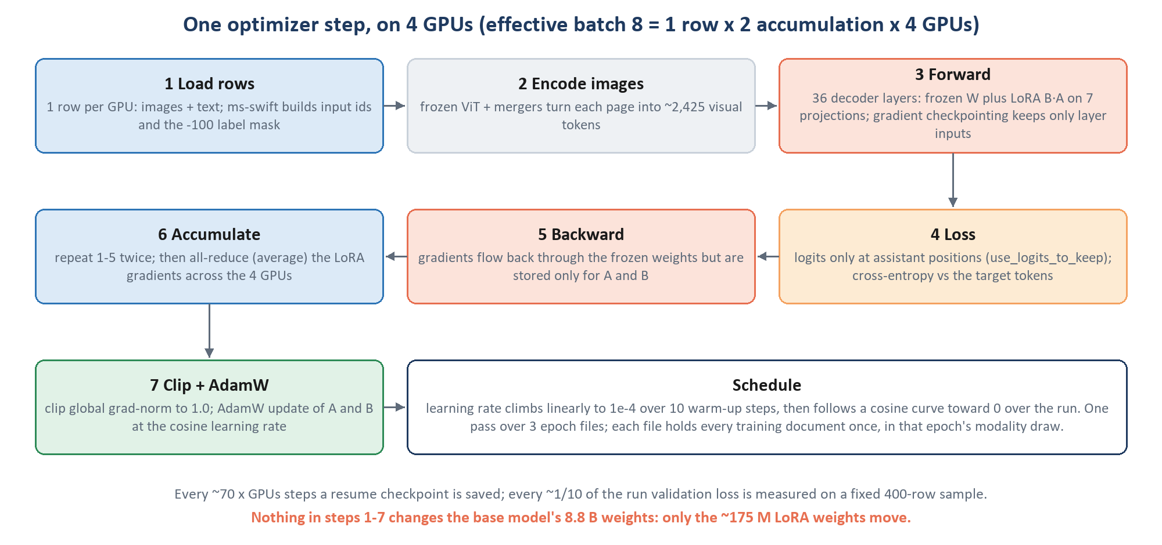
Figure 10. One optimizer step on a 4-GPU pod.
- Load. Each GPU takes one row. The processor resizes its page images to the budget and builds input ids, image positions and the -100 label mask.
- Encode images. The frozen ViT and mergers turn each page into about 2,425 visual tokens (plus DeepStack features).
- Forward. The sequence runs through 36 decoder layers. In each of the 252 adapted projections the output is W·x + 2·B·A·dropout(x). Gradient checkpointing stores only each layer's input and recomputes the inside during backward, trading about a third more compute for a large cut in activation memory.
- Loss. Logits are computed only at the assistant positions (use_logits_to_keep); cross-entropy against the target tokens.
- Backward. Gradients flow back through every layer, frozen weights included, but are accumulated only in A and B.
- Accumulate and synchronise. Steps 1-5 repeat twice per GPU (gradient accumulation 2). The LoRA gradients are then averaged across the 4 GPUs (all-reduce), so the update reflects 8 rows.
- Update. The global gradient norm is clipped to 1.0, and AdamW updates A and B at the current learning rate.
DEEP DIVE
AdamW, per trainable number θ with gradient g (β1 = 0.9, β2 = 0.999, ε = 1e-8, weight decay λ = 0):
m ← β1·m + (1 − β1)·g v ← β2·v + (1 − β2)·g²
θ ← θ − η_t · ( m̂ / (√v̂ + ε) + λ·θ ) with m̂, v̂ the bias-corrected moments
Learning rate η_t: linear warm-up over w = 10 steps, then cosine decay over the remaining T − w steps:
η_t = η_max · t / w (t < w) η_t = η_max · ½ · (1 + cos(π · (t − w) / (T − w))) (t ≥ w)
Gradient clipping: if ‖g‖ > 1.0 the whole gradient is scaled down to norm 1.0, which protects a freshly initialised adapter from one unusually large batch.

14.7 Memory and speed techniques
Table 31. Memory and speed settings (configs/training/unified.yaml:82-109).
Technique | Setting | What it does | Why here
bf16 | bf16: true, torch_dtype: bfloat16 | 16-bit brain-float maths and weights | half the memory of fp32 with fp32's range; the base is served in bf16
Flash-attention 2 | attn_impl: flash_attn | tiled exact attention, no full attention matrix | 32k-token rows; standard attention memory grows with length squared
Gradient checkpointing | gradient_checkpointing: true | keep layer inputs, recompute activations in backward | activations of 36 layers x 32k tokens would not fit
Logits only where needed | use_logits_to_keep: true | LM head applied only at assistant positions | a 151,936-wide distribution at 32k positions 'dominates activation memory on its own'
Padding-free batching | padding_free: true | rows concatenated without pad tokens | no memory spent on padding
Length grouping | group_by_length: true | rows of similar length batched together | a short row is not padded to a long one
Parallel length pass | dataset_num_proc: 8 | ms-swift measures every row's length up front | ~2 rows/s on one process: ~5 h for the full corpus

14.8 Epochs are files
The corpus writes four epoch files; each holds every training document once, in that epoch's modality draw. A three-epoch run passes the first three files to ms-swift and sets num_train_epochs: 1, so the trainer reads the concatenation once. The content equals a three-epoch run: each document three times, in up to three modalities. The order differs, since the trainer shuffles the concatenated rows and groups them by length.
WATCH OUT
Setting num_train_epochs: 3 as well would loop the three files three times: 'nine passes for a 3 epoch run, the inflation per-epoch sampling exists to remove' (train.py:477-481).

14.9 Every hyperparameter, and why
Table 32. Hyperparameters (configs/training/unified.yaml).
Hyperparameter | Value | Why this value | Rejected value and reason
Learning rate | 1e-4 | same at pilot and production scale | 2e-4 (v1): 'aggressive for ~25 documents per type and a rank-64 adapter'
Schedule | cosine | smooth decay to ~0 by the end | -
Warm-up | 10 steps | a fixed number of steps | ratio 0.03: 'rounds to zero warmup' at pilot volume, so the first step hits a fresh adapter at full rate
Epochs | 3 document passes | three modality draws per document | v1's 3 x 3 = 9 effective passes
Per-device batch | 1 | rows are up to 32k tokens | -
Effective batch | 8 | enough updates per run at pilot size | 32: 'most of an epoch in one step', so the cosine schedule 'never gets anywhere'
Optimizer | AdamW (adamw_torch) | standard; ~1.4 GB of state for 175 M weights | paged 8-bit AdamW: a second quantisation approximation, unnecessary at this size
Weight decay | 0.0 | dropout regularises instead | 0.01: 'pulls B toward zero, which is where it starts - a shrinkage prior on the update itself'
Gradient clip | 1.0 | stability | -
LoRA dropout | 0.10 | pilot-scale regularisation | 0.05 at pilot size 'will memorise them' (planned at >= 200 docs/type)
Seed | 42 | reproducible runs and data draws | -
Precision | bf16 | train on the weights that are served | fp16 (narrow range); NF4 base (mismatch, slower)
Max length | 32,768 | largest task cap in scope | a single 8,192 cap could not hold even a one-page ACORD with its image and schema
Early stopping | none passed | ms-swift 3 has no patience argument; selection is by generated F1 anyway | -

14.10 GPUs, data parallelism and DeepSpeed
Training runs on a RunPod pod with H200 SXM GPUs (141 GB each). With distributed.gpus: auto it uses every visible GPU, data-parallel: ms-swift starts one process per GPU through torchrun (NPROC_PER_NODE), each GPU holds a full copy of the model and processes different rows, and gradients are averaged after each step. Gradient accumulation is recomputed so the effective batch stays 8 and the result matches a single-GPU run step for step:
Table 33. Gradient accumulation by GPU count (train.py:156-171). A count that does not divide the batch is refused.
GPUs | Rows per GPU per micro-step | Accumulation steps | Effective batch
1 | 1 | 8 | 8
2 | 1 | 4 | 8
4 | 1 | 2 | 8
8 | 1 | 1 | 8

DEEP DIVE
DeepSpeed ZeRO splits training state across GPUs: stage 1 the optimizer state, stage 2 also the gradients, stage 3 also the weights. With LoRA, optimizer state and gradients are tiny (about 1.5 GB), so ZeRO-2 is 'close to a no-op'; only ZeRO-3 saves real memory, by sharding the 17.5 GB base, and that works cleanly only because the base is bf16 (bitsandbytes 4-bit weights do not partition cleanly).
The repo's order of escape hatches, if a row does not fit: first sequence parallelism (one long sequence split across GPUs), then ZeRO-3. Neither is needed today: a 32,768-token row peaked at 99 GB on one H200 when measured on the pod. configs/deepspeed/zero2.json and zero3.json exist and are used only when --deepspeed is passed explicitly.

WATCH OUT
Once, 'training ran on one GPU of four without saying so', because CUDA_VISIBLE_DEVICES did not pass into the tmux session. scripts/pod_run.sh now passes it explicitly, and the preflight checks that every visible GPU is free.

14.11 Checkpoints, evaluation cadence and resume
The cadence is sized to the run rather than fixed (at pilot volume a fixed 50 steps gave one checkpoint and nothing to choose between):
training/train.py:120-196
steps = ceil(train_rows / 8) # optimizer steps in the run
interval = ceil(steps / 10) # evaluations_per_run = 10
every = 70 x gpus # a resume point about every hour
per_eval = ceil(interval / every)
save_steps = ceil(interval / per_eval) # resume checkpoints
eval_steps = save_steps x per_eval # every n-th checkpoint is also evaluated

- Validation loss is measured on a fixed, stratified 400-row sample (by line x modality, chosen by hash), not on all ~3,300 validation rows: at the old cadence full validation 'cost 50-60 h of a ~35 h training run'.
- Checkpoints carry the adapter and the optimizer state (~1.8 GB). Enough are kept that the last three evaluation checkpoints plus the best-loss one survive for selection.
- Resume: an interrupted run continues from its latest complete checkpoint, but only if run_fingerprint.json shows the same corpus and settings. --continue-from <adapter> starts a new run from an earlier adapter's weights (not mid-schedule).
- Status: the run manifest moves from training to trained or failed; training_complete.json marks a finished run.

14.12 Time and cost
Table 34. Run time.
Quantity | Value | Source
Optimizer step, one H200 | about 51 s | unified.yaml:127-128 (measured)
Full delivered corpus, one H200 | about 35 h of training | unified.yaml:142
Four H200s | each step about 4x faster, same steps and schedule | commit 6da9ccd
Length pass before step 1 | ~5 h single-process; now 8 processes | unified.yaml:93-98
Peak memory at 32,768 tokens | 99 GB | sequence.yaml:91 (measured on the pod)
End-to-end long run on 4x H200 | about 17-19 h, about $235-265 | planning estimate from earlier working sessions (includes OCR, length pass, selection); not recorded in the repo

14.13 Hyperparameter sweeps (written, deferred)
Sweeps are authored but refused below 200 documents per type (training/sweep.py), because sweeping on 25-30 documents per type 'measures noise'. The order is: pass the pilot, then sweep, then train at production scale. Each phase fixes the previous phase's winner:
Table 35. Sweep plan (configs/sweeps/). The sweep command line is not wired yet.
Phase | Swept | Candidates (unified adapter) | Metric
1 | learning rate | 5e-5, 1e-4, 2e-4 (1 epoch each) | eval loss (spec says field F1; see Appendix E)
2 | epochs | 2, 3, 4 | field_normalized_match, patience 2
3 | rank (only if F1 plateaus) | 32, 64, 128 with rsLoRA | field F1

15 How the model learns, and why it beats the base model
Training changes 175 million numbers. This chapter explains what that change does to the model's behaviour, what the base model already knows, what fine-tuning adds, what it cannot fix, and how the improvement will be measured.

15.1 What 'learning' means mechanically
IN PLAIN ENGLISH
Every training example is a worked answer. At each token of the answer, the model is shown the correct next token and nudged to make it a little more likely, and every other token a little less, in this kind of context. After tens of thousands of answers, the nudges add up to habits: the right key next, the right date format, the page number from the marker, stop when done.

Concretely, at one position the model produces logits z and probabilities p = softmax(z). If the correct token is y, the gradient of the loss with respect to the logits is:
∂L / ∂z_w = p_w − 1[w = y]
The correct token's logit is pushed up by (1 − p_y); every other token's logit is pushed down in proportion to how much probability it wrongly took. That signal flows back through the LM head and the 36 layers into the LoRA matrices, which change so that in similar contexts the same shift happens. Example: after "effective_date": {"raw": "06/15/2026", "parsed": ", a model left to itself may put weight on 2026 (ISO dates are common in its pre-training, and our gold labels store ISO too). The target says 06. After enough such examples, the low-rank update has learned 'in a parsed date, write month first', and it applies to every date field and every document.

15.2 What the base model brings, and what fine-tuning adds
The base model brings reading (printed and scanned text, tables, check boxes), layout understanding, general insurance vocabulary, JSON syntax and instruction following. Fine-tuning adds the behaviours of our contract, each taught by a specific property of the training data:
Table 36. What fine-tuning teaches.
Behaviour learned | How the training data teaches it
Exact schema keys and nesting, in schema order | every target uses the canonical keys, written in the order the decoding grammar enforces (common.canonical.in_schema_order)
The envelope: raw verbatim, parsed normalised, page_ref cited | every leaf in every target
Fixed formats (MM/DD/YYYY, plain numbers, negatives in parentheses) | gold parsed values converted by to_model_target
Sparse output: omit what is not stated; {} for empty groups | targets contain only stated values; windows with nothing to extract have target {}
Insurance roles (named insured vs producer, period vs issue date, limit vs deductible vs premium) | thousands of labelled examples across 23 carriers' wordings
Declarations precedence; every table row, in order | labels follow these rules; tables are labelled completely
Trust the image over wrong OCR | 20% noisy-OCR rows: the text is wrong, the image and target are right
Read without OCR | 30% image-only rows
Know which pages it was given | windows with skipping <page N of M> markers; values on unseen pages absent from the target
Do not invent | filled values kept only where the OCR prints them; sparse targets
Stop at the end | the end-of-turn token is supervised

15.3 Why the improvement should generalise, not memorise
- Families never cross splits, so validation and test measure layouts the model has not trained on.
- Ten twins per source vary names, numbers, dates and scan quality on the same layout, so memorising values does not pay.
- Three modalities per document over three epochs: the same page in different evidence conditions.
- Regularisation: LoRA dropout 0.10, a rank limit, only three passes, and a learning rate chosen for small data.
- Line balancing keeps small lines from being drowned out by homeowners.
- Selection on generated output, on held-out validation documents, chooses the checkpoint that extracts best, not the one that fits training best.

15.4 The interaction with constrained decoding: a real lesson
At serving time, xgrammar forces the output to follow the schema, and it builds each object's grammar from the schema's properties in order: a key may be skipped, but never written after a key declared later. The first training targets kept each label's own key order, and some templates put form_title before form_number. The model learned to open a form with its title; after that, the grammar no longer allowed the number. On the smoke run 'every form came back without one, and list recall was 0.0 against the base model's 0.25'. 193 of 335 sampled windows had at least one object out of schema order (commit 9480b02).
IN PLAIN ENGLISH
The model was trained to say things in an order the serving rules then forbade. Training and serving must agree not only on the prompt and the image size, but even on the order of keys. Every target is now written in the decoding schema's order (tests/test_schema_order.py).

15.5 Other lessons from the smoke run
Table 37. Smoke-run findings that changed the training setup (late September 2026).
What happened | Cause | Fix
A third of the documents set aside | declarations answers reach ~2,550 tokens; 2,048 were reserved | answer budgets raised to 4,096 / 8,192
Correct rows rejected before training | the masking check did not expect the supervised newline after <|im_end|> | check updated (commit a079d2f)
Checkpoint selection crashed on the first image | vLLM 0.11.0 wrapped the vision tower in LoRA (prefix mismatch) | inference_core/vllm_patches.py
19 of 132 answers looped; page_ref counted to 1,528 | nothing bounded page numbers | decoding schema bounds page_ref to 1..page count; looping output is scored as a wrong answer
List recall 0.0 on every checkpoint | the row matcher fell back to matching on every field | match table rows on identifier keys (commit 6bd07f6)
~50 s per validation row | generation one row at a time | batches of 32
No way to compare with the base model | - | scripts/diagnose_generation.py --against-base

15.6 What fine-tuning cannot fix
- Illegible input. If a digit is unreadable at the pixel budget, no adapter can recover it. The ViT gate's first remedy is more resolution, not more training.
- Pages no window reads. The windowing ceiling is 96.07% recall before any model runs.
- Fields outside the schema. 21.7% of stated values have no schema field; they are neither trained nor scored.
- Label errors. The model learns what the labels say. That is why the audit, the OCR check and label verification exist, and why four labelling questions (dwelling lists, Hagerty valuation names, two synonym pairs) are open with the labelling team.
- New layouts far from the training families. Measured by held-out families, and in future by held-out carriers.
- Confidence and the full key set. Neither is trained: confidence comes from calibration, and the full key set from a deterministic post-process (training the model to emit hundreds of nulls would multiply output length and latency).

15.7 How 'better than the base' will be shown
The base model and a trained version run through the same pipeline on the same documents: python -m orchestration.run extract --model base|v1, with every schema key present in both outputs, so the comparison is like for like. The pilot's Experiment A is exactly this zero-shot baseline; the golden eval set and the gate (chapter 16) then compare each new version with the last promoted one. Until the pilot runs, no accuracy figure exists for either model.

16 How training is evaluated
A model is judged at four points: while it trains, when its best checkpoint is chosen, when a release is gated, and (once, before scaling up) in the pilot protocol. Each uses a different measure, for a reason.
Table 38. The four evaluation points.
When | What is measured | On what | Decides
During training | cross-entropy loss | 400-row stratified validation sample, ~10 times per run | nothing; monitoring only
After training | field accuracy of generated answers (vLLM) | the same 400 rows; ties on the full validation split | which checkpoint is merged
Release | 15 gate metrics + calibration | the frozen golden eval set, all three modes, through the serving pipeline | whether the version is packaged and promoted
Pilot (once) | zero-shot baseline, overfit smoke test, pilot run | small fixed sets | whether to invest in full annotation

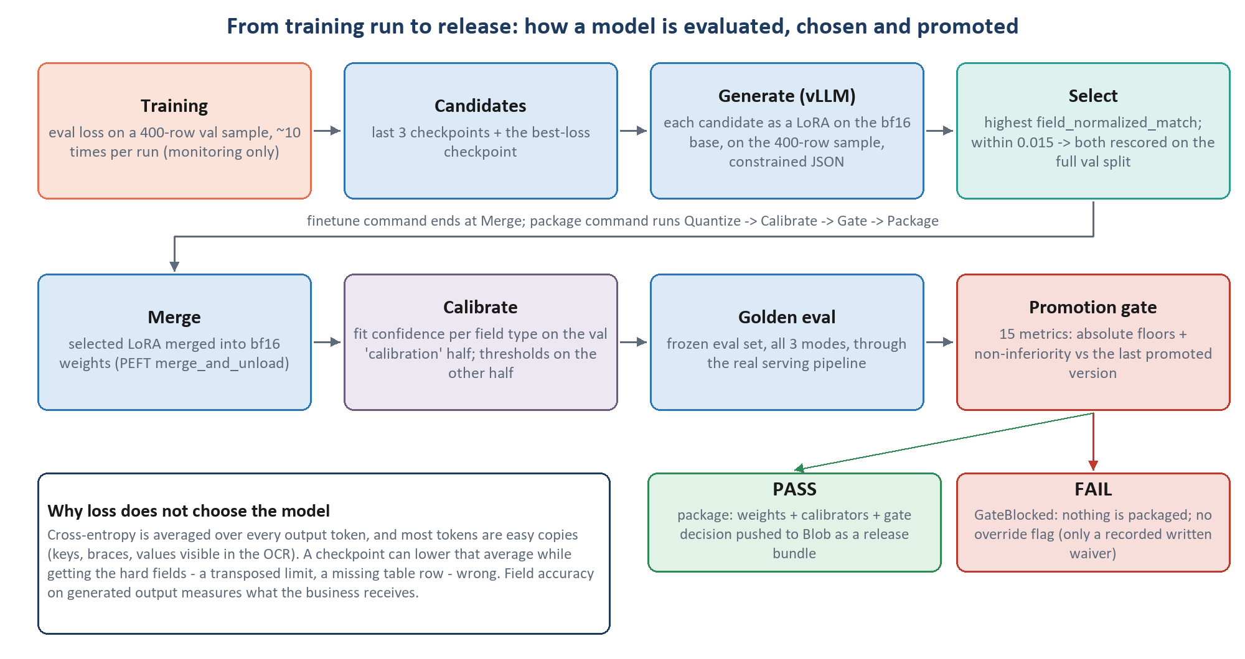
Figure 11. From a finished training run to a promoted release.

16.1 Why training loss does not choose the model
Loss is useful for watching a run (is it learning? is it diverging?), and it is logged. But it is averaged over every output token, and most output tokens are easy: keys, braces, quotation marks, values copied straight from clean OCR. A checkpoint can lower the average while getting the hard fields wrong: a transposed limit, a missing table row, a value under the wrong role. Those are exactly the errors that matter. So 'loss here is for early stopping only and never selects what ships' (unified.yaml:111-115), and load_best_model_at_end is off.

16.2 Checkpoint selection
- Candidates: the last 3 evaluation checkpoints plus the best-loss checkpoint (from trainer_state.json).
- Generate: each candidate is loaded in vLLM as a LoRA on the bf16 base (no merge needed) and answers the 400-row validation sample, in batches of 32, with the same constrained decoding as serving.
- Score: with the gate's own scorer; the metric is field_normalized_match. Unusable JSON counts as wrong answers; a pass is refused if more than 10% of rows fail to generate or more than 50% are unusable.
- Tie-break: if the top two are within 0.015, both are rescored on the full validation split. Exact ties go to the later step.
- Record: the choice, and whether loss and field accuracy disagreed, go to checkpoint_selection.json; the winner is merged.

16.3 The metrics
Table 39. Evaluation metrics (evaluation/run_eval.py, evaluation/metrics/, evaluation/gating.py).
Metric | Definition | Gated
field_normalized_match | share of scalar fields whose value matches gold after normalisation; averaged per document reading, so a 60-window policy counts once | floor 0.85
field_exact_match | the same with raw equality | floor 0.85
field_precision / recall / f1 | precision = right among written; recall = right among gold-filled | reported
list_field_recall | table rows found, matched on identifier keys (claim number, form number, VIN ...) | floor 0.75
field_f1_list_fields | F1 of table rows | non-inferiority
schema_validity_rate | outputs valid against the line's schema | floor 0.98
image_only_accuracy, scanned_accuracy, ocr_arbitration_accuracy | normalised match on the image-only, scanned and noisy-OCR subsets | non-inferiority
lob_detection_accuracy | set-F1 over line-of-business values | floor 0.85
confusable_misattribution_rate | values wrong for their own field but correct for another field (e.g. a deductible written as the limit) | ceiling 0.05
false_null_rate | gold has a value, the model returned nothing | non-inferiority
ece_confidence | expected calibration error of the confidence scores | non-inferiority
auto_accept_error_rate | wrong values among those delivered without a review flag | ceiling 0.02
lossrun_totals_reconciliation_rate | Loss Runs whose claims add up to their printed totals | floor 0.80 (when present)
hallucination_rate, page_selection_recall, list_field_precision | written but not enforced yet | pending

16.4 When is a value 'correct'?
One function, common/normalize.values_match, defines correctness for the gate, checkpoint selection, calibration labels and the test harness. The normaliser is chosen from the field's name:
Table 40. Value comparison (common/normalize.py).
Kind | Chosen when the name contains | Normalisation
date | date, dated, dob | parsed to ISO from 12 formats; two-digit years resolved with a 10-year horizon
currency | premium, limit, deductible, paid, amount, ... | float; symbols and commas stripped; (1,200.00) = -1200; tolerance 0.005
identifier | _number, _no, number | upper-case letters and digits only
entity | _name, carrier, producer, insured | case-folded, & -> and, punctuation dropped, abbreviations expanded, legal suffixes (LLC, Inc) removed
text | anything else | Unicode-normalised, whitespace collapsed, case-folded

- Absent and absent is correct. A field the gold does not state and the model leaves empty is a correct extraction.
- An invented value is wrong. A non-empty value the gold does not state counts against the model; an empty extra costs nothing, which is why the all-keys post-process does not change scores.
- Only the value is scored. Envelopes are collapsed to parsed (else raw); page_ref and confidence are not scored (a page_ref accuracy metric is a listed follow-up).
- Table rows are paired on the first identifier column filled in at least half the gold rows; without one, on all fields.
DEEP DIVE
Expected calibration error. Fields are binned by confidence into 10 equal bins B_b; in each, compare the share actually correct with the average confidence:
ECE = Σ_b ( |B_b| / N ) · | accuracy(B_b) − mean confidence(B_b) |
A perfectly calibrated model has ECE 0: of fields given 0.9 confidence, 90% are right.

16.5 The golden eval set
The release is scored on the frozen golden eval set (section 13.7), never on a build's own test split, which is redrawn on every rebuild. evaluation/golden_eval.py refuses a partly frozen set, checks that no frozen document appears in the corpus's train or validation split, and runs every document in all three modes through the real serving pipeline (serving.pipeline.extract), so routing, windowing, merging, calibration and post-processing are all part of what is measured. A failed extraction is scored as an empty answer, never dropped. Results are reported for the full set and the subsets image_only, scanned, noisy_ocr and long_policy (more than 5 pages), plus a real_only section and the windowing ceiling for reference.

16.6 The promotion gate
evaluation/gating.py decides whether a version may be released. Every applicable gated metric must:
- be measured: an absent metric blocks (absence is not success); a few are conditional on the eval set containing the relevant documents, such as Loss Run reconciliation;
- meet its absolute floor (table in section 2.6);
- be non-inferior to the last promoted version of the same scope: not worse by more than a per-metric margin δ, for example 0.010 for normalised match and list recall, 0.005 for schema validity and auto-accept error, 0.015 for the subset accuracies;
- and at least one primary metric (field_normalized_match or list_field_recall) must improve with its confidence-interval lower bound above zero, or the release must name a defect it fixes. A first release is exempt.
The confidence intervals come from a paired bootstrap: resample the eval documents with replacement 10,000 times (seed 42), recompute candidate minus current each time, and take the 2.5th and 97.5th percentiles. Non-inferiority then means the interval's lower bound is above -δ.
WHY WE CHOSE THIS
There is no override flag. The only exception is a recorded written override: a named approver (not 'system', 'ci' or similar), a reason of at least 20 characters, and the list of waived gates. It lifts only gates that actually failed and is stored with the release, which then reads 'PASS (with N waived gate(s))'. Gate blocks are never retried automatically, and package independently refuses a version whose recorded decision did not pass.

16.7 Calibration: a confidence for every field
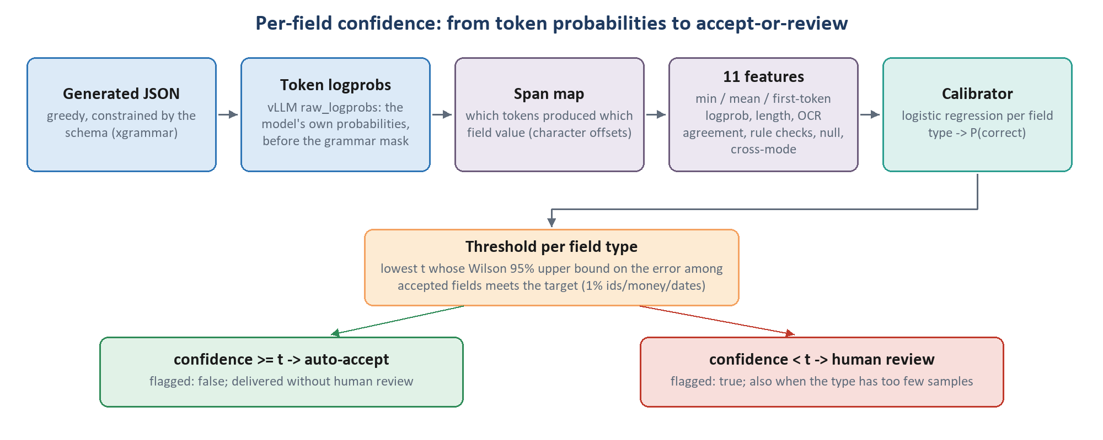
Figure 12. From the model's token probabilities to an accept-or-review decision per field.
A served value is only useful if we know when to trust it. The repo turns the model's own token probabilities into a calibrated probability that the field is correct:
- vLLM returns each generated token's log-probability in raw_logprobs mode, the model's own probabilities before the grammar mask (asserted at engine start, since grammar-masked probabilities would be meaningless).
- inference_core/span_map.py maps tokens to fields by character offsets in the JSON.
- calibration/features.py computes 11 features per field: minimum, mean and first-token log-probability; log of the token count; whether the printed value appears in the OCR of the pages shown (absent in image-only); rule checks (start before end date, totals equal the sum of rows, identifier shape); whether the value is null; cross-mode agreement.
- A logistic regression per field type (identifier, money, date, number, entity, address, enum, free text) maps the features to P(correct), fitted on the validation 'calibration' half; a type with fewer than 300 examples gets no calibrator and all its fields go to review.
- A threshold per field type is chosen on the other half (section 16.8). Fields at or above it are delivered with flagged: false; below it, flagged: true for human review.
P(correct) = σ( w_type · f + b_type ) σ(z) = 1 / (1 + e^(−z))

16.8 Auto-accept thresholds: a promise backed by evidence
For each field type the threshold is the lowest t on a 0.50-0.99 grid such that at least 30 fields are accepted and the Wilson 95% upper bound on the error rate among accepted fields is within the target:
Table 41. Error targets per field type (calibration/thresholds.py:45-53).
Field type | Maximum error among auto-accepted fields
identifier, money, date, number | 1%
enum | 2%
entity, address | 5%
free text | never auto-accepted

Table 42. What a target costs in evidence (calibration/thresholds.py:59-72).
Accepted fields, all correct | Wilson 95% upper bound on their error rate
100 | 3.7%
200 | 1.9%
300 | 1.3%
400 | 0.95%

The second table is the sobering part: even a perfect run on 200 fields cannot support a 1% promise. 'A 1% guarantee needs roughly 400 clean auto-accepted fields of that type', so at pilot volume identifiers, money and dates route everything to review. 'That is the system working: the alternative is a promise the evidence does not support.' The gate then checks the promise end to end: auto_accept_error_rate on the golden set must be at most 2%.

16.9 The pilot protocol
Table 43. Pilot protocol (SPEC_15; pilot/).
Experiment | What | Pass / decision
A: zero-shot baseline | the untuned base model on 10 documents per type | > 0.70 proceed; 0.40-0.70 proceed with targeted data; < 0.40 fix prompt and schema first
B: smoke test (overfit) | 5 documents per type, 5 epochs, lr 2e-4, no validation | loss < 0.05 within 2 epochs, train-set F1 > 0.95, all 7 pipeline components pass
C: pilot run | a real training run at pilot scale | field F1 > 0.80, list recall > 0.75, image-only gap < 15%, LoB > 0.85, misattribution < 0.05, and more, each with a diagnosis path

python -m pilot.pilot_report reports incomplete until all three have written a report, no_go if anything blocks, and go otherwise. Each experiment explains the next one's failures: an overfit test that fails points at the pipeline, not the data.
CURRENT STATUS
- No experiment has run; no accuracy is recorded (testing/metrics/ is empty; no pilot reports).
- The gate's bootstrap is implemented but the pipeline stage does not pass per-document scores yet, so in practice non-inferiority is a point comparison and the improvement rule is skipped with a warning.
- There is no command-line flag for recording a written gate override yet.
- MLflow tracking is written but not called; the run manifest in Blob is the record of each run.
- orchestration.run extract and the zero-shot baseline both stop with 'needs a live model backend' until a GPU backend is wired, so Experiment A cannot run yet.

17 After training: merge, package, serve
A trained adapter becomes a release: merged weights, calibrators and a gate decision in Blob. Serving then uses exactly the prompt, image budget and decoding rules the model was trained and calibrated with.

17.1 Merge and formats
training/merge.py loads the base in bf16 on the GPU, applies the selected checkpoint with PEFT, calls merge_and_unload() and saves 5 GB safetensors shards with the processor, written to a .partial folder and renamed when complete. The merge stays in bf16 ('not fp16 ... FP8 is quantized from this artifact').
Table 44. Serving formats (postprocessing/quantize.py, quant_thresholds.py). The vision encoder, mergers and LM head are never quantised.
Format | Status | Allowed accuracy change vs bf16
bf16 | cycle 1: the only served format | -
FP8 (W8A8) | planned default from cycle 2, after the Phase 0 spike verifies it | exact match -0.5 pp; names -1.0 pp; ECE +0.01
AWQ INT4 | only for constrained serving | exact match -1.0 pp; names -2.0 pp; ECE +0.02
GGUF | edge export only (targets llama.cpp, not vLLM) | -

17.2 The serving pipeline
- Route the request to a release (the narrowest release covering the document's type and line wins); low classifier confidence is flagged, not guessed.
- Generate. A canonical policy is always read in windows planned by the same function used for training, run as one vLLM batch and merged; other long documents are page-routed into one interleaved call.
- Decode greedily (temperature 0), with xgrammar enforcing the JSON schema (whitespace disabled, page_ref bounded), up to 8,192 new tokens in a 32,768-token context, at the training pixel budget.
- Confidence: span mapping, features, calibrator and thresholds as in section 16.7; row-count checks flag incomplete tables.
- Envelope: add confidence and flagged; system fields such as source_file_name and page_count are added deterministically at confidence 1.0.
- Validate against the client's full schema (strict by default).
- Complete the keys: with_all_keys adds every schema key the model did not emit, as an empty envelope (raw: null, parsed: null, confidence 0.0, page_ref: [], flagged: false), every missing object with its keys, and missing tables as []. Row counts are not padded.

17.3 One base, several adapters
With one release, vLLM serves its merged model. With several (for example separate scopes or versions), vLLM loads the bf16 base with LoRA enabled (max_loras: 4, max_lora_rank: 64) and applies each release's adapter per request: one LoRA per request, which is exactly why the unified-adapter design was needed (section 9.6).
CURRENT STATUS
Open: where serving-time OCR runs. The endpoint does no OCR; requests carry page texts, which must come from MinerU at the corpus pin, on a GPU. MinerU cannot share an environment with vLLM 0.11, so it cannot simply be added to the serving worker. Training is unaffected.

18 Status, open items and recommendations
Where the project stands on 4 October 2026, what must be settled before the long training run, and which gaps between the documentation and the code are worth closing.

18.1 Build status
Table 45. From the README. 'Phases 1-10 prove the plumbing. They do not prove the model works.'
Phase | Scope | State
0 | Infrastructure and dependency spike on the GPU | pending
1-9 | Contracts and configs, Blob I/O and registry, ingestion and OCR, inference core, labelling and corpus builder, training, evaluation and calibration, merge/serving/harness, orchestration and CI | done
10 | Pilot validation protocol | built; runs when the corpus is ready

18.2 Before the long training run
Pre-training work is parked until the new training set is delivered (2 October 2026). When it arrives, the agreed order is:
- Check the new data: prepare_bundles, the label-issue analysis and the windowing check; decide whether it replaces or adds to the current delivery.
- Answer the four open label questions (sent to the labelling team): add document_type_detail to the homeowners, dwelling fire, motorcycle and RV schemas; dwelling fire as one dwelling or a list; Hagerty stated_amount vs agreed_value; total_loss_settlement_basis / garaging_type vs the schema's names.
- Decide the declarations-page rule (about 5,000 values sit on pages the declarations group does not read), after scripts/diagnose_windowing.py --blob on the pod.
- Keep the current window design for this run and measure latency first (merging groups or lowering resolution needs retraining).
- On the pod: confirm xgrammar rejects undeclared keys; run the windowing check with real OCR; take a short smoke run through calibrate, gate and package.
- After training: review field types (configs/field_types.proposed.yaml), the 2% auto-accept ceiling, prefix caching, FP8, sweeps, a page_ref accuracy metric.

18.3 Recommendations from this review
GENERAL ML CONTEXT (NOT A REPO DECISION)
These are this document's suggestions, drawn from reading the code; they are not recorded decisions in the repo.

- Run the Phase 0 spike and Experiment A first. The zero-shot baseline is the yardstick for every later claim, and it costs no annotation.
- Make the noisy-OCR table corruptions work on HTML tables (section 13.2); otherwise a third of the arbitration training signal quietly turns into character noise.
- Add field descriptions. The prompt tells the model 'each field's description in the schema is its definition', but the canonical schemas carry almost none (a strict-xfail test tracks the missing schemas/descriptions/). Glosses are prompt text, so add them before the corpus build: changing them later forces a rebuild and retrain.
- Wire the paired bootstrap into the gate stage so non-inferiority and the improvement rule are enforced as designed.
- Before any rank-128 sweep, set use_rslora in phase3_rank.yaml and raise vLLM's max_lora_rank.
- Resolve de-identification (text and images together) before any production data enters a corpus.

Appendix A Glossary
Term | Meaning
Adapter (LoRA) | the pair of small matrices A and B added beside a frozen weight; the only trained part of our model.
AdamW | optimizer that keeps running averages of each gradient and its square; 'W' = decoupled weight decay (0 here).
α (alpha) | LoRA scaling numerator; the update is multiplied by α/r (128/64 = 2).
Autoregressive | generating one token at a time, each conditioned on all previous ones.
bf16 | bfloat16: 16-bit floating point with fp32's exponent range; our training and serving precision.
Bootstrap (paired) | re-sampling eval documents with replacement to get a confidence interval for a difference between two models.
Calibration | mapping raw model scores to probabilities that match observed accuracy.
Causal mask | prevents a token from attending to later tokens; makes the decoder a left-to-right generator.
Checkpoint | a saved snapshot of the adapter (and optimizer state) during training.
Cross-entropy | the training loss: minus the log-probability the model gave the correct next token.
DDP | distributed data parallel: one model copy per GPU, gradients averaged each step.
DeepStack | Qwen3-VL's injection of intermediate ViT features into the first decoder layers.
DeepSpeed ZeRO | sharding of optimizer state (1), gradients (2) and weights (3) across GPUs; off here.
Effective batch | rows per optimizer step = per-device batch x accumulation x GPUs (8).
Epoch file | one pass over all training documents with that epoch's modality draw; three are used.
Family | a source document and its synthetic twins; the unit of splitting.
FieldValue envelope | {raw, parsed, page_ref} (+ confidence, flagged when served).
Flash-attention | an exact attention algorithm that never materialises the full attention matrix.
Frozen | a weight that receives no updates during training.
GQA | grouped-query attention: 32 query heads share 8 key/value heads.
Gradient accumulation | summing gradients over several micro-batches before one optimizer step.
Gradient checkpointing | storing fewer activations and recomputing them during backward to save memory.
Golden eval set | the frozen set of labelled documents every release is scored on.
Label -100 | PyTorch's 'ignore' label; positions with it contribute nothing to the loss.
LM head | the final matrix mapping a 4,096-d vector to 151,936 token scores.
LoRA | Low-Rank Adaptation: learn ΔW = B·A of rank r beside a frozen W.
Logit / logprob | raw score for a token / log of its softmax probability.
Merge | folding the adapter into the weights: W' = W + (α/r)·B·A.
MinerU | the OCR / layout engine (1.x) producing per-page markdown with HTML tables.
Modality mode | ocr_plus_image, noisy_ocr_image or image_only.
ms-swift | ModelScope's fine-tuning framework; our trainer (swift sft).
NF4 / QLoRA | 4-bit NormalFloat storage of the frozen base; LoRA trained on top.
Non-inferiority | 'not worse than the current release by more than δ'.
Padding-free | batching rows end to end without pad tokens.
page_ref | the pages a value was read from, as given by <page N of M> markers.
PEFT | Hugging Face's parameter-efficient fine-tuning library (implements LoRA).
Rank (r) | inner dimension of the LoRA update; 64 here.
Residual stream | the 4,096-d vector per token to which each block adds its output.
RMSNorm | normalisation by root-mean-square, applied before attention and MLP.
RoPE / MRoPE | rotary position embeddings; multimodal variant with time/height/width parts.
rsLoRA | rank-stabilised LoRA: scale by α/√r instead of α/r.
SFT | supervised fine-tuning on input-output examples.
SwiGLU | the gated MLP: down(SiLU(gate(x)) ⊙ up(x)).
Teacher forcing | training on the whole correct answer at once, predicting every next token in one pass.
Token | a unit of text (or an image patch group) the model reads.
ViT | vision transformer: the image encoder (27 layers in Qwen3-VL-8B).
vLLM | the high-throughput inference engine used for selection, calibration, evaluation and serving.
Visual token | one merged 32x32-pixel image region, a 4,096-d vector in the decoder.
Window | one section group over a set of pages; one training row and one serving call.
Wilson bound | a confidence interval for a proportion that behaves well at small counts.
xgrammar | the structured-decoding backend that constrains output to the JSON schema.

Appendix B Key numbers
Area | Number | Value
Model | parameters (total / trainable) | about 8.77 B / 174.6 M (2.0%)
Model | decoder layers, hidden, heads (Q/KV), MLP | 36, 4,096, 32/8, 12,288
Model | ViT layers, width, patch, merge | 27, 1,152, 16 px, 2x2 (32 px per token)
Model | DeepStack ViT layers | 8, 16, 24
Model | vocabulary | 151,936
Images | max / min pixels per page | 2,483,200 / 200,704
Images | visual tokens per page (max / US Letter / A4) | 2,425 / 2,408 / about 2,240
Sequence | max length; answer reserve decl / schedule | 32,768; 4,096 / 8,192
LoRA | rank, alpha, dropout, targets | 64, 128, 0.10, 7 projections x 36 layers
Training | lr, warm-up, schedule, optimizer | 1e-4, 10 steps, cosine, AdamW (wd 0, clip 1.0)
Training | effective batch, epochs, seed | 8, 3 passes, 42
Training | step time; full run on one H200; peak memory | about 51 s; about 35 h; 99 GB
Data | bundles (train / val / test) | 1,702 (1,329 / 186 / 187)
Data | originals; families; carriers; lines | 152; 156; 23; 7
Data | modality mix | 50 / 20 / 30%
Data | windows per document; windowing recall ceiling | 5.4; 96.07%
Data | values outside the schema | 21.7%
Evaluation | validation sample; selection tie margin | 400 rows; 0.015
Evaluation | frozen set minimum; bootstrap resamples | 150 docs per type; 10,000
Evaluation | floors: normalised match, list recall, schema validity, auto-accept error | 0.85, 0.75, 0.98, <= 0.02
Calibration | min examples per field type; threshold sample | 300; 30 accepted fields

Appendix C Where each setting lives
File | Controls
configs/base_model.yaml | model id and revision pin, local weights path, bf16 vs 4-bit, attention implementation, train_vit
configs/training/unified.yaml | LoRA, optimizer, schedule, batch, memory flags, evaluation cadence, line balance, GPUs
configs/shared/vision.yaml | pixel budgets per task (read by corpus build, training and serving)
configs/shared/sequence.yaml | sequence and answer caps per task
configs/schema_sections.yaml | section groups for windowing and the declarations-page rule
configs/scopes.yaml | training scopes (unified, policy, lossrun, personal_lines)
configs/canonical schema/LOB Schema/ | the client's canonical schemas (read-only)
configs/inference/vllm_serving.yaml | decoding, logprobs mode, LoRA limits, serving caps
configs/deepspeed/zero2.json, zero3.json | optional DeepSpeed configs (off by default)
configs/sweeps/*.yaml | deferred hyperparameter sweeps
common/constants.py | modality modes and mix, split ratios, review threshold, special tags
prompts/*.jinja | system prompt and per-document-type guidance
training/train.py | builds and launches the ms-swift command; pre-launch checks; checkpoint cadence
training/stage_data.py, length_check.py, data_collator.py | staging, length check, masking check
training/merge.py | LoRA merge
data_pipeline/dataset_builder/ | corpus build: splits, modes, noise, windows, caps
evaluation/ | metrics, checkpoint selection, golden eval, gate, bootstrap
calibration/ | features, calibrators, thresholds
serving/pipeline.py | the extraction pipeline used in serving and the golden eval
orchestration/run.py, pipeline_dag.py | the operator commands and the 13 stages

Appendix D Operator commands
# laptop: prepare and audit the delivery
python -m data_pipeline.ingestion.prepare_bundles --input "data/training data" --out data/bundles
python -m data_pipeline.ingestion.fill_synthetic_labels --input "data/training data" --apply
python -m data_pipeline.audit
azcopy sync "D:\Fine-Tuning\data\training data" "https://<account>.blob.core.windows.net/<raw>/intake/personal-v1?<SAS>" --recursive

# pod: set up, pull, import, OCR, check
bash scripts/pod_bootstrap.sh
python -m data_pipeline.ingestion.import_labeled_pdfs --from-blob personal-v1 --doc-type policy
/workspace/venv-ocr/bin/python -m data_pipeline.ocr.run_mineru --doc-type policy --all-unprocessed
python -m data_pipeline.ocr_check --doc-type policy

# pod: prove the path, then train
python -m orchestration.preflight --scope personal_lines
python -m orchestration.smoke_run --batch <batch> --train-sources N --tenant <new> --version <new>
python -m orchestration.run finetune --scope personal_lines --skip-ingest --corpus-version v1 --out-version v1
python -m orchestration.run freeze-eval-set --corpus v1
python -m orchestration.run package --version v1 --release-id release-2026.11.1 --formats bf16
python -m orchestration.run extract --model base|v1 --input testing/test_data/

# watching long jobs (they run in tmux on the pod)
bash scripts/pod_run.sh list | status <name> | attach <name> | tail <name>

Appendix E Where the documentation and the code disagree
The README's rule: if the specs and the code disagree, 'that is a bug in one of them - fix the disagreement rather than picking a winner'. These are the disagreements found while preparing this document. The code column is what actually runs.
Table 46. Spec/code disagreements (collected from the training, data and evaluation review).
# | Topic | Documentation says | Code does
1 | Gate bootstrap | 10,000-resample paired bootstrap (arch 15.5) | implemented, but the pipeline stage passes no per-document scores: point comparison only
2 | Gate override | a recorded written override | the record exists; no CLI flag sets it
3 | Gate floors | names/addresses 0.80; image-only within 15%; auto-accept 'reported only' | no separate name floor; image-only via non-inferiority; auto-accept gated at 0.02
4 | Row matching, ANLS | Hungarian matching; ANLS fuzzy match | identifier-key matching; no ANLS
5 | ECE | per field type | one pooled ECE
6 | Sweep phase-1 metric | field F1; loss never selects | eval_loss in phase1_lr.yaml
7 | rsLoRA in rank sweep | on | not set in phase3_rank.yaml; sweep CLI not wired
8 | --train-vit | trains a ViT LoRA (SPEC_06) | refused by train.py
9 | Evaluations per run | at least 5; load best model at end | 10; load_best_model_at_end: false
10 | Early stopping | patience 3 | not passed (ms-swift 3 has no such argument)
11 | GPU count | one H200 | all visible GPUs, data-parallel
12 | Shuffling | within each epoch | across the concatenated epoch files
13 | SPEC_00 targets | projector/merger is a LoRA target; 'foundation + adapters' | decoder only; one unified adapter
14 | Stale constants | LORA_DROPOUT = 0.05, projector comment (common/constants.py) | 0.10 from unified.yaml is what trains
15 | base_model.yaml leftovers | max_seq_len: 8192 (TODO); long-side cap 1,792 | per-task caps up to 32,768; pixel budget
16 | vLLM config leftovers | foundation + per-type LoRA comments | one LoRA per release; max_lora_rank 64 blocks rank 128
17 | Modes | two modes (README) | three, 50/20/30; serving exposes two
18 | Noisy OCR tables | - | table corruptions target pipe tables; MinerU emits HTML
19 | Field descriptions | the prompt relies on each field's description | canonical schemas have almost none
20 | Pages per window comments | decl 7 / arrays 8 / line block 7-8 / dtd 7 | computed 7 / 6 / 5-6 / 3
21 | Pilot vs gate thresholds | pilot field F1 > 0.80; schema validity 100% | gate floor 0.85; schema validity 0.98
22 | Stage boundaries | SPEC_00: gate inside finetune | gate inside package (as SPEC_13)
23 | MLflow | tracking planned | log_to_tracker never called; report_to: none
24 | Counts in specs | 34 schema files, 13-value LoB enum, ~1,460 tests | 33 files, 12 values, 1,800+ tests
25 | CI coverage target | split_train_val_test module | module is split_groups.py

