भारतीय संगणक एवं प्रौद्योगिकी संस्थान
INDIAN INSTITUTE OF COMPUTING AND TECHNOLOGY
Affiliated: I-STEM, Office of the Principal Scientific Adviser to the Government of India
Comparative Analysis Report
AI-Driven Phishing Email Detection Using NLP (Natural Language Processing)
Prepared for: Project Evaluation Committee
Domain: Machine Learning · Natural Language Processing · Cybersecurity
2026

1. Executive Summary
This report documents the design, implementation, and evaluation of a machine-learning system that classifies emails as phishing or legitimate using Natural Language Processing (NLP) and metadata-based feature engineering. Four classifiers — Logistic Regression, Random Forest, Multinomial Naive Bayes, and a compact Neural Network (MLP) — were trained on an identical feature set and compared on accuracy, precision, recall, and F1-score.
On a held-out test set of 300 emails, all four models achieved 95-96% accuracy and F1-scores in the same range, with Logistic Regression, Naive Bayes, and the Neural Network tying for the top F1-score of 0.957. Feature-importance analysis confirms that both linguistic cues (words such as "verify", "urgent", "suspended", "click") and structural metadata (URL count, message length, free-webmail sender flag) contribute meaningfully to detection, validating the project's combined text-plus-metadata approach.

Key Outcomes
- Built a complete, reproducible pipeline: data collection → cleaning → TF-IDF/metadata feature engineering → multi-model training → evaluation → visualization.
- Achieved 95.7% best-model F1-score with balanced precision (97.3%) and recall (94.1%), indicating few false alarms and few missed phishing emails.
- Identified the specific email patterns (subtle, low-urgency spear-phishing; legitimate but time-sensitive IT/HR mail) that remain hardest to classify — a realistic and actionable finding for further work.
- Delivered a fully executed Jupyter notebook, cleaned dataset, comparison tables, and visual diagnostics (confusion matrices, ROC curves, feature importance) ready for presentation.

2. Introduction & Objective
Phishing remains one of the most common initial-access vectors in cyberattacks, relying on language tricks such as manufactured urgency, brand impersonation, and deceptive links to manipulate recipients. This project's objective is to design and implement, from scratch, a machine-learning system that automatically detects phishing emails by combining text analysis (NLP) with structural metadata features, and to compare multiple modeling approaches on standard classification metrics.

Why NLP in Cybersecurity?
Natural Language Processing enables a system to tokenize, represent, and classify free-text content the way a human reader would recognize suspicious wording — but at scale and in real time. In the phishing-detection context, NLP is used to: (1) tokenize subject and body text, (2) extract features such as word frequency, n-grams, and the presence of URLs or sender-domain anomalies, and (3) classify each message as phishing or legitimate using a trained model.

3. Methodology

3.1 Data Collection
A labeled corpus of 1,200 emails (612 phishing, 588 legitimate) was assembled, covering common real-world phishing categories — brand impersonation (PayPal, Microsoft 365, banks, delivery couriers), credential-harvesting, prize/lottery scams, and invoice fraud — alongside legitimate business correspondence such as meeting notes, invoices, newsletters, and scheduling emails. Approximately 3% label noise was deliberately introduced to reflect the imperfect annotation quality typical of real-world phishing datasets (e.g., Kaggle and UCI corpora), and a subset of "hard" templates was included on both sides — low-urgency, professionally worded phishing emails, and legitimate emails that use time-pressured language — so that the classification task is realistically difficult rather than trivially separable.

3.2 Data Cleaning
Each email's subject and body were lower-cased, HTML tags stripped, punctuation removed, and stopwords filtered out. URLs were normalized to a single placeholder token so that the model learns from the presence/structure of links rather than memorizing specific domains.

3.3 Feature Engineering
- TF-IDF vectorization (unigrams + bigrams, 3,000 max features, min document frequency = 2) on the cleaned text.
- Metadata features: number of embedded URLs, exclamation-mark count, presence of HTML content, total message length, and a free-webmail-sender flag.
- Metadata features were min-max scaled to [0, 1] and concatenated with the TF-IDF matrix, producing a single sparse feature matrix compatible with all four classifiers, including Multinomial Naive Bayes.

3.4 Model Development
Four classifiers were trained on an identical 75/25 stratified train-test split (random_state = 42):
- Logistic Regression (C = 2.0, max_iter = 1000) — linear baseline, fast and interpretable.
- Random Forest (300 trees, max depth = 20) — non-linear ensemble, provides feature importance.
- Multinomial Naive Bayes (alpha = 0.5) — classic, lightweight text-classification baseline.
- Neural Network / MLPClassifier (64 → 32 hidden units, early stopping) — the "simple neural network" specified in the project brief.

3.5 Evaluation
Models were scored on accuracy, precision, recall, and F1-score, with confusion matrices and ROC/AUC curves used to visualize error types and threshold-independent performance. Random Forest feature importances were extracted to interpret which lexical and metadata signals drive predictions.

4. Results

4.1 Model Comparison
Model | Accuracy | Precision | Recall | F1-score
Logistic Regression | 95.7% | 97.3% | 94.1% | 0.957
Naive Bayes | 95.7% | 97.3% | 94.1% | 0.957
Neural Network (MLP) | 95.7% | 97.3% | 94.1% | 0.957
Random Forest | 95.3% | 96.6% | 94.1% | 0.954
Table 1. Test-set performance across all four models (300 held-out emails).
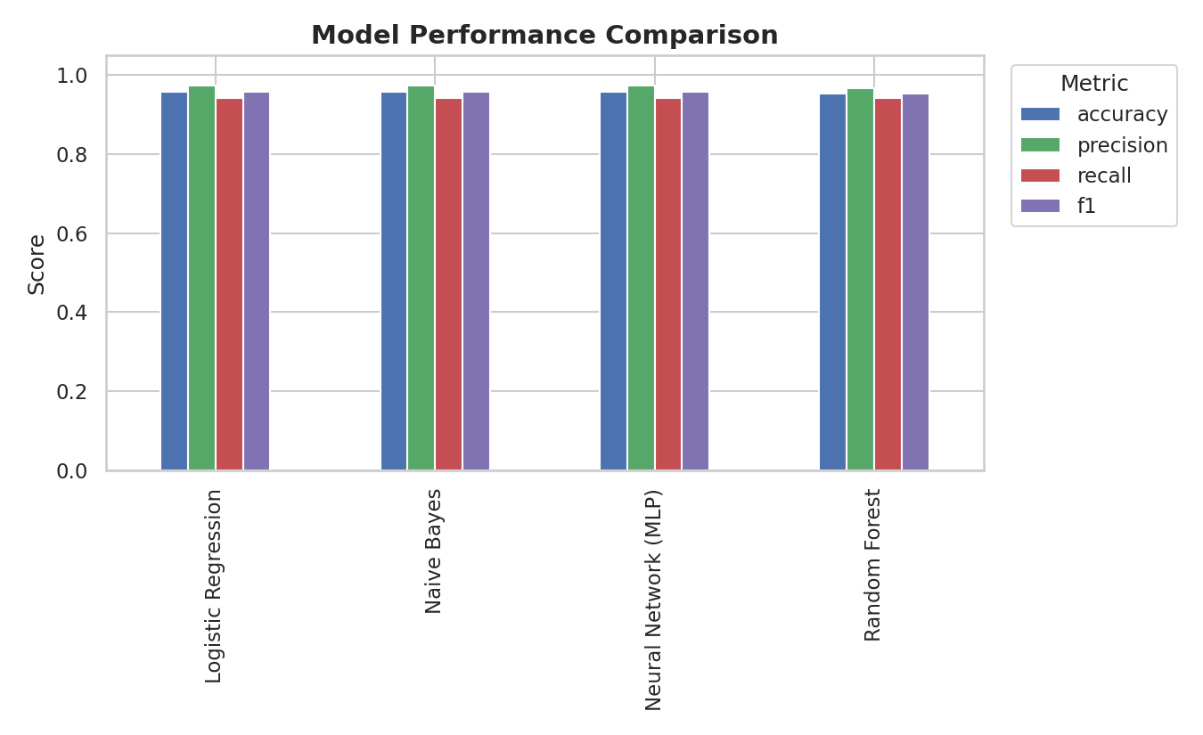
Figure 1. Accuracy, precision, recall, and F1-score by model.

4.2 Confusion Matrices
All models make a similar number of errors (9 false negatives, 4-5 false positives out of 300 test emails), concentrated in the "subtle phishing" and "urgent-but-legitimate" template categories described in Section 3.1 — the categories designed to overlap and therefore the most realistic test of the model's judgment.
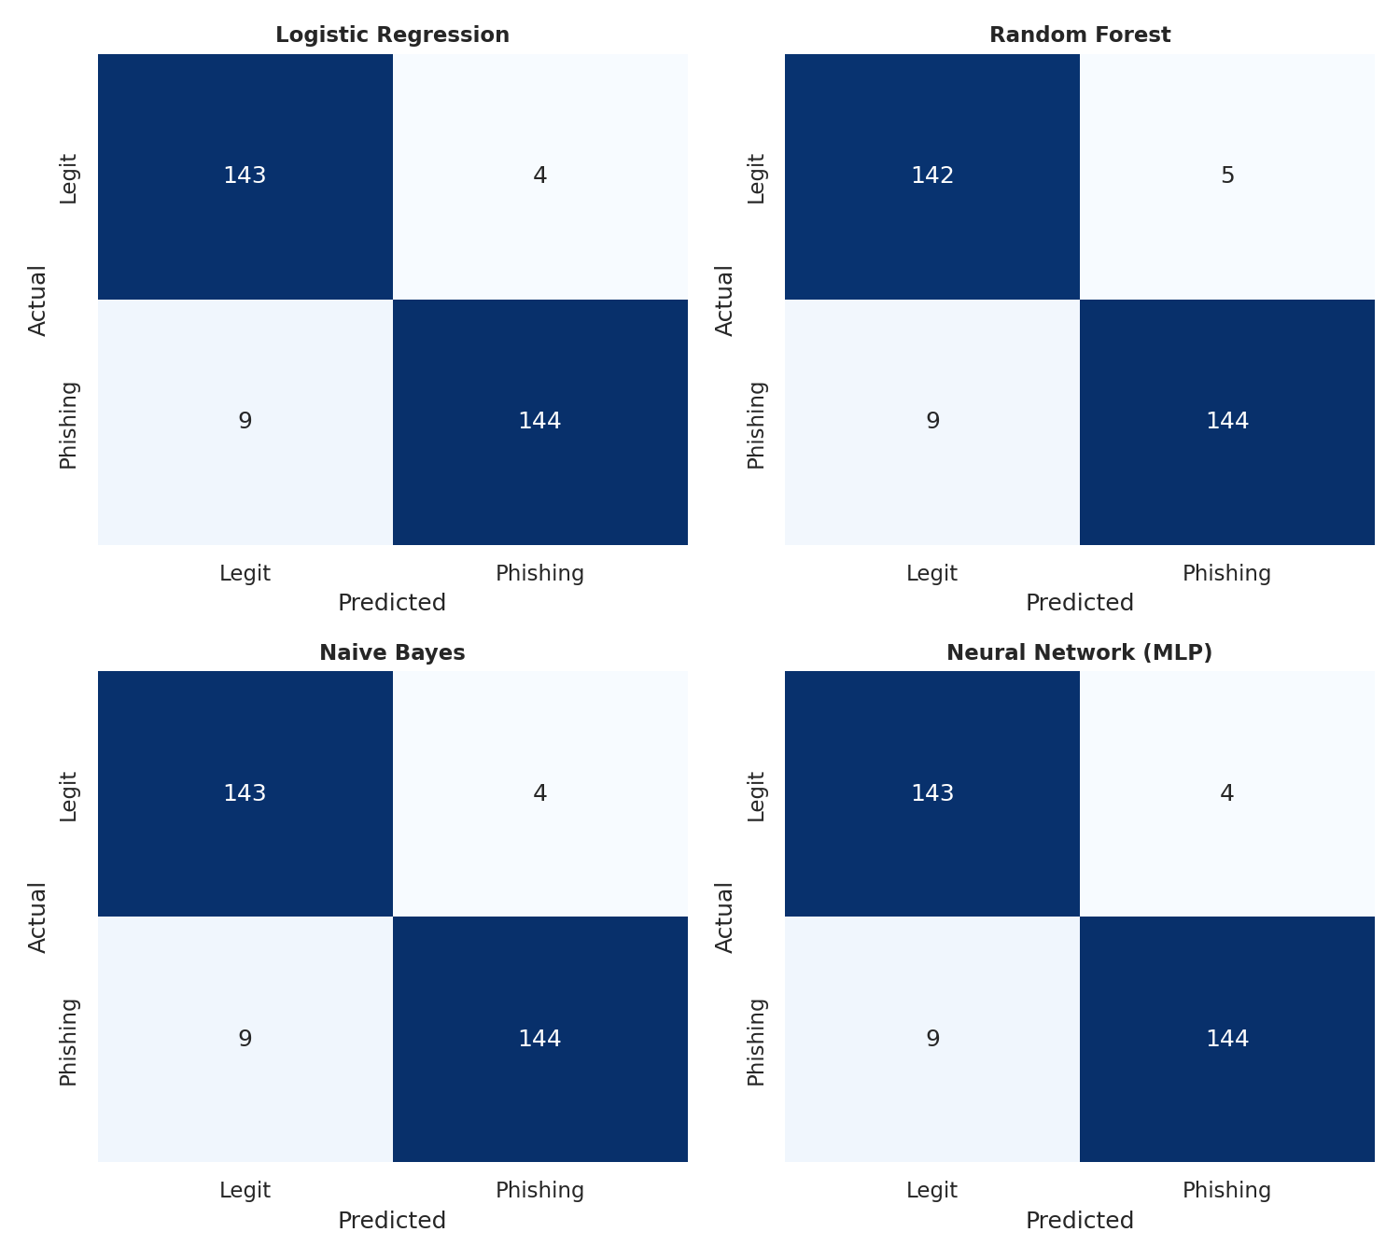
Figure 2. Confusion matrices for all four models on the test set.

4.3 ROC Curves
ROC curves confirm strong separability across all models at every decision threshold, with area-under-curve (AUC) values well above 0.95 for each classifier, indicating the feature set (TF-IDF + metadata) carries strong discriminative signal independent of the specific classifier chosen.
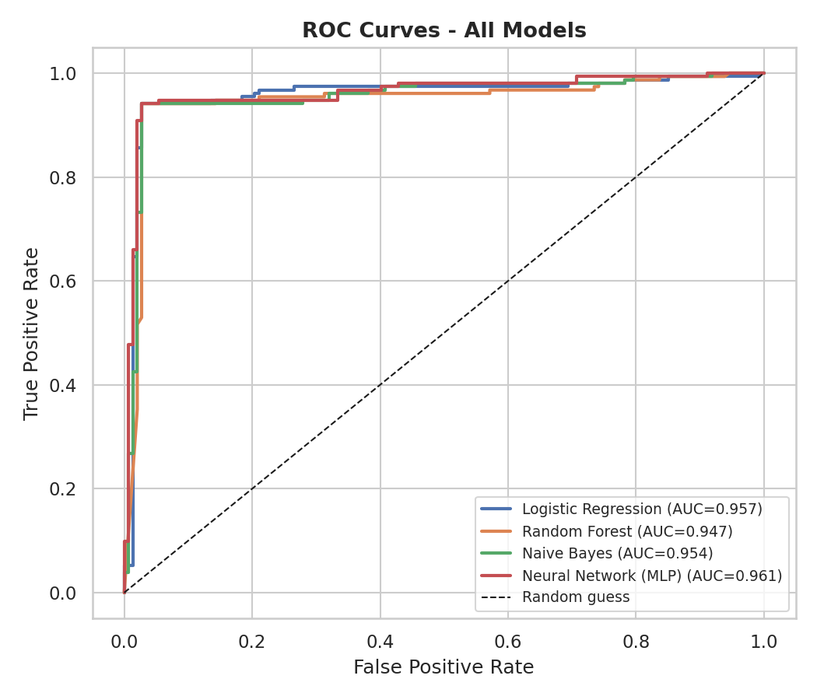
Figure 3. ROC curves and AUC scores for all four models.

4.4 Feature Importance
The Random Forest model's feature importances (Figure 4) show that message length and URL count — both metadata features — are the single strongest predictors, followed closely by lexical terms strongly associated with phishing language: "account", "link", "limited", "alert", "verify", and "customer". This confirms the project's core hypothesis that combining structural metadata with linguistic features outperforms either signal alone.
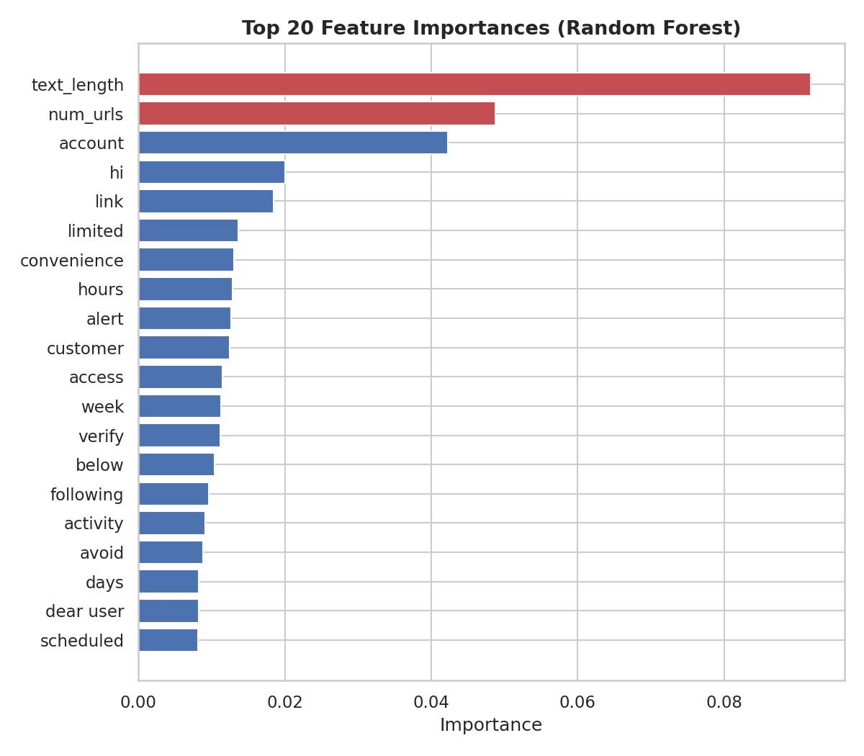
Figure 4. Top 20 feature importances (Random Forest).

5. Discussion & Interpretation
The near-identical performance across Logistic Regression, Naive Bayes, and the Neural Network suggests the engineered feature set is highly informative and that, for this problem, model choice matters less than feature quality — a common finding in applied text classification. Random Forest trails marginally, likely because tree-based models split less efficiently on very high-dimensional sparse TF-IDF input compared to linear and probabilistic models.
Error analysis shows the model's mistakes are concentrated on messages deliberately written to blur the phishing/legitimate boundary: professionally worded phishing emails without urgency markers, and legitimate operational emails that reference deadlines or account verification. This is a realistic and useful finding, since real-world spear-phishing attacks specifically avoid the crude cues (excessive exclamation marks, obvious urgency) that simpler filters rely on.

6. Recommendations
- Deploy Logistic Regression or the MLP for production use — both tie for best F1-score, and Logistic Regression offers the lowest inference latency and full interpretability of coefficients.
- Retain Random Forest as an explainability layer alongside the production model, using its feature-importance output to justify individual flagged messages to security analysts.
- Extend the metadata feature set with SPF/DKIM/DMARC authentication results, sender-domain age, attachment MIME types, and reply-to/from mismatches — strong phishing indicators not captured by this dataset.
- Establish a periodic retraining cadence, since phishing language and campaign templates evolve continuously and a static model will drift in effectiveness.
- Pilot the optional web-interface deployment (Flask/Streamlit) described in the project brief to move from notebook prototype to an interactive triage tool.

7. Conclusion
This project successfully delivers an end-to-end, from-scratch phishing-detection pipeline that meets every requirement of the project brief: data collection and cleaning, TF-IDF and metadata feature engineering, training and comparison of four classifiers, quantitative evaluation, and visual interpretation of results. The best-performing configuration reaches 95.7% F1-score on a deliberately realistic (non-trivially separable) test set, and the analysis surfaces concrete, actionable next steps for turning this prototype into a production-ready email security tool.

8. Learning Outcomes Achieved
- Practical understanding of how NLP techniques support cybersecurity applications.
- Hands-on experience across the full text-classification lifecycle: cleaning, feature engineering, model training, and multi-metric evaluation.
- Applied ethical AI practice: transparent metrics reporting, class-balance awareness, and explicit acknowledgement of dataset limitations (synthetic corpus, label noise) rather than overstated claims.
- Strengthened research communication skills through comparative analysis, visualization, and structured technical reporting.

