PES UNIVERSITY

(Established under Karnataka Act No. 16 of 2013) 100 Ft. Road, BSK III Stage, Bengaluru – 560 085

|  |  |
| --- | --- |
| **Course Title: Computer Networks** | **Course code:UE17CS301** |
| **Semester :5** | **Section: F** |
| **SRN: PES1201802417 PES1201802478**  **PES1201701853** | **Name: AKSHAY KADAM MADHU KS**  **YASH GOEL** |

# ASSIGNMENT REPORT

**TITLE: Online Campus Recruitment System**

DESCRIPTION :

This is a project for computer networks. It is an online campus recruitment system, where student can register by uploading his details like name, registration number, CGPA, mobile phone number through a front end which is residing on the client system.

Once all of this information is uploaded, it will be sent to server machine (i.e. company, acting as a server machine). Now the server will go through all the uploaded details of the students. The company will select the students who meet their eligibility criteria and the server (company) will send an email to the following selected students. Now the interviews can be held offline.

LIST OF MODULES DEVELOPED :

* Student registration form inhtml
* Client file to send data in php using TCP (transmission control protocol)

PES UNIVERSITY

(Established under Karnataka Act No. 16 of 2013) 100 Ft. Road, BSK III Stage, Bengaluru – 560 085

* Server file to receive data in php using TCP (transmission control protocol)
* Student list php file to New studentlist
* Smtp file in php to sendmail

# NETWORKS CONCEPTS USED:

TCP (Transmission Control Protocol) :TCP/IP stands for **Transmission Control Protocol**/Internet Protocol, which is a set of networking protocols that allows two or more computers to communicate. The Defense Data Network, part of the Department of Defense, developed TCP/IP, and it has been widely adopted as a networking stand

Socket Programming: A **socket programming** interface provides the routines required for interprocess communication between applications, either on the local system orspread in a distributed, **TCP**/IP based network environment. Once a peer-to-peer connection is established, a **socket** descriptor is used to uniquely identify the connection.

SMTP: **SMTP** stands for Simple Mail Transfer Protocol. **SMTP** is a set of communication guidelines that allow software to transmit an electronic mail over the internet is called Simple Mail Transfer Protocol. It is a program used for sending messages to other computer users based on e-mail addresses.

INPUT AND OUTPUT:

PES UNIVERSITY

(Established under Karnataka Act No. 16 of 2013) 100 Ft. Road, BSK III Stage, Bengaluru – 560 085

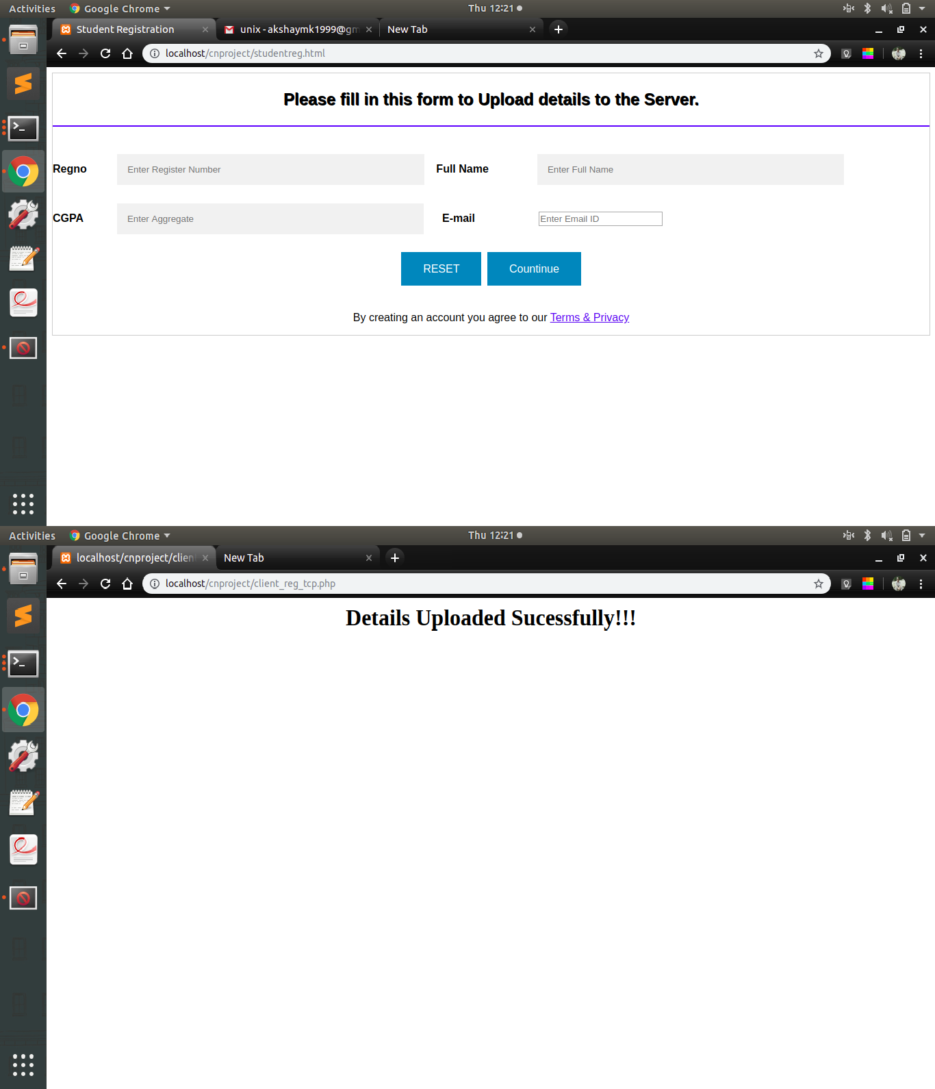

PES UNIVERSITY

(Established under Karnataka Act No. 16 of 2013) 100 Ft. Road, BSK III Stage, Bengaluru – 560 085

