Practical – 10
GitHub Link: https://github.com/Akshaykashyap0121/Node-js-AKSHAY
- Goal: Set up an mTLS server that:
Requires client certificates
Supports certificate reload without restart
- Tasks: Create mtls-server.js that watches cert files and updates TLS context.

Project Structure: mtls-server.js:
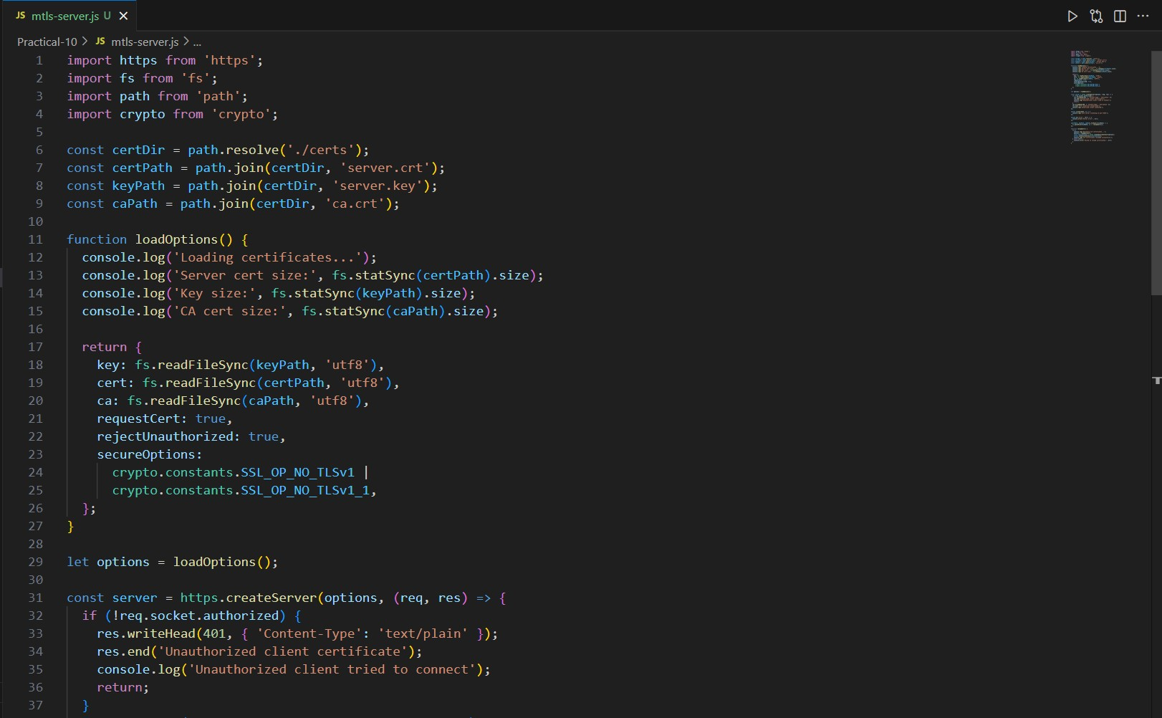
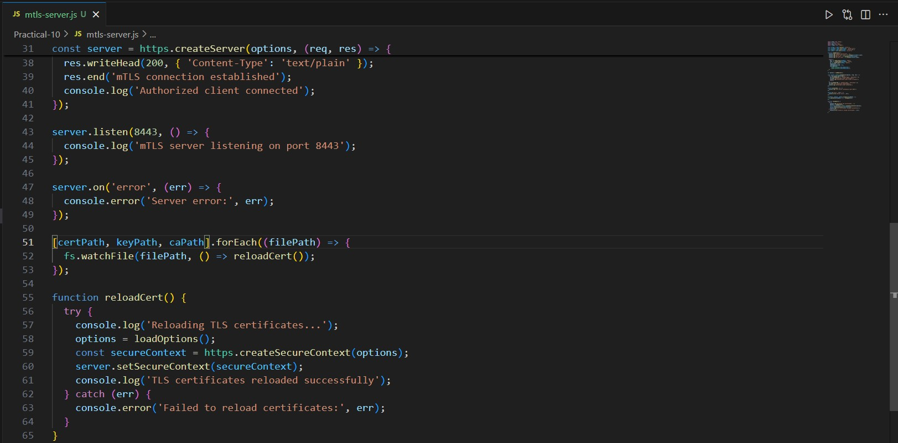
Output:
