Practical – 11

GitHub Link: https://github.com/Akshaykashyap0121/Node-js-AKSHAY
Create the website and track the patterns. If there is redundancy, resolve it using the different path module and if no redundancy, which path module you will be executing and why? Answer with the code and along with your opinion.

Project Structure: app.js:
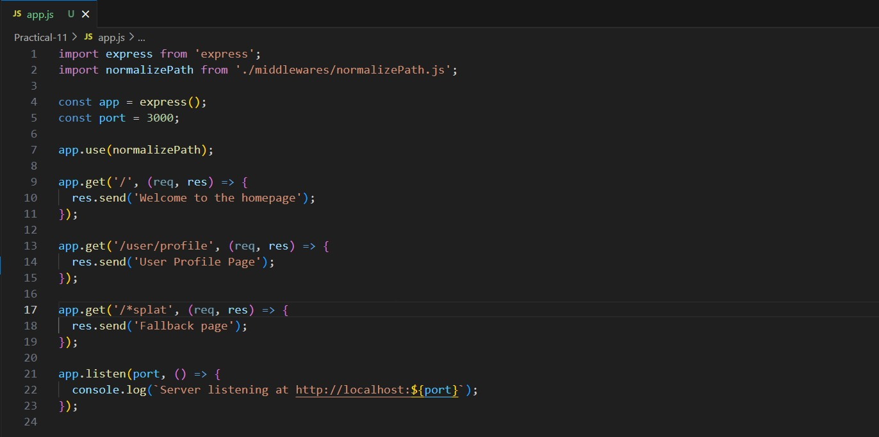

routes/index.js:
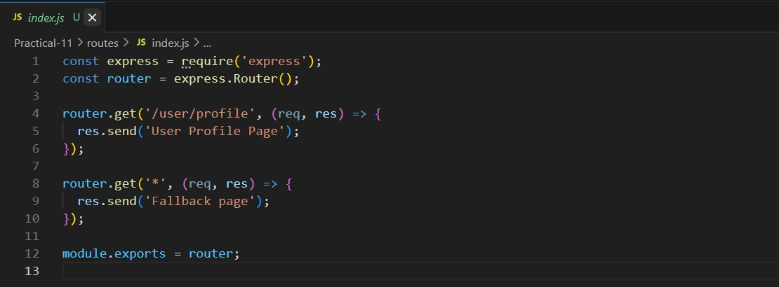
middlewares/normalizePath.js:
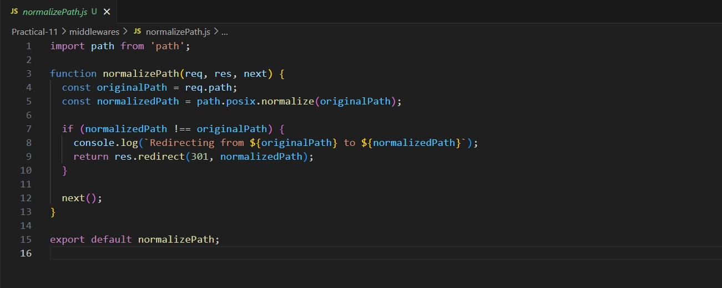
Output:
Terminal:
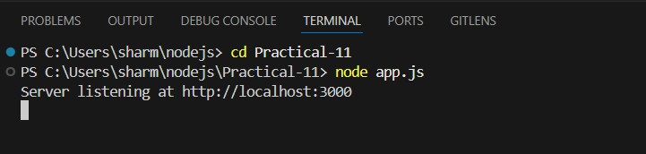
Homepage (localhost:3000):
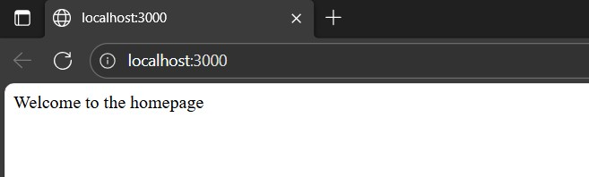

User Profile (localhost:3000/user/profile):
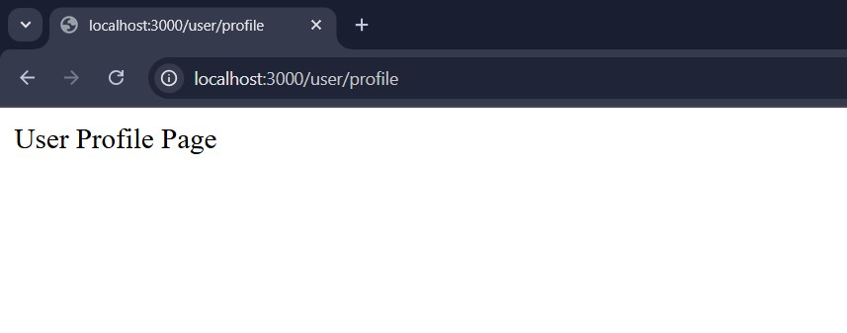

Visiting any undefined route like (http://localhost:3000/random) shows:
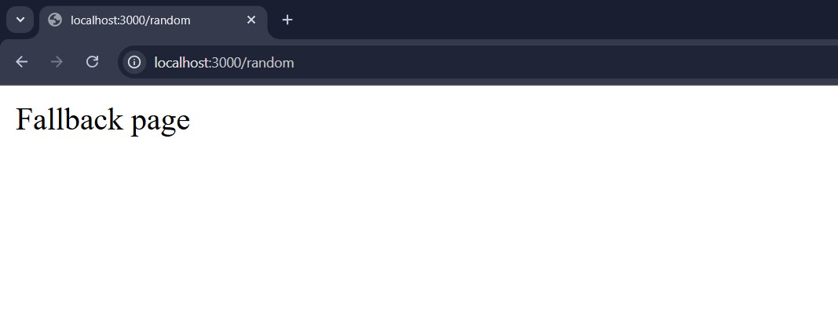
Opinion on Path Module Usage:
- For resolving URL path redundancies, path.posix.normalize() is used as URLs always use POSIX-style forward slashes (/). This method efficiently removes redundant segments like multiple slashes.
- When there is no redundancy, path.posix is used for consistency and crossplatform compatibility since URLs follow POSIX path conventions regardless of the operating system.
- Modules like path.resolve() are mainly for filesystem paths and can produce incorrect results for URLs, so avoid them for URL path manipulation.

Explanation:
- The Node.js path module is a built-in utility that handles file and URL paths, abstracting differences between Windows and Unix-style separators.
- The path.posix variant provides POSIX-compliant path functions suitable for URLs, ensuring consistent forward-slash use.
- The middleware uses this to normalize every incoming URL path, redirecting redundant URLs to their canonical form, improving SEO and user experience.

