Practical – 12

GitHub Link: https://github.com/Akshaykashyap0121/Node-js-AKSHAY

Goal: Build a robust middleware stack with:
- X-Request-Id correlation
- High-precision timing
- Body size limits and JSON parse safety
- CORS (locked down to a whitelist)
- Per-route schema validation
- Centralized error handler returning RFC-7807 “problem + json”
- A simple endpoint to prove ordering works Constraints:
- No unhandled rejections; async errors must hit the error handler. • All responses include X-Request-Id and X-Response-Time-ms

Project Structure: app.js:
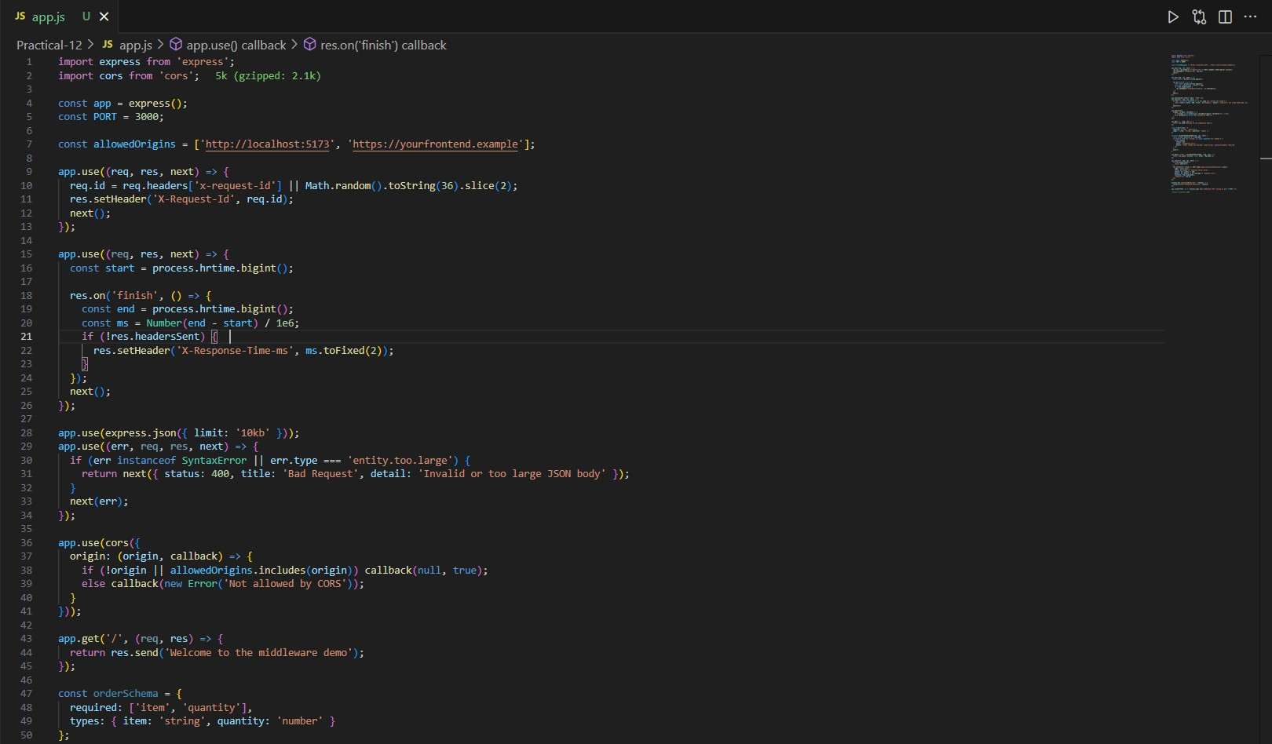
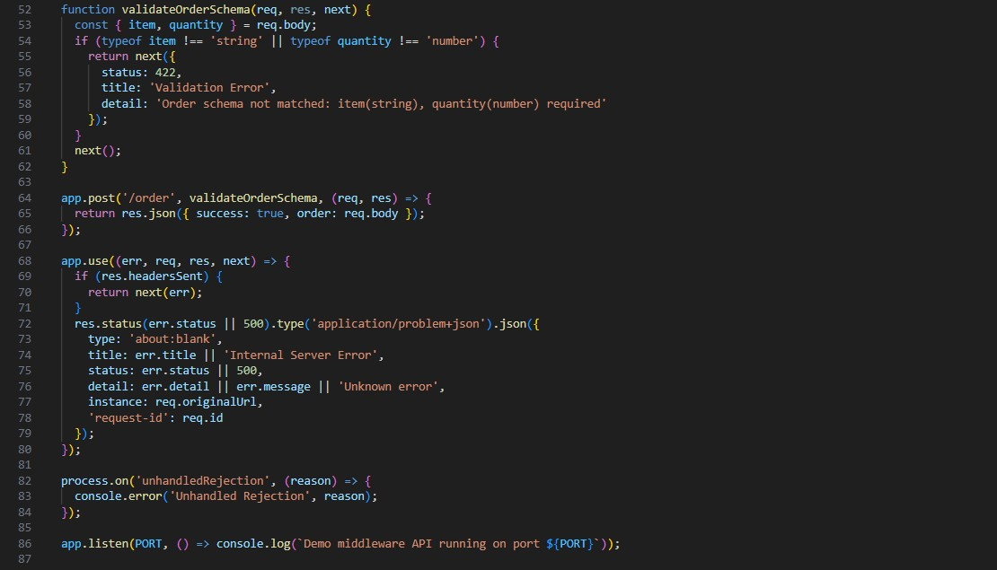
Output:
