Practical – 13

GitHub Link: https://github.com/Akshaykashyap0121/Node-js-AKSHAY

Task 1: Streaming & Backpressure + Client Abort-Aware Middleware
Goal: Implement a streaming endpoint producing NDJSON. If a client disconnects, the middleware must stop work.
Task 2: Content Negotiation Middleware (JSON vs. XML)
Goal: Return JSON or XML based on Accept header with a reusable negotiate middleware.

Project Structure: app.js:
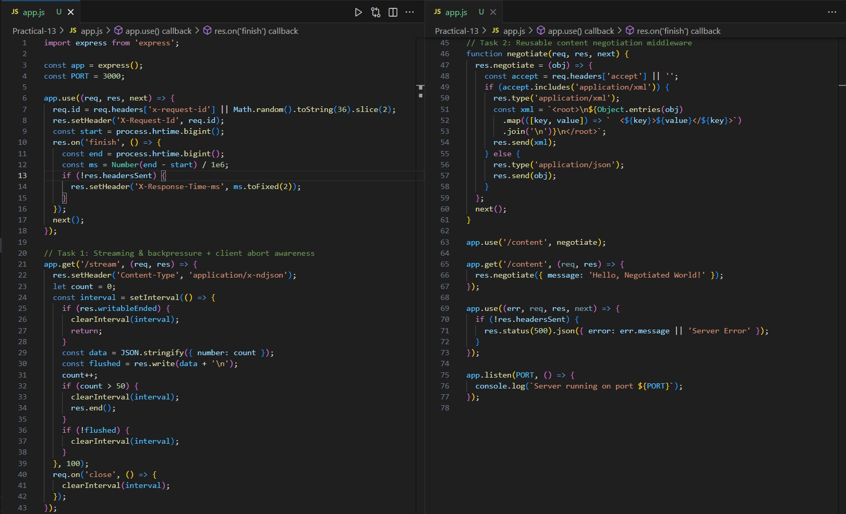
Output:
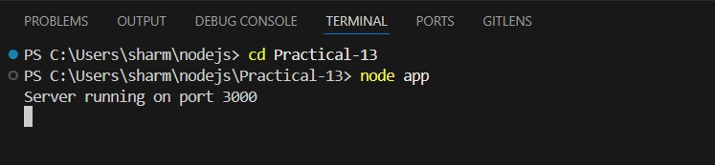
Task 1:
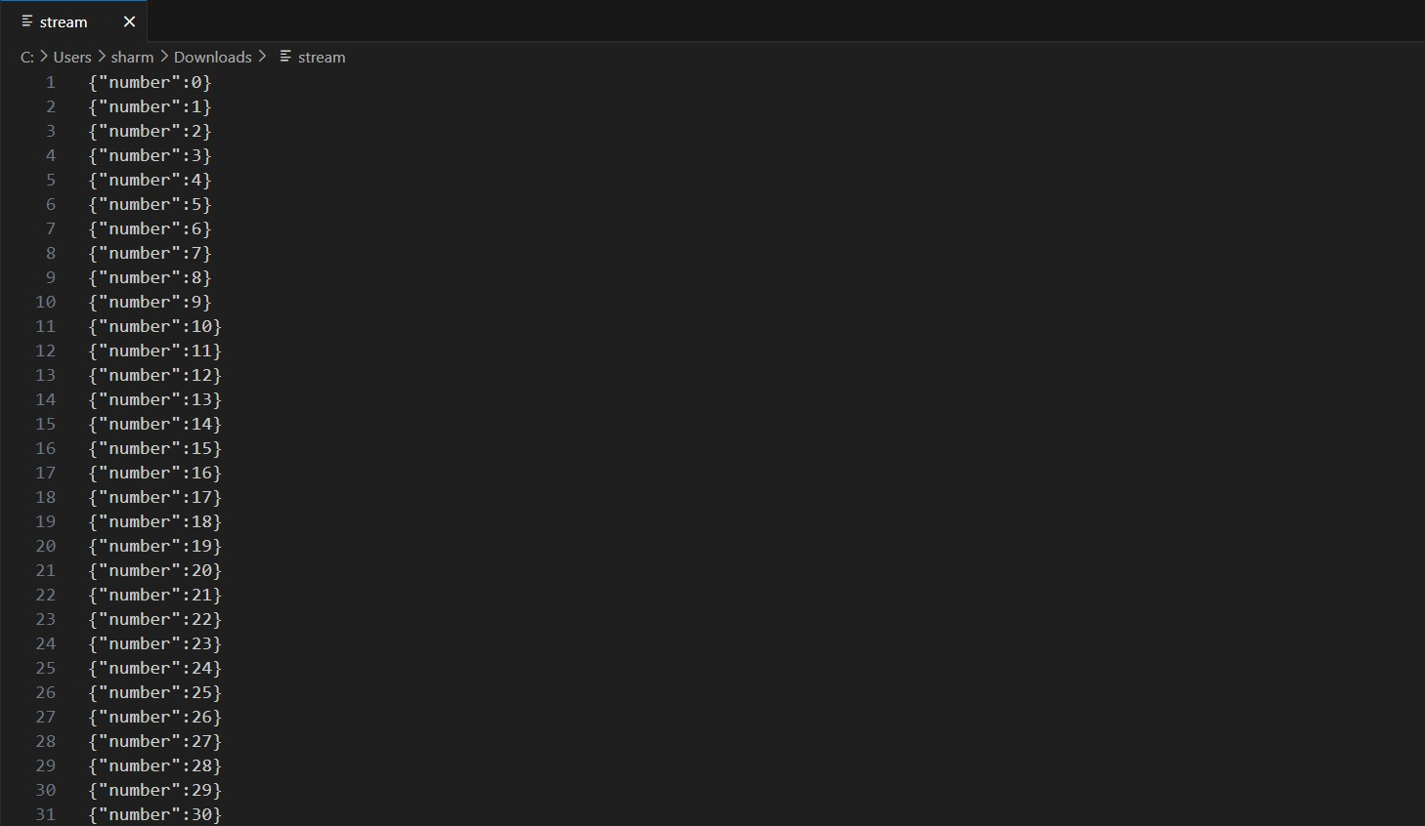
Task 2:
