Practical – 14

GitHub Link: https://github.com/Akshaykashyap0121/Node-js-AKSHAY
Task:
Implement DDL, DCL and DML languages in Mongo DB.

Project Structure:

Playground-1.mongodb.js:

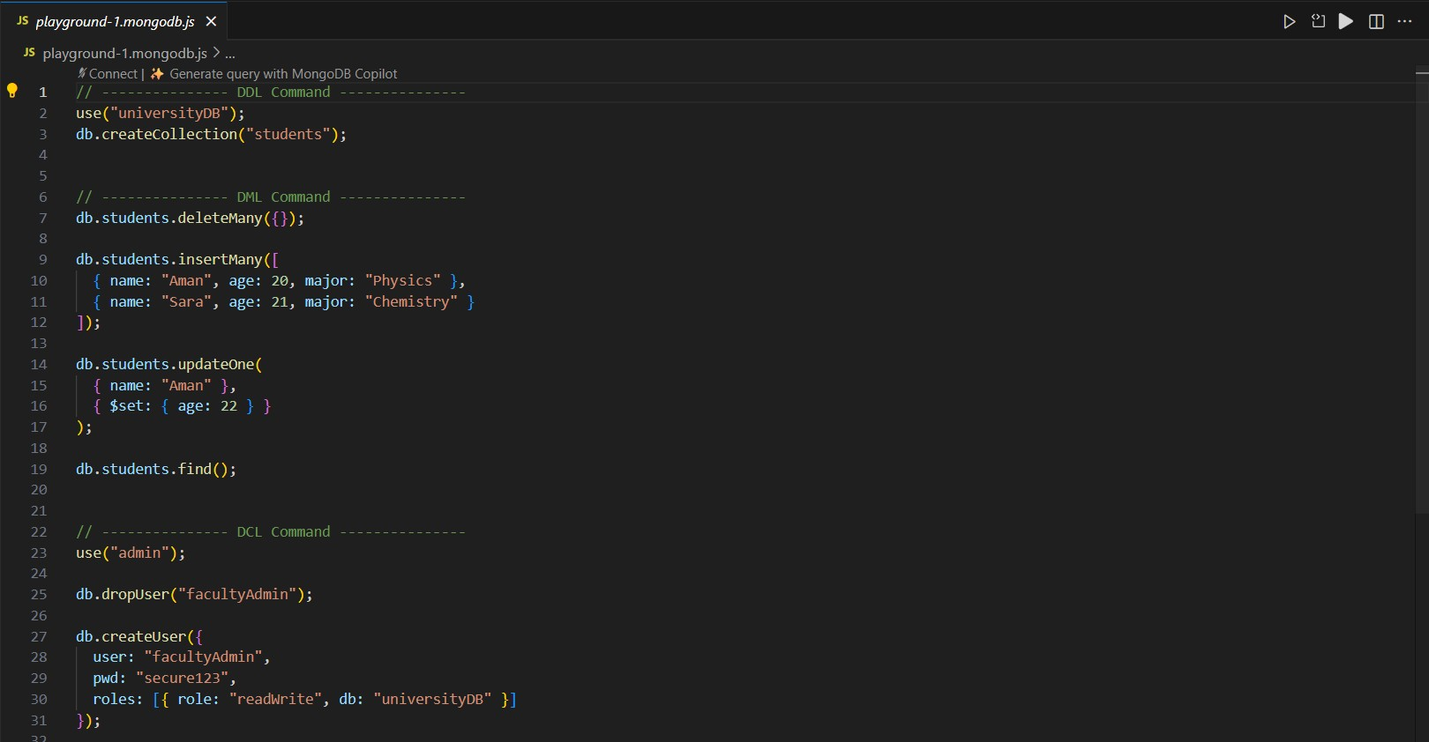
Output:
