Practical - 4
GF202349106 AKSHAY
Build a simple to do API to do node.js with:
Post/todos – add to todos
Get/todos -list todos Code:
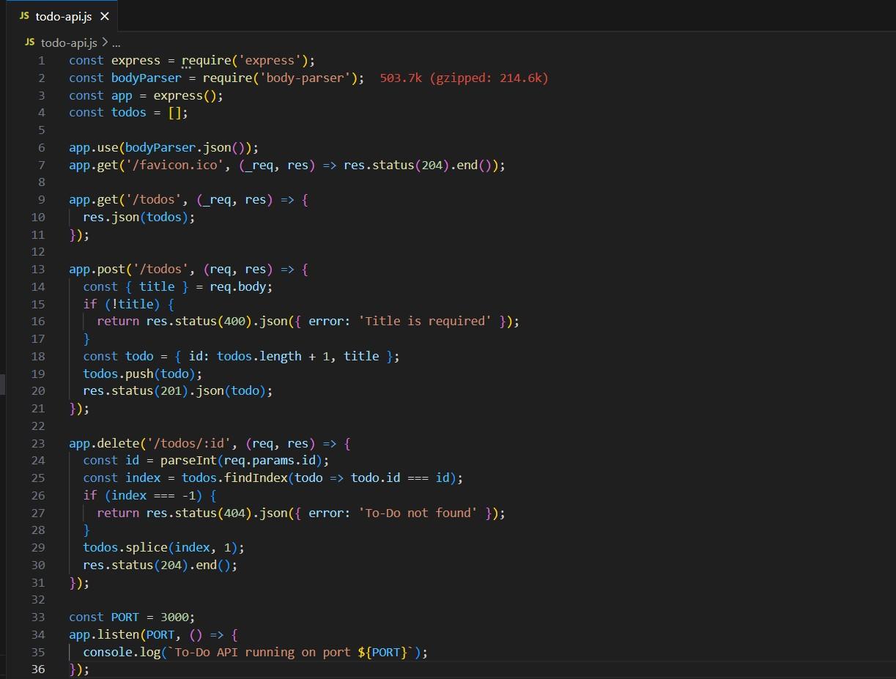
Output:
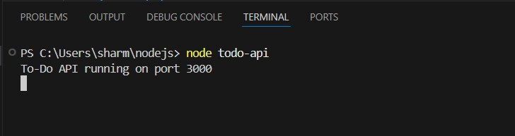
Add a To-Do Item (POST):
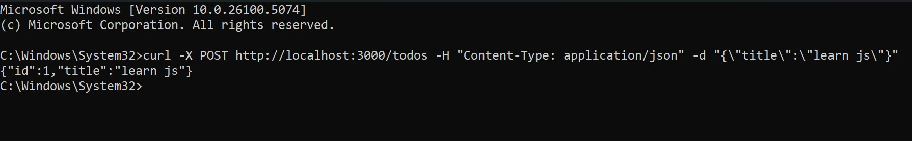
List all To-Do Items (GET):
