Practical - 5
Name: Akshay
ID: GF202349106
Link: https://github.com/Akshaykashyap0121/Node-js-AKSHAY

Problem 1: Emit an event "greet" and listen to it.
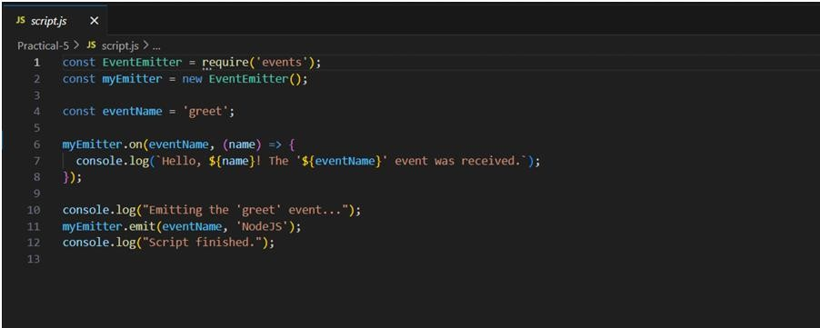
Output:
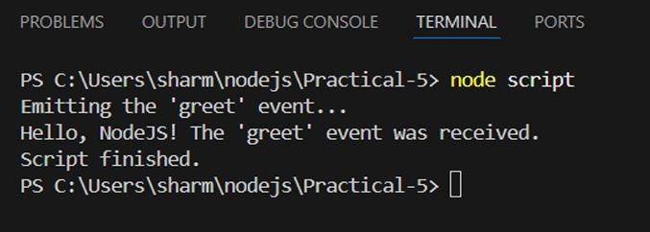
Problem 2: Connect Node.js to MongoDB and insert a user record.
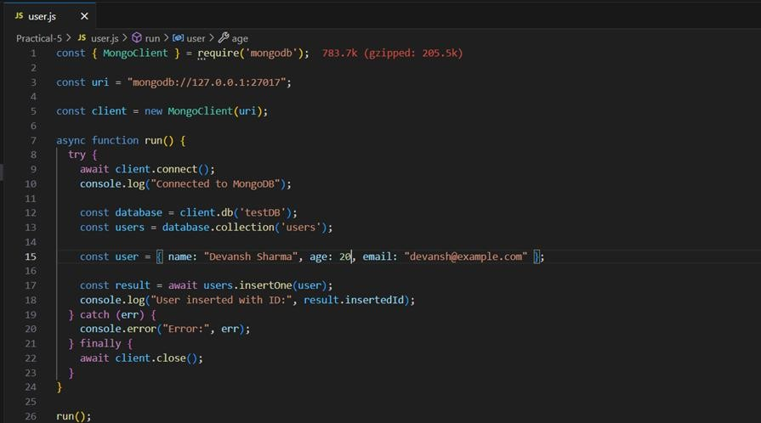
Output:
