Practical – 6
GitHub Link: https://github.com/Akshaykashyap0121/Node-js-AKSHAY
- Write a program to create the server with dynamic imports with top level await.
- Goal: Use stream, readline, pipeline, backpressure.
Tasks: Given data/users.csv (~1M rows), count users per domain from email. Write results to out/domains.json without loading all into memory.
- Create an EventEmitter-based logger with transports and rotation: Logger emits log events; transports subscribe (console, file). Implement size-based rotation at ~5-0KB per file.
Project Structure:
- main.mjs: Main program file implementing the server, CSV processing, and logger.
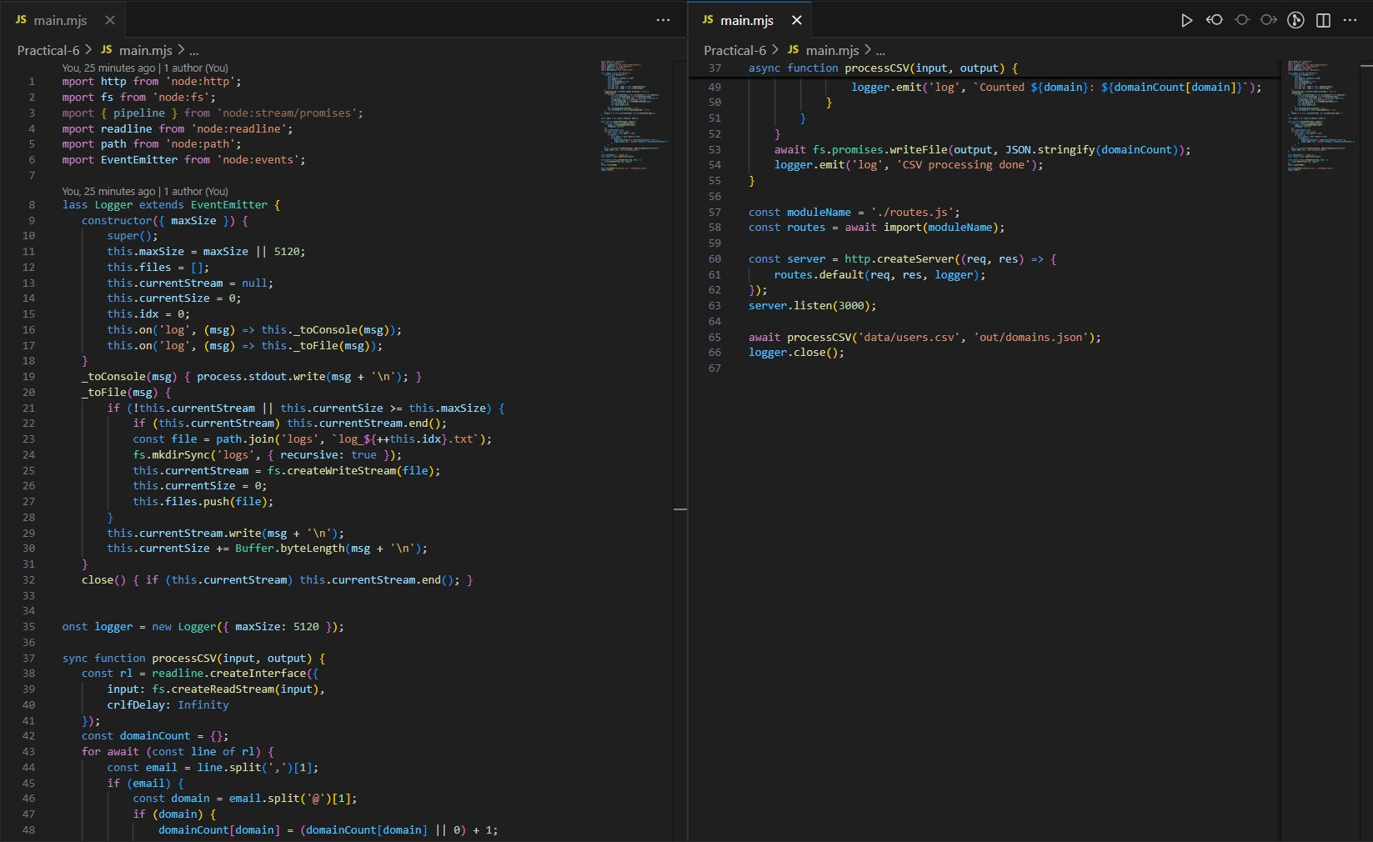
- routes.js: Module handling HTTP request responses.
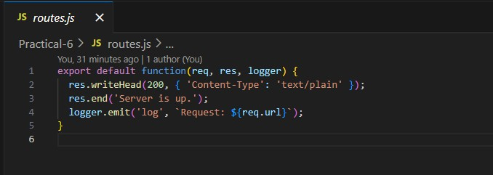
- data/users.csv: Input CSV with user data (id, name, email).
- out/domains.json: Output JSON file to save domain counts (created after processing).
- logs/: Directory where rotating log files are saved.

Output:
